Titanic Block One: Writing Task Preparation

You will be creating a piece of writing from the perspective of either a first or third class passenger on board the Titanic.

Knowledge task:
Take a double page spread of your exercise book. One of these pages will be for research notes on what first class was like and the other is for research notes on what third class was like.
You should write clearly at the top which page is which. You will then be filling the page with notes, these can in boxes, bullet point lists or you could write in paragraphs. You can add pictures if you/ wish to.
First Class

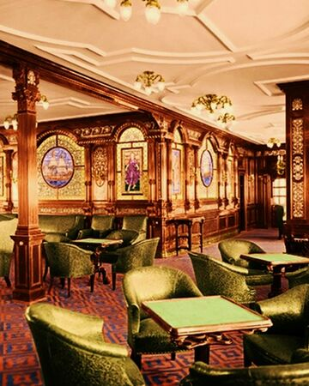
First class on board Titanic was the ultimate in luxury. It included veranda cafes, a smoking room, restaurant, a dining saloon and a reading and writing room.

Perspectives task:
- What is a perspective? Write a definition, in your own words
You now need to think about the thoughts and feelings of the people in first class and the people in third class.
Create a table like the one below. In the ‘Good’ column you need to write out a list of feelings a wealthy passenger may feel when they get on board the Titanic and see what their first class area looks like. Then you need to write as many synonyms as you can for that word in the ‘Better’ column – use a thesaurus or thesaurus.com to help you here.
Finally you need to choose the best, most ambitious word from those synonyms to put in the ‘Best column’.
Good | Better | Best
Satisfied

Pleased

Happy

Once you have done this for the first class passenger you need to do the same for a third class passenger.

What did the Titanic mean to people?
- Why might a poor person want to get a ticket for the Titanic?
- Why might a rich person want to get a ticket for the Titanic?
- What would a poor person think of America (the destination of the Titanic?)
- What would a rich person think of America (the destination of the Titanic?)

Who was the Titanic aimed at and why do you think that?

Why might the Titanic have had to cater for every different class of person?

