Romeo and Juliet Home Learning
Part 2: Act 5

Task 1: Act 5 Summary
Copy and paste the website link below into your web browser and click on ‘Act 5’ then read the summary.
https://www.rsc.org.uk/shakespeare-learning-zone/romeo-and-juliet/story/scene-by-scene#:~:text=Act%201%20Scene%201,Tybalt%20arrives%20things%20get%20worse.
The following web link is also really useful for understanding plot:
https://www.bbc.co.uk/bitesize/guides/zfpcwmn/revision/1
- Create a storyboard/ comic strip to show what happens in Act 5 of the play. You can do this by folding an A4 page in half once, then a second time and then a third time so you have 8 boxes. You will need to plan what will go in each box before you start to draw.

Task 2: Romeo’s death
Firstly, read through the script of Romeo’s final words with the modern translation to help you understand what he is saying.
ORIGINAL TEXT | MODERN TEXT
How oft when men are at the point of death  Have they been merry, which their keepers call  A lightning before death! Oh, how may I  Call this a lightning?—O my love, my wife!  Death, that hath sucked the honey of thy breath,  Hath had no power yet upon thy beauty.  Thou art not conquered. Beauty’s ensign yet  Is crimson in thy lips and in thy cheeks,  And death’s pale flag is not advancèd there.—  Tybalt, liest thou there in thy bloody sheet?  O, what more favor can I do to thee,  Than with that hand that cut thy youth in twain  To sunder his that was thine enemy?  Forgive me, cousin.—Ah, dear Juliet,  Why art thou yet so fair? Shall I believe  That unsubstantial death is amorous,  And that the lean abhorrèd monster keeps  Thee here in dark to be his paramour?  For fear of that, I still will stay with thee,  And never from this palace of dim night  Depart again. Here, here will I remain  With worms that are thy chamber maids. Oh, here  Will I set up my everlasting rest,  And shake the yoke of inauspicious stars  From this world-wearied flesh. Eyes, look your last.  Arms, take your last embrace. And, lips, O you  The doors of breath, seal with a righteous kiss  A dateless bargain to engrossing death.  (kisses JULIET, takes out the poison)  Come, bitter conduct, come, unsavoury guide.  Thou desperate pilot, now at once run on  The dashing rocks thy seasick, weary bark.  Here’s to my love! (drinks the poison) O true apothecary,  Thy drugs are quick. Thus with a kiss I die. | How often are men happy right before they die! They call it the lightness before death.  Oh, how can I call this lightness? Oh, my love! My wife!  Death has sucked the honey from your breath, but it has not yet ruined your beauty.  You haven’t been conquered. There is still red in your lips and in your cheeks. Death has not yet turned them pale.  Tybalt, are you lying there in your bloody death shroud? Oh, what better favour can I do for you than to kill the man who killed you with the same hand that made you die young.  Forgive me, cousin! Ah, dear Juliet, why are you still so beautiful? Should I believe that death is in love with you, and that the awful monster keeps you here to be his mistress?  I don’t like that idea, so I’ll stay with you. And I will never leave this tomb.  Here, here I’ll remain with worms that are your chamber-maids. Oh, I’ll rest here forever. I’ll forget about all the bad luck that has troubled me. Eyes, look out for the last time!  Arms, make your last embrace! And lips, you are the doors of breath. Seal with a righteous kiss the deal I have made with death forever. (ROMEO kisses JULIET and takes out the poison)  Come, bitter poison, come, unsavoury guide!  You desperate pilot, let’s crash this sea-weary ship into the rocks! Here’s to my love!  ROMEO drinks the poison.  Oh, that pharmacist was honest! His drugs work quickly. So I die with a kiss.
ROMEO dies | ROMEO dies.

Now answer the questions below:
- What is Romeo saying about how Juliet looks?
- Who does Romeo ask for forgiveness and why does he?
- Looking at this quote: ‘Come, bitter conduct, come, unsavoury guide.’ (Come, bitter poison, come, unsavoury guide!) How does Romeo view the poison he is about to take? Explain your answers.

Task 3: Zooming in
‘pilot’ = person in control of sailing a ship
‘bark’ = ship

Romeo is talking to ‘someone’ now, saying they are in control of a ship which he wants to crash into rocks and ruin. The ship in this is his life, which he wants to be over.

- What technique is this?
- He is talking to someone else, asking them to end his life. What theme does this link into? (hint: it links to the prologue and to Romeo’s prophecy before he enters Capulet’s party and fits into mythology)
- Look at how Romeo is describing his death – crashing into rocks and wrecking the ‘ship’. He seems to be wanting a painful, violent, dramatic death, why might this be?
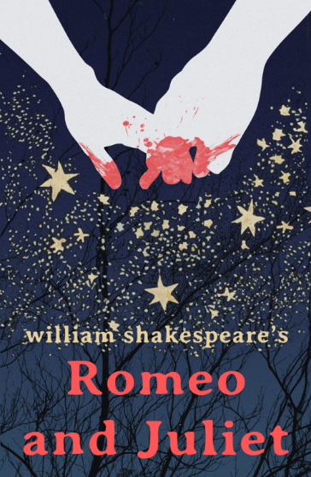
Task 4: Creating a New Cover
Design and create a new book or play cover for Romeo and Juliet. Use images which you think represent what Romeo and Juliet is all about and a line or two about the play. You could also include a brief quote from yourself giving the play a review!
Type ‘Romeo and Juliet’ covers into Google to get some inspiration!

Extension Task: Alternative Endings

Re-write the ending of Romeo and Juliet, in story form, imaging Romeo makes it to Juliet in time.
This doesn’t have to mean it ends happily for them! Fate still might be controlling them…
If you’re struggling: draw a storyboard/ comic strip of the new ending
Challenge yourself: Write the alternative ending as a script

