Romeo and Juliet Home Learning
Part 2: Act 4

Task 1: Act 4 Summary
Copy and paste the website link below into your web browser and click on ‘Act 4’ then read the summary.
https://www.rsc.org.uk/shakespeare-learning-zone/romeo-and-juliet/story/scene-by-scene#:~:text=Act%201%20Scene%201,Tybalt%20arrives%20things%20get%20worse.

The following web link is also really useful for understanding plot:
https://www.bbc.co.uk/bitesize/guides/zfpcwmn/revision/1

- Create a storyboard/ comic strip to show what happens in Act 4 of the play. You can do this by folding an A4 page in half once, then a second time and then a third time so you have 8 boxes. You will need to plan what will go in each box before you start to draw.

Task 2: Juliet’s Soliloquy

Firstly, look up and write down the definition of a soliloquy.
Then read through Juliet’s soliloquy below, which has a translation to help you understand what she’s saying.

ORIGINAL TEXT | MODERN TEXT
My dismal scene I needs must act alone.  Come, vial. (holds out the vial)  What if this mixture do not work at all?  Shall I be married then tomorrow morning?  No, no. This shall forbid it. Lie thou there.  (lays her knife down)  What if it be a poison, which the friar  Subtly hath ministered to have me dead,  Lest in this marriage he should be dishonored  Because he married me before to Romeo?  I fear it is. And yet, methinks, it should not,  For he hath still been tried a holy man.  How if, when I am laid into the tomb,  I wake before the time that Romeo  Come to redeem me? There’s a fearful point.  Shall I not, then, be stifled in the vault  To whose foul mouth no healthsome air breathes in,  And there die strangled ere my Romeo comes?  Or, if I live, is it not very like  The horrible conceit of death and night,  Together with the terror of the place—  As in a vault, an ancient receptacle,  Where for these many hundred years the bones  Of all my buried ancestors are packed;  Where bloody Tybalt, yet but green in earth,  Lies festering in his shroud; where, as they say,  At some hours in the night spirits resort—?  Alack, alack, is it not like that I,  So early waking, what with loathsome smells,  And shrieks like mandrakes torn out of the earth,  That living mortals, hearing them, run mad—? | Alright, here’s the vial. What if this mixture doesn’t work at all? Will I be married tomorrow morning? No, no, this knife will stop it. Lie down right there.  (she lays down the knife)  What if the Friar mixed the potion to kill me? Is he worried that he will be disgraced if I marry Paris after he married me to Romeo? I’m afraid that it’s poison. And yet, it shouldn’t be poison because he is a trustworthy holy man.  What if, when I am put in the tomb, I wake up before Romeo comes to save me? That’s a frightening idea.  Won’t I suffocate in the tomb? There’s no healthy air to breathe in there. Will I die of suffocation before Romeo comes?  Or if I live, I’ll be surrounded by death and darkness. It will be terrible. There will be bones hundreds of years old in that tomb, my ancestors' bones.  Tybalt’s body will be in there, freshly entombed, and his corpse will be rotting. They say that during the night the spirits are in tombs.  Oh no, oh no. I’ll wake up and smell awful smells. I’ll hear screams that would drive people mad.

Now answer the following questions:

- What does the word dismal mean and what could it tell us about how she views her situation?
- What is she worried the friar has done and why does she think he might be have done this?
- Why does she decide she can actually trust the friar?
- What else is Juliet scared of happening?
- How many questions have been used in this soliloquy? What could this suggest to us about how Juliet is feeling?

Here Juliet is frantically talking about getting trapped in the family vault where her family – including Tybalt – are buried. At the end, in this section, she is imagining waking there and hearing screams and going ‘mad’.
- How prepared do think Juliet is for what she is about to do? Explain your answer.
- What is your impression of Juliet based on this soliloquy? Explain your answer.

Task 3: Techniques

Shall I not, then, be stifled in the vault
To whose foul mouth no healthsome air breathes in

- Here Juliet is saying the vault has a mouth but doesn’t ‘breathe in’ fresh air. What technique is this?
- What impression does this give you about the vault?

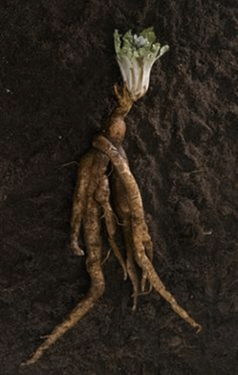
shrieks like mandrakes torn out of the earth

Mandrakes are plants which roots were thought to have resemblance to human features, and when separated from the earth will emit shrieks (think Harry Potter.)
- Here Juliet is suggesting she will become like a mandrake, a body in the ground screaming because she’s gone ‘mad’. What technique is this?
- How could this be going against religion, if the dead are just bodies in the ground?
- How does this show how Juliet has changed over the course of the play? Link to when she met Romeo.

