A Christmas Carol Unit Core Tasks

- Answer the question below using a PEA structure:

How has Charles Dickens presented the character of Scrooge at the beginning of ‘A Christmas Carol’?

- You should be aiming for 3 x PEA paragraphs – so 3 x different ideas about how Scrooge has been presented
- You need to be using quotes from the novella for every point you make, with single word analysis/ zooming in on words
- You also need to make sure you are linking what you say to your knowledge of the time period and why Dickens wrote the story

You may use the sentence starters below if you need to:

Charles Dickens has presented Scrooge as….
Evidence of this can be found in the quote ‘…’
The (word) would have connotations of… so readers would feel…
This fits into the time period, when…
So Dickens may be doing this to…

Additionally, readers may feel like Scrooge is… because of the line ‘…’
This is because the (word) ‘_____’ would make them think of…
During this time, the Victorian period…
This may be because Dickens want to…

Now have a go at the third paragraph yourself!

- Write a description of the image below, which depicts Christmas during the Victorian times.

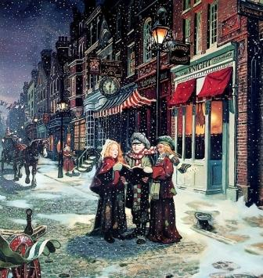

- You should be aiming for at least a page of writing
- You need to make sure you PLAN your ideas first
- If you need help structuring your ideas, try to write about what’s going on in sky first, then the outsides of the image and then zoom in eventually to a smaller detail – like a swirl
- You also need to make sure you’re including the criteria from the box below:

Descriptive Writing Criteria
- Range of SOSMAPS+ techniques
- Adjectives!
- Sophisticated vocabulary
- Variety of sentence types
- A range of punctuation

