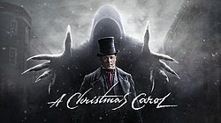
A Christmas Carol, by Charles Dickens
Stave Five

Firstly…
Read Stave Five in in your copy of A Christmas Carol or from the link on the accompanying PowerPoint
Watch Stave Four on the link provided in the ac companying PowerPoint

Yes! and the bedpost was his own. The bed was his own, the room was his own. Best and happiest of all, the Time before him was his own, to make amends in!
- Look at the opening quote from the chapter. Answer the questions below as full sentences or annotations.
What kind of tone or mood is presented to the reader here? How?
Even though this is the narrator continuing the story, this sounds like Scrooge. Why has the narrator taken on the voice of Scrooge?
How is the tone of this quote considerably different from the previous staves? What does this suggest to the reader about the pace and tone of the rest of Stave Five? Refer to specific quotes.

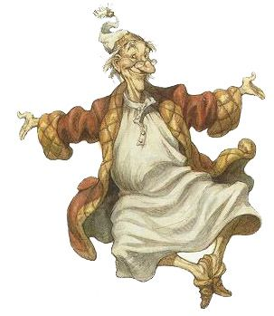
- Copy out the following table, which shows different methods Dickens has used to create a joyous atmosphere in the final stave. Fill in the missing boxes with either: the method used, an explanation for why that method has been used/ the effect or a quote from this stave which shows the method in use.

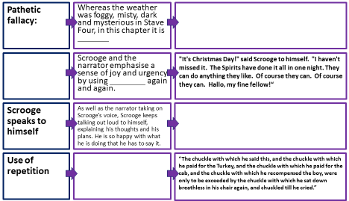
Structure of ‘A Christmas Carol’:
Dickens uses a cyclical structure so that all the major characters and events from Stave One are revisited in Stave Five

It helps to show the contrast in behaviour between the old Scrooge and the new, but it also allows Scrooge to right his previous wrongs and embody the Christmas spirit.

- Before writing out the ideas above, copy the link below and make notes on structure from the web page, watch the video and take the test – without cheating!
https://www.bbc.co.uk/bitesize/guides/zsf2v4j/revision/3
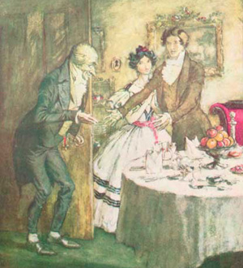
- Can you think of any other books you have studied which have been structured in a cyclical way?

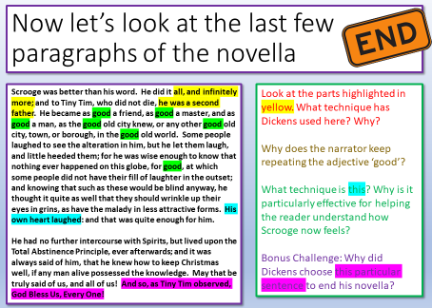

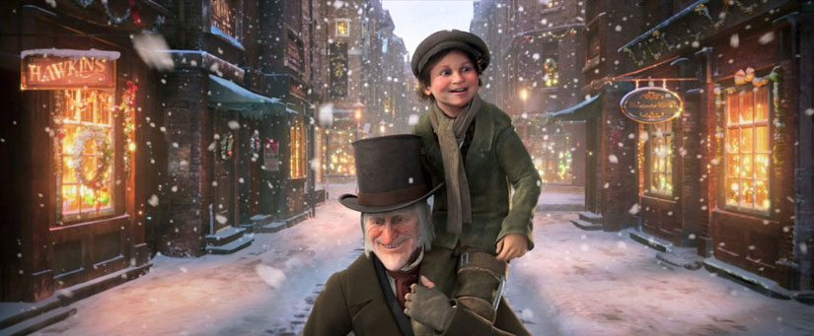
- Stave Five Done!

