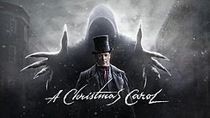
A Christmas Carol, by Charles Dickens
Stave Four

Firstly…
Read Stave Four in in your copy of A Christmas Carol or from the link on the accompanying PowerPoint
Watch Stave Four on the link provided in the accompanying PowerPoint

The Three Spirits:
- The Ghost of Christmas Past, is often said to look like an angel
Find where this ghost is introduced (Stave Two) and look for evidence of this
- The Ghost of Christmas Present, is often said to look like father Christmas
Find where this ghost is introduced (Stave Three) and look for evidence of this
- What famous figure could The Ghost of Christmas Yet to Come look like?
Find where this ghost is introduced (Stave Four) and look for evidence of this

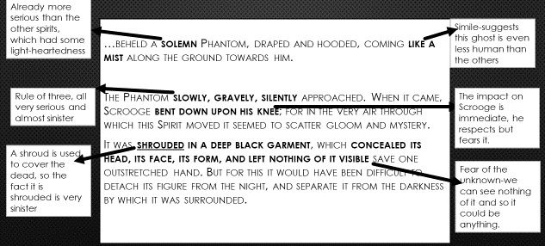
- Find the section below in your copy of A Christmas Carol (you can always copy and paste it from the online copy in the Accompanying Resources PPT) and make the annotations you see below:

- Copy out and fill in the table below:

 | Jacob Marley’s Ghost | The Ghost of Christmas Past | The Ghost of Present | The Ghost of Christmas Yet to Come
Quotes which show Scrooge’s reaction to the ghost
(with explanation if needed)
Readers’ response
(how do we feel about Scrooge at this point, and why?)
Dickens now takes reads on a journey through the ‘slums’ (poverty ridden) Victorian London. This is the spirits’ last chance to reform Scrooge – and Dickens’ last chance to convince his readers society needs to change – so it makes sense these would be the most powerful and hard hitting images.
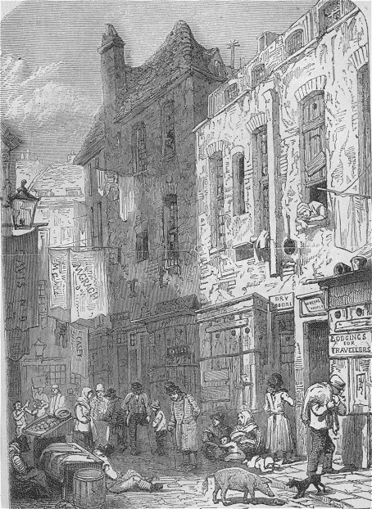

“They left the busy scene, and went into an obscure part of town, where Scrooge had never penetrated before, although he recognised its situation and its bad repute.”

- What does it suggest about Scrooge – and wealthy people – if he had never been to this area, but knew how much suffering went on here?

http://www.dailymail.co.uk/news/article-1033919/It-worst-slum-Victorian-Britain-Yet-crime-ridden-streets-SAFER-todays.html#ixzz1AQqbkqjU
Old Joe’s:
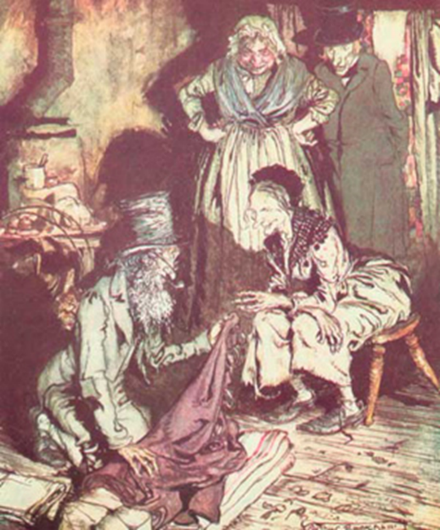
- Answer the following questions using page 42 of your copies of A Christmas Carol (or the online linked version)

What are we told about Scrooge’s ‘death’?

What items are taken from Scrooge after he ‘dies’?

How do Old Joe’s visitors justify stealing from Scrooge?

Has Scrooge reformed?
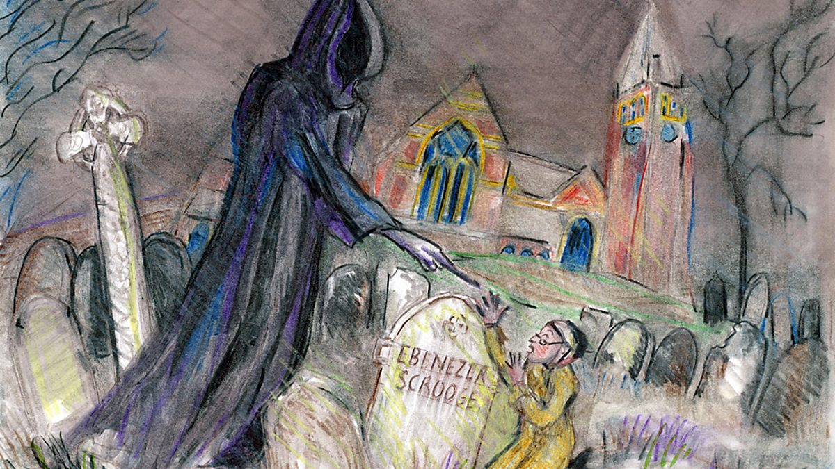
- Take a whole page and in the middle write the question above, then around the outside note down every bit of evidence you can find in this stave (especially focus on the end) that Scrooge is a changed man. Add any explanations you need to for the quotes, and if you want to stretch yourself further find evidence from earlier in the novella which show the difference in his character.
Does this image accurately represent the way to the two characters are at the end?
- Find evidence and then explain what this suggests about power.

- Stave Four Done

