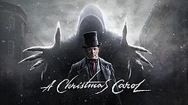
A Christmas Carol, by Charles Dickens
Stave Three

Firstly…
Read Stave Three in in your copy of A Christmas Carol or from the link on the accompanying PowerPoint
Watch Stave Three on the link provided in the accompanying PowerPoint

Answer all questions in COMPLETE SENTENCES
1. What first alerts Scrooge to the presence of the second spirit? How does he respond?
2. When the second spirit invites Scrooge into the room, what does Scrooge find there?
3. Describe the second spirit physically.
4. Describe the personality of the second spirit.
5. What does the spirit mean when it says it has more than eighteen hundred brothers?
6. Where does the Ghost of Christmas Present take Scrooge on the first part of their journey? What do they see?
7. Describe the Cratchits’ reaction to their Christmas feast. What does their celebration show Scrooge?
8. What does the spirit predict will happen to Tiny Tim? How does Scrooge respond?
9. Why does Fred continue to see his uncle?
10. Describe the two children that emerge from the second spirit’s robes.
11. What do they symbolize? How are they “man’s children?”
12. How does Scrooge change as a result of his visit with the Ghost of Christmas Present?
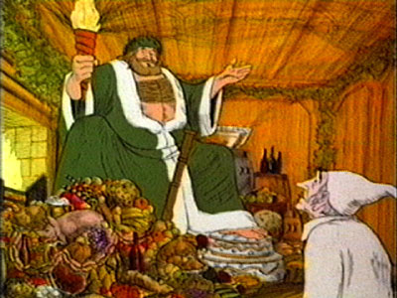
The Ghost of Christmas Present
(Read from ‘Stave Three’ and stop at ‘Scrooge’s third visitor’)

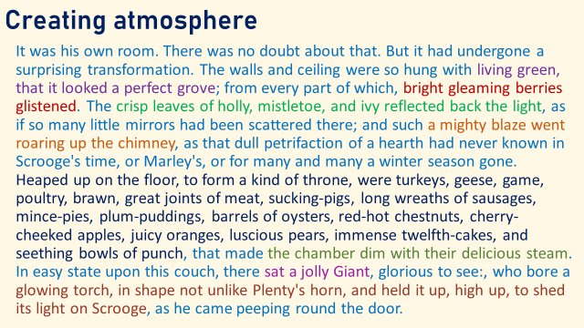
- Note down the adjectives used in this descriptive passage. What do you think about these word choices, what kind of atmosphere do they create and why do you think this?
- Find and note down some classic images/ symbols of Christmas
- Find and note down the simile – what is it describing and what does it suggest?
- How is the fire in the room described, and why was this an unusual sight?
- What does the long list within this paragraph tell us is in the room and what does having it in a list do?
- What is creating a foggy haze within the room?
- How has this ghost been described?
- What is above Scrooge’s head? What could we associate with this act/ item?

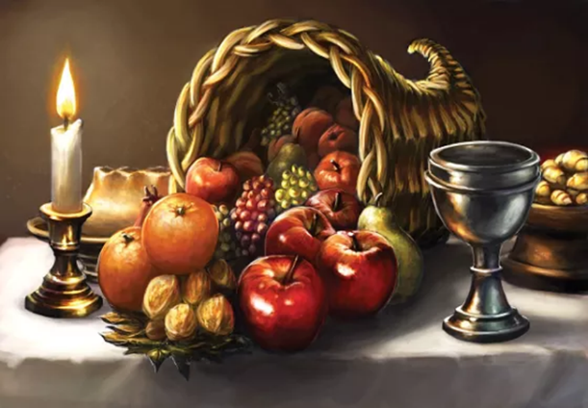
Context: The Horn of Plenty
- Mythological reference
- Otherwise known as cornucopia
- A symbol of abundance and nourishment, commonly a large horn-shaped container overflowing with produce, flowers or nuts
- Associated with the harvest, prosperity, or spiritual abundance

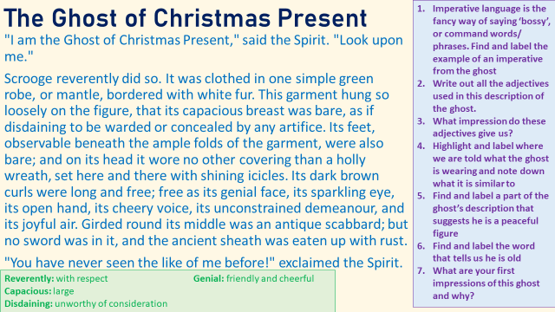
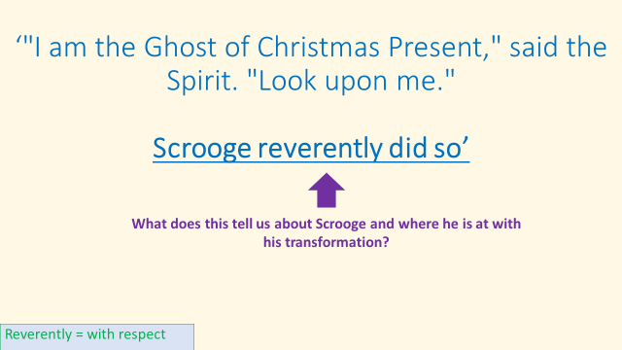
So back to Scrooge…

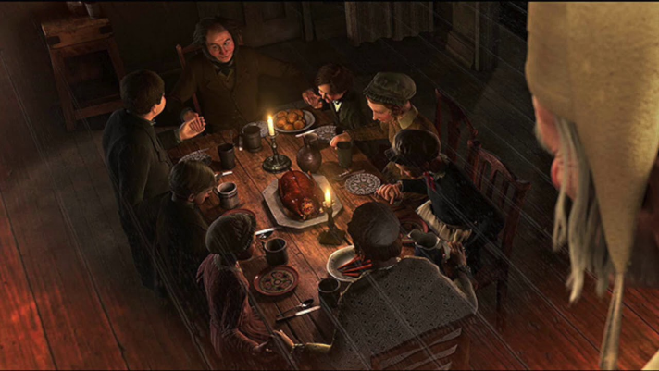
The Cratchits
(Read from ‘Scrooge’s third visitor’ to ‘By this time it was getting dark’)

Then up rose Mrs Cratchit, Cratchit's wife, dressed out but poorly in a twice-turned gown, but brave in ribbons, which are cheap and make a goodly show for sixpence; and she laid the cloth, assisted by Belinda Cratchit, second of her daughters, also brave in ribbons; while Master Peter Cratchit plunged a fork into the saucepan of potatoes, and getting the corners of his monstrous shirt collar (Bob's private property, conferred upon his son and heir in honour of the day) into his mouth, rejoiced to find himself so gallantly attired, and yearned to show his linen in the fashionable Parks. And now two smaller Cratchits, boy and girl, came tearing in, screaming that outside the baker's they had smelt the goose, and known it for their own; and basking in luxurious thoughts of sage and onion, these young Cratchits danced about the table, and exalted Master Peter Cratchit to the skies, while he (not proud, although his collars nearly choked him) blew the fire, until the slow potatoes bubbling up, knocked loudly at the saucepan-lid to be let out and peeled.

- The Cratchit name has been repeated several times throughout this section. This could represent the idea that poor people don’t have much – but they do hav their name and their family. How do you think readers would respond to this?
- What do you think ‘dressed out but poorly in a twice-turned gown’ means?
- What impression does ‘but brave in ribbons, which are cheap and make a goodly show’ give you about Mrs Cratchit?
- What is the formal way in which Bob’s son has been introduced and why might Dickens have done this?
- What does ‘conferred’ mean, and how does ‘Bob's private property, conferred upon his son and heir in honour of the day’ show a big difference between rich and poor?
- How does ‘rejoiced to find himself so gallantly attired, and yearned to show his linen in the fashionable Parks’ show a naivety in Peter Cratchit?
- What could ‘basking in luxurious thoughts’ suggest about the Cratchit children?
- What technique is ‘the slow potatoes bubbling up, knocked loudly at the saucepan-lid to be let out and peeled’ and what could it say about the Cratchit’s Christmas if even the food wants to come out?

- Use this extract on the Cratchit’s and research on poverty in the Victorian times to have a go at writing a PEA style paragraph for the following question. You have an example to read through and sentence starters to use if you want to. To strtch yourself further try to link to the beginning of the novella!
How has Charles Dickens suggested his views on poverty in A Christmas Carol?
Charles Dickens has suggested that just because people are poor that doesn’t mean they have to be miserable. This is presented through the Cratchit family: ‘two smaller Cratchits, boy and girl, came tearing in, screaming’. The word ‘tearing’ implies a destructive force, as if nothing will stand in their way, and ‘screaming’ shows they just can’t contain their energy and excitement. This would impress both a Victorian and a modern audience because the Cratchit children won’t be getting presents or even the best meal but are still overjoyed that it’s Christmas day. Dickens is showing that happiness doesn’t come with money, and that Christmas is a time to celebrate and be happy no matter what your wealth. Christmas changed significantly during this time with an emphasis on decorations, presents, food and parties, so it was time for the rich to show off their wealth which the poor could never do, yet the Cratchits prove that it should be about family and working together instead.

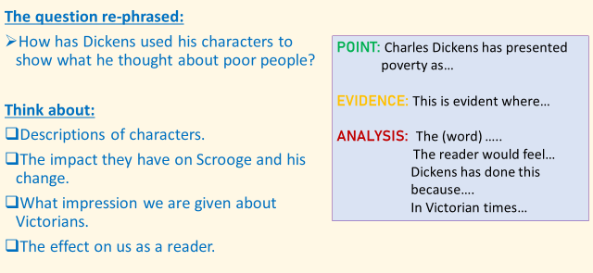

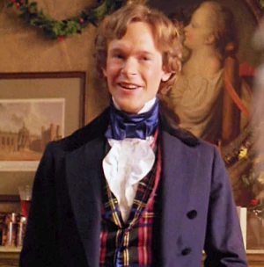
Fred’s Party
(Read from ‘By this time it was getting dark’ and stop at ‘Stave Four’)

- Note down everything you can remember about Fan, Scrooge’s sister and Fred’s mother?
- Can you find a quote which tells readers what happened to her?
“He has given us plenty of merriment, I am sure,” said Fred, “and it would be ungrateful not to drink his health. Here is a glass of mulled wine ready to our hand at the moment, and I say, ‘Uncle Scrooge’!... A Merry Christmas and a Happy New Year to the old man, whatever he is!... He wouldn’t take it from me, but may he have it, nevertheless. Uncle Scrooge!”

- How does this extract present the character of Fred, Scrooge’s nephew?
- What could this suggest Dickens wanted the ‘Christmas spirit’ to be about?
- Find the description of Fred’s wife. How has she been presented?
- Find a piece of evidence which shows Scrooge’s emotions after seeing Fred

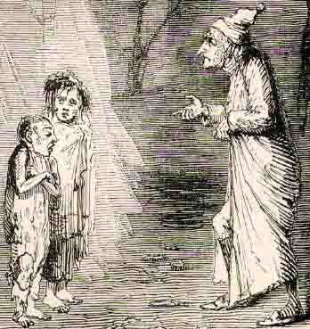
Ignorance and Want

- Stave Three Done!

