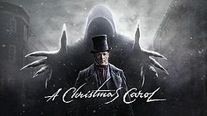
A Christmas Carol, by Charles Dickens
Stave Two

Firstly…
Read Stave Two in in your copy of A Christmas Carol or from the link on the accompanying PowerPoint
Watch Stave Two on the link provided in the accompanying PowerPoint

- DRAW a timeline of Stave 2 events. Include characters/places
Answer the following questions in complete sentences. Use EVIDENCE (in quotation marks) where possible
- DESCRIBE the appearance of the first spirit.
- What is the first spirit called and what does it symbolize?
- How does Scrooge initially react to the spirit? How would you describe his attitude?
- What part of his past does the spirit show him first?
- What do you learn about Scrooge when his sister Fan visits him at school?
- What kind of family are the Fezziwigs?
- Why does Belle end her relationship with Scrooge? What does she say?
- Does Scrooge show any regret as each scene unfolds?
- How does Scrooge try to ‘extinguish the light’?
- What does the light symbolize?
- How has Scrooge changed after the visit of the Ghost of Christmas Past?

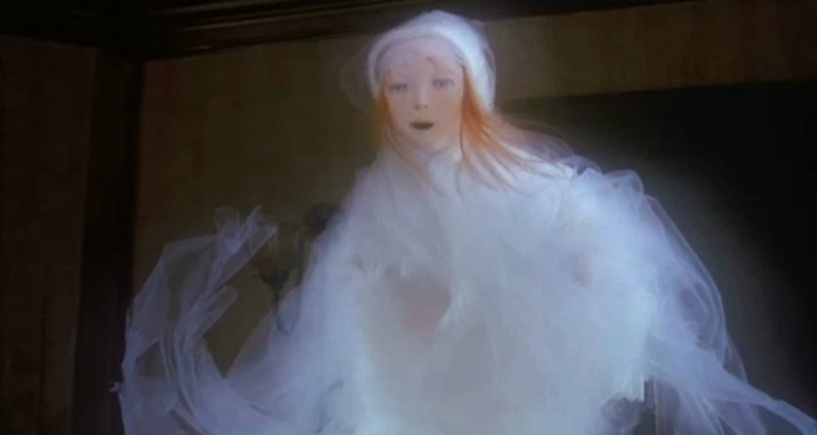
The Ghost of Christmas Past!
(Re-read from ‘Stave Two’ and stop at ‘It would have been in vain’)
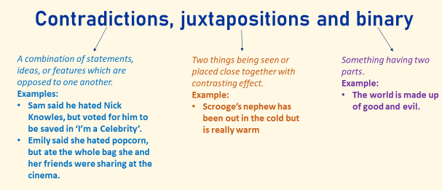
- Copy out the three key terms below:

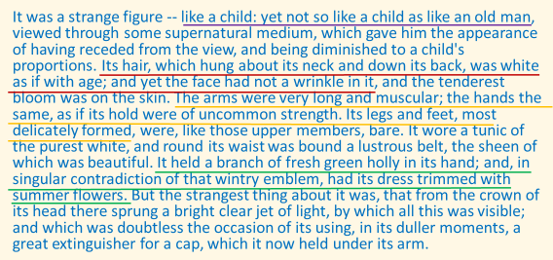
- Read the following description of the ghost:

- Split your page in half, drawing a line down the middle. On one side fill out the quotations you have been given, on the other you need to find where the ‘contradiction’ or ‘opposite’ is and write it out.
‘like a child’ | ‘like an old man’
‘as close to it as I am now to you’
‘Its hair… was white as if with age’
‘The arms were very long and muscular’
‘It held a branch of fresh green holly in its hand’
‘from the crown of its head there sprung a bright clear jet of light’
‘what was light one instant‘
‘no outline would be visible in the dense gloom’

Dickens’ intentions:
- Copy down the ideas below which explore why Dickens has presented the ghost using juxtaposition and contrasts:

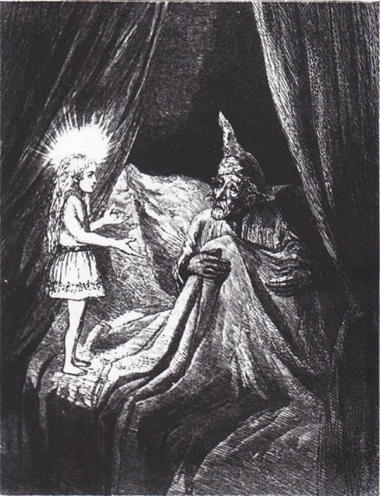
- Dickens presents the ghost as being both old and young, suggesting our past and our present are perhaps closer than we think. Our childhood changes the way we are as adults.
- The ghost is full of contradictions, suggesting there are contradictions in all of us. Good/ bad, kind/unkind etc. and this is why there is still hope for Scrooge to change which side he lives by. And for you too!
- The ghost is old and young, experienced and naïve. This could represent how just because you’re old in years you can be naïve and almost clueless when it comes to certain things.
- Contradictory people are often called hypocrites, the ghost could then reflect society and how hypocritical it is: Victorians wanted to do something about the poor but did nothing!

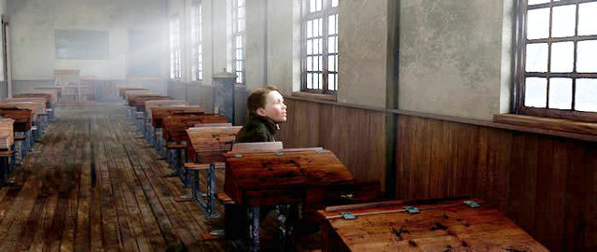
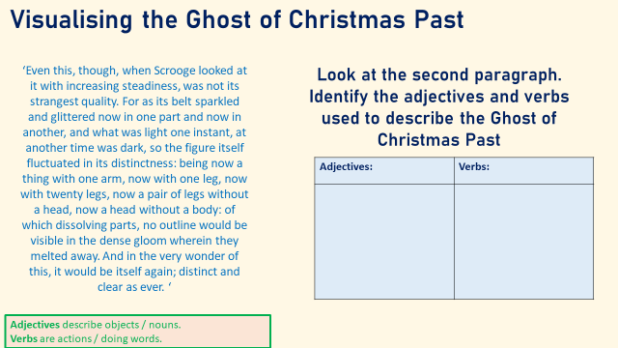
Scrooge’s first memory
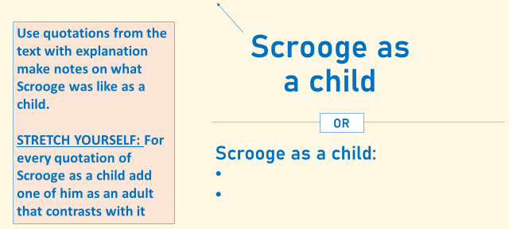
(Read from ‘It would have been in vain’ and stop at ‘Although they had but that moment left the school’)
The importance of Fan:
- Copy out the notes below about Fan, filling in the blanks from the selections below.
- Fan is important because she provides ___________ at a time when Scrooge felt frightened. For example she picks him up from ________when he was feeling isolated and _________.
- She also seems like his __________ because she tells him how his father is ‘much kinder’; home is now ‘like Heaven’.
- She also escorts him safely past the schoolmaster who ‘threw Scrooge into a dreadful state of mind’; she has the power to________ situations it seems as the ‘terrified voice in the hall’ is soon replaced with the __________________.
- We realise that never had she been physically strong or healthy; she is described as a __________________________________but, nevertheless, she ‘had a large heart!’. She did make it into womanhood, giving birth to Fred, but died young.
- This anecdote seems to cause Scrooge trouble: ‘Scrooge seemed uneasy in his mind: and answered briefly, “Yes”. We assume that in remembering his sister in this way has made him feel__________for the way he has treated Fred.
- Fan as a character is significant because, despite her small stature, her influence is great; this would make the Victorians believe that heroism can be achieved through_____________, through loving and through courage. Humankind could easily help other humans in need.

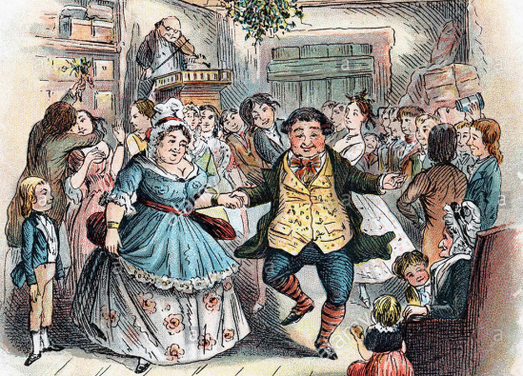
Mr Fezziwig’s Ball
(Read from ‘Although they had but that moment left the school’ and stop at ‘”My time grows short”’)

What is the significance of Fezziwig as a character?
Rank the statements in order of most true to least true.
Provide at least one evidence (from pg20-21) to support your top three statements.
- Fezziwig is significant because he is such a nice character in a novel where there are few nice characters.
- Fezziwig is significant because he is rich but generous.
- Fezzwig is significant because he allows Scrooge to recognise his own shortcomings as a master.
- Fezziwig is significant as a Victorian gentleman because he doesn’t believe in any social hierarchy but in equality; this is why he treats everyone with the same friendliness.
- Fezziwig is significant because Dickens presents him as a shining paradigm of excellence; an example which others should follow.
- Fezzwig is significant because Dickens presents him as a progressive man as he treats his wife as his equal.
Why, it’s old Fezziwig! Bless his heart; it’s Fezziwig alive again!”
Old Fezziwig laid down his pen, and looked up at the clock, which pointed to the hour of seven. He rubbed his hands; adjusted his capacious waistcoat; laughed all over himself, from his shoes to his organ of benevolence; and called out in a comfortable, oily, rich, fat, jovial voice:
“Yo ho, there! Ebenezer! Dick!”
Glossary:
Capacious – having a lot of space inside; roomy ("she rummaged in her capacious handbag“)
Organ – a part of a person that has a specific and vital use to the running of you body
Benevolence – the quality of being well meaning; kindness
Jovial – cheerful and friendly ("she was in a jovial mood“)

What do you think the effect is of using the following?
- Repetition
- Exclamation
- Verbs
- Personification
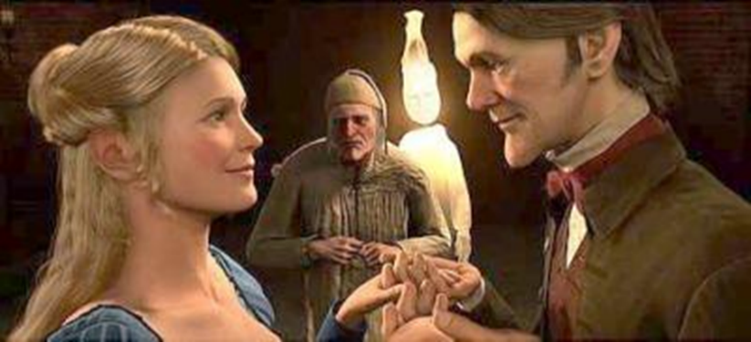
- List of adjectives
Scrooge gets dumped
(Read from ‘”My time grows short”’ and stop at ‘Stave Three’)

- Find the quote which references what Belle says she has been replaced by in Scrooge’s affections
- What does this quote mean? Try to zoom in on key words and their connotations

- Stave Two done!

