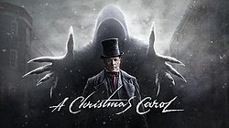
A Christmas Carol, by Charles Dickens
Stave One (Part One)

Firstly…
Read Stave One in in your copy of A Christmas Carol or from the link on the accompanying PowerPoint
Watch Stave One on the link provided in the accompanying PowerPoint

- Draw a storyboard of the events of Stave One

- Answer the comprehension questions below:

- What is the simile in the second paragraph? Why does Dickens use it?
- Describe the relationship between Scrooge and Marley.
- What does ‘Once upon a time’ make it sound like?
- Where is there an example of direct address – who is talking and who are they talking to?
- How does Dickens show the differences between Fred and Scrooge?
- What, besides Christmas, does Scrooge make fun of in his conversation with his nephew?
- What does Scrooge’s reaction to the charity men show?
- Find a quotation that sums up Scrooge’s attitude toward the poor.
- How does Scrooge treat his clerk? How does he respond to his clerk’s request for Christmas day off?
- What strange incident happens to Scrooge as he reaches his house?
- Describe Marley’s ghost – provide both a physical and emotional description.
- What does Scrooge think has caused this ghost to appear?
- What warning does Marley give to Scrooge?

- Write out the following two similes with plenty of space around them, then, like a spider diagram, make notes in the space focusing on zooming in on the key words and their connotations.
- ‘Hard and sharp as flint’
- ‘Solitary as an oyster’

- Read through the following PEA paragraph for quote 1. Then, using it as a guide, and the sentence starters provided, write your own PEA paragraph for quote 2.
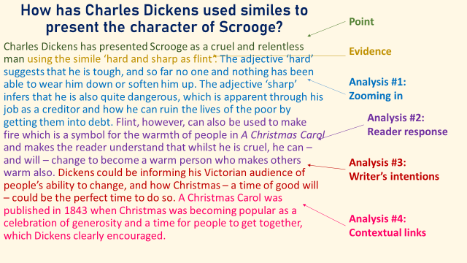
Sentence starters:
Charles Dickens has presented Scrooge as…
using the simile ‘…’.
The adjective ‘solitary’ suggests that he is.... The noun ‘oyster’ infers that he is...
Because of this a reader would feel...
Dickens could be informing his Victorian audience that....

- So what about Bob..?
‘The door of Scrooge's counting-house was open that he might keep his eye upon his clerk, who in a dismal little cell beyond, a sort of tank, was copying letters. Scrooge had a very small fire, but the clerk's fire was so very much smaller that it looked like one coal. But he couldn't replenish it, for Scrooge kept the coal-box in his own room…’
- What do we learn about the relationship between Scrooge and his clerk (Bob Cratchit)?
- What do we learn about their social positions?
- Why make reference to fire?

Pathetic fallacy
Read the following extract again:
Once upon a time—of all the good days in the year, on Christmas Eve—old Scrooge sat busy in his counting-house. It was cold, bleak, biting weather: foggy withal: and he could hear the people in the court outside, go wheezing up and down, beating their hands upon their breasts, and stamping their feet upon the pavement stones to warm them. The city clocks had only just gone three, but it was quite dark already—it had not been light all day—and candles were flaring in the windows of the neighbouring offices, like ruddy smears upon the palpable brown air. The fog came pouring in at every chink and keyhole, and was so dense without, that although the court was of the narrowest, the houses opposite were mere phantoms. To see the dingy cloud come drooping down, obscuring everything, one might have thought that Nature lived hard by, and was brewing on a large scale.

- Copy down the following definition:
Pathetic fallacy is a type of personification. It is where something is given human emotions – usually the weather.

- Note down any examples of pathetic fallacy you can find in the extract above.
- Answer the question below using PEA structure:
How has Dickens presented the weather in this extract from Stave One?

Now it’s your turn…
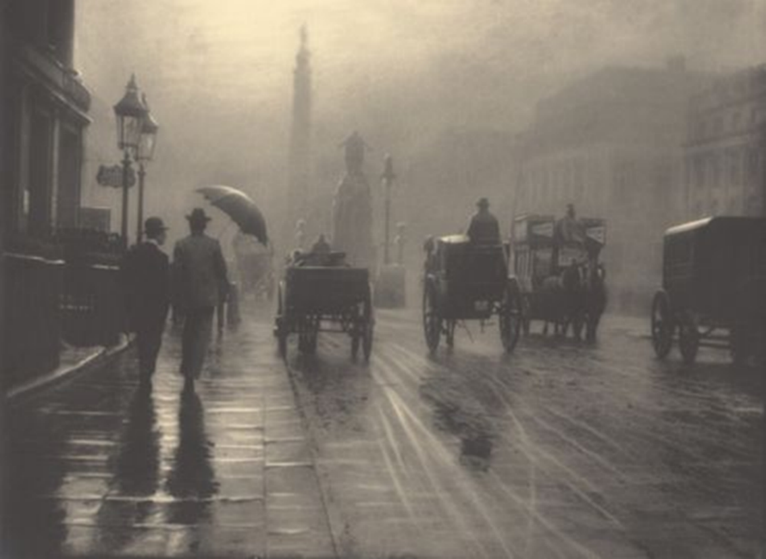
Have a go at writing a description of this image using the weather and pathetic fallacy to create atmosphere and setting.

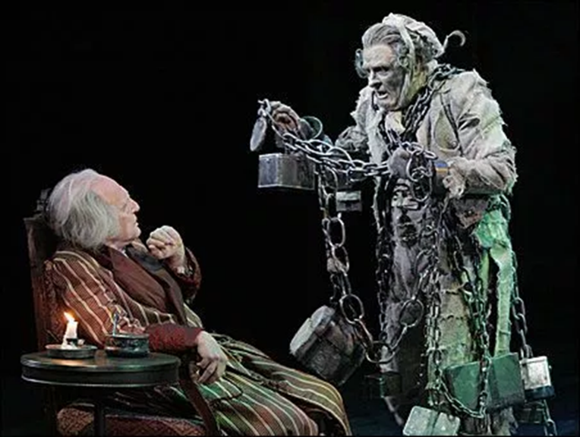
Jacob Marley’s Ghost!
Recap: Jacob Marley was Scrooge’s old business partner in the counting house. He died exactly seven years ago, on Christmas Eve and Scrooge was the only person to go to his funeral.

‘The chain he drew was clasped about his middle. It was long, and wound about him like a tail: and it was made … of cash-boxes, keys, padlocks, ledgers, deeds, and heavy purses wrought in steel’

‘I wear the chain I forged in life’

- What do we associate with chains?
- What do the items Marley has hanging from him symbolise?
- What does the verb ‘forged’ mean?
- So what does ‘I wear the chains I forged in life mean’?
- What could Dickens be saying with this quote?

Re-read the ‘Marley’s Ghost’ section and answer the questions below:
- How does Scrooge react to Jacob Marley’s ghost? Does he change throughout the interaction?
- What is Jacob Marley’s warning for what will happen to Scrooge if he doesn’t change?
- What does Marley say will happen to Scrooge after his visit?
- What does Scrooge see outside his window?

- Stave One complete!

