**A Christmas Carol Preparation Tasks**

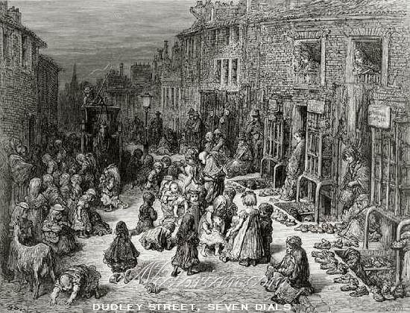**One:**

**Research poverty in the Victorian times and present your findings in either:**

* **Poster**
* **Leaflet**
* **PowerPoint**
* **Fact file**

**You should make sure you find out about Malthus’ Poor Law and the workhouses!**

**Two:**

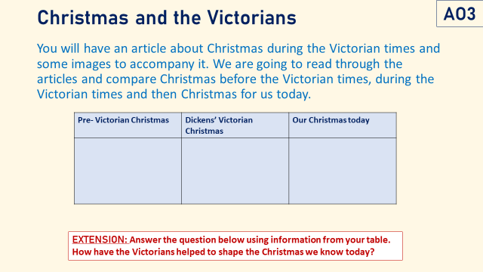

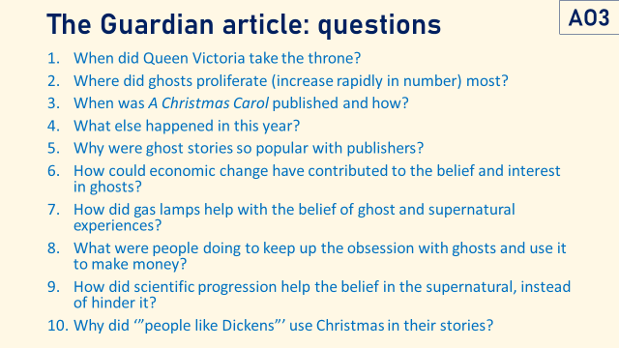**Three:**

**This is what Charles Dickens had to say about writing Christmas stories (he wrote lots!) One of the key words here is secular, which means non-religious. Use the following sentence starter to note this down in your own words.**

**“When writing Christmas stories Dickens wanted to…”**

