Ancient Greek Theatre
In Ancient Greece, the theatre was a very important aspect of society. Crowds of 15,000 people would gather to see a play. Theatre was so important to the ancient Greeks that prisoners would be released from gaol temporarily so they could attend. Every town had at least one theatre. The ancient Greeks held drama competitions with winners for playwriting and performing. These competitions were not only held in their own towns, but also in competition with other towns. Large outdoor theatres were built on hillsides to accommodate the large number of people that attended. Theatres were built on hillsides because it allowed the audience to see what was going on in the orchestra pit - the stage area. The entire seating section was called the Theatron, which is the origin of our word theatre. Part of the reason plays were so important is that originally plays were performed to honour the God Dionysus. However, over time, many different gods got in the act especially the 12 Olympians - the major gods of ancient Greece. The Greeks were always weaving the gods into their theatre stories. Sophocles was the most famous ancient Greek playwright. He wrote 120 plays. However, there were many Greek playwrights because plays were so popular.
There were three types of plays:
Tragedies: The first type they invented was the tragedy. In tragedies, one or more major characters always suffered a disastrous end.
Comedies: Comedies were invented next. In comedies, plays always had a happy end. The third type was the satire.
Satires: Satires were plays that made fun of mortal legends and of real people. In ancient Greece, you did not poke fun at the gods - not in a play, not in real life, not ever. But you could poke fun at your leaders. And that was uniquely Greek. Satires in ancient Greece were often political in nature, and could indeed affect people's opinions about current events.
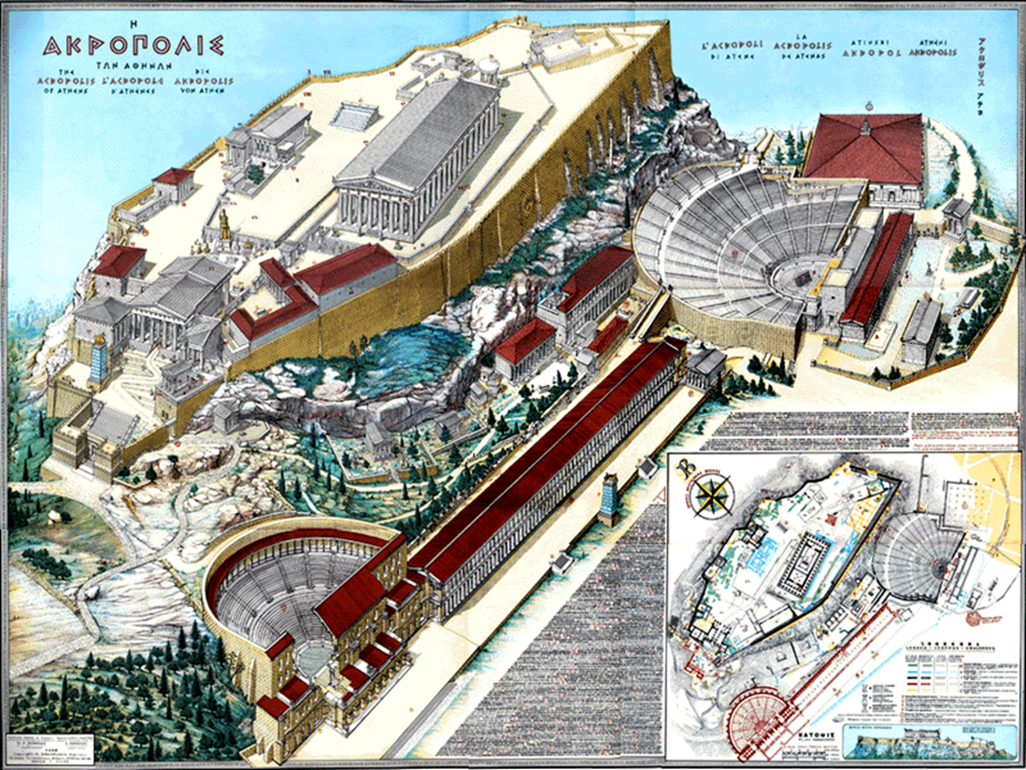
This is a diagram of an Ancient Greek theatre. Why did the ancient Greeks build their theatres so large?

Greek theatres
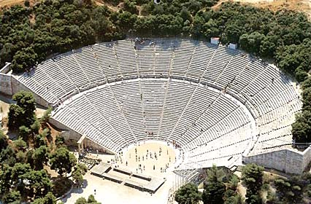
- Greek theatres were large and semi-circular, with rows of tiered seating.
- The centre was circular with an altar dedicated to Dionysus.
- The stage was raised within the circle – this shape made sure all the audience could see and helped amplify the sound.
- Very important visitors would sit in the front seats.
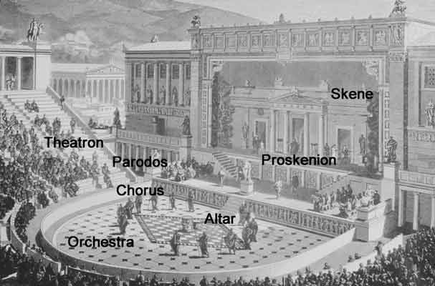
Plays
- Plays were performed in Ancient Greece to honour the God Dionysus.
- Dionysus was the god of theatre and wine.

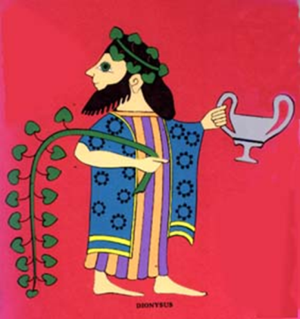
The plays
- Women could attend the plays, but all the actors were men (even playing the parts of women!).
- Some famous playwrights include: Aeschylus, Sophocles and Euripides (who wrote tragedies) and Aristophanes (who wrote comedies).

The audience
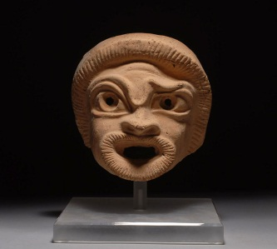
- The audience would throw food and a stone if they thought the acting wasn’t good enough!
- The actors wore masks, bright colours for comedies and dark colours for tragedies.
- You could see if someone was happy or sad by the shape of their mask.
- The masks were made from fabric, stiffened with plaster.

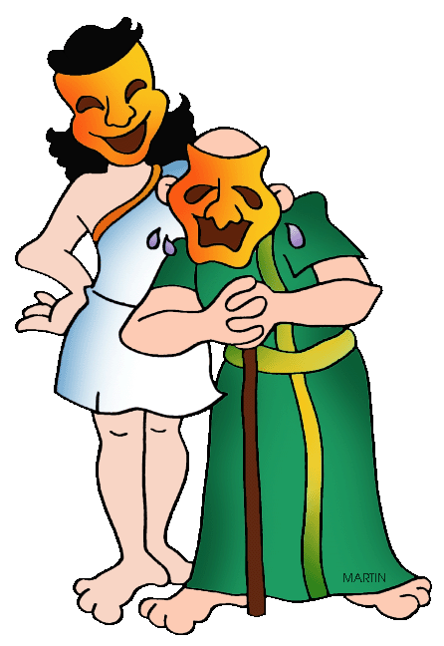
Use the information above to answer the following questions:
- Why was theatre so important to the ancient Greeks?

- What is a satire play?

- How many people would attend ancient Greek plays?

- Why were theatres built on the hillsides?

- Which God were plays dedicated to?

- Who was the most famous Greek playwright?

- The stage was raised within the circle, why was it built this way?

- What would the audience throw if they weren’t happy with the play?
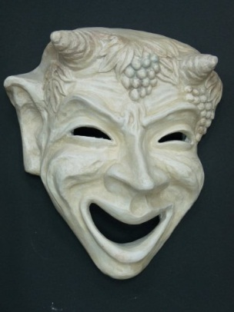
TASK:
Design your own ancient Greek theatre mask. Create a drawing of your mask and include a one paragraph description. Include what type of play/actor it could be used in.

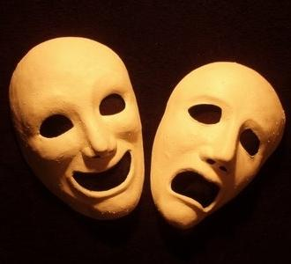
Visit the following website to answers the questions below. http://www.ancientgreece.co.uk/festivals/explore/exp_set.html
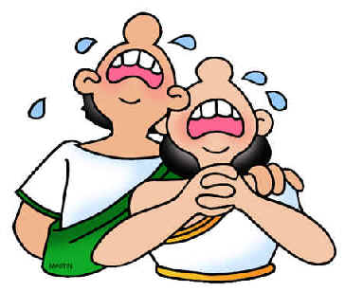
- Finish this sentence. Theatres were the setting for plays...

- Why did actors wear different types of masks?

- How would a mask help project the actor’s voice?

- Why would actors play more than one role, both female and male roles?

- What type of costume was worn during a comedy?

- What type of costume was worn during a tragedy?

- What was the skene?

- Who was the chorus?

- How many people were in the Chorus and where did they come from?

- Describe the VIP seating area.

- Describe the theatron.

- How was the auditorium divided?

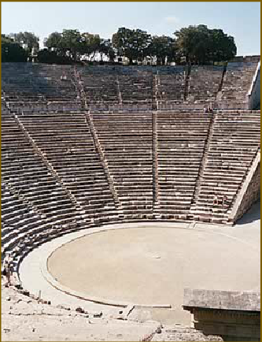
- Using this picture, describe the auditoriums of ancient Greece. How different are they from contemporary theatres?

TASK:

Write a letter to a family member about a visit to the Ancient Greek theatre. Include in this letter –

- Where you sat
- What play you watched
- What the actors looked like
- What the Chorus did
- The response of the audience
- Include a rating out of 10 for the play and the performance of the actors

Dear ______________________________

