Year 9
Record Album/CD Cover Design
You have approx. 3 -4 lessons to design and create a series of album/CD covers using Photopaint.
Step 1 Decide on the band name, decide on the album title.
The covers could be for an existing band/musician or one that you make up. Both the band name and the album title must go on the covers.
As starting resources, you can use unedited images from the internet, or you can bring in your own pictures.
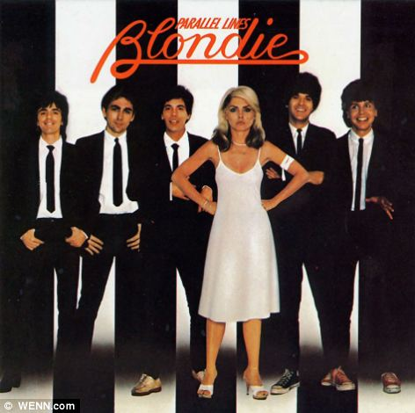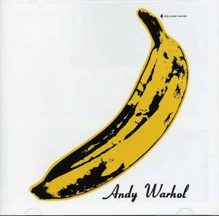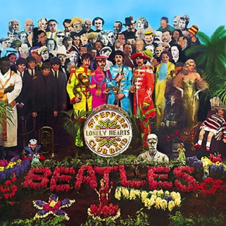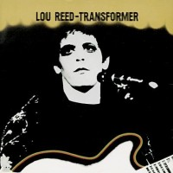
Step 2 Design: write a short description of what you want the cover to look like: this must relate to the album title in some way. You must describe use of colours, text, fonts, layout etc. List the resource images that you think you’ll need. You might want to try to sketch what your page will look like. Save this into your photo-editing folder.
Step 3 Make: test out the techniques you want to use, and then make the first cover in the design series. Try modifying your first design to produce a series of alternative versions – save each one separately in your folder. You could use different effects or colour ways, for example, on the different versions, or you could use completely different image ideas for the same album name. Add the text last.
