/50
- Identify the two different types of sport?
- _______________________________________
- _______________________________________
(2 marks)

- State a type of physical activity
- ______________________________________
(1 mark)

- Match up the correct terms with their definitions
Sport |  | This is linked to development changes in the brain that help you become a healthy adult.
Physical Activity |  | A chemical linked with an energetic and positive outlook on life.
Positive risk taking |  | An activity involving physical exertion and skill in which an individual or team competes against another or others for entertainment.
Endorphin’s |  | Outdoor activity refers to activities engaged in outside, most commonly in natural settings.
Outdoor activities |  | Any bodily movement produced by skeletal muscles that results in energy expenditure.

(5 marks)

- List 5 different benefits of sport and physical activity.
- ___________________________________________________________________________
- ___________________________________________________________________________
- ___________________________________________________________________________
- ___________________________________________________________________________
- ___________________________________________________________________________
(5 marks)

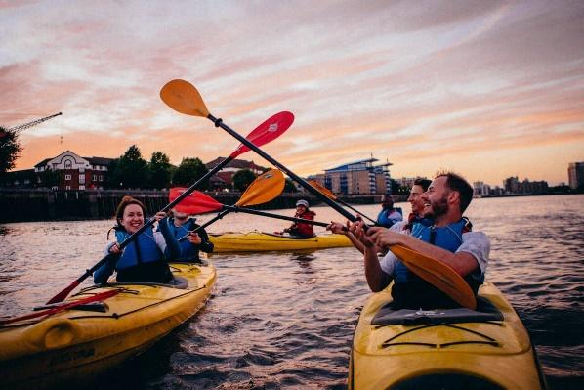
- Determine what this activity be classed as?

__________________________________________

(1 mark)

- Identify the three different provisions in sport?
- _______________________________________
- _______________________________________
- _______________________________________
(3 marks)

- Select a sports provision and explain who provides these and the purpose of the provision.
Sports Provision: ______________________________________
Purpose: _____________________________________________________________________________________________________________________________________________________________________________________________________________________________________________
(2 marks)
- State an advantage and disadvantage of the private sector
Advantage | Disadvantage

(2 marks)
- List the four different age groups that participants to fall under
- ___________________________________________________________________________
- ___________________________________________________________________________
- ___________________________________________________________________________
- ___________________________________________________________________________
(4 marks)

- Discuss how visual impairment may impact on an individual’s performance?
_____________________________________________________________________________________________________________________________________________________________________________________________________________________________________________
(2 marks)

- Identify 2 long term health conditions that could impact on taking part in sport and physical activity.
- _______________________________________
- _______________________________________
(2 marks)

- State what all individuals must minimise to meet the physical activity guidelines?
_______________________________________________________________________________
(1 mark)

- Recall the physical activity guidelines for children aged 5 – 18 years old?
- ___________________________________________________________________________
- ___________________________________________________________________________
- ___________________________________________________________________________
(3 marks)

- List 2 specific exercises older people could to engage in?
- _______________________________________
- _______________________________________
(2 marks)

- Explain the benefits for older people if they participate within these activities. _____________________________________________________________________________________________________________________________________________________________________________________________________________________________________________
(2 marks)

- List 2 physical health needs
- _______________________________________
- _______________________________________

(2 marks)

- Identify 2 social health needs
- _______________________________________
- _______________________________________

(2 marks)

- Name 2 mental health needs
- _______________________________________
- _______________________________________

(2 marks)

- Explain why cost could be a barrier to participation?
____________________________________________________________________________________________________________________________________________________________________
(1 mark)

- Describe why time could be a barrier to participation?
____________________________________________________________________________________________________________________________________________________________________

(1 mark)

- Discuss how would you address a situation if someone had an access issue to taking part in physical activity?
______________________________________________________________________________________________________________________________________________________________________________________________________________________________________________________
(2 marks)

- Explain how you would address a situation if someone has a cultural barrier to taking part in physical activity?
______________________________________________________________________________________________________________________________________________________________________________________________________________________________________________________
(2 marks)

Total 50 marks

