[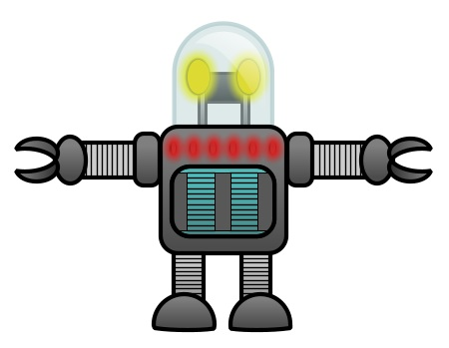](http://www.google.co.uk/url?sa=i&rct=j&q=cartoon+robot+drawing&source=images&cd=&cad=rja&docid=Pi7PBMBLTrB-0M&tbnid=d_csDsnhczXgLM:&ved=0CAUQjRw&url=http%3A%2F%2Fwww.how-to-draw-funny-cartoons.com%2Fcartoon-robot.html&ei=biCJUYuqNYKKhQedm4DIBQ&bvm=bv.45960087,d.ZGU&psig=AFQjCNGkzAgbq4prCTIuGhxqAGr43M-nIg&ust=1368027624008698)[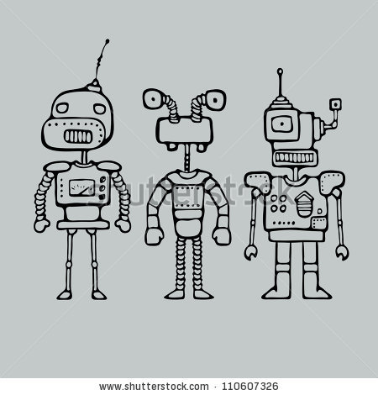](http://www.google.co.uk/url?sa=i&rct=j&q=cartoon+robot+drawing&source=images&cd=&cad=rja&docid=xcvx5-OMlHRC1M&tbnid=IzFapsL--8xBpM:&ved=0CAUQjRw&url=http%3A%2F%2Fwww.shutterstock.com%2Fpic-110607326%2Fstock-vector-cartoon-outlines-drawing-with-three-robots-vector-illustration.html&ei=ASGJUYHLDMHNhAeko4CoDw&bvm=bv.45960087,d.ZGU&psig=AFQjCNGkzAgbq4prCTIuGhxqAGr43M-nIg&ust=1368027624008698)[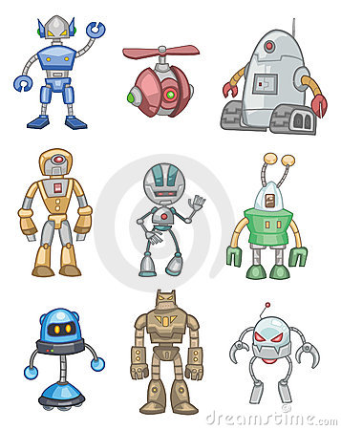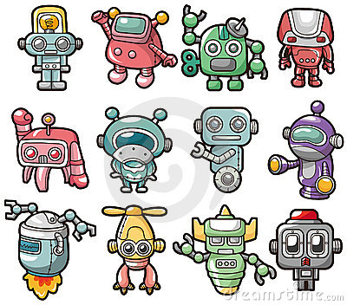](http://www.dreamstime.com/royalty-free-stock-photo-cartoon-color-robot-icon-image18552195)[](http://www.google.co.uk/url?sa=i&rct=j&q=robot&source=images&cd=&cad=rja&docid=X2iwriUwNbj-TM&tbnid=rnu1yahr-hxIxM:&ved=0CAUQjRw&url=http%3A%2F%2Fclassroomclipart.blogspot.com%2F2011%2F06%2Frobots.html&ei=LiCJUdaOG8bLhAeOvYGoBg&bvm=bv.45960087,d.ZGU&psig=AFQjCNE960W_spwG3eEEE2NtXA5KB4bsGQ&ust=1368027558233512)[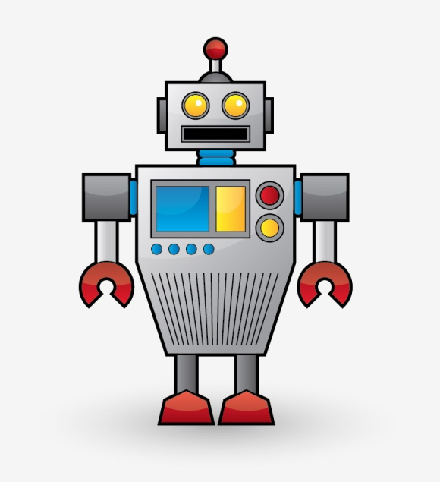](http://www.google.co.uk/url?sa=i&rct=j&q=robot&source=images&cd=&cad=rja&docid=CP2nBb7guPCo6M&tbnid=036ykqxMXoOSIM:&ved=0CAUQjRw&url=http%3A%2F%2Fblog.spoongraphics.co.uk%2Ftutorials%2Fcreate-a-cool-vector-robot-character-in-illustrator&ei=oB-JUaPuEIK2hAfT84GwDg&bvm=bv.45960087,d.ZGU&psig=AFQjCNFjlS4vSHJoejwu8KNY-jRUfCoJKw&ust=1368027372085366)