Conflict and Tension 1918-1939 – Example Exam Questions

Question 1 – Source A Opposes/Supports

Source A – A British newspaper cartoon about the Treaty of Versailles, 1919. The Big Four (Clemenceau, Lloyd George, Wilson and Orlando of Italy) are holding the spoon. On the box it says ‘Big Four Pills worth millions a box’.
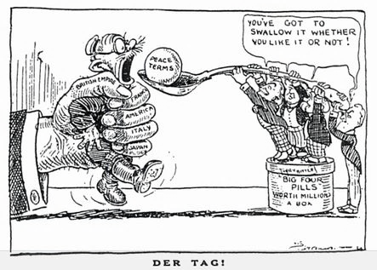

Study Source A. Source A opposes the Treaty of Versailles. How do you know?
Explain your answer using Source A and your contextual knowledge [4 Marks].

Source B – An American cartoon from around 1919.
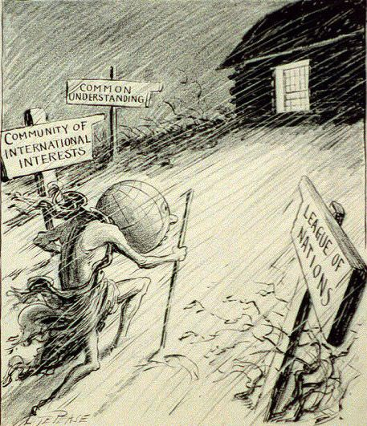

Study Source B. Source B supports the work of the League of Nations. How do you know?
Explain your answer using Source B and your contextual knowledge [4 Marks].
Source C – The front page of a British newspaper from 1st December 1925.
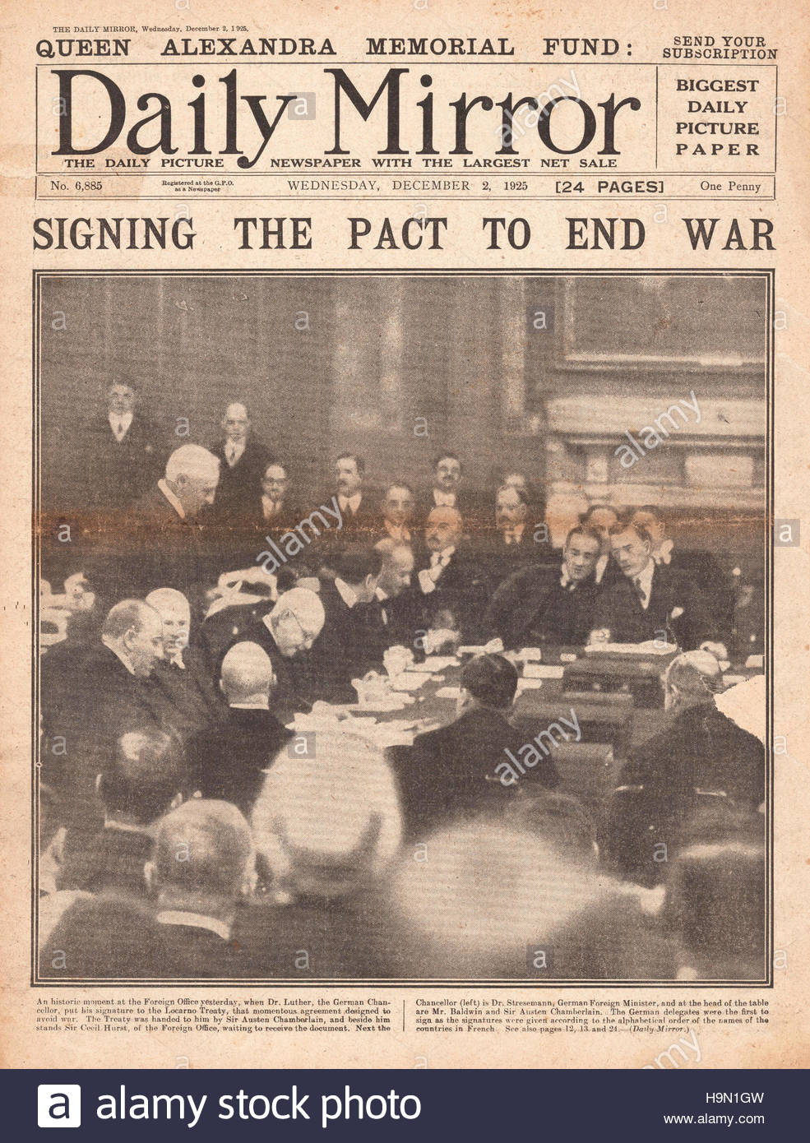

Study Source C. Source C supports the Locarno Treaties. How do you know?
Explain your answer using Source C and your contextual knowledge [4 Marks].

Source D – ‘Trial by Geneva’; the judges represent the League of Nations and lawyers are frantically reading the Lytton Report; Japan, not intimidated, is pulling faces.
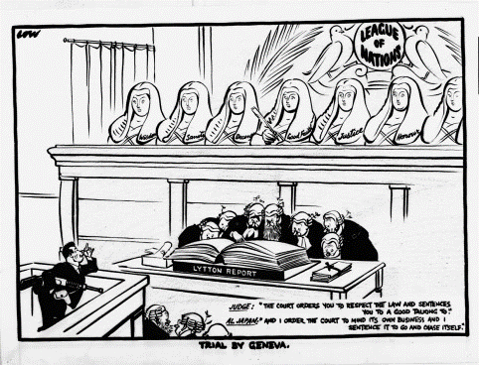

Study Source D. Source D opposes the League of Nations. How do you know?
Explain your answer using Source D and your contextual knowledge [4 Marks].
Source E – A poster by John Heartfield – a German Communist who made photomontages (a mixture of photographs and paintings) that criticised the Nazis. The poster shows the bombing of the Spanish town of Guernica by German planes in April, 1936. Many civilians were killed and the town was devastated. The text reads ’This is the heil they bring’. ‘Heil’ refers to the salute the Nazis gave.
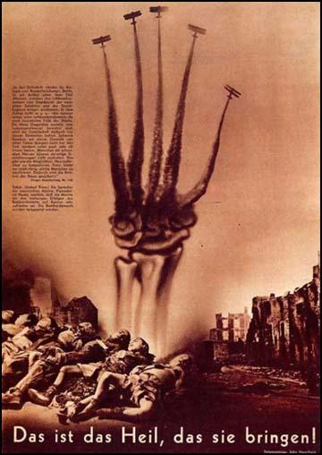

Study Source E. Source E opposes Hitler’s involvement in the Spanish Civil War. How do you know?
Explain your answer using Source E and your contextual knowledge [4 Marks].

Source F – An American cartoon from 1939. The caption says ‘Wonder how long the honeymoon will last?’.
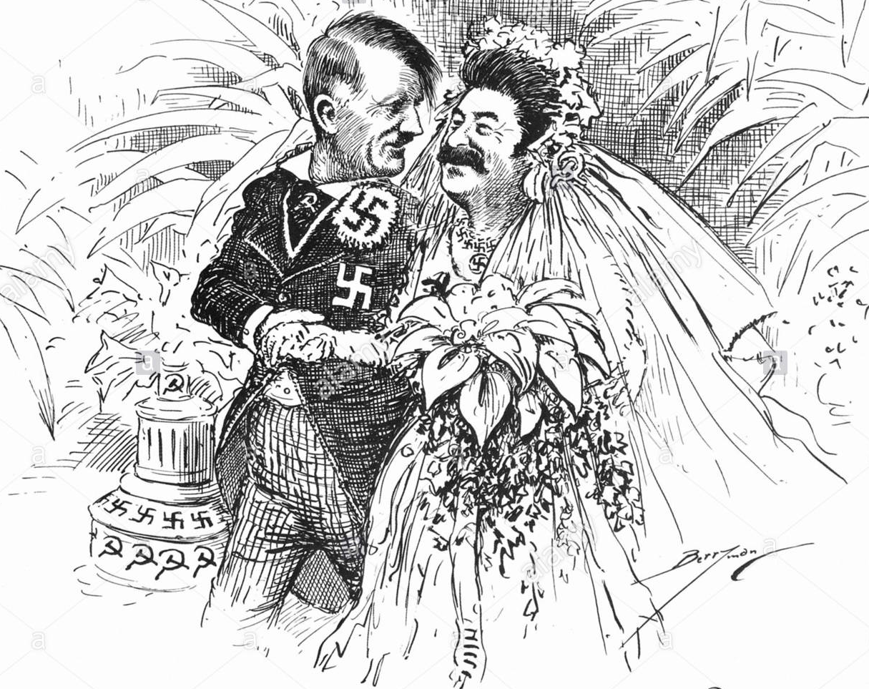

Study Source F. Source F opposes the Nazi-Soviet Pact. How do you know?
Explain your answer using Source F and your contextual knowledge [4 Marks].
Source G – A cartoon published in Britain in February 1919 entitled ‘Giving Him Rope’.
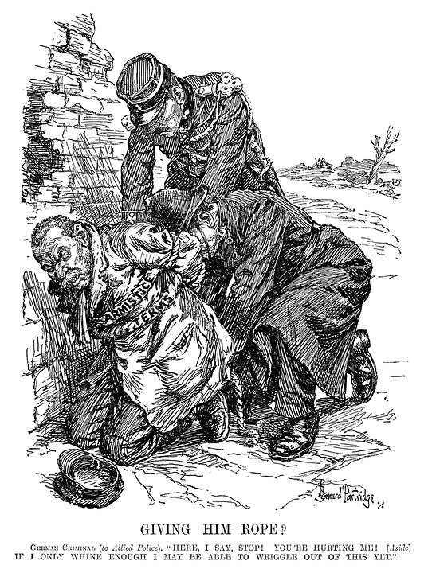

Study Source G. Source G opposes Germany. How do you know?
Explain your answer using Source G and your contextual knowledge [4 Marks].

Source H – A cartoon drawn by Viktor Deni in 1919 and published in Soviet newspapers. Deni was an important Communist and the words in Russian say, ‘The League of Nations: Capitalists of all countries unite!’ The three seated figures represent France, the US and Great Britain.
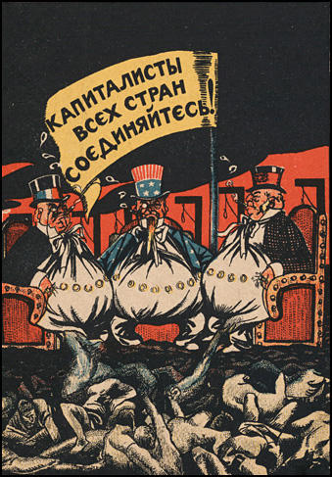

Study Source H. Source H opposes the League of Nations. How do you know?
Explain your answer using Source H and your contextual knowledge [4 Marks].
Question 2 – How Useful

Source A – Adapted from Princess E Bluecher, An English wife in Berlin, 1920; Evelyn married a German aristocrat in 1907 and kept a diary of their life in Berlin during and after the First World War.
I fear that England has missed the right moment for laying the foundations of a lasting peace in Europe. The entente could have done anything with the German people had they made the slightist move towards reconciliation. People are ready here to make reparation for the wrong done by their leaders. But now they say that Wilson has broken his word, and an undying hatred will be smouldering in the heart of every German. Over and over again I hear the same refrain, ‘We shall hate our conquerors with a hatred that will only cease when the day of our revenge comes’.

Source B – A cartoon from the German satirical magazine, Simplissimus, 1919.
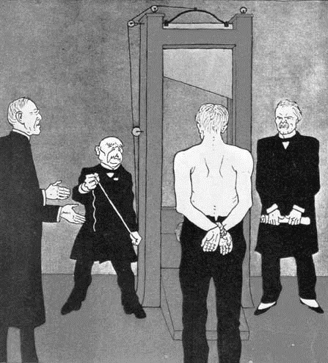

Study Sources A and B. How useful are Sources A and B to a historian studying criticisms of the Treaty of Versailles? Explain your answer using Sources A and B and your contextual knowledge [12 Marks].

Source C – Adapted from an entry in a 1934 essay competition, by a German railway worker.
Thousands of factories closed their doors. Hunger was the daily companion of the German working man. Many an honest working man had to resort to theft to obtain food. All fellow citizens yearned for better times. As for me, like many another, I had lost all I possessed, so, early in 1930, I joined the Nazi Party.

Source D – Unemployed Germans queuing to find work outside an employment office in Hanover in 1930. The writing on the warehouse wall translates as ‘Vote Hitler’.
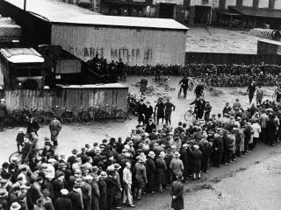

Study Sources C and D. How useful are Sources C and D to a historian studying the impact of the Depression on Germany? Explain your answer using Sources C and D and your contextual knowledge [12 Marks].
Source E – A speech by Anthony Eden, British foreign secretary; this speech was given to parliament on 18th June 1936.
There was a very good reason for the Leauge to enforce the particular sanctions they chose, because with an incomplete membership they were the only ones they could impose and which by their own action alone they could hope to see effective. Oil could not be made effective by the League action alone.
I think it is right that the League should admit that sanctions have not realised their purpose and should face that fact.

Source F – A British cartoon from 1939. Czechoslovakia and Poland were the last two countries Hitler invaded before Britain and France declared war on him in 1939.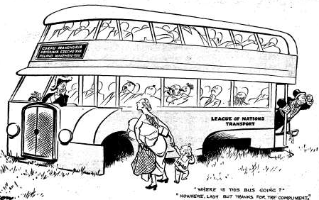

The bus says – Corfu, Manchuria, Abyssinia, Czechoslovakia, Poland.

Study Sources E and F. How useful are Sources E and F to a historian studying opinions about the collapse of the League of Nations? Explain your answer using Sources E and F and your contextual knowledge [12 Marks].

Source G – Adapted from a speech given by Hitler to the people of Berlin, 1938:
We are not interested in breaking peace. I am thankful to Mr Chamberlain for all his trouble and I assured him that the German people want nothing but peace, but I also declared that I cannot go beyond the limits of our patience. I further assured him, and I repeat here, that if this problem is solved, there will be no further territorial problems in Europe for Germany.

Source H – From the Italian magazine Illustrazione del Popolo, 9th October 1938.
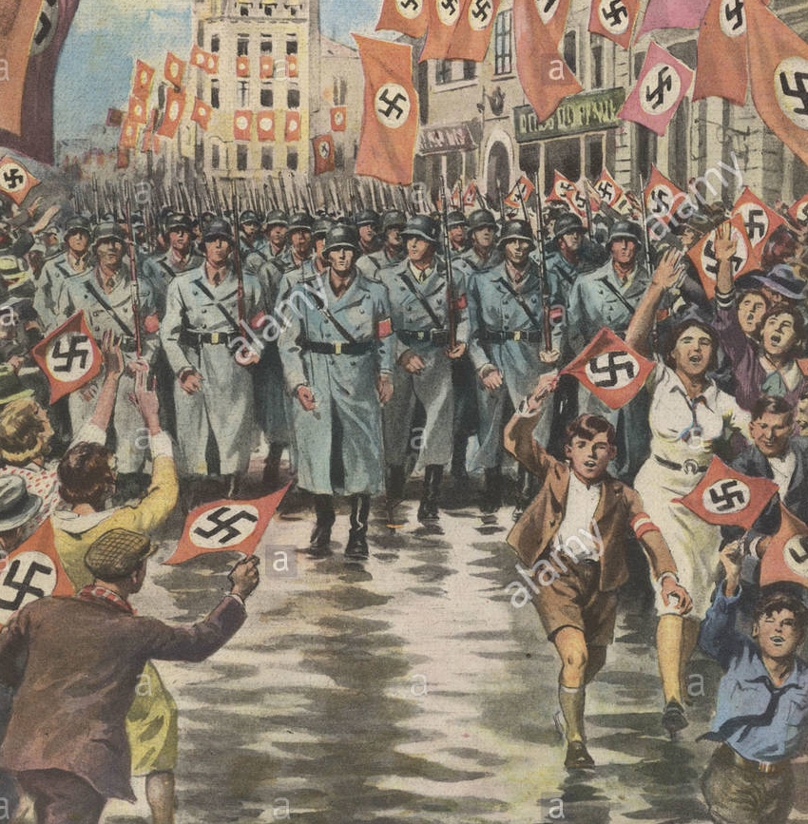

Study Sources G and H. How useful are Sources G and H to a historian studying why Britain allowed Hitler to take the Sudetenland? Explain your answer using Sources G and H and your contextual knowledge [12 Marks].
Source I – From a speech given by Stalin in 1941, shortly after Hitler had invade Russia; he was speaking about why he had agreed to the Nazi-Soviet Pact.
We secured peace for our country for eighteen months, which enabled us to make military preparations.

Source J – By American cartoonist Herblock in 1939; a bear is often used to symbolise the USSR.

Study Sources I and J. How useful are Sources G and H to a historian studying why Russia signed the Nazi-Soviet Pact? Explain your answer using Sources G and H and your contextual knowledge [12 Marks].

Source K – From a book by JM Keynes published in 1919. He was a leading economist for the British government but resigned in protest three weeks before the Treaty of Versailles was signed.
Nations should not morally visit on the children of their enemies the wrongdoings of parents or of rulers. The Treaty includes no provisions for the economic recovery of Europe nothing to make the defeated Central Empires into good neighbours. The Big Three were preoccupied with other issues – Clemenceau to crush the economic life of his enemy, Lloyd George to bring home something that would be acceptable for a week, the President to do nothing that was not just and right.

Source L – A German newspaper cartoon from July 1919 entitled ‘Clemenceau the Vampire’. The figure on the bed represents Germany.
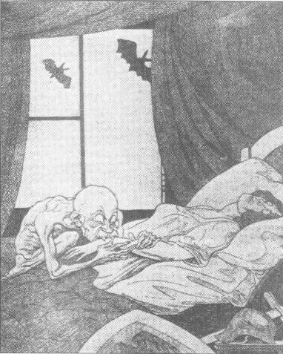

Study Sources K and L. How useful are Sources K and L to a historian studying opinions about the Treaty of Versailles? Explain your answer using Sources K and L and your contextual knowledge [12 Marks].
Source M – From a speech by Sir Samuel Hoare, the British Foreign Secretary, to the House of Commons, December 1935.
Mussolini made it clear that if he had to go to war, his aim would be to wipe the name of Abyssinia from the map. I have been terrified by the thought that we might make Abyssinia think that the League could do more than it can. In the end there would be a terrible moment of disappointment when Abyssinia would be destroyed altogether.

Source N – From a cartoon published in a British magazine, August 1935. (A memorandum is a type of note).
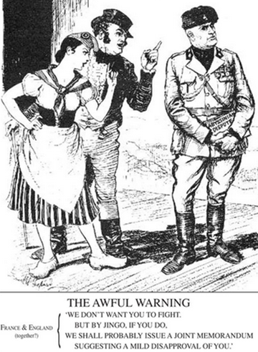

Study Sources M and N. How useful are Sources M and N to a historian studying the Abyssinian Crisis? Explain your answer using Sources M and N and your contextual knowledge [12 Marks].

Question 3 – Write an Account

- Write an account of how the Versailles peace settlement was affected by the fact that the war was mainly fought in France [8 Marks].

- Write an account of how the Treaty of Versailles caused problems for Germany [8 Marks].

- Write an account of how Mussolini’s invasion of Abyssinia led to Italy leaving the League of Nations [8 Marks].

- Write an account of how Hitler broke the terms of the Treaty of Versailles between 1933 and 1935 [8 Marks].

- Write an account of how the Nazis achieved Anschluss [8 Marks].

- Write an account of how Britain went about appeasing Hitler in the 1930s [8 Marks].

- Write an account of how events in Manchuria became an international crisis in the years 1931 to 1933 [8 Marks].

- Write an account of how problems relating to the Sudetenland led to an international crisis in 1938 [8 Marks].

Question 4 – How Far Do You Agree

- ‘Territorial losses were the worst punishment faced by Germany in the Treaty of Versailles’. How far do you agree with this statement? Explain your answer [16 Marks + 4 SPaG Marks].

- ‘Clemenceau was the least satisfied of the “Big Three” by the Treaty of Versailles’. How far do you agree with this statement? Explain your answer [16 Marks + 4 SPaG Marks].

- ‘The organisation and structure of the League meant that it was always going to fail’. How far do you agree with this statement? Explain your answer [16 Marks + 4 SPaG Marks].

- ‘The League of Nations failed more often than it succeeded in the 1920s.’ How far do you agree with this statement? Explain your answer [16 Marks + 4 SPaG Marks].

- ‘Structural weaknesses in The League of Nations when it was first set up were the main reasons it was doomed to fail’. How far do you agree with this statement? Explain your answer [16 Marks + 4 SPaG Marks].

- ‘The main reason other countries failed to react to Hitler’s foreign policy was their fear of war’. How far do you agree with this statement? Explain your answer [16 Marks + 4 SPaG Marks].

- ‘The policy of appeasement was a mistake that led to the outbreak of the Second World War’. How far do you agree with this statement? Explain your answer [16 Marks + 4 SPaG Marks].

- ‘The Nazi-Soviet Pact was the main reason for the outbreak of the Second World War in 1939’. How far do you agree with this statement? Explain your answer [16 Marks + 4 SPaG Marks].

- ‘The main reason why Germany hated the Treaty of Versailles was because of its military terms.’ How far do you agree with this statement? Explain your answer [16 marks + 4 SPaG Marks].

