Conflict and Tension 1918-1939

Part One – Peacemaking

- The aims of Lloyd George, Clemenceau and Wilson. | Page 4
- Wilson, Clemenceau and Lloyd George and the difficulties of establishing a compromise. | Page 4
- The terms of the Treaty of Versailles. | Page 5
- Reactions to the Treaty of Versailles. | Page 5
- How satisfied the Allies were with the Treaty of Versailles. | Page 6
- How satisfied Germany was with the Treaty of Versailles. | Pages 6 & 7
- Evaluation of the fairness of the Treaty of Versailles and the wider settlement. | Page 7
- How Germany’s allies were treated at the end of WWI. | Page 8
- How happy the ‘Big Three’ were with the Treaty of Versailles. | Page 9

Part Two – The League of Nations and International Peace

- The formation of the League of Nations. | Page 9 & 10
- The strengths and weaknesses of the League of Nations. | Page 10
- How the League of Nations was organised. | Page 11
- The main commissions (agencies) of the League of Nations. | Pages 11 & 12
- The successes and failures of the League – Vilna, Upper Silesia, The Åland Islands, Corfu, Bulgaria and the Wall Street Crash. | Pages 12 & 13
- Diplomacy outside the League – the Locarno treaties and the Kellogg-Briand Pact. | Page 13
- The decline of international cooperation in the 1930s. | Page 14
- The Manchurian crisis and its significance. | Pages 14 & 15
- The Abyssinian crisis and its significance. | Pages 15 & 16
- The reasons why the League of Nations failed by 1939. | Page 16

Part Three – The Origins and Outbreak of WWII

- Hitler’s aims. | Pages 16 & 17
- How other countries reacted to Hitler’s policies. | Pages 17 & 18
- German rearmament and the road to war. | Pages 18 & 19
- German reoccupation of the Rhineland. | Page 19
- German alliances in Europe. | Pages 19 & 20
- Anschluss with Austria. | Pages 20 & 21
- The Sudeten Crisis. | Page 21
- The Munich Conference. | Page 21 & 22
- British and French reaction to Hitler’s actions. | Page 22
- Arguments for and against appeasement. | Page 22 & 23
- The Nazi-Soviet Pact. | Page 23
- The invasion of Poland and outbreak of WWII. | Page 24
- The causes of WWII. | Page 24

Overview of Conflict and Tension Content

Part One – Peacemaking

- The Aims of Lloyd George, Clemenceau and Wilson

- In November 1918 an armistice (temporary cease fire) was signed and peace talks were begun. In January 1919 representatives from all 32 winning countries met in the Palace of Versailles for the Paris Peace Conference. The main leaders, known as ‘the Big Three’ all had different ideas of what should happen at the peace talks.

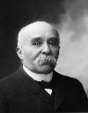
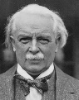
Georges Clemenceau
French Prime Minister

- Clemenceau was under pressure to get revenge on Germany for the damage caused in WWI.
- Wanted to cripple Germany to make it impossible for Germany to attack again.
- Wanted to reduce German armed forces.
- Wanted to push Germany’s border back to the Rhine.
- Wanted Germany to pay compensation for all the damage caused to France.
David Lloyd George
British Prime Minister

- He promised to make ‘Germany pay’.
- Conscious that if Germany was treated too harshly it could lead to its people wanting revenge.
- Wanted to keep Germany strong enough to trade with and keep Britain powerful.
- Wanted to take some of Germany’s colonies to expand the British Empire.
- Aimed to reduce Germany’s navy to stop it from rivalling Britain’s naval power.

What were the Aims of ‘The Big Three’?

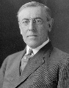
Woodrow Wilson
President of the USA

- Did not see the need for revenge.
- Was also concerned that treating Germany too harshly could lead to its people wanting revenge and another war.
- Wanted a future where everyone was treated fairly.
- Wanted a League of Nations.
- Wanted self-determination (where countries have the freedom to rule themselves).
- Wanted freedom of the seas where people could sail ships in any waters.
- Wanted a ‘better world’ (Fourteen Points).

- Wilson, Clemenceau and Lloyd George and the Difficulties of Establishing a Compromise
There were time constraints. The conference lasted 12 months and each point was discussed in great detail. However, there was pressure to come to a quick decision so that reparations could be started.
France argued that terms from the armistice (such as Germany paying reparations and returning Alsace-Lorraine to them) should be in the final treaty.
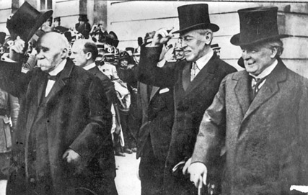

The Allies had made promises to countries that had provided them with support during the war. These countries also believed that these should be fulfilled. For example, Italy had been promised land from the Austro-Hungarian Empire.
Within Europe, many countries had become unstable, again meaning a quick treaty was required. In Russia the Communists had taken over whilst countries within the Austro-Hungarian Empire were breaking away and declaring independence.

There were other difficulties for example, Clemenceau wanted huge reparations when Lloyd George wanted a Germany to trade with. Clearly these two viewpoints made it hard to compromise.

- The Terms of the Treaty of Versailles

- In June 1919 the agreement at the Paris Peace Conference was announced.
- Germany had not been invited to the peace talks and called it a Diktat (dictated peace).
- The majority of the terms of the Treaty of Versailles (as it became known) can be separated into different categories: blame, reparations, army and territory (or BRAT).

Category | Examples of Terms
Blame | - Article 231 was known as the war guilt clause. Germany and its allies had to take full responsibility for starting the war.
Reparations | - Article 232 said that Germany had to pay reparations to the winners. In 1921 this figure was agreed at £6,600 million.
Army | - The German navy was limited to 15,000 men.  - The army was limited to 100,000 men and conscription was banned.  - Only 6 battleships were allowed and no submarines.  - The Rhineland (on the border between France and Germany) was demilitarised (meaning that Germany could not put an army or defences there).  - No air force was permitted nor were any tanks.
Territory | - Anschluss (union) between Germany and Austria was forbidden.  - Germany was split in half by the Polish Corridor, where German land was given to Poland to allow them access to the sea.  - Danzig was taken from Germany and made a free city under League of Nations control.  - The Saar was put under League of Nations control for 15 years.  - Colonies in Africa were taken and given as mandates to the League of Nations (which meant that the League of Nations controlled them until they were ready to govern themselves).  - 10% of all Germany’s land was taken and given to the winning countries (including Alsace-Lorraine given back to France).

- Also, a key component of Woodrow Wilson’s wishes for a peace treaty was the introduction of a League of Nations. However, Germany was forbidden from joining.

- Reactions to the Treaty of Versailles.

- Immediately following its signing, the Treaty of Versailles became international law. However, there was a mixed reaction to its terms. Some were outraged that the terms were too harsh, others said it was not harsh enough on Germany and others said that it was a fair and justified treaty.

Reasons That The Treaty of Versailles Was A Disaster | Reasons People Defend the Treaty of Versailles
- Seen to be unjust in Germany and therefore created hatred amongst the Germany population. Therefore, many wanted revenge.  - Led to financial ruin in Germany.  - Enabled Hitler to rise to power.  - Gave Hitler an excuse to invade other countries to reclaim the land that had been taken.  - It was not properly enforced so Germany was able to rebuild its military and start WWII. | - Under the terms of the Treaty, Germany was able to rebuild their economy. At the start of WWII Germany was economically stable.  - It was an unprecedented situation, so no plans on what to do existed.  - It did establish peace in Europe from 1918-1939.  - It could have been harsher if Clemenceau got his own way.  - Germany is now a leading economic power Therefore, the Treaty has not led to a long-term depression.

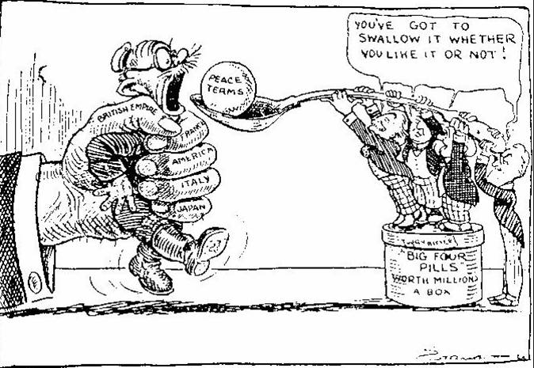

This cartoon is just one example of the viewpoints that existed about the Treaty of Versailles. Germany the mouse is being squeezed by the allies and force-fed the peace terms. This clearly gives the view that the Treaty of Versailles was a diktat.

- How Satisfied the Allies were with the Treaty of Versailles

British Reaction
- The British felt little sympathy towards the Germans, they had suffered massively and experienced food shortages.
- The general feeling therefore was that it was a fair treaty. However, there were many people who thought that it could and should have been much harder.
- David Lloyd George was greeted as a hero following his return from Versailles.
- However, Lloyd George himself thought that the risk of a second war was incredibly high.
- He was pleased with the extra colonies Britain gained as well as the restrictions placed on the German navy.
- He was concerned that reparations were too high, and said that giving German lands to Poland would lead to further tensions between the two countries.
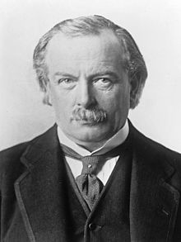

French Reaction
- France had suffered most during WWI, and argued for the most severe punishment.
- They were pleased that the threat of another attack from Germany was reduced.
- Also, they were pleased that Germany was being forced to pay reparations.
- However, the vast majority of the French people were furious with the Treaty. They felt that the terms should have been much more severe. They felt that the terms did not reflect the amount of losses they suffered.
- Clemenceau felt that Germany should not have been allowed even a small army.
- He also felt that the Rhineland should become an independent state and the Saar should permanently belong to France. He also argued that reparations were too low.
- Shortly after the Treaty, France held an election. Clemenceau was voted out (reflecting the view that Germany had got off too lightly).
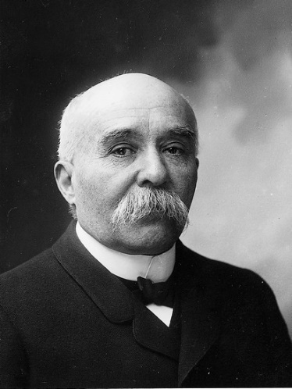

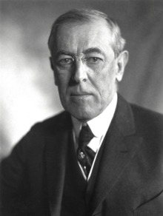
American Reaction
- America had suffered little as the fighting was not on their territory and they only joined the war in 1917. Many thought that the Treaty was unfair on Germany.
- They wanted a Treaty that guaranteed peace in the future, but were concerned that they got the opposite instead.
- Wilson was criticised by other American politicians as they felt that it was not in their interests as it had not been based on the Fourteen Points.
- The Treaty had to be ratified (agreed) by the Senate (government) but the opposing Republicans refused agree to it. This meant that the USA were not able to join the League of Nations.
- Wilson continued to campaign for America to join the League of Nations but the efforts caused him to die of a stroke in 1924.

- How Satisfied Germany was with the Treaty of Versailles

- What Germany Hoped For: The Germans hoped for a fair treaty. They had suffered massive losses during the war. The British had blocked ports and many German people had starved to death. Like the Allies, Germany needed support to rebuild as their country lay in tatters. They had followed the Allies demands and forced the Kaiser to abdicate before signing the armistice. They felt that this alone meant that the main person responsible had already been punished so no further punishment was necessary.

- What Germany Got: They were shocked at the severity of the treaty. They were angry that they had not been able to negotiate the terms of the Treaty. Many people called for a rejection of the Treaty but the only alternative was to restart the war again. Therefore, the government knew they had no choice but to sign the Treaty.
- German Reactions: The German public began to blame the new government, the Weimar Republic. They called them the ‘November Criminals’. The main clause that Germans resented was Article 231 (the war guilt clause) which they felt was particularly unfair. Many Germans also felt vulnerable as their armed forces had been reduced to just 100,000 men. Furthermore, the loss of territories meant that nearly 6 million German nationals now found themselves living in different countries, resenting the people who were governing them. A final concern was a growing threat in the east, Communism.

- Growing tensions led to a series of revolts breaking out between 1919 and 1924:

28th June 1919 – Treaty of Versailles signed.
January 1919 – The Spartacists (Communists) attempt to overthrow the German Government.
October 1918 – Revolts in Germany where people protest about the war and food shortages.
November 1918 – The armistice is signed and Kaiser Wilhelm II abdicates.

January 1923 – Germany misses a reparation payment. The French seize the Ruhr and the Germans go on strike.
April 1921 – League of Nations agrees the final total of £6,600 million in reparations.
March 1920 – The Kapp Putsch against the government is only narrowly defeated.
11th August 1919 – Weimar Constitution is introduced and adopted.

April 1924 – The Dawes Plan means America loans Germany 800 million gold marks to help them rebuild their economy.
November 1923 – Hyperinflation leads to the Nazis attempting (but failing) to overthrow the government in the Munich Putsch.
February 1923 –Passive Resistance in January leads to hyperinflation as the value of money falls. By November a loaf of bread is 200,000 million marks.

- Evaluation of the Fairness of the Treaty of Versailles and the Wider Settlement

The Treaty and Wider Settlement was Unfair | The Treaty and Wider Settlement was Fair
- 6 million Germans found themselves living outside of Germany – they feared persecution.  - German families were forced off land they had owned for generations as it was taken away by other countries.  - Many people who said it was too harsh were concerned it would lead to another war.  - The German population were vulnerable. Their small army and navy was not enough to prevent an attack.  - Germans felt bitter about the war guilt clause. Germany was not solely responsible for starting WWI.  - Germans felt that the Treaty was a Diktat (dictated peace). They could not send representatives to negotiate.  - The Germans thought that the Treaty would be based on Wilson’s Fourteen Points. This would have made the terms fairer. Most of Wilson’s ideas were ignored however.  - The reparations were far too high, crippling the German economy. It was estimated that they would not pay them off until the 1980s.  - The other treaties united people together who did not want to be joined.  - Countries, like Turkey, revolted against the severe terms of the other treaties meaning they could not be enforced. | - The Treaty of Versailles was created at the end of the most devastating war that had ever taken place. It was therefore right that the losing countries should pay for the damage.  - It was normal for the losers of a war to agree to harsh peace terms. Russia, for example had been forced to sign the Treaty of Brest-Litovsk when they withdrew from WWI. This meant Germany took away one quarter of their farmland and population.  - Treaties like the Treaty of Brest-Litovsk could be seen as evidence that if Germany had won WWI then they would have punished the Allies with equally harsh or even more severe terms.  - The peacemakers had to act quickly as Europe was very unstable Therefore, they did the best they could under the pressure they faced.  - There was no precedent available from a similar war to use and improve upon. Instead, they had to quickly start from scratch taking in the views of all the countries who had won the war.
- How Germany’s Allies were Treated at the End of WWI

Treaty of St Germain 1919 (Austria – Main Country Affected)
- Austria lost land to create Czechoslovakia and Yugoslavia. Consequently, they lost much of their industry meaning that Austria’s economy collapsed in 1921.
- Other Austrian land was given to Italy and Romania. Italy however felt they were not given enough land.
- The new nations formed often clashed as they contained people of different nationalities. Europe now consisted of lots of small states rather than a powerful empire.
- Austria was expected to pay reparations (never fixed).
- The Austrian army was reduced to 30,000 and they were not allowed a navy.
- Austria was forbidden to unite with Germany.

Treaty of Trianon 1920 (Hungary – Main Country Affected)
- Hungary lost land to Romania, Czechoslovakia, Yugoslavia and Austria.
- Agreed that reparations should be paid but amount not fixed and Hungry never paid.
- 30,000 in the army, no conscription and Hungary was only allowed 3 patrol boats.

Treaty of Neuilly 1919 (Bulgaria – Main Country Affected)
- Bulgaria had to give land to countries including Greece and Romania.
- Bulgaria did however gain land from Turkey.
- Had to pay £100 million in reparations.
- The Bulgarian army was reduced to 20,000, they only had 4 battleships but no air force. Conscriptions were not allowed.

Treaty of Sèvres 1920 (Turkey – Main Country Affected)
- Turkey lost land to Greece.
- Turkey lost all of its land in Europe apart from a small piece around the capital of Constantinople (Istanbul).
- The Turkish Empire (Ottoman Empire) was split up.
- The Turkish army was reduced to 50,000 men. The navy was restricted to 7 sail boats and 6 torpedo boats.
- The Dardanelles and the Bosphorus straits had to be opened to other countries to allow them to get from the Black Sea through to the Mediterranean.
- The Allies were allowed to keep troops in Turkey.
- The Turkish were furious that they revolted and overthrew the government. The new president threatened to fight the Allies so they overwrote it with the Treaty of Lausanne.

Treaty of Lausanne 1923 (Turkey – Main Country Affected)
- Turkey regained some of the land Greece had taken.
- They regained control of the Dardanelles and Bosphorus straits.
- They also gained the right to decide how big their armed forces were.
- Reparations were cancelled and Allied troops were withdrawn.

- Significance: These treaties were significant for many reasons:
  - These Treaties, especially the Treaty of Sèvres showed that they were unenforceable. The threat of rebellions was so high, countries were prepared to alter the terms to suit.
  - Amending the treaties made it look like the old, original treaty was unfair.
  - Amending treaties showed to other leaders in Europe like Hitler and Mussolini that they could break international law or threaten to rebel and get away with it.
  - Some of the new countries formed worked well. For example, Czechoslovakia was politically stable and rich in natural resources.
  - Other countries like Poland which were expanded (through the Polish Corridor) experienced many problems. It was hard to defend and its new borders were continually argued about.
- How Happy the ‘Big Three’ were with the Treaty of Versailles
Success – Army and navy reduced. Rhineland demilitarised. Germany could not unite with Austria.
Success – British Empire was bigger than before WWI. Britain gained territory from Germany.
Success - Germany was held responsible for the war and was humiliated.

Failure – Felt the Treaty was so harsh that another, more expensive war would happen.
Protection (Reduce Germany’s Armed Power)
Failure - Germany was not destroyed and some people felt that France had not got full revenge.
Punishment and Revenge
Reduce German Empire and preserve British Empire

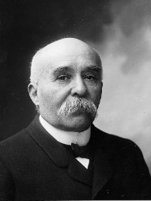
Failure – Felt that Germany should have no army. Wanted a fully independent Rhineland.

Reduce Risk of Another War
Failure – German economy crippled so could not trade with Britain.
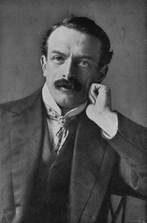
Success - £6,600 million set to pay. France received coal from the Saar for 15 years.
Trade with Germany
Georges Clemenceau
Reparations
Did The ‘Big Three’ Achieve Their Aims?
David Lloyd George
Success – War guilt clause and reparations pleased the British people.
Failure – Reparations were too low compared to the estimated cost of 200 billion Francs. The French felt they should have been given the Saar.
Naval Supremacy
Failure – Worried that the Treaty was too harsh and Germany would want revenge.
Punishment and Revenge
Woodrow Wilson
Success – Many nations, once part of the Austro-Hungarian Empire were given independence.
Success – German navy massively reduced.
Success – 42 countries joined the League of Nations when it was set up in 1920.
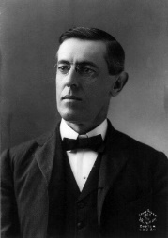
Failure – The US Senate refused to join and instead pushed for isolationism, far from the idea of collective security.
Failure – Some countries were given to the League of Nations. However, this really meant France and Britain controlled them.
Self-Determination

League of Nations

Success – Countries in the League of Nations worked hard to keep the peace.
Stop Future Wars
Failure – Wilson felt the terms were so harsh that Germany would seek revenge.

Part Two – The League of Nations and International Peace

    - The Formation of the League of Nations

- At the end of WWI, Woodrow Wilson argued for a League of Nations to be introduced. This was the last of his ‘Fourteen Points’.
- The Treaty of Versailles contained the basic rules about how the League of Nations was going to work.
- All countries who signed the Treaty of Versailles agreed to stick to the rules of how the League was to be run.

Who Joined The League Of Nations?

- There were 42 founding members, rising to 58 by 1934.
- There were 4 permanent members of the council: Britain, France, Italy and Japan.
Why Was It Formed?

- It was designed to:
- Stop a second war.
- Encourage disarmament.
- Improve working conditions.
- Tackle deadly disease.
What Was The League Of Nations?

- It was a vision for bringing the world together in peace.
- A group of countries would work together and solve problems.

What About the USA?

- The Senate refused to agree to the USA joining.
- America wanted isolationism (to isolate themselves from Europe) as they had seen many soldiers die in WWI, despite no fighting on US soil.
Where Was The League Based?

- Switzerland (Geneva) was chosen as the base for the League because it had not been involved in WWI, remaining neutral throughout. Another organisation, the Red Cross was also located there.
The Creation of the League of Nations.

What Did Britain and France Think?

- France was happy as they saw it as extra protection from a second German invasion.
- Britain was critical at first but eventually saw it as a place to discuss ideas but without any real power.
How Did The League Plan To Keep Peace?

- They wanted to use collective security to protect the interests of every nation.
- They set up the Permanent Court of International Justice to establish international laws.
Did All Powerful Countries Join?

- Russia was not allowed to join as they had a Communist government.
- Germany and other losing countries could not join at first, this changed in 1926 following the Locarno Treaty.

- If the League couldn’t prevent disputes, the Covenant (agreement about how the League would be run) set out how to deal with aggression:
  - Mitigation – Getting countries to talk through problems together.
  - Moral Condemnation – Giving the country involved a telling off.
  - Economic Sanctions – Other members of the League would not trade with the warring countries.
- However, the League did not have its own army. As a last resort if it needed to raise an army then the League was to ask its members to lend it their armed forces.

- The Strengths and Weaknesses of the League of Nations

- Lots of historians have argued that the League of Nations was doomed to fail from the beginning because of its structure and organisation. This meant that the League had many weaknesses. However, it did have several strengths:

Strengths of the League of Nations | Weaknesses of the League of Nations
- The League of Nations was written into all of the peace treaties created at the end of WWI. This meant that all countries involved had to recognise the League of Nations as an organisation.  - It had a vast membership.  - The large number of member countries meant that economic sanctions and moral condemnation were daunting punishments for many countries. | - Many countries of importance could or would not join the League. For example, the USA never joined. This undermined the League as a ‘global’ organisation.  - If a country faced economic sanctions they could still trade with some of the most powerful and richest countries who were not in the League.  - The League had no army. This meant that forcing people to obey the League was always going to be difficult.  - The structure was complicated which slowed action.  - Decisions had to be unanimous which meant that decision-making was slow.

- How the League of Nations was Organised

- The League of Nations was divided into many different sections, each with its own issue to focus on. The League of Nations was very ambitious it aimed to: settle disputes, encourage disarmament, improve working conditions and tackle deadly diseases.

The Council
- In an emergency, an Assembly of 42 countries was too large to act quickly and effectively when making decisions.
- The Council therefore was a smaller group who met much more frequently.
- There were 4 permanent members. These were: Britain, France, Italy and Japan.
- In addition to the permanent members, 4 other countries would be chosen to sit on the Council for a 3 year term (later 9 non-permanent members).
- They could veto any decision, including a unanimous one.
The Assembly
- Every country could send representatives to the Assembly.
- It met once a year (1st Monday in September) to discuss and vote on matters.
- Every country had an equal vote.
- For decisions to be passed then the vote had to be unanimous (every country had to agree).
- They decided on issues such as: deciding when a new country could join or how money could be spent.
- The first meeting had representatives from 42 countries.

The Secretariat
- The civil service of the League.
- It was in charge of administration and organising any action that the League wanted to take.
- It consisted of a body of experts from different areas who carried out decisions (apart from military) taken by the League.

The Permanent Court of International Justice
- Set up to settle international arguments.
- For each dispute, 11 judges and 4 deputy judges would be involved in reaching a verdict.
- The Court would then give advice to the sides involved in the dispute.
- It was not a compulsory ruling and it was hard to enforce as the League had no army.
- Judges were elected by the Assembly and the Council and would serve for 11 years.
Special Commissions
- These were groups put together to tackle key issues the League was worried about.
- They included:
  - The International Labour Organisation.
  - The Slavery Commission.
  - The Commission for Refugees.
  - The Health Committee.
  - The Permanent Central Opium Board.
  - The Disarmament Commission.

- The Main Commissions (Agencies) of the League of Nations

- The League of Nations believed that if people were happy they would be less likely to argue. Therefore, a number of commissions (agencies) were set up to tackle important issues:

- The International Labour Organisation (ILO)
- Aim: To improve workers conditions.
- Successes – In 1922 it banned the use of white lead in paint.
– In 1928, 77 countries agreed to set a minimum wage.
– In 1930 helped Greece set up social insurance (paid to people unemployed because of illness).
- Failures – In 1919 it tried to stop children under 14 from working but it was not adopted due to cost.
– In 1935 it suggested the working day should be limited to 8 hours but did not get passed again due to the cost.

- The Slavery Commission
- Aim: To ensure that people were not being kept in slavery.
- Successes – In 1927 Sierra Leone abolished (got rid of slavery) after a series of organised raids on the camps of slave traders in the country.
- The Commission for Refugees
- Aim: To return prisoners of war home and help support refugees by improving camps and helping them return to their home country once the conflict had passed.
- Successes – In 1921 the League freed about 427,000 out of 500,000 prisoners of war from WWI.
– In 1921, the League helped rehome approximately 1.5 million Russians made homeless by civil war.
– Created the Nansen Passport which was used as identification by refugees.
- Failures – In 1933 the League tried to appoint a High Commissioner for refugees, who were mainly Jewish, fleeing from Germany. This was rejected by Germany (let in the League from 1926), so the motion was defeated as it was not unanimous. The commissioner was appointed but as an independent body separate from the League, meaning they had less power.

- The Economic and Financial Committee
- Aim: To support and help develop World economies and maintain global trade.
- Successes – Helped Austria and Hungary rebuild their economies and stop them from going bankrupt.
– Developed a set of codes (rules) for importing and exporting which all countries had to follow.
- Failures – Struggled to cope following the global depression in 1929.

- The Organisation for Communications and Transport
- Aim: To continue to develop transport that was begun during the war to keep people safe.
- Successes – Introduced shipping lanes and reducing collisions.
– Produced a highway code so all drivers followed the same traffic rules wherever they travelled.

- The Health Committee
- Aim: To continue to improve the general health of people worldwide.
- Successes – Campaigned to kill mosquitos so that cases of malaria and yellow fever would be reduced.
– Worked in Russia to teach people how typhus was spread.
– Sent doctors to Turkey to look after refugees in camps in the 1920s.
– Later renamed the World Health Organisation (WHO), which still exists today.

- The Permanent Central Opium Board
- Aim: To reduce the cultivation and global trading of opium. After 1925 it became the Permanent Central Narcotics Board which tackled other illegal drugs that were traded as well.
- Successes – Introduced a licence certificate which companies had to have to allow them to import opium.
– 4 large companies involved in illegal trading were blacklisted.
- Failures – There were claims that some key members of the League did not back it fully because they made a large amount of money from the trade of opium.

- The Successes and Failures of the League – Vilna, Upper Silesia, The Åland Islands, Corfu, Bulgaria and the Wall Street Crash

1921: The Åland Islands
Sweden and Finland claimed the Åland Islands which were between the two countries. They both threatened the other with war. The League decided that they should go to Finland. Finland was banned from building forts on the islands so they could not be used as a base to attack Sweden from. Sweden agreed meaning that the League successfully avoided war.
1921-25: Upper Silesia
Upper Silesia is between Germany and Poland. In 1921 a plebiscite (vote) was held to see who would own it. Germany won. Poland complained to the League that the vote was unfair. The League decided to split the country based on the vote. Poland got most of the industrial zones, whilst Germany got most of the rural areas. Poland was not happy because around ½ million Poles were stuck in the new German territory. Germany also lost coal mines and a source of income. Tensions between the two countries increased.
1920: Vilna
Lithuania was created after WWI, formed from part of the Austro-Hungarian Empire. Its capital was Vilna. However, most of the people who were going to live there wanted to be Polish and live in Poland. A Polish army took control of Vilna, so Lithuania asked the League for help. The League told Poland to remove its army but it refused. France refused to help too as Poland was seen as a potential ally against Germany. Britain also refused to provide troops. This meant that overall, the League did nothing and Poland took Vilna.

1929: Wall Street Crash
In October 1929 the American economy crashed. This plunged America into a devastating depression which would last throughout the 1930s. Global economies were also affected because America traded with many countries and had lent a lot of money which had to be returned. People lost faith in their governments and turned to extremist parties such as the Nazis. The League was powerless to help people through this depression. They also could not control the new extremist party leaders who were happy to resort to violence to get their own way.
1925: Bulgaria
Following Greek soldiers being killed on the Bulgarian coast, Greece invaded. Bulgaria then appealed to the League for help. They condemned the Greeks and ordered them to withdraw and pay compensation. Greece said the League was hypocritical as Mussolini had got away with similar actions in Corfu in 1923. However, Greece being a small country they obeyed as they did not want to upset the relationship with powerful countries like France and Britain.
1923: Corfu
Following WWI, the boundaries of Greece and Albania were still to be agreed. The job was given to an Italian called Tellini but him and his team were murdered. Mussolini, the Italian dictator, was furious and blamed Greece but they were unable to find the culprits. On 31st August he invaded and occupied Corfu killing 15 people. The League condemned Mussolini but said that Greece should pay Italy compensation. They said the League would hold the money until the killers were found. Mussolini complained to the Conference of Ambassadors who undermined the League, forcing Greece to pay directly to Italy. Mussolini then withdrew his troops. This showed that a big country could threaten a smaller one and ignore and overturn the actions of the League.

- Diplomacy Outside the League – The Locarno Treaties and the Kellogg-Briand Pact

- Not all major discussions and agreements went through the League of Nations. Instead, sometimes it was left out of international agreements. For example the Locarno Treaties and the Kellogg-Briand Pact were both arranged outside of the League. All of these agreements damaged the League’s reputation and undermined it as an important force.
  - The Locarno Treaties, 1925:
    - In 1925 German foreign minister Gustav Stresemann, met the French foreign minister Aristide Briand to sign a series of 7 treaties in Locarno, Switzerland.
    - They was designed to improve relations between the two countries, which had traditionally been enemies
    - These treaties meant that Germany’s borders were officially accepted, and they gave up claims they had on French areas like Alsace-Lorraine.
    - They were organised independently because Germany was not a member of the League of Nations.
    - It was also signed by Britain, Italy, Belgium and Czechoslovakia. They all agreed not to go to war with each other. However, the treaties also said if one country did break the agreement then the rest would support the country that was invaded.
    - This made Germany less vulnerable to a French attack that had been a possibility previously.
    - Significance: They showed Germany was trying to become more peaceful and, at the time, ended resentment felt towards the Treaty of Versailles. However, some historians say it marked a clear failure for the League of Nations who were not at the forefront of this important agreement.

  - The Kellogg-Briand Pact, 1928:
    - 65 countries met in Paris and signed an agreement that they would not use war as a way to solve disputes.
    - It was done outside of the League because neither Germany nor the USA were members.
    - Significance: It again looked like the League was just a place to air problems, without finding practical solutions, because this important pact was made independently of the League.

  - Other Agreements Signed Outside of the League:
    - Rapallo Treaty, 1922: Involved Russia and Germany (neither in the League) who agreed that Germany would return the money and land taken from Russia, that had been part of the Brest-Litovsk Treaty signed during WWI. Both countries agreed to cooperate in the future.
    - Washington Arms Conference, 1921-1922: Organised and held by the USA. Countries like Britain, France and Japan attended and discussed how big navies could be. This shows how countries like Britain saw the League of Nations as a low priority compared to external agreements.
- The Decline of International Cooperation in the 1930s
2. The effects of the Wall Street Crash meant many people turned to extremist parties. These included Hitler and the Nazis in Germany as well Mussolini and the Fascists in Italy.
1. October 1929 saw the abrupt end of the economic recovery following WWI. This was due to the Wall Street Crash.
3. Hitler and the Nazis promised ‘Freedom, bread, work’ and to take greater care of unemployed people. Hitler also promised Lebensraum (Living Space) so that the German people would have ample space, food and resources. These wars also distracted people from the problems at home and restored national pride.

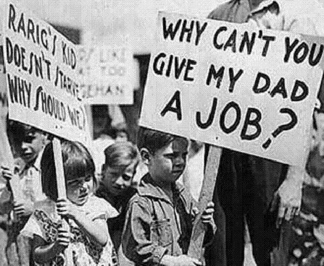

5. Hitler and Mussolini were not afraid to use violence to get what they wanted. This increased throughout the 1930s following the Depression. They were not interested in the aims of the League of Nations such as collective security,

4. The Wall Street Crash also enabled extremist parties to find a minority group to blame the problems on, encouraging racism. For example, Hitler blamed all of Germany’s problems on the Jews.

6. The cost of the Depression meant that countries did not want to provide soldiers to fight a war against aggressive dictators.

7. This meant that the only sanctions available to the League were economic. These were largely ignored because of the economic impact that this may have on their own people (e.g. unemployment).
8. Ultimately, countries were so busy dealing with their own problems that they had very little time to support the League of Nations.

- The Manchurian Crisis and its Significance

- The League of Nations faced its biggest test in September 1931 following the Japanese staging an invasion of Manchuria in China. Japan was a permanent member of the League’s Council so should have been committed to world peace.

Where is Manchuria? | - On the north-east coast of China.  - It is rich in natural resources like coal and iron ore.  - Japan and Russia had factories there in the 1930s.  - China was a divided and weak country split into different regions run by warlords.
Why did Japan Invade Manchuria? | - Japan was suffering from the Great Depression. It had been particularly badly hit because its economy was based on exporting luxury goods like silk which people could no longer afford.  - Japan has few natural resources so looked elsewhere to acquire some.  - Japan chose to invade Manchuria because:  - It was close to Japan.  - They had large industries (e.g. the South Manchurian Railway) in the area already.  - There was confusion over who owned the area.  - Japan was scared that China might kick out its industry.  - It would upset Japan’s enemy Russia and distract people from domestic problems.  - The Japanese army was getting stronger and acting independently of the government.  - The Japanese government became dominated by army generals from 1932 when the prime minister was killed and the new leaders wanted to be more aggressive overseas.
The Mukden/ Manchurian Incident. | - On 18th September 1931 there was an explosion on the South Manchurian Railway. The Japanese claimed that it had been attacked by Chinese soldiers.  - The Chinese denied the attack and said their soldiers had been asleep.  - The Japanese Kwantung army then used this as an excuse to take over Manchuria.  - The Japanese people celebrated openly in the streets after the invasion.  - Manchuria was renamed Manchukuo. Pu Yi was put in charge as a puppet ruler (meaning that Japan could control him).
Why was the League Reluctant to Act? | - The League did not want a big fight despite it being a clear case of Japanese aggression.  - Many people believed that Japan owned Manchuria and therefore had the right to take control.  - China had agreed in treaties that Japan had economic rights in the region.  - China and Japan were too far away from the League’s headquarters in Switzerland to be a concern.  - Japan claimed that they had been attacked first and therefore were not to blame.  - China was a disorganised country and so some people felt that it was a good thing that Japan was in charge of Manchuria to introduce organisation.
What did the League do? | - They issued a moral condemnation and told Japan to withdraw its troops, but in reality could do little because:  - The Depression meant that countries like Britain could not afford to send troops to fight.  - Economic sanctions were ineffective as Japan’s main trading partner was the USA who was not in the League.  - The USSR (Russia) that was closest to Manchuria could not be asked to help as it too was not in the League.  - So they put together the Lytton Report (led by Lord Lytton) in October 1932 which investigated what happened. It officially stated that Japan was in the wrong. However Japan ignored the findings.
What Happened Following the Lytton Report? | - Japan left the League of Nations.  - In February 1933 the Japanese invaded another Chinese region Jehol.  - In 1937 Jehol and Manchuria were used as bases to invade the rest of China.  - By 1938 most Chinese cities were controlled by the Japanese army.
Why was the Manchurian Crisis Significant? | - The Manchurian crisis showed that the League was failing. The Covenant had been ignored by a permanent member of the Council and had acted with aggression.  - The League acted slowly and ultimately achieved nothing.  - It did little long-term damage to the League as European countries still believed that if there was a problem closer to home that the League would be able to deal with it.  - Other dictators in Europe like Hitler and Mussolini saw this weakness however and began acts of aggression of their own.

- The Invasion of Abyssinia and its Significance

- Mussolini had come to power in 1922. He wanted to make Italy powerful again and create a new Roman Empire. As part of his territorial expansion, he invaded Abyssinia in 1935 meaning the League again had to act.

Where is Abyssinia? | - Today Abyssinia is called Ethiopia. It is on the eastern coast of Africa.  - It was surrounded by British colonies (like Sudan) and French colonies (like Libya) but had remained independent.
Why did Mussolini and Italy Invade? | - Mussolini promised that he was rebuild the Ancient Roman Empire.  - Britain and France had many African territories so felt that they could not object.  - Italy owned neighbouring territories like Eritrea and Somaliland so he thought that invading Abyssinia would be easy.  - Abyssinia was rich in natural resources (like grazing land) useful to Italy.  - Italy had failed to take over Abyssinia in 1896, Mussolini promised revenge for this defeat.  - Mussolini saw the League fail to deal with Manchuria. He also had ‘got away’ with bullying Greece during the Corfu crisis in 1923. Therefore, he was sure he could ‘get away’ with invading Abyssinia.  - In 1935 Italy had signed an agreement, along with Britain and France, to form the Stresa Front, uniting against Hitler. This gave Mussolini the impression that France and Britain would allow him to do anything in order to keep Italy as their ally.
How did Mussolini Invade Abyssinia? | - In December 1934, Italian soldiers classed with Abyssinians at Wal Wal, an oasis on the border between Abyssinia and Somaliland. 150 Abyssinians and 2 Italians were killed.  - The League tried to intervene but it was difficult as both Abyssinia and Italy were members.  - In January 1935, the French foreign minister met Mussolini and made a series of secret agreements. It promised that Mussolini could deal with Abyssinia however he saw fit.  - Mussolini then invaded Abyssinia on 3rd October 1935. They bombed villages and used chemical weapons to force people to surrender. They met little resistance as the small Abyssinian army had only spears.  - 30th June 1935, Emperor Haile Selassie warned the League of the effects of failing to deal with Mussolini and on 5th May 1936, the Italians took Addis Ababa (the capital of Abyssinia).
Why did the League Fail to Stop Mussolini? | - There were many reasons that the League of Nations failed to stop Mussolini in Abyssinia. These included:  - They failed to close the Suez Canal: Doing this would have forced Mussolini to travel around the Cape of Africa with all his supplies and troops, slowing him down.  - They failed to agree on trade sanctions: Key resources like coal and oil were not banned meaning that Mussolini could still use his tanks.  - Trade sanctions against Abyssinia: Abyssinia was left virtually defenceless against Mussolini’s modern army and weapons.  - The Hoare-Laval Pact: In December 1935, Pierre Laval and Samuel Hoare went to offer Italy a settlement. It agreed that Italy would be given some of Abyssinian lands. The Abyssinians would keep the mountainous areas and Italy would gain the fertile areas. This showed that Britain and France were willing to undermine the League.
What Happened After? | - In May 1936, Italy left the League of Nations. This meant that only Britain, France and the USSR were left to run the League.
Why was the Invasion of Abyssinia Significant? | - From this point forward, many people’s faith in the League of Nations was ruined as they once again had failed to protect a member from breaking the Covenant.  - For many, it was no longer viewed as a serious peacekeeping organisation.  - Small countries lost respect for the League because they knew that it would not protect them from invasion.  - Dictators like Mussolini and Hitler realised that the League was powerless to stop them starting a war.

- The Reasons Why the League of Nations Failed by 1939

- America refused to join whereas other powerful countries like Germany and the USSR were not allowed to join.
- The League’s plans were very ambitious. It can be argued that they were so ambitious that they never stood a chance of succeeding.
- Trade sanctions were ineffective because countries could still trade with places like the USA.
- Decision-making was very slow because the League met only once a year and any decisions had to be unanimous.
- Powerful countries were not really concerned about moral condemnation so the League’s sanctions were useless.
- The Great Depression meant that countries were concerned with their own problems.
- It had no army of its own to use to settle disputes.
- The League’s structure was very complex. Also there were not enough people to carry out decisions that were made.
- The Depression meant people turned to dictators like Hitler and Mussolini who were aggressive towards other countries. The League was powerless to stop them.
- The League of Nations was slow to act during the Manchurian crisis and failed to prevent the Abyssinian crisis as they were more worried about keeping Mussolini as an ally.
Why Did The League of Nations Fail?

Part Three – The Origins and Outbreak of WWII

    - Hitler’s Aims

- Hitler came to power in January 1933. For many historians he was the single most important reason why WWII broke out in 1939. He promised to solve Germany’s economic problems that they had been experiencing since the Wall Street Crash
in 1929. Hitler identified a range of aims that he intended to achieve after becoming Chancellor of Germany. These include:
  - To overturn the Treaty of Versailles as he felt that it humiliated Germany.
  - Rearm Germany to make them strong again.
  - Create jobs in new munitions factories to help with the rearmament.
  - Take Lebensraum (living space) in the east so Germans had enough land to live on.
  - Unite Volksdeutsche. These were people with German blood but without German citizenship as they were living in other countries created as a result of the Treaty of Versailles. This would enable Hitler to create a Greater Germany.
  - Unite Germany and Austria in Anschluss.
  - Destroy Communism.

- All of Hitler’s aims and policies meant that it was more likely a second world war would happen:
  - In order to gain Lebensraum Hitler had to invade other countries. The allies of these invaded countries would have to declare war against Germany as a result.
  - Hitler’s rearmament broke the Treaty of Versailles which had restricted his army.
  - Trying to reunite German-speaking people meant again that Hitler had to invade other countries.
  - A Communist government existed in the USSR. They had begun to form better relationships with Britain and France, as well as being allies of other eastern European countries. Hitler therefore was provoking a powerful country who was bound to fight back.

    - How Other Countries Reacted to Hitler’s Policies

- Neville Chamberlain was prime minister from 1937-1940. Like the British public he was worried about Hitler’s aggression.
- However in 1934, Hitler signed a non-aggression pact with Poland which satisfied politicians that Hitler did not want a war.
- The British people remembered the horrors of WWI so were prepared to do anything to prevent another war.
- In 1937 Chamberlain sent Lord Halifax to meet with Hitler to find out what he wanted. He hoped to appease Hitler by giving him a little bit of what he wanted.
- Appeasement was used by Chamberlain until 1939.
Britain’s Reaction
- The British public had also started to believe that the Treaty of Versailles was too harsh and Germany should be able to reclaim some of what had been taken.
- However, some people including Winston Churchill felt that a stronger stance should be taken against Hitler and argued that appeasement was a mistake.

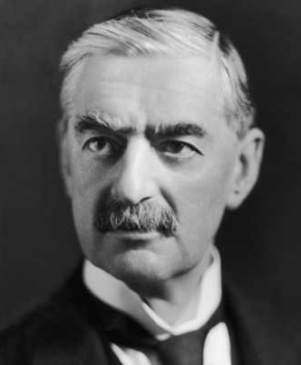

- Édouard Daladier was president of France for most of the 1930s.
- The 1930s were a difficult time for France because its people suffered greatly due to the Depression.
- Some French people were so angry about conditions in France that they began rebelling.
- Consequently, the French government had little time to concentrate on the threat from Hitler.
- France could also not afford to act against Hitler without the support of Britain.
France’s Reaction

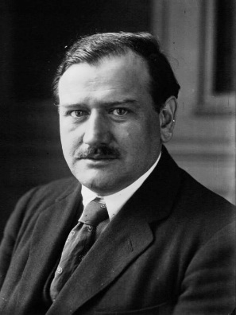

- Josef Stalin was the Communist leader of the USSR.
- The USSR had hostile relationships with other European countries because they had different government systems to their own.
- Stalin was concerned about Hitler because he had promised to completely destroy Communism. However, he was also wary of Britain, France and the USA too.
- In 1934 relations with most of Europe improved because the USSR was allowed to join the League of Nations.
- In 1935 a treaty of mutual assistance was signed with France, saying that the two countries would work together.
USSR’s Reaction

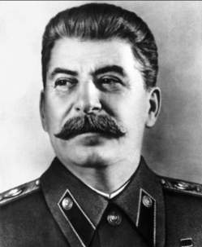

- So initially, Stalin felt it was worth cooperating with capitalist states to prevent Hitler’s expansion in the East.

USA’s Reaction
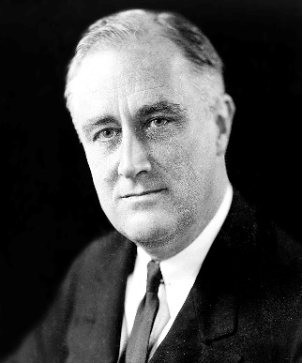
- Franklin D Roosevelt was made president of the USA in 1932.
- Throughout the 1920s the USA had followed a policy of isolationism and had avoided getting involved in European affairs.
- This did not change in the 1930s during the Depression. Unemployment levels reached 25% so Franklin D Roosevelt focused on creating jobs for his people.
- In 1934, a poll took place where 70% of the votes said that the USA should not have been involved in WWI. It also said if a second world war started that the USA should not interfere.
- So in 1934 Roosevelt promised to keep the USA out of any war in Europe.

- In 1938, Roosevelt tried to get Hitler to promise to stop invading other countries. However, there was little more that the USA could do than prepare its armed forces, just in case.

    - German Rearmament and the Road to War
January 1935: The Saar Plebiscite
The Saar had been given to the League of Nations for 15 years under the Treaty of Versailles. This was due to expire so a plebiscite (when people not politicians vote on a matter) was held to decide whether France or Germany should rule the area. 90% of people voted to rejoin Germany. This meant that Germany also gained rich coalfields which helped industrial growth.
1934: The Dollfuss Affair
Many people, including Hitler were outraged when Anschluss (union between Germany and Austria) was forbidden by the Treaty of Versailles.
The Austrian chancellor Dollfuss banned the Nazi Party. In 1934 Hitler told Austrian Nazis to create havoc in the country. They murdered Dollfuss. However, Hitler did not succeed as the Austrian army supported the government. Also Mussolini moved his troops on to the Austrian border, promising to stop Anschluss.
1933: Hitler Leaves the League of Nations Disarmament Conference
Hitler promised to disarm, if every other nation promised too. He said if this did not happen then Germany should have an army the same size as France. The French refused to cooperate and Hitler stormed from the conference. Shortly after, Germany left the League of Nations.

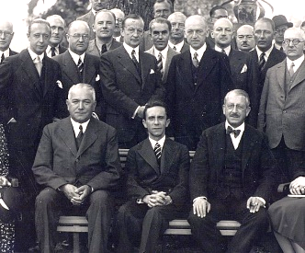
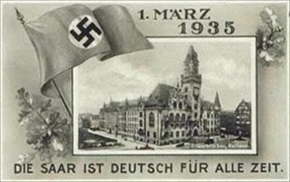

June 1935: Anglo-German Naval Agreement
In June 1935 an agreement was signed that said that Germany could build their navy to 35% of the size of the British navy.
Britain also allowed Germany to build 45% of the number of British submarines.
This agreement however really meant that the Treaty of Versailles was dead. Significantly, Britain had not consulted France and Italy before signing this agreement.
April 1935: The Stresa Front
The Stresa Front was an agreement between Britain, France and Italy saying that they would work together to guarantee the Locarno Treaty.
This meant that they would protect Austrian independence and work together to stop Hitler breaking other Treaty of Versailles terms. Hitler was not concerned by this agreement.

March 1935: Rearmament
At the Freedom to Rearm Rally in 1935, Hitler showed off how much he had rearmed. He also announced that he was:
- Reintroducing conscription (he did this in 1936).
- Expanding his army to 1 million men.
- Creating a Luftwaffe (air force).

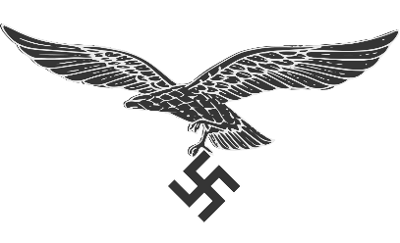
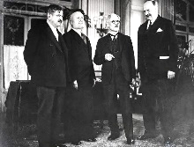

    - German Reoccupation of the Rhineland

- With his aim of Lebensraum in the east, Hitler knew that he had to defend his borders in the west. This was because invasion of other countries was likely to provoke a response from Britain and France. The remilitarisation of the Rhineland was key to securing the German border with France.
- Hitler used the Franco-Soviet pact as a reason to claim that Germany was under threat from France. Therefore in March 1936, Hitler took 22,000 soldiers to the Rhineland (demilitarised zone bordering France). This was banned under the Treaty of Versailles.
- Hitler’s troops met little resistance. They arrived on bicycles and there was no air support.
- Britain didn’t react because they had their own issues and believed that Hitler was simply reclaiming land that was rightfully his.
- The French were also not prepared to risk a war and were busy fighting a general election.
- The League of Nations was too preoccupied with Mussolini in Abyssinia to worry about Hitler.
- For Hitler however, the entry to the Rhineland was a big gamble. His army was too small to fight against France and Britain and if they were stopped they would face crippling fines.

- However, the reoccupation of the Rhineland was a big step towards a second world war because:
  - Hitler became confident that he could do as he pleased.
  - It allowed Hitler to begin thinking how he could overcome other terms of the Treaty of Versailles.
  - It meant that Britain and France also began rearming.
  - France turned its attention to its own defences. This meant that it found it hard to upkeep treaties with other Eastern European countries who they promised to protect.
  - Britain and France signed an agreement to strengthen the Locarno Treaty, reaffirming that they would protect each other and Belgium if Germany attacked.
  - Mussolini and Hitler began to work together. They signed the Rome-Berlin Axis and even sent weapons to Spain where there was a civil war. This enabled Hitler to develop and test weapons and allow men to gain experience of war.
  - Hitler was now ready to defend his western borders. This meant that he could concentrate on Lebensraum in the East.

- German Alliances in Europe

Potential Ally | Did they form an Alliance/Pact? | Reasons For/Against an Alliance
Britain | No | Hitler admired the British traditions and values. Therefore in 1936 he suggested a non-aggression pact which would last for 25 years. This meant that Britain and Germany would not attack each other. Some British politicians wanted to cooperate with Germany but they
 |  | had no intentions of signing up to an official alliance. The agreement after the remilitarisation of the Rhineland only strengthened Britain’s relationship with France and Belgium.
Italy | Yes | Hitler saw that they he had many things in common with Italy although Mussolini had stopped him from invading Austria after the Dollfuss Affair in 1934. However, in 1936 the Rome-Berlin Axis was created which meant Germany and Italy would work more closely together. Italy’s relationship with Britain and France however suffered.
Spain | Yes | In 1936 the Spanish Civil War broke out between the democratic Republicans and the nationalist Fascists (led by General Franco). Hitler and Mussolini sent troops and weapons to help support Franco. Franco’s enemies were supported by the Communist USSR who Hitler had promised to destroy. In 1939 Franco was able to defeat the Republicans and became the new Fascist dictator of Spain.
Japan | Yes | There was much hatred between the USSR and Japan dating from 1905. The USSR had formed the Comintern (a group dedicated to spreading Communism). So on 25th November 1936 Germany and Japan signed the Anti-Comintern Pact saying they would work together against Communism. They were later joined by Mussolini.
Italy & Japan (triple alliance with Germany) | Yes | Italy, Japan and Germany tried to agree a triple alliance. However they could not agree the focus. Due to this disagreement, Japan was not involved in agreeing the first pact on 22nd May 1939. This first agreement between Italy and Germany was formally known as the Pact of Friendship although Mussolini called it the Pact of Steel (implying their armies would work together in any war that broke out). Japan joined the Pact of Steel in 1940 (making the three allies in WWII).

- Anschluss with Austria

- Hitler felt strongly that Austria and Germany belonged together so was determined to achieve Anschluss (the union of Germany and Austria). This would mean Hitler was closer to uniting all German-speaking people in a Greater Germany.
- Hitler had unsuccessfully tried to unite Germany with Austria in 1934 during the Dollfuss Affair. One of the main reasons this failed was because Mussolini stood up to Hitler at this time. However, the signing of the Rome-Berlin Axis and the Anti-Comintern Pact had improved relationships with Italy greatly. Hitler also now had the support from General Franco and Spain. So, in 1938 Hitler attempted Anschluss again:
1934 – The murdered Dollfuss was replaced with Schuschniqq. He made a deal with the Nazis, giving them key positions in the Austrian government.
Schuschnigg met with Hitler. However, in discussions he was intimidated and had little say over the agreed terms.
Schuschnigg decided to hold a plebiscite to allow the Austrian people to vote on whether they wanted Anschluss.
January 1938 – Demonstrations against the Austrian government take place in towns like Vienna. These were all led by the Austrian Nazis.
The terms included appointing Nazi solicitor Seyss-Inquart as minister for the interior with full power over the Austrian police. Nazis were also made finance and war ministers. Schuschnigg had 3 days to agree.
January 1938 – Austrian police raid the Austrian Nazi Party headquarters and discover plans to overthrow Schuschnigg.

10th April 1938 – Hitler holds a plebiscite with heavy Nazi presence at voting booths. 99% of Austrians voted for the Anschluss.
12th March 1938 – Nazi troops invaded Austria. It was a badly planned invasion but there were no deaths and it faced no opposition.
March 1938 – Hitler demanded the vote be postponed and forced Schuschnigg to resign. Seyss-Inquart was made Chancellor.
Schuschnigg decided to hold a plebiscite to allow the Austrian people to vote on whether they wanted Anschluss.

Reaction to Anschluss
German Reaction: For many Germans, Hitler was the hero who saved Austria and was the saviour beginning to unite German speaking people. Germans also recognised that Austria was useful as it contained natural resources such as steel and iron ore which could help with rearmament.

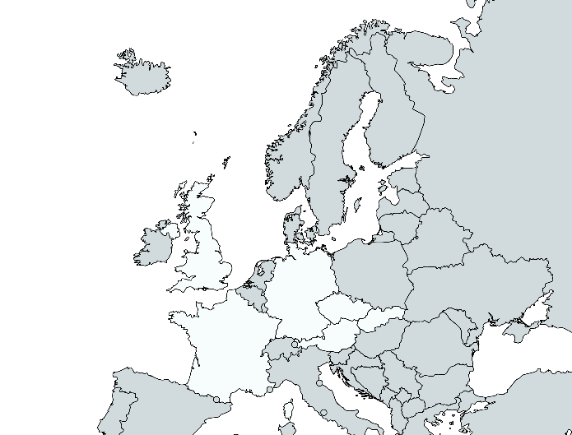

Czech Reaction: The Czech government was very concerned about Anschluss because they shared a border with Austria. They felt that they would be next to face Nazi pressure as Hitler pursued his quest for Lebensraum. Neville Chamberlain made Hitler give his promise that he would leave Czechoslovakia alone.

Austrian Reaction: Many Austrians were delighted to unite with Germany as they hoped it would make Austria great again. However, for Austrian Jews they recognised the danger that the Nazis posed with their anti-semitic views. Thousands of Jews left Austria quickly fearing for their future.

French Reaction: France was more concerned with its own economic problems rather than the fate of Austria.
Britain: Many people in Britain considered Germany and Austria as essentially one country and therefore felt they should be allowed to unite. There was some opposition from Winston Churchill but in reality, there was little appetite to get involved.

- The Sudeten Crisis

- Hitler did not keep his promise to leave Czechoslovakia alone for long. He had faced little opposition to his invasion of Austria so decided to expand Lebensraum in the East, starting with the border region known as the Sudetenland.
- The Sudetenland also had many resources that the Nazis would find useful if they could take them over. These included: forts, railways, glass and lignite (a type of coal) factories as well as the Skoda factory which could be converted to build tanks and weapons.
- The Sudetenland was also home to 3 million German-speaking people. They claimed they had been persecuted by the Czechs. It was also a good base to launch an attack on the whole of Czechoslovakia as it surrounded it on three sides.
- However, Czechoslovakia had a big army and strong fortifications.
- So, the Nazis started demonstrations in the Sudetenland to weaken the government. He claimed that the German-speaking people needed protection.
- On 15th September 1938, Neville Chamberlain (British Prime Minister) met Hitler to resolve the crisis.
- Hitler, demanded that he should be given the Sudetenland. Chamberlain agreed, desperate to avoid a war (called appeasement). Chamberlain then forced the Czech government to agree to Hitler’s terms.
- Chamberlain then met Hitler on 22nd September 1938 but he had changed his demands. He wanted the Sudetenland by 1st October and said that Hungary and Poland should also receive Czech land. WWII seemed to be closer.

- The Munich Conference
- On 29th September 1938, Germany, Britain, France and Italy met to discuss Czechoslovakia’s borders at the Munich Conference.
- Hitler made the same demands as before, he wanted the Sudetenland and said that Hungary and Poland should gain land from Czechoslovakia. In return he promised peace in Europe.
- France and Britain quickly gave in to Hitler’s demands, claiming they had prevented a second war.
- On 10th October 1938, Hitler took the Sudetenland. However, the Czech people had not been consulted and felt they had been invaded.
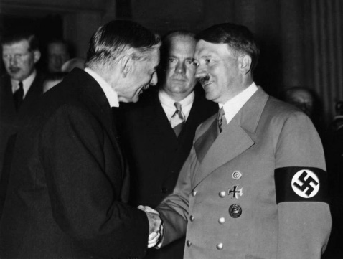

- Also, the USSR felt betrayed by Britain and France as they too had not been consulted. USSR leader Stalin began to believe that he needed to form a closer relationship with Hitler and Germany.
- Chamberlain claimed that the Munich Conference was a success. On 30th September 1938 (the day after) he signed an Anglo-German declaration saying the two countries would not go to war.
- Chamberlain even went as far to declare ‘peace in our time’.
- The 1938 invasion of Czechoslovakia was significant for many reasons. These included:
  - It was the first time that Hitler had invaded a country which Germany had no claim to.
  - Czechoslovakia was a strong country but its help in preventing a full-scale world war was lost.
  - Britain and France had lost the USSR as an ally.
  - Hitler did not keep his promises. In 1939 he invaded the rest of Czechoslovakia. This meant that appeasement had failed.
  - Chamberlain promised Poland that Britain would guarantee its independence.

- British and French Reaction to Hitler’s Actions
Date | Event | How Britain and France Reacted
1933 | Hitler leaves the League of Nations Disarmament Conference. | The French refused to disarm so they could not force Hitler to disarm.
13th January 1935 | People in the Saar vote to rejoin Germany. | Britain and France thought there was no reason to do anything as it was a legal vote for what the people wanted.
March 1935 | The Rearmament Rally. | Many saw Hitler as a potential ally against the Communist USSR so felt he should be allowed weapons. Also they felt the Treaty of Versailles had been too harsh and unrealistic.
18th June 1935 | Anglo-German Naval Agreement. | Britain felt that if they made an agreement with Hitler then they could have some control over the level of growth of the German navy.
7th March 1936 | Remilitarisation of the Rhineland. | Britain and France felt that Germany had the right to protect and defend their own borders so did nothing.
July 1936 | Hitler and Mussolini support Franco in the Spanish Civil War. | Britain and France did not want to get involved. A war was not declared so they just watched Hitler and Mussolini support Franco.
October 1936 | The Rome-Berlin Axis. | France and Britain were not happy about this but were not prepared to do anything to about it.
25th November 1936 | The Anti-Comintern Pact. | Britain and France viewed any alliance against the USSR and Communism to be a good thing so allowed the pact between Japan and Germany.
12th March 1938 | Anschluss with Austria. | Most people thought that Austrians were really Germans anyway so did not bother to stop it.
September 1938 | Munich Conference (Hitler is given the Sudetenland). | Britain continued with appeasement as they felt that Hitler was a reasonable politician who would stick to his promises.
15th March 1939 | Hitler invades the rest of Czechoslovakia. | The final straw. It became obvious that appeasement was not working so Britain and France stepped in to help protect Polish independence.

- Arguments For and Against Appeasement
Arguments For Appeasement | Arguments Against Appeasement
- Many British people felt safer that they were not facing a second world war.  - People felt that the Treaty of Versailles was too harsh so Hitler was only claiming what was rightfully Germany’s.  - WWI meant many families had suffered greatly already, they were keen to avoid this happening again. | - On many occasions, Hitler had said that violence had to be used so politicians like Chamberlain misjudged him.  - Opportunities were missed to stop Hitler when his army was not strong enough. This could have prevented WWII.  - Many, including Winston Churchill, felt that the more Hitler was given, the more he would ask for.
- Hitler kept saying that he would keep his promises. Initially, the British people had no reason not to believe him.  - Many of Hitler’s actions (like Anschluss) went with the public vote and therefore were popular.  - In Britain, the ‘Peace Ballot’ carried out in 1934 said that the public did not want Britain to take military action.  - Chamberlain who advocated appeasement was seen as a hero, representing the desires of the British public.  - The Depression meant that Britain could not afford to fight. Instead, they could concentrate on their own problems.  - British people were fearful of Communism. They thought a government like the Nazis would protect them.  - Britain was not ready to fight as they did not start to rearm until 1936.  - The USA had also said they would not get involved in a European war meaning France and Britain were too weak.  - Even as late as the 1938 Munich Conference, appeasement appeared to bring hope of an everlasting peace in Europe. | - Appeasement was morally wrong as it gave countries like Czechoslovakia and Austria away to the Nazis.  - Czechoslovakia could have stopped Hitler. However, appeasement forced them to back down to him.  - The remilitarisation of the Rhineland was a clear chance to stop Hitler, appeasement meant this was a missed opportunity.  - By the start of WWII, Britain’s relationship with the USSR was strained, alienating a powerful ally.  - Appeasement meant that the leaders of Britain and France were viewed by many as cowards who were simply afraid to stand up to Hitler.  - The appeasers were foolish giving into Hitler as he became more confident that he could get away with anything he wanted.

- The Nazi-Soviet Pact
Why Didn’t The USSR Trust Britain and France?
In WWI, Russia had been allies with Britain and France. However, Stalin felt that he could not trust his allies because:

- He saw how weak they had been in the League of Nations (e.g. in Manchuria).
- Russia and France had signed an agreement to protect each other but the USSR could not be sure France would stick to it.
- Britain and France clearly did not trust Stalin as he was a Communist so he could not trust them.
- Stalin was not consulted about the Munich Agreement in 1938.
- Meetings with the USSR were slow and looked like the British did not consider them important.
- Hitler sent a very senior Nazi to discuss with Stalin. This suggested to Stalin that Hitler respected him and the USSR more than Britain and France.
- The Polish did not want Russian troops in their country. However, Britain and France promised to protect Poland, adding to the mistrust.

Why Did Germany Want Poland?
Poland was the next step for achieving Lebensraum. At the end of WWI, many Germans were living within Poland as a result of the Treaty of Versailles. With no natural frontiers it would be easy to attack, apart from the USSR’s reaction to an invasion.
What Was In It For Germany?
Germany lost WWI primarily because it had to divide its troops fighting on two fronts. Signing the pact took Russia initially out of the equation.

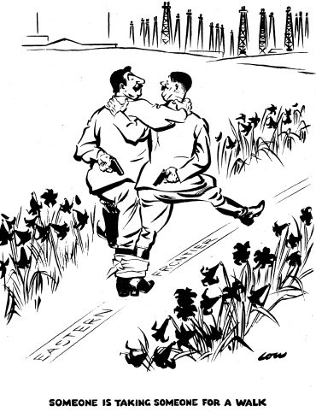
What Was The Nazi-Soviet Pact?
The USSR had also lost land to Poland at the end of WWI. So, both Germany and the USSR despised the new state. Hitler sent his foreign minister, Joachim von Ribbentrop to the USSR.
On 23rd August 1939 the Nazi-Soviet Pact was signed (a non-aggression pact) saying that Hitler could invade Poland and in return would give the USSR some Polish territory.

Why Did Russia Sign?
They would gain territory without having to do any fighting. This territory would be useful as a buffer for if (and when) Hitler decided to invade Russia.
It also gave Russia the chance to build up their army as they bought time signing the pact.
Also, it can be argued that Stalin had no choice because he was isolated (it was therefore better to be allies with Hitler than invaded by him).
What Was The Significance Of The Pact?
It made war inevitable because Hitler knew he was no longer fighting a war on two fronts therefore invading Poland was to be the next logical step.
It also meant that Britain and France needed to prepare for war and protect Poland when Hitler invaded.
Britain and France also realised that once the war started they would face Germany without the support of the USSR who instead would be siding with Hitler.

- The Invasion of Poland and Outbreak of WWII

- Throughout the 1920s and 1930s Britain and France had tried to use policies of appeasement with dictators like Hitler and Mussolini. However, on the 1st September 1939 Hitler entered Poland.
- At 4.45am a German battleship (the Schleswig-Holstein) opened fire on the port of Danzig. 90% of the population was German. It had been made an independent state, run by Poland under the Treaty of Versailles.
- Simultaneously the German army and Luftwaffe aeroplanes invaded and defeated the Polish air force.
- However, some of Hitler’s generals worried the Germans were not ready for war and leaked plans to Britain.
- On the 3rd September 1939 the British told the Germans to withdraw or they would join the war. At 11:15am Chamberlain issued an address to the British public declaring war on Germany. The French followed shortly afterwards.
- Poland was completely defeated within four weeks but WWII was only just beginning.

- The Causes of WWII
Hitler had to invade countries to stop Communism spreading.
Hitler said that taking Lebensraum and overturning the Treaty of Versailles was key to making Germany strong so had to invade other countries.
Opportunities were missed to stop Hitler e.g. when he remilitarised the Rhineland.
Chamberlain misjudged Hitler by trusting him.
Appeasement
The Munich Agreement alienated Stalin who then signed the Nazi-Soviet Pact.
Politicians like Chamberlain were to blame.
People were desperate to avoid the horrors of WWI.
Hitler did not have to face a war on two fronts.
Allowed Hitler to invade Poland which Britain and France had promised to protect.
Germany and the USSR were now allies.
The Nazi-Soviet Pact
Considered too harsh on Germany.
Britain felt it was too harsh so did not intervene to prevent events like Anschluss happening (appeasement).
The Treaty of Versailles
Territory was taken from Russia to create Poland. This meant the USSR signed the Nazi-Soviet Pact.
Many new states were created which contained many German people who Hitler promised to reunite in a Greater Germany.
Hitler promised to overturn the Treaty.
Desperate countries were too preoccupied with their own problems to support the League of Nations.
Economic sanctions could not be put on aggressors by the League of Nations.
Failure in Manchuria showed the League was weak.
The effects made people turn to dictators like Mussolini and Hitler.
Failure of the League of Nations
Failure in Abyssinia showed Britain and France would undermine the League and not deal with aggression (no action/no army).
Hitler had to invade countries to stop Communism spreading.
Hitler to Blame
The Depression
The Causes of WWII

