**Britain: Health and the People c1000-Present Day**

**Part One – Medicine Stands Still**

|  |  |
| --- | --- |
| 1. The work of a Medieval doctor. | Page 4 |
| 1. Christianity and medicine. | Pages 4 and 5 |
| 1. Islam and medicine. | Page 5 |
| 1. Medieval surgery. | Page 6 |
| 1. Medieval public health. | Pages 6 and 7 |
| 1. The Black Death. | Page 7 |

**Part Two – The Beginnings of Change**

|  |  |
| --- | --- |
| 1. The Renaissance. | Page 8 |
| 1. The work of Andreas Vesalius. | Pages 8 and 9 |
| 1. The work of Ambroise Paré. | Pages 9 and 10 |
| 1. The work of William Harvey. | Page 10 |
| 1. New Renaissance treatments. | Page 11 |
| 1. The Great Plague. | Pages 11 and 12 |
| 1. Renaissance hospitals. | Page 12 |
| 1. The work of John Hunter. | Page 13 |
| 1. The work of Edward Jenner. | Pages 13 and 14 |

**Part Three – A Revolution in Medicine**

|  |  |
| --- | --- |
| 1. The development of anaesthetics and the work of James Simpson. | Pages 14 and 15 |
| 1. Louis Pasteur and the discovery of germ theory. | Pages 15 and 16 |
| 1. The work of Joseph Lister. | Pages 16 and 17 |
| 1. Why germ theory was accepted in Britain. | Page 17 |
| 1. The work of Louis Pasteur and Robert Koch in developing vaccinations. | Pages 17 and 18 |
| 1. Public health in the early 19th century. | Pages 18 and 19 |
| 1. Cholera, Chadwick, Snow and the First Public Health Act. | Pages 19 and 20 |
| 1. The Great Stink and the Second Public Health Act. | Page 20 |

**Part Four – Modern Medicine**

|  |  |
| --- | --- |
| 1. Magic bullets and the discovery and development of penicillin. | Page 21 |
| 1. Drugs and treatments since 1945. | Page 22 |
| 1. Antibiotic resistance and alternative treatments. | Pages 22 and 23 |
| 1. The impact of WWI and WWII on medicine. | Pages 23 and 24 |
| 1. Public health improvements since 1900. | Pages 24 and 25 |
| 1. 21st century public health and the NHS. | Page 25 |

**Overview of Health and the People Content**

**Part One – Medicine Stands Still**

1. **The Work of A Medieval Doctor**

They followed the ancient Greek idea of clinical observation (diagnosis produced by observing symptoms at the bedside of the patient).

Treatments included natural remedies made from plants and animal products. Doctors also used bloodletting often involving leeches. Purging the body was also common, for this a patient would be given a mixture of herbs to make you vomit or go to the toilet

Doctors would focus on the pulse of the patient and the colour, smell and taste of the urine.

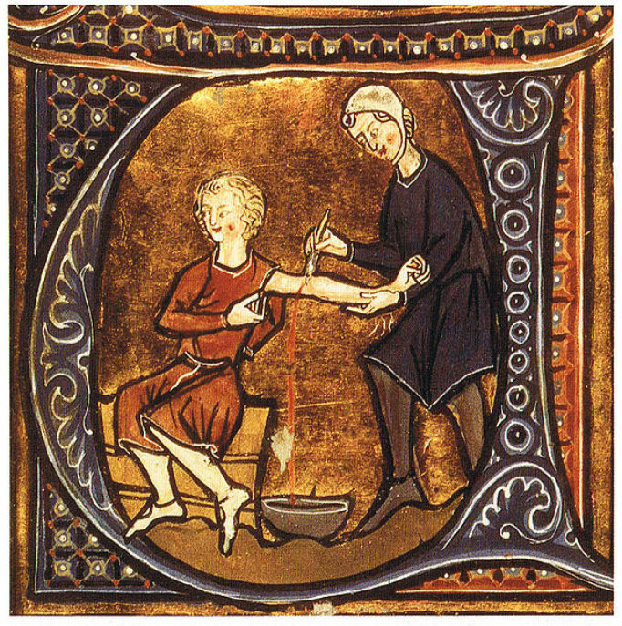

Doctors were very expensive and only for the wealthy. Poorer people had to turn to other options such as barber surgeons, wise women or even quack doctors. These had varying degrees of success. A common option was praying in a Christian monastery or church.

Natural treatments were often combined with supernatural approaches such as prayers, charms or using astrology (the planets).

Doctors had seven years training at a university. They read books but spent little time with patients. They were taught treatments from Hippocrates and Galen as well as Gilbert Eagle’s *Compendium Medicine.* Many of these combined natural and supernatural approaches.

A popular theory about the cause of disease and how to treat it was the Four Humours. This was an Ancient Greek idea which said that the body was made of four liquids (humours). These were blood, phlegm, yellow bile and black bile. A person was ill if the humours were out of balance

If the humours were unbalanced the doctor would have to restore balance. For example a nose bleed meant too much blood so the patient would be bled to remove the excess. If the patient had too little blood they would be given something red, like red wine.

1. **Christianity and Medicine**

* Christians believed that they had a duty to care for the sick, this was similar to how Jesus healed the sick in the Bible.
* This led to Christian people founding many hospitals.
* However, the focus in these hospitals was to care not cure the sick. Curing an illness would be seen as a challenge to God who was believed to send it as a punishment or a test of face.
* Prayers were therefore the most important and common treatment.
* The Church also encouraged the idea of miraculous healing. For example, people were encouraged to make pilgrimages to shrines full of relics (such as bones or hairs) to show God that you were a devout Christian. A famous example of this was the shrine of Saint Thomas Becket in Canterbury.
* Whilst prayers were important, the ideas of Hippocrates and Galen (four humours and the theory of opposites) were also respected. Monks were tasked with preserving and studying these ideas, copying out ancient manuscripts.
* Over 700 hospitals were started between 1000AD and 1500AD. There were lots of different types:
  1. Small hospitals with only twelve beds (same number as Jesus had disciples).
  2. Hospitals without doctors, run instead by a monk or nun and based on a strict diet and prayers.
  3. Asylums to treat the mentally ill such as Bedlam in London.
  4. Monasteries with dormitory wards/infirmaries which provided free treatment.
  5. Larger hospitals (not many) such as St Leonard’s in York. The most famous large Medieval hospital was the Hotel Dieu in Paris which was where the French king’s doctors worked.
  6. Lazar houses which cared for people with leprosy. This disease was contagious so people and crusading orders, such as the Knights Templar, set them up to look after crusaders who caught the disease whilst going round the Middle East.

|  |  |
| --- | --- |
| **Christianity Helped Medicine** | **Christianity Hindered (Held Back) Medicine** |
| * Christianity did provide training to doctors. Successful completion of training led to a doctor receiving a licence. * The Church did encourage people to look after and care for each other. * Monasteries provided free treatments which meant that even the poor could benefit. * People at the time felt that the Church did provide comfort to them if they were ill and helped families put their affairs in order. | * The Church controlled training and universities. Within these institutions it was made clear that doctors were not to try to discover new ideas. Instead they had to study the ancient ideas which fitted in with the Church as well as the Bible. * The Church approved of Galen meaning that his ideas could not be challenged. This was because they fitted in with the idea of a creator and a single God. * Criticism of ideas which the Church approved of was seen as heresy which could possibly result in a prison sentence. |

1. **Islam and Medicine**

* In 750AD, the Islamic Empire was reaching its height. It covered large areas of the Middle East, North Africa and even the majority of Spain.
* The Empire was ruled by a Caliph. Many of these Caliphs were interested in science, technology and medicine but more importantly developing and discovering new ideas. The Koran encouraged people to seek and discover new cures stating *‘For every disease, Allah has given a cure’.*
* Baghdad became a centre for learning. Within its city walls, was a centre for translating ancient Greek manuscripts into Arabic There were also huge libraries known as ‘Houses of Wisdom’ which also acted as study centres for scholars.
* Hospitals were set up for people with mental illnesses and cared for as victims of an unfortunate illness rather than being punished by God.
* There were many great Islamic doctors who had great influence on medicine in Western Europe:

**Ibn Nafis**

Like Rhazes he also challenged some of Galens ideas. In particular he disagreed with Galen’s idea about how blood flowed around the body. He then wrote his own explanation of blood circulation. His books did not make it to Britain so Galen’s ideas continued to be used.

**Al-Razi (Rhazes)**

He stressed the need for careful observation. He was able to write the first accurate description of both measles and smallpox, noting their differences. He studied Galen’s ideas but encouraged people to challenge them and develop new ideas. He wrote 150 books including one called *Doubts about Galen.*

**The Great Islamic Doctors**

**Abulcasis**

He translated the ideas of Paul of Aegina who had described how to do simple surgery. Muslim surgeons later improved on his methods to operate on veins and remove cancers. He was the first physician to identify the hereditary nature of haemophilia.

**Ibn Sinna (Avicenna/Ibn Sina)**

He wrote a huge encyclopaedia of medicine called the *Canon of Medicine* which contained over 1 million words. It listed the medicinal properties of 760 different drugs and contained chapters on medical problems such as anorexia and obesity. It became the standard teaching textbook.

d

1. **Medieval Surgery**

* In the Medieval period surgery was very risky. Surgeons did not have access to antiseptics or anaesthetics. Some surgeons even believed that it was good to cause pus in wounds.
* Therefore, most deaths were due to pain (shock), infection and bleeding.
* Most surgeons were not really surgeons. They were really barbers who cut hair as well as carried out small operations and tooth extractions.
* They were seen as inferior healers to trained physicians (doctors) and they only learned skills by watching and copying other surgeons rather than being given formal training. One way to learn was becoming an apprentice to a surgeon on the battlefield.
* Bleeding was one of the most common treatments as was amputation. Sometimes, they carried out more complex operations like trepanning (cutting a hole in the skull to let out evil spirits). Cauterisation (burning a wound to stop bleeding with a heated iron) was both common and painful.
* Patients typically had to be held or tied down although some natural treatments could be used such as opium and hemlock as an anaesthetic.
* Despite surgeons being less important than physicians, there was progress in surgery during the Medieval period. This was down to several key individuals including:

|  |  |
| --- | --- |
| **Name** | **Description** |
| **Abulcasis** | He was considered the father of modern surgery. He wrote a 30-volume medical book ‘*Al Tasrif’* in 1000AD. He invented 26 new surgical instruments and described new procedures including using ligatures for tying up blood vessels and made cauterisation popular. |
| **Roger Frugardi** | He wrote a book called ‘*The Practice of Surgery’* in 1180AD which was used across Europe. He attempted operations on the chest and tried to remove bladder stones. |
| **Hugh of Lucca and his son Theodoric** | They worked at Bologna University, Italy. Together they wrote a book in 1267AD challenging the idea that pus was needed for a wound to heal. They used wine on wounds to reduce infection and developed new ways to remove arrows. They were never that popular as their ideas went against Hippocrates and Galen. |
| **Mondino de Luzzi** | He was a professor who supervised a public dissection in Bologna in 1315AD. He wrote a textbook *‘Anathomia’* which became the main dissection manual. Dissections were then introduced into most European universities to train doctors and show that Galen was correct. |
| **Guy De Chauliac** | He was a French surgeon who wrote a book called ‘*Great Surgery*’ in 1363AD. It contained ideas from ancient Greek scholars like Galen and Islamic writers like Avicenna. He was also the main person to criticise Hugh of Lucca’s idea about preventing infection and pus. |
| **John of Arderne** | He was famous in Britain. He wrote a surgical book called ‘*Practica*’ in 1376AD. This contained illustrations of operations and instruments. He used opium and henbane to reduce pain. He also developed a technique to treat anal abscesses (common in knights who rode horses for long periods) and charged a large fee for this. In 1368AD he created the Guild of Surgeons to separate surgeons from barber-surgeons. |

1. **Medieval Public Health**

|  |  |
| --- | --- |
| **Public Health in Medieval Monasteries (Better)** | **Public Health in Medieval Towns (Worse)** |
| * Religious buildings such as monasteries, abbeys and nunneries had much better public health. * They were situated in isolated places away from the polluted conditions found in Medieval towns. * These buildings were typically found next to rivers or other fresh water sources. If water was not readily available they would redirect a river to ensure a water supply. For example this happened at Rievaulx Abbey in Yorkshire. They could then deliver fresh water to their buildings. | * In Medieval towns public health was poor. * In many areas the Roman public health systems (like sewers and aqueducts) were destroyed. * Population growth meant that existing systems of sewers could not cope with increased demands for water. * New pipes that were build were made either out of wood (which rotted) or lead (which caused lead poisoning). * Toilet waste was often just thrown out on the street along with other rubbish. |
| * Monasteries had a huge connecting pipe network to deliver fresh water to where it was needed such as wash basins (lavers). They also had filtering systems to remove impurities from the water. * These buildings also had facilities for washing (called a lavatorium). The waste from this area was emptied directly into a river and washed downstream. * Faeces from these complexes would be buried in a pit, away from living areas or stored in lined cesspits which would be regularly emptied. * Monks, in particular had high standards of hygiene. They were expected to bathe more frequently than the ordinary person. They also had to regularly wash their clothes as well as their face, head and feet. * Monasteries also contained an infirmary (like a hospital ward) where leeches, bleeding and natural herbal remedies were all used along with prayers. * Monks would also spend time copying ancient manuscripts like Galen and Hippocrates. | * Rivers and streams were also used as places to dump waste meaning that people were drinking polluted water supplies. * Cesspits were often left overflowing with waste or they were not properly lined meaning that waste again seeped into rivers. * Streets were typically not paved and instead were covered with a mix of mud and waste. * Business waste (for example from leather tanners and butchers) was also typically washed directly into rivers. * Open sewers/drains ran down the centre of the roads. * People blamed miasmas and bad air for disease so did not attempt to clear waste, instead trying to cover up bad smells. * Raising taxes to pay for improvements was unpopular and people did not want government interference (laissez faire attitude). Often if laws were passed they were often not properly enforced or ignored. |

1. **The Black Death**
2. **What Was the Black Death?**

The Black Death was the name given to two different plagues which first came to Britain in 1348.

1. Bubonic Plague: caused by flea bites leading to buboes (pus filled lumps), fever and vomiting.
2. Pneumonic Plague: Caused by plague spores reaching the lungs. It would lead to fever, coughing and ultimately death. This form of the Black Death was always fatal.
3. **What Impact Did The Black Death Have? (Peasant Wages)**

The Black Death meant that many lords were short of workers. This led to them encouraging peasants to leave their villages to come work for them. However, many peasants demanded higher wages as they believed God had specially protected them. This led to new laws stating that they could not be paid more upsetting them and eventually leading to the Peasants’ Revolt).

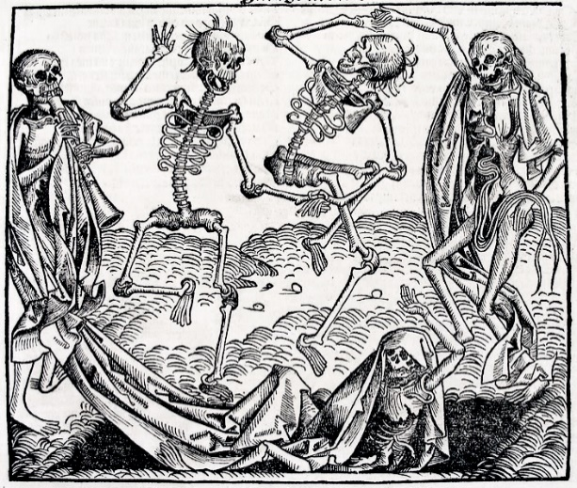

1. **What Did Medieval People Think Caused It?**

There were many theories about the cause of Black Death. These included: the stars and planets (astrology), miasmas and the poisoning of wells by Jews. A common theory was that it had been sent by God to punish people for their sins.

1. **What Impact Did The Black Death Have? (Food Shortages)**

Towns and cities faced food shortages as villages could not provide them with food. Food prices rose (inflation) causing poverty and starvation. Some farms changed to sheep farming which required fewer workers as many peasants died due to the epidemics.

1. **How Did People Try To Treat It?**

People tried anything to try to escape the effects of the Black Death including:

1. Drinking mercury.
2. Shaving a chicken and strapping to the buboes.
3. Eating crushed emeralds.
4. Running away to other villages.
5. Avoiding contact with other people.
6. Quarantine infected places.
7. **Why Did It Spread So Quickly?**

The Black Death spread quickly due to several reasons for example:

1. People lived close together.
2. People did not understand the link between fleas and the disease.
3. People who handled dead bodies did not protect themselves.
4. Poor public health in towns allowed rats and fleas to thrive.
5. **What Really Caused Black Death?**

The Black Death is believed to have been caused by the bacteria *Yersinia pestis.* This bacteria is known to have thrived in the stomachs of fleas. These fleas then bit rats, transferring the disease to them ultimately killing them. After the rats had died, the fleas moved on to humans. People in Britain generally had poor diets (caused by frequent food shortages) meaning they had low immunity.

**Part Two – The Beginnings of Change**

1. **The Renaissance**

* The Renaissance was a period which lasted from approximately 1400AD to 1750AD.
* It began in Italy where wealthy traders and businessmen paid scholars to study the ancient world and translate their texts. It was given the name the Renaissance as it means rebirth in Italian.
* As the scholars studied the ancient ideas in more detail they began to question their accuracy. This led to people beginning to experiment with new ideas. For centuries people accepted that the Church had the answers but now people wanted to use more scientific techniques to discover the answers for themselves.
* Books initially were very expensive. However, in 1451AD the printing press was invented. This allowed books to be copied more quickly, spreading ideas across the globe.
* There were developments in many areas for example:
  1. New scientific experiments. These were based on setting hypotheses and testing them with experiments.
  2. Traders exploring new areas of the world due to improvements in navigation and mapping. This allowed the discovery of the Americas in the late 1400s.
  3. New inventions were developed such as gunpowder.
  4. Doctors were encouraged to look for natural causes of illness rather than God. Gunpowder also meant that doctors had to find new ways to treat new wounds.
  5. Artists began to paint more lifelike images than ever before.

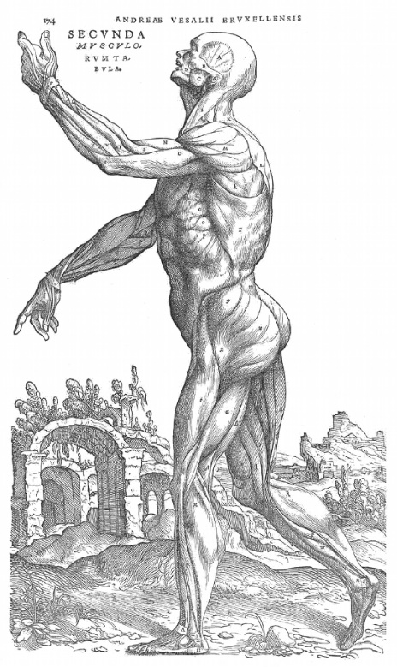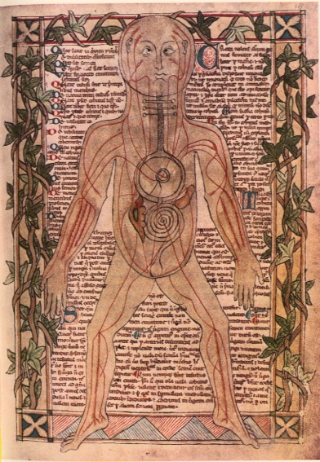

Medieval image of the human body.

Renaissance image of the human body.

1. **The Work of Andreas Vesalius**

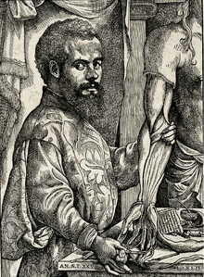

|  |  |  |
| --- | --- | --- |
|  | **Who was Andreas Vesalius?** | Vesalius was born in 1514AD in Belgium. He went to Paris where he got the chance to study Galen. He then went on to become Professor of Surgery at the University of Padua, Italy. There he carried out many dissections on human bodies. |
| **Why was he Significant?** | Whilst dissecting many bodies he began to realise that Galen had made many mistakes. Due to the Church, these mistakes had been believed for nearly 1500 years. Vesalius soon realised that Galen’s errors had mainly been due to Galen dissecting animals rather than human bodies. This led Vesalius to prove that the human body had a breastbone made of three pieces, not seven like an ape. He also disproved Galen’s view that blood flowed through |
| Related image |  | tiny holes in the septum of the heart. Dissecting the heart meant that Vesalius simply showed these did not exist. Furthermore, he also found errors with Galen’s idea about the female womb. This was because Galen used a dog to dissect.  All of these ideas were illustrated accurately by Renaissance artists in his book *‘The Fabric of the Human Body*’ (1543). |
| **What was his Contribution to Medical Progress in England?** | Within two years, a printer called Thomas Geminus published *Compendiosa* which included copies of all of Vesalius’ illustrations. This was very popular and three editions were published. Importantly, this meant that Vesalius’ work came to Britain as Germinus’ book reached England, used by barber-surgeons as a manual. In the later 16th century, copies of the original book came to England. |

1. **The Work of Ambroise Paré**

It was widely believed by surgeons in the 16th century that gunshot wounds were poisonous.

In 1536 he became an army surgeon and spent his years treating sword and gunshot wounds.

Paré was born in 1510. He was apprenticed to his brother who was a barber surgeon who worked in the famous Parisian hospital, the Hotel Dieu.

This boiling oil was agonising for the patient, and often led to death through surgical shock.

In order to treat these poisonous gunshot wounds, surgeons believed that they had to be burned out using boiling hot oil.

However, Paré ran out of hot oil in 1537 and had to improvise.

Paré soon challenged other surgical methods……

He created his own mixture to put on the wounds. It was made of egg yolks, oil of roses and turpentine.

The wounds that Paré had treated with the new mixture healed quickly.

Traditionally, bleeding had been stopped by using a cautery (red hot iron) and melting the blood vessels.

Paré revived an old method, tying ligatures around blood vessels. This successfully stopped bleeding.

This method again was incredibly painful and could lead to shock, killing people.

* Paré’s mixture was incredibly successful and saved lives instantly on the battlefield.
* However, whilst ligatures were clearly useful to tie up blood vessels many surgeons chose not to use them. This was because they were not sterilised (as there were no antiseptics), leading to infection.
* Surgeons also disliked ligatures because they slowed surgery down. Speed was crucial in battle surgery so many surgeons ignored ligatures to continue to use cauterising.
* In England, Paré’s book *‘Works on Surgery’* was widely read. The content even included parts of Vesalius’ writings which he translated from Latin into French. A copy was given to the library of Barber-Surgeons in London in 1591. Several famous surgeons followed Paré’s methods. This included William Clowes (surgeon to Elizabeth I) who admired Paré as a master of surgery. Through his work, Clowes agreed with Paré that gunshot wounds were not poisonous.

1. **The Work of William Harvey**

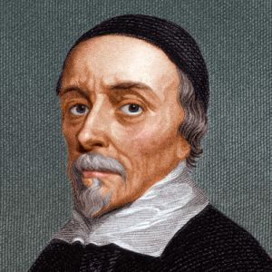

**Background of William Harvey**

William Harvey was born in 1578 in England. He studied medicine firstly at Cambridge then Padua, Italy. His first job was at St. Bartholomew’s Hospital in London in 1609. He continued to demonstrate and develop his skills, eventually becoming doctor to King Charles I in 1632.

**The Old Theories About Blood Circulation**

Galen said that blood was constantly made by the liver and used up throughout the body as a fuel. He also said that blood travelled through invisible holes in the

septum. This idea had been challenged by Ibn Nafis as well as Vesalius but people continued to ignore their views, instead continuing to believe Galen. There were other theories about the blood. For example Realdo Columbo said that blood flowed along veins and arteries. Furthermore, Fabricus also proved that there were valves in the veins.

**Harvey’s Methods and Discoveries**

Harvey carried out many experiments. These included dissections on cold-blooded reptiles (because he could observe their slow-beating hearts) which showed how the muscles worked. He also pumped liquid and pushed rods down veins and arteries to show that blood could only circulate the body in one direction. He also methodically observed and experimented on human hearts. He was able to calculate how much blood was pumped around the body. In 1628 he published his book *‘De Motu Cordis’* (On the Motion of the Heart), which contained his findings.

**Harvey’s Limitations**

Harvey was unable to explain why blood circulated (only how). He also could not say why blood in arteries was red and blood in veins was blue. Furthermore, he could not fully explain how blood moved from the arteries to the veins. He did predict that capillaries would exist but he did not have a powerful enough microscope to prove he was right.

**Reactions to Harvey’s Discovery**

Many people refused to believe his ideas or simply ignored them. Many of these chose to continue to believe Galen over Harvey. In 1636, Professor Caspar Hofmann watched Harvey demonstrating then declared his calculations about the amount of blood in the body as a trick. In total it took around 50 years for the University of Paris to teach Harvey’s theory to their medical students.

Some doctors ignored his findings as they believed they were not useful. Indeed it was just a theory which did not save lives. However, there were also plenty of doctors who accepted his theory whilst Harvey was still living. Although these people attempted blood transfusions these were typically unsuccessful as people did not know about blood groups. Blood tests also needed further scientific developments.

1. **New Renaissance Treatments**

* During the Renaissance some of the treatments became more scientific.
* However, many treatments were still based on the old, unscientific and supernatural ideas such as the Four Humours. These ideas were even used to treat the richest people including the king at the time Charles II.

**Treating Charles II**

In 1685 Charles II’s health took a massive turn for the worse. His own doctor, Sir Charles Scarburgh, described that the king collapsed with a disturbance in his brain.

Over the next few days he was treated using 58 drugs. He was also purged, bled, deliberately blistered and cauterised. None of these treatments helped the king who today is believed to have been suffering from a kidney disease (possibly brought on by mercury used to ‘cure’ syphilis.

This example clearly shows that despite the new Renaissance discoveries many old ideas were used as many of Charles II’s treatments were based on the Four Humours.

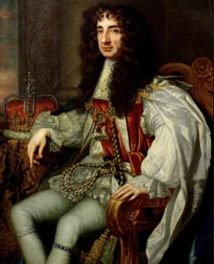

* For ordinary people, doctors and trained physicians were still too expensive. Therefore, they had to rely on a choice of other healers such as:
  1. Barber surgeons: They would cut hair and perform simple surgery such as teeth pulling or bloodletting.
  2. Apothecaries: These sold medicines and potions based on little or no medical training.
  3. Wise women: They often had knowledge of natural treatments using plants and herbs. However, many of their techniques relied on superstition or supernatural ideas.
  4. Quack doctors: These were travelling salesmen, who often claimed to have medicinal knowledge and formal training. They would sell all sorts of medicines and ‘cure-alls’ many of which were useless.
* Ordinary people also continued to believe that a touch from the king could cure scrofula (called the king’s evil). Many other people relied on the woman at home for handed-down cures such as honey and willow tree (which contains aspirin which dulls pain).
* However, for some ordinary people they began to access books on herbal remedies. This included Nicholas Culpepper’s *The complete herbal* (1653). This promoted a huge range of different herbal treatments as well as astrology. Culpepper’s work also criticised bloodletting and purging.
* Exploration also enabled the discovery of new natural remedies. For example, Cinchona tree from South America was used to help treat malaria and opium was brought from Turkey as it was shown to be useful as an anaesthetic. Furthermore, tobacco was brought from North America as it was widely believed to cure conditions like toothache and plague.

1. **The Great Plague**

* The Great Plague hit Britain in 1665. It was the same disease as the Black Death that had affected Britain in 1348. It was again caused by fleas and rats (but people did not realise this).
* The outbreak killed 100,000 people in London alone (about 25% of the population).

|  |  |
| --- | --- |
| **What People Thought Caused The Great Plague** | **How People Tried To Treat The Plague** |
| * Sent as a punishment by God for their sins. * The movement of the planets. * Miasmas or poisonous air. * Poisons in soils. | * Bloodletting and using leeches. * Sniffing flower (posies) or sponges in vinegar. * Using animals like snakes and scorpions to ‘draw out’ the poison. * Praying and apologising to God and using charms. * Herbal medicines. * Burning sweet-smelling herbs. * Quarantining and isolating people. |

* Some people began to make a link between dirty conditions and the disease. For example, some people studied the Bills of Mortality and recognised that most deaths occurred in the filthiest, poorest places of London.
* Compared to the 14th century and the Black Death, there was arguably a more organised approach to dealing with the Plague for example:
  + 1. They identified people with the illness and noted symptoms.
    2. People were then locked in their houses (quarantined) where watchmen were placed to stand guard.
    3. The door of the house was painted with a red cross along with the words ‘Lord have mercy on us’.
    4. The bodies were then taken out of the city in carts and buried in a mass pit.
    5. Homeowner were ordered to sweep the streets.
    6. Animals such as pigs, dogs and cats were banned from the streets.
    7. Activities which would bring people together were banned (such as plays)
    8. Trade between towns where the infection had affected people was banned.
    9. The border with Scotland was closed.
* The Great Plague declined and ended, not because of the Great Fire of London, but because rats developed greater resistance to the disease. This meant that fleas no longer had to find a human host as the rat population increased.

1. **Renaissance Hospitals**

Henry VIII closed down the monasteries (called the dissolution of the monasteries) as he began his search for a son. This meant that monastery hospitals that had existed during the Medieval period also closed.

Other Renaissance hospitals were founded because people increasingly believed that hospitals should be using modern cures.

To replace some of these monastery hospitals, the king gave money to start new ones. These included St Bartholomew’s and St Thomas’ in London.

These new Renaissance hospitals were founded by rich people who provided charitable gifts.

[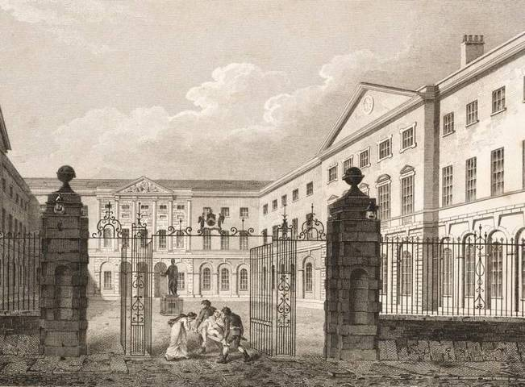](http://www.google.co.uk/url?sa=i&rct=j&q=&esrc=s&source=images&cd=&cad=rja&uact=8&ved=0ahUKEwiC0YzZ2rnZAhUBXRQKHb2KBToQjRwIBw&url=http://www.1902encyclopedia.com/H/HOS/hospital.html&psig=AOvVaw11jTAN6K_WUHLuZkEmpcEN&ust=1519395287107980)

For example, Westminster Hospital was founded in 1719 by a private bank. Also, Guy’s hospital, in the image, was founded by wealthy merchant Thomas Guy in 1724.

Some Renaissance hospitals were built by private subscription. This meant that local people ‘clubbed together’ to pay for the hospital construction.

By 1800 London’s hospitals were handling over 20,000 patients a year. This clearly was a huge increase from the Medieval period.

Renaissance hospitals began to focus far less on religious ‘cures’ such as praying. The idea of sin being a cause of illness was also less common.

The new hospitals also provided training for doctors and medical schools were typically attached to the hospital complex.

The 18th century also saw the development of specialist hospitals. For example, St Luke’s Hospital was for the mentally ill. London’s Lock Hospital was for venereal diseases (sexually transmitted). Furthermore, there were wards in Middlesex Hospital for pregnant women. Finally, in 1741, Thomas Coram, started the Foundling Hospital for sick or orphaned children found on the street.

Doctors were also all able to gain an official post at the hospitals. Poorer people were treated for free, however fees were paid by wealthy, private patients.

Treatments were still based on the four humours such as bleeding and purging.

1. **The Work of John Hunter**

|  |  |  |
| --- | --- | --- |
| **Biography** | Hunter worked for his brother John as well as two famous surgeons of the era William Cheselden and Percivall Potts. He became an army surgeon in 1760. In 1763 he left the army and set up his own surgical practice in London. In 1768 he became a surgeon at St George’s Hospital. His expertise meant that he was appointed surgeon to King George III in 1776. He was then elevated to Surgeon-General to the army in 1790. He earned lots of money but spent it all on research and his specimen collection. He died in 1793. | Image result for john hunter |
| **Books** | He wrote a wide range of books. These included *The Natural History of the Teeth (1771)* which was based upon dentistry he learned. Famously, he published *On Venereal Disease (1786)* which was largely based on an experiment he carried out on himself. Thirdly he wrote *Blood inflammation and gunshot wounds* based on his army experience. It argued that gunshot wounds should be cut out and were not poisonous. |
| **Teaching** | He was allowed in the Company of Surgeons in 1768. Following this he set up a large practice to train hundreds of surgeons in his scientific approach. Many of these went on to be very successful for example Edward Jenner. | Image result for john hunter specimen collection |
| **Scientific Method** | He encouraged observation and careful scientific methods. For example, in 1767 he experimented on himself. He injected himself with the pus from the sores of a gonorrhoea patient. However, the patient he chose also had syphilis. It took him three years to recover using mercury This however disproved the theory that gonorrhoea and syphilis were the same disease and couldn’t exist in the same patient. In 1785 he treated a man in St George’s Hospital with an aneurysm (throbbing lump) in his knee. The typical treatment was amputation. Instead, Hunter cut into the man’s leg and tied off the artery above the knee to restrict the blood flow, diverting it elsewhere. 6 weeks later the man walked out of hospital, his leg had been saved. |
| **Specimens** | Hunter collected a huge number of anatomical specimens. In total he had around 3,000 stuffed or dried animals, plants, fossils, diseased organs, embryos and body parts. A famous item was the body of Irish giant, Charles Byrne, which measured 2.3 metres tall. He acquired this in 1783. |
| **Significance** | He showed the importance of anatomical and theoretical knowledge and revolutionised the scientific approach to research. He recognised that each surgeon needed these in order to be successful. He stressed the importance of dissection, observation and willingness to experiment. His dissections allowed him to make discoveries about: disease, infections, cancer and the circulation of the blood. His books were translated into several European languages and were widely read. | Image result for john hunter specimen collection |

1. **The Work of Edward Jenner**

* Smallpox was one of the greatest killers in the 18th century. It was highly infectious and caused a fever, headaches and a rash followed by pus-filled blisters all over the body. This could cause permanent scarring and blindness even if you survived. In total it is estimated to have resulted in the deaths of 30% of people who caught it.
* At the start of the 18th century, the most popular treatment in parts of China and Asia was inoculation. This involved scratching pus from smallpox victims into the skin of healthy people. This would cause them to ‘hopefully’ develop a mild form of the disease which allowed them to become immune (build up resistance to) the disease.
* By 1721 smallpox inoculation became fashionable in Britain. An aristocrat, Lady Mary Wortley Montague had her children inoculated after watching it happen in Turkey.
* However, inoculation was very controversial:
  1. Doctors seemed more interested in making huge profits from charging for inoculations rather than caring for the patient. This also meant that only the rich could afford inoculations.
  2. There was still a religious objection. Inoculation was seen as a challenge to Gods power who had sent illness to punish and test people.
  3. Germ theory was not yet published. This made it hard for people to accept that a small dose of smallpox could protect you and reduce the risk of death.
  4. Sometimes inoculation was done incorrectly. The wrong dose was given which meant that the person would die or not be protected from smallpox.
  5. Inoculation meant that more people were infectious and meant that the disease spread.

1. Jenner was the apprentice to a country surgeon between the age of 13 and 19.
2. He then went to London to study under John Hunter.
3. In 1772 he returned to Gloucestershire. Here he hears stories that milkmaids who catch cowpox (similar to smallpox but milder which affects cows) were protected against smallpox.
4. 1796 was the year of his most famous experiment. He injected 8 year old, James Phipps, with cowpox. 6 weeks later he gave him smallpox. No disease followed, the procedure had worked. He called it vaccination (after the Latin for cow (*vacca*)). He tested his idea 16 times over several weeks, none of them caught smallpox, proving that his vaccination worked.
5. In 1798 he published a book on vaccination.
6. In 1802 he was given £10,000 to open a vaccination clinic.
7. He was appointed physician to King George IV in 1821.

**Edward Jenner**

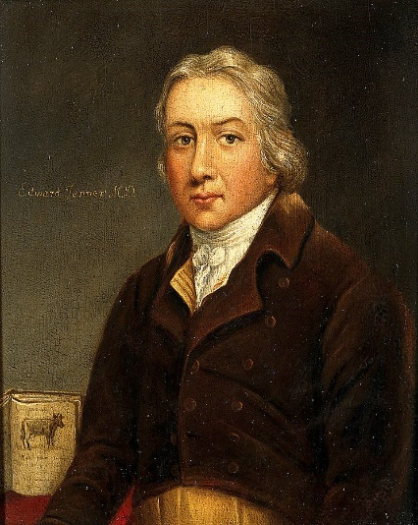

* Not everyone accepted Jenner’s vaccination immediately. This was because:
  1. He could not explain how it worked (germ theory was not published).
  2. Doctors did not like vaccination because they made great profits from inoculation so chose to ignore or oppose Jenner’s idea as it would cost them money.
  3. Some doctors (e.g. William Woodville and George Pearson) attempted to use Jenner’s method and ideas. However, their equipment was contaminated so their patients died. This led to them concluding that Jenner was wrong.
  4. Jenner was viewed by people as only a country doctor and not a fashionable city doctor so there was snobbery against him and his idea.
* However, gradually people began to change. Jenner did have powerful supporters who promoted his ideas. This increased when members of the royal family were vaccinated. This encouraged people to get their own family vaccinated. By the 1800s doctors were using his technique in America and Europe. Finally by 1853, the British government made smallpox vaccination compulsory. This led to the eventual eradication of the disease.

**Part Three – A Revolution in Medicine**

1. **The Development of Anaesthetics and the Work of James Simpson**

* Surgery in the 1800s was unsuccessful for three main reasons. These were, pain (shock), infection and bleeding. Surgery was so dangerous that it frequently led to death.
* Pain relief had been used in the Medieval period. Natural pain-relieving substances such as mandrake and opium were used to dull the pain but it was difficult to judge the correct dose.
* Alcohol was also used but it made the heart beat faster and made the bleeding more difficult to control. Therefore, many doctors discouraged this.
* Therefore, to increase the success rate of surgery, doctors tried to complete operations as quickly as possible. Robert Liston, a British surgeon, was known for holding a record for the quickest amputation.
* Throughout the 19th century, doctors and scientists tried to search for effective pain relief:

|  |  |
| --- | --- |
| **Anaesthetic** | **Description** |
| 1. **Nitrous Oxide** | In 1795, Humphry Davy experimented with laughing gas (nitrous oxide). He published an account in 1799 that it made him feel giddy and relaxed. It was used in 1844 to remove teeth by American dentist Horace Wells. However, it failed to catch on and convince doctors. |
| 1. **Ether** | In 1842 Ether was used in a tooth extraction by US dentist William Clark. It was then used by Robert Liston in 1846 to amputate a leg. This was successful and meant that the first effective anaesthetic had arrived in Britain. However, it had its drawbacks. It was difficult to inhale, caused vomiting and was highly flammable (and could be explosive). Many doctors also disliked Ether because it slowed surgery down, when they still thought speed was important. |
| 1. **Chloroform** | In 1847 Scottish doctor, James Simpson discovered chloroform. Simpson had been testing a number of different substances when he discovered chloroform, waking up after passing out. Although it obviously was effective, chloroform still faced opposition. For example, some army surgeons felt that soldiers should dutifully put up with the pain. Also some doctors disliked it because women uttered coarse language. Hannah Greener also died in 1848 during an operation on her toenail using chloroform. Furthermore, religious people objected to chloroform as they felt that God had provided pain as a punishment for sin and should not be removed. However, these objections were largely overcome when Queen Victoria used chloroform to give birth to Prince Leopold in 1853 and spoke openly about the positive effect it had on labour. |

1. **Louis Pasteur and the Discovery of Germ Theory**

**Louis Pasteur**

* Pasteur was a French chemist and biologist.
* In 1861 he famously published Germ Theory. This made it clear that microorganisms and bacteria caused disease.
* Later on in his career he went on to use his discovery of germs to develop other vaccines as well as the process of pasteurisation (killing bacteria in liquids like milk).

[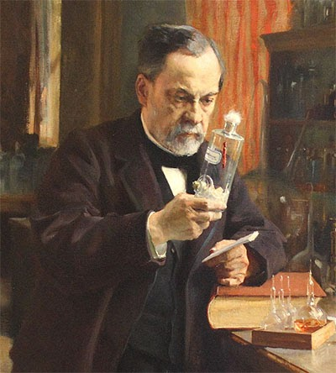](http://www.google.co.uk/url?sa=i&rct=j&q=&esrc=s&source=images&cd=&cad=rja&uact=8&ved=2ahUKEwj_luuwp8jZAhWBVxQKHWx2CCIQjRx6BAgAEAY&url=http://wielkiewynalazki.blogspot.com/2017/05/ludwik-pasteur.html&psig=AOvVaw1cFGVfcvYYygAFw_2fb3jE&ust=1519896914096134)

* The first microscope was invented in 1677. This was powerful enough to enable scientists to see microorganisms in liquids. However, no link was made between these microbes and disease.
* Consequently by the eighteenth century, scientists had many theories about how disease was caused. Probably the most popular theory was the idea of spontaneous generation. This was the idea that microbes appeared by magic when something rotting (thus the idea that disease caused microbes to appear. People also believed that microbes were pretty much all identical.

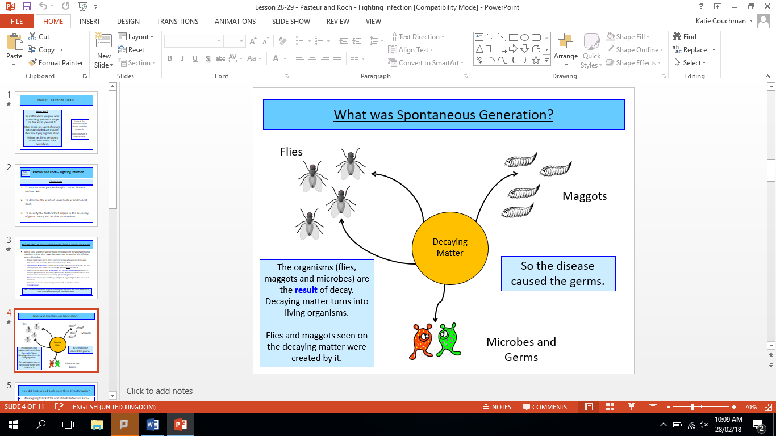

* In the nineteenth century people began to question these ideas. In 1840, Friedrich Henie a Swiss Professor was the first person to challenge spontaneous generation and instead suggest that microbes were the cause of disease. This was ignored at the time.
* Instead, people continued to have different views about disease. Miasmas were still incredibly popular, however, people also said that contact between people (contagionist theory) or the environment (anti-contagionist theory) were to blame.
* However, between 1857 and 1860 Louis Pasteur conducted a series of experiments to show why wine and beer went sour. He was also able to show that gently heating the liquid (pasteurisation) could kill all the microbes. His research also proved that germs did not magically appear. Instead he demonstrated that the microbes were the cause of the disease. In 1861 he published this idea which became known as Germ Theory.

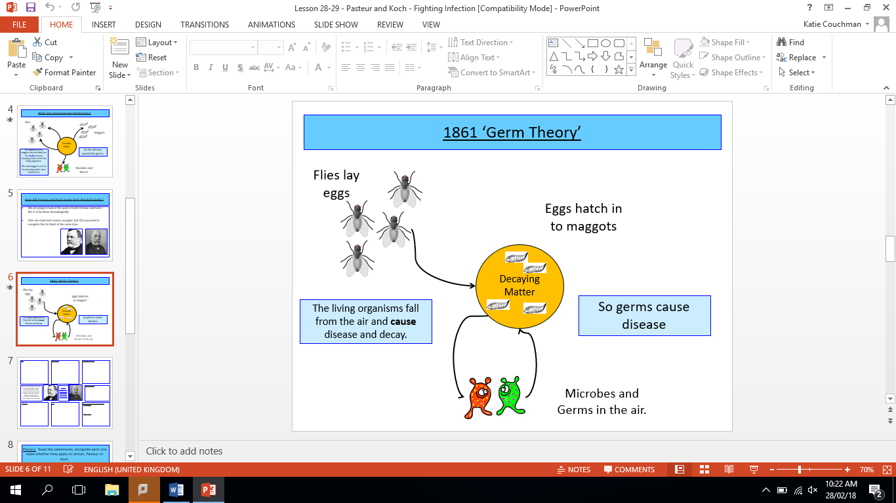

1. **The Work of Joseph Lister**
2. However much opposition came because carbolic acid was unpleasant. It irritated and cracked surgeon’s hands and could irritate lungs. Furthermore, it slowed surgery down when speed in surgery was still seen as important.
3. Lister was clearly a great thinker. However, people found him very cold and aloof. Other doctors refused to change simply because they did not like Lister and preferred their own methods instead.
4. Lister was a Professor of Surgery who was particularly concerned that operations often became infectious, killing the patient. He realised that keeping the wound clean meant that infection would not occur.
5. However, people opposed Lister’s ideas. For example at this time many people still did not accept Pasteur’s Germ theory. This meant they could not accept Lister’s antiseptic.
6. Lister was given a chance to read Pasteur’s Germ Theory and soon became convinced that this explained the problems of infection he encountered.

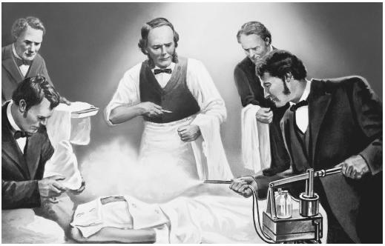

1. Lister also sterilised ligatures used to tie up blood vessels. This revolutionised Paré’s discovery (see pages 9 and 10).
2. He soon discovered a chemical (carbolic acid) which could kill bacteria.
3. Lister then began to test and experiment with his new antiseptic approach. He devised a new carbolic spray (diluted) which could be used to coat: the surgeon’s hands, the wound and the surgical instruments. He also continued to soak the bandages before they were used to wrap the wound.
4. In fact, Lister discovered that the irritation was caused by the strength of the carbolic acid. He then replaced the bandages with fresh ones soaked with carbolic. Six weeks later, Jamie walked out of hospital completely infection free.
5. In 1865 Lister decided to experiment. He set the broken leg bone of a young boy (Jamie Greenlees) and wrapped his leg with dressings which had been soaked in carbolic acid. These were used for four days before Jamie complained of irritation. Taking off the bandages he found that the wound was healing.

* In Britain, Lister’s work was important because it publicised and championed Pasteur’s Germ Theory. Lister gave several lectures about his antiseptic technique, making it clear that infection was caused by microbes in the air causing the disease. This was published in his work in 1867.
* This added weight to the argument that spontaneous generation was incorrect. Although today we know Lister to be correct, at the time people in Britain criticised him, preferring their own theory about the cause of disease.
* For example, influential writer, Charlton Bastian continued to strongly support the idea of spontaneous generation in the late 1860s and early 1870s, arguing against Lister’s discovery.
* Similarly in 1868, Professor John Bennett argued that as cells died they spontaneously generated infection.

1. **Why Germ Theory Was Accepted in Britain**

* In the 1860s, many people still refused to accept Pasteur’s Germ Theory as the main cause of disease. By the 1890s the majority of people accepted it. Surgery was further transformed. Instead of covering the entire operating theatre with carbolic acid to kill microbes (antiseptic surgery) techniques were developed to exclude microbes from the start (aseptic surgery).
* Aseptic surgery meant that surgeons had to wear sterile gowns and gloves and use clean instruments. The first use of rubber gloves was by Berkeley Moynihan in the 1890s.
* This change of surgery and acceptance of Germ theory was down to several reasons:
  1. Cattle Plague of 1866: Initially this plague was blamed on spontaneous generation. Farmers were reluctant to kill cattle so it spread quickly initially. However, it soon became clear that the slaughtering and quarantining of cattle was necessary which led to food shortages and rising prices. In June 1866, Professor Lionel Beale investigated the plague. He found that a ‘minute microbe’ was the cause of the contagious outbreak and also demonstrated the importance of the microscope in research. This supported Pasteur’s theory about disease.
  2. John Tyndall: Despite Beale’s finding, the main theory was spontaneous generation, argued strongly by Charlton Bastian who was very influential. However, in 1870 John Tyndall publicly defended Germ Theory, arguing against Bastian. He also did demonstrations which showed microbes clearly in the air.
  3. Typhoid Fever: Typhoid fever was an infectious and common disease in Britain throughout the 19th century. However, in 1861 Prince Albert the husband of Queen Victoria died of typhoid. Importantly, Emanuel Klein announced in 1874 that he had identified the bacteria responsible for typhoid. He was mistaken but within a couple of years Robert Koch and others proved that Germ Theory could explain human diseases.

1. **The Work of Louis Pasteur and Robert Koch in Developing Vaccinations**

* Pasteur published Germ Theory in 1861. However, he had been unable at the time to use his theory to cure a human disease, he was a chemist, not a doctor. When he looked at samples of microorganisms he could not even identify which one was causing the disease.
* It took the work of another important individual, Robert Koch, to help link Germ Theory to humans.

**Robert Koch**

* Robert Koch was born in Germany and studied to become a doctor.
* He worked in the Franco-Prussian War from 1872 to 1880.
* His key discoveries include:
  1. Identifying specific microbes.
  2. Growing cultures for experiments using a plate of solidified agar (this is a seaweed extracts which encourages bacteria to grow).
  3. Staining bacteria using dyes to make them stand out amongst the other bacteria in the sample.
  4. Photographing bacteria to record their features so that other scientists could use them in their research.

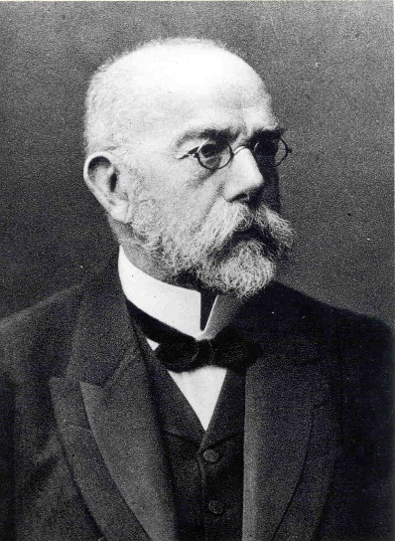

* In 1876, Robert Koch managed to identify, stain and grow the bacteria that was specifically responsible for causing anthrax in sheep. He proved his theory by injecting mice which then contracted the disease. He was then able to use Germ Theory to apply it to human diseases.
* Later on, Koch was also able to identify the specific bacteria responsible for cholera and tuberculosis, both of which were deadly diseases affecting humans.
* In order to make his ground-breaking discoveries, Koch had a huge research team. Using Koch’s methods a wide variety of different bacteria were identified in the late 19th century.
* In 1876, Germ Theory supporter, John Tyndall lectured to a number of British doctors about the work of both Pasteur and Koch.
* Soon after, Manchester doctor William Roberts used the work of Robert Koch to draw more attention to the idea that germs caused disease in humans, supporting Germ Theory.
* Furthermore, in 1879, William Cheyne (Joseph Lister’s deputy surgeon) translated Koch’s work from German into English and wrote a paper about Koch’s findings. This was one of the final nails in the coffin for the idea of spontaneous generation.
* However, between 1880 and 1900, a number of new developments took place following the early work of Pasteur and Koch. This included a number of different vaccinations (for anthrax, chicken cholera and rabies). These developments were due to a number of factors:

**Communication**

Pasteur’s development of a vaccination against anthrax was demonstrated in front of politicians in 1881. News of this amazing discovery was sent around Europe by electric telegraph. Koch’s work was spread in scientific articles and at conferences.

**Luck**

In 1879 Pasteur was investigating chicken cholera. One of Pasteur’s assistants, Charles Chamberland, used old and weakened germs by mistake. This was shown to have provided immunity to the chickens, when they were injected with full-strength germs they survived. This by luck led to a second vaccination.

**War**

Pasteur and Koch were rivals. This was because Pasteur was French and Koch was German. In 1871 France had lost the Franco-Prussian war against Germany. This pushed the French to support Pasteur to restore pride to their country. Also medical research was important because it could help save men on the battlefield.

**The Development of Vaccines by Pasteur and Koch between 1880 and 1900.**

**Individual Brilliance**

Pasteur and Koch were both brilliant scientists. Pasteur managed to discover and develop Germ Theory and developed vaccines for anthrax, chicken cholera and rabies. Koch managed to identify anthrax followed by other bacteria such as TB and cholera.

**Government and Finance**

Both Pasteur and Koch were funded by their governments to purchase a laboratory and pay a team of scientists. This enabled them to complete large amounts of research to help develop cures for humans.

**Teamwork**

Teamwork was used in all of the vaccinations. Pasteur’s work with Charles Chamberland led to the development of chicken cholera as well as rabies (in 1880-1884). Koch also worked closely with Emil Behring to show that weakened diphtheria could produce an antitoxin against the disease.

1. **Public Health in the Early 19th Century**

* Public health in the 1800s was very poor. The average life expectancy for a working-class man was 30 although in some polluted, industrial towns it could be as low as 15.
* Infant mortality was also incredibly high, as many as 1 in every 5 children in Manchester died before the age of 1.
* Arguably, people’s public health was even worse than it had been in previous centuries.
* Rapid industrialisation in the first 50 years of the 1800s resulted in a huge decline in people’s health. People flocked to industrial cities to find a job working in a factory manufacturing goods such as cloth, pottery or iron. These factories burnt huge amounts of fossil fuels like coal producing a polluting smog that often made the sky appear black.
* In these new industrial areas such as Sheffield, back-to-back houses were thrown up quickly to produce cheap accommodation close to the places of work. Essentially, many of these were no better than slums, with typically five or more people living in one room. In 1847, 40 people were found living together in a back-to-back in Liverpool.
* The back-to-backs had very basic facilities. Very few of them had a toilet. Instead a bucket would be used and the waste chucked on to the street. Water was typically collected from a local river or pond.
* The local river would be used for dumping sewage, washing, bathing and drinking from.
* Consequently, diseases like typhoid, TB and cholera were common. However, nobody knew the causes of these diseases.
* Local governments were concerned about the outbreaks of disease but did not know how to deal with them. They were also not prepared to spend tax money to fund improvements (laissez-faire attitude).

1. **Cholera, Chadwick, Snow and the First Public Health Act**

The most common theory about the cause of cholera was miasmas spread by dirt on the streets.

In 1831 cholera came to Britain for the first time. The outbreak killed over 50,000 people.

We know today that cholera is a waterborne disease spread through polluted water.

Some councils were concerned about the miasmas that they even began to clean the streets. However, they did still not understand the need for clean water.

The symptoms of cholera were horrific. Sufferers were violently sick, had painful diarrhoea, their skin and nails turned black and then they fell into a coma and died.



Following 1831 there were several other outbreaks of cholera killing many people. For example, 1837 and 1838 saw bad outbreaks of the disease.

So many people died that cemeteries were forced to close because they were too full. Even coffins could not be made fast enough for the dead.

Nobody at the time was able to explain how cholera was caused or how to cure it.

In 1839, the national government set up an inquiry into what the health of the poor was like across Britain.

This inquiry was spearheaded by a government official called

Edwin Chadwick.

|  |  |
| --- | --- |
| **Edwin Chadwick** | **John Snow** |
| Image result for edwin chadwick | Related image |
| * Edwin Chadwick was a civil servant and a lawyer who devoted his efforts towards health and social reforms. * He went out and studied the contrasts between rural areas (such as Rutland) and urban areas (such as Liverpool). | * John Snow was a famous surgeon who worked on Broad Street in Soho, London. * In 1854 another cholera epidemic hit London and on Broad Street, over 700 people died over a short period of ten days. |
| * What he found was that life expectancy was far lower and poverty was far higher in urban areas. * What was even more shocking was that Chadwick showed that life expectancy was worse in urban areas for all social classes, including the wealthiest (gentry). Over 10,000 copies of his 1842 report was handed out to politicians and journalists. 20,000 more were sold to the public. * However, Chadwick mistakenly blamed miasmas for the cause of disease (before Germ Theory). * Nevertheless, his report called for several improvements. These included: clean water supplies, better housing and a medical officer for health to look after every people in every district in Britain. * However, his ideas needed support from parliament to get them introduced. | * Snow carried out a survey of the area. This identified houses where people had died of cholera and where the people had got their water from. * He soon realised that the ones who had died got their water from the Broad Street pump. People who did not get cholera got their water from other sources (e.g. in the brewery people drunk beer not water). * With his evidence he realised that cholera was in the water and the handle of the Broad Street pump was removed. This meant there were no further deaths. * Further investigation found that a street toilet nearby had a cracked lining which meant that sewage was leaking into the water supply. * This meant that Snow proved that cholera was not caused by miasmas but was caused by polluted water. |

* Following Chadwick’s 1842 report the government did nothing. Many people did not want government interference in their private lives. This is known as a laissez-faire attitude (French meaning leave alone). People felt that the government’s role was to keep law and order and not public health.
* However, another cholera epidemic forced the government to act. They introduced the **First Public Health Act** in **1848**.
* This First Public Health Act gave local councils the power to spend money to clean up towns, but this was not compulsory.
* Consequently, many town councils did nothing. Only 103 towns set up their own Boards of Health and in 1854 the Central Board of Health was closed down. This meant that the First Public Health Act had failed.

1. **The Great Stink and the Second Public Health Act**

By 1858, London was a dirty and polluted city. The Thames was being used as the main dumping ground for any waste.

Consequently, London had become a breeding ground for disease like diphtheria, scrofula and cholera.

By 1854 the First Public Health Act had failed because people continued to protest against government interference.

The smell got so bad that the Houses of Parliament were affected. The politicians demanded to meet somewhere else.

But in 1858, extreme summer temperatures caused the smells in the River Thames to smell worse than other. It became known as the ‘Great Stink’.

However, the evidence from John Snow in 1854 combined with the smell meant that something had to be done to solve the issue.

They were finished in 1866. They were so successful that cholera never returned to London.

To solve the problem, they turned to Joseph Bazalgette. He was given £3 million in 1858 to construct a series of sewers under London.

In total he used 318 million bricks to build 83 miles of sewers removing 420 million gallons of sewage a day.

* In 1867, working-class men were given the vote and began to push for greater improvements to public health. Politicians obliged because they realised that they would get more votes. Working-class people getting the vote, essentially saw the end of laissez-faire and arguably is one of the most important reasons why public health was improved.
* In **1875** the **Second Public Health Act** was brought in. This was compulsory for all local town councils. It meant that public health finally began to improve. Open sewers were covered, fresh water was supplied and rubbish collections were begun. However, improvements took many years and much money.

**Part Four – Modern Medicine**

1. **Magic Bullets and The Discovery and Development of Penicillin**

Following Germ Theory in 1861, knowledge about disease increased greatly. Research into medicine was split into two different lines:

* 1. Prevention: The work of Pasteur and Koch demonstrated that using weakened forms of diseases like rabies and anthrax could give the body immunity to the disease and prevent people from contracting it. Scientists were working hard to create further vaccinations against other diseases.
  2. Cure: Robert Koch discovered that chemicals could ‘find’ specific bacteria in the body. His assistant, Paul Ehrlich worked hard to find a chemical that could ‘find’ and kill a specific type of bacteria. In 1909 he discovered ‘salvarsan 606’, a chemical which was an effective cure for syphilis. This was the first ‘magic bullet’. In 1932, Gerhard Domagk discovered ‘prontosil’ which was effective against blood poisoning. Scientists then worked hard to identify the active ingredient called a sulphonamide. This enabled more magic bullets to be discovered e.g. a cure for meningitis.

1. **Magic Bullets**

* In the 1920s staphylococcus was a particular concern. It could not be defeated by magic bullets. However, untreated it could cause a huge range of illnesses such as food and blood poisoning.
* In 1928, bacteriologist Alexander Fleming, was trying hard to develop a chemical to kill staphylococcus.
* He went away on holiday, leaving his plates of germs on a bench. When he returned he realised that a large amount of mould had grown in the petri dishes.
* Studying the plates further he soon realised that the staphylococcus next to the mould had been killed. He soon identified this as penicillin (which probably came from a research room below Fleming’s and travelled up the stairs).
* He published his findings in 1928. However, he failed to test penicillin by injecting it into an animal or a human.
* Therefore, he wrongly concluded that penicillin was an antiseptic instead of an antibiotic.
* Few people took note of his discovery and even Fleming lost interest in it. This meant that little was done until WWII.

1. **Discovery of Penicillin**

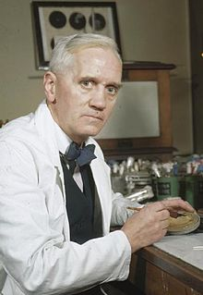

1. **Development of Penicillin**

* In the 1930s, Howard Florey and Ernst Chain got hold of Fleming’s research.
* They asked the British government for funding but were given only £25 because WWII had started.
* They managed to use the money to produce enough to test penicillin on 8 mice.
* Following the successful trial on the mice they then used; milk bottles, hospital bedpans and a bath to grow enough penicillin to test on one human.
* Once they had enough they tested it on policeman (Albert Alexander) who had a nasty infection. Penicillin was soon shown to be effective but he died after 5 days because they ran out.
* In 1941, Florey went to America. They recognised the potential of penicillin and paid US chemical companies to produce penicillin. By 1945 250,000 soldiers were being treated using the drug.
* It is believed that over 15% of wounded British and US soldiers would have died without penicillin.
* Following WWII, huge drug companies such as GlaxoSmithKline started mass-producing penicillin for public use. They also have worked hard to produce other antibiotics such as mitomycin (1956) which has been used as a chemotherapy drug for different cancers.

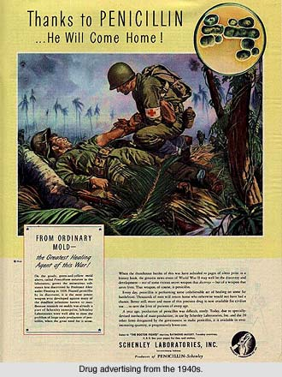

1. **Drugs and Treatments Since 1945**

* Since 1945, medicine has changed massively. There has been an explosion in scientific and medical discoveries meaning that life expectancy has continued to rise. Today it around 83 for women and 79 for men. More people than ever are living to 100. These developments can be split into three categories: body and disease, surgery and treatment.

|  |  |  |  |  |  |
| --- | --- | --- | --- | --- | --- |
| **Body and Disease** | | **Surgery** | | **Treatment** | |
| 1951 | A hormone is created which stops women ovulating. This leads to the first contraceptive pill. | 1950 | Canadian, William Bigelow, performs open-heart surgery to repair a hole in a baby’s heart. | 1954 | Vaccination for diphtheria, whooping cough and tetanus is available for free. |
| 1953 | Francis Crick and James Watson discover DNA. | 1958 | First pacemaker is fitted in Sweden to regulate the heart. | 1955 | Free vaccination for polio is made available in the UK. |
| 1973 | Geoff Hounsfield invents the CAT scanner to build up a 3D image of the body. | 1967 | South African doctor, Christian Barnard, performs the first heart transplant. | 1957 | Thalidomide is used for morning sickness but is soon shown to cause deformities in babies. |
| 1975 | Endoscopes are developed to see inside the body through tiny cuts. | 1984 | Skin grafts using laboratory-grown skin are successful. | 1969 | Free vaccination for rubella in the UK. |
| 1987 | MRI scanning is widely used to monitor the brain for tumours or stroke damage. | 1986 | Davina Thompson becomes the first person to have a heart, lung, and liver transplant. | 1970 | Cyclosporine is used to stop the rejection of transplanted organs from happening. |
| 1990 | The Human Genome Project begins. This aimed to research and decode all human genes. | 2007 | There is a large breakthrough in prosthetics as the Argus II prosthetic eye is released. | 1978 | IVF is used successfully when Louise Brown from the UK becomes the first ‘test tube baby’. |
| 2013 | The first human organ, a liver, is successfully grown using stem cells. | 2008 | Following a partial face transplant in 2006, a full-face transplant is carried out. | 2006 | First HPV (anti-cancer) vaccine is developed and begins to roll out free to school-age girls. |

* The health of people in Britain has improved greatly since 1945 for several reasons:
  1. War: WWI and WWII meant that governments had to spend money on research and testing to help treat wounded soldiers. Today other wars continue in the world meaning other improvements are likely.
  2. Governments and Finance: Today governments are spending more on health than ever before. For example, in the UK they have invested in a breast and cervical cancer screening programme to reduce deaths from these diseases.
  3. Communication: Increased media like TV and the internet have made people more aware of health risks e.g. the risks associated with alcohol and smoking.
  4. Individuals: Many people have made ground-breaking discoveries for example Crick and Watson have revolutionised medicine following their discovery of DNA.
  5. Attitudes: The government have had to introduce policies to help improve the health of the population. For example, the Healthy Eating Standards meant that food served in schools must include quality ingredients such as fresh meat, fruit and vegetables.
  6. Technology: New technologies such as MRI scanning have helped doctors more easily identify illnesses and treat them successfully. Further research on the human genetic code will lead to further understanding of genetic diseases and cancers.

1. **Antibiotic Resistance and Alternative Treatments**

* A big concern in the 21st century is antibiotic resistance. Antibiotics have proven effective against many diseases such as: polio, measles, mumps and whooping cough. However, some diseases such as MRSA cannot be killed used antibiotics. This is because the disease has evolved and become resistant to common antibiotics.
* This has led to the development of alternative treatments. These are alternative means of treating an illness that does not rely on mainstream medicine using proven scientific methods. People have begun to use these methods for a variety of reasons including:
  1. Lack of confidence in conventional doctors. Some scandals (such as Dr Harold Shipman who deliberately murdered his patients and stole their money) have also reduced public confidence.
  2. Better licencing of alternative treatments, some of which (e.g. acupuncture) is now available on the NHS.
  3. Greater availability of alternative treatments.
  4. More research carried out in to the effectiveness of alternative treatments.

**Homeopathy**

This involves a patient taking a natural remedy which causes similar symptoms to the illness they are suffering from. This is believed to stimulate the natural defence of the body and cure the patient. It is shown to be effective against hay fever, depression and eczema.

**Aromatherapy**

This involves the use of essential oils from plants. These can be inhaled or massaged into the skin. These are believed to stimulate part of the brain and promote healing. Massaged oils are believed to improve mental function and nervous system function.

**What Alternative Treatments are Available?**

**Acupuncture**

This is a Chinese technique which involves the use of fine needles placed at key points around the body. The needles are believed to release blocked energy and restore balance. It has been shown to be effective for healing and has even been used as an anaesthetic during surgery.

**Hypnotherapy**

This involves a trained therapist hypnotising a patient. It is based upon the idea of positive thinking (that the patient’s own mind can cause healing). When totally relaxed the technique has been shown to help with stress, allergies and physical addictions like smoking.

1. **The Impact of WWI and WWII on Medicine**

|  |  |  |
| --- | --- | --- |
| **Helped or Hindered** | **The Impact of WWI** | **The Impact of WWII** |
| Hindered Medicine | * Thousands of doctors were taken away from their ‘normal work’ to go to the frontline. This meant that medicine for ordinary people at home saw few improvements. * Research also stopped because countries wanted to focus on the war effort. * Libraries and places of learning were destroyed meaning information was lost. | * Similar to WWI, WWII saw many doctors taken away from their practices to fight or save lives on the frontline. This led to many of them being killed but also the health of ordinary people suffered. * WWII involved far more airstrikes than WWI. Consequently, many more libraries, research centres and hospitals were destroyed meaning research slowed and information was lost. |
| Helped Medicine | * WWI saw over 10 million deaths. This gave doctors and surgeons the chance to practice their techniques and develop new ideas. * Shell shock started to be recognised officially as a mental health condition towards the end of WWI. Today it is known as PTSD. * Blood transfusions improved because in 1900 Kar Landsteiner discovered blood groups and in 1914 Albert Hustin discovered that glucose and sodium citrate stopped blood from clotting. This meant that transfusions were more successful. * X-rays were discovered in 1895 by Wilhelm Röntgen. The war demonstrated how important these could be as they allowed doctors to locate bullets or shrapnel inside a wounded soldier. * Plastic surgery improved thanks to the hard work of army doctor Harold Gillies. He set up Queen’s Hospital in Kent in 1917 to help treat solders with facial wounds using skin grafts. By 1921, Gillies and his team had treated over 5000 servicemen. This led to the development of plastic surgery. | * WWII saw over 20 million deaths. This gave doctors and surgeons the chance to practice their techniques and develop new ideas. * Blood transfusions developed further. The British National Blood Transfusion Service opened in 1938 which led to the creation of large blood banks saving many lives. * Archibald McIndoe used new drugs such as penicillin to prevent infections caused by plastic surgery. This improved the reconstructions that could be carried out further. * Heart surgery improved. Dwight Harken cut into beating hearts and removed bullets and shrapnel. * Rationing and food shortages were common during WWII. People were encouraged to grow their own food. This improved people’s diets as they ate mainly fresh vegetables. * In 1942, William Beveridge proposed a free National Health Service as the government looked to increase involvement with healthcare. This was set up just after the end of WWII in 1948. |
|  | * Infections called gas gangrene were common, caused by the filthy conditions in the trenches. Doctors worked out that cutting away infected flesh and soaking the wound in a saline (salt) solution was most effective. This was an important development that saved many lives. * During WWI the Army Leg Splint (called the Keller-Blake Splint) was developed to helped knit broken bones together. This was important as it meant that fractures were much more likely to heal successfully. This is still used today. | * The war meant it was important that the people at home did all they could to stay ‘fighting fit’. The government encouraged people to wash hands and immunise their children using vaccinations. * Evacuation saw children move from the cities to the countryside. This highlighted the levels of poverty in cities where conditions were very poor. This meant that the government vowed to improve living conditions further after the war. * Penicillin was developed and mass-produced during WWII. |

* Since the end of WWII, technological developments have continued. Better anaesthetics and antiseptics have meant that more complicated operations can be attempted.
  1. Keyhole surgery using small fibre-optic cameras linked to computers has meant that operations can be performed through very small cuts. It has allowed surgeons to re-join nerves and blood vessels, for instance, if they have been damaged.
  2. Radiation therapy (radiotherapy) has further developed and is successful in the treatment of cancerous cells and the shrinking of tumours.
  3. Laser surgery is increasingly popular in the treatment of skin conditions and in the removal of tumours.

1. **Public Health Improvements Since 1900**

* At the start of the 20th century, public health was still very worrying. However, within just a few years the government had begun to introduce a number of different reforms to make people fitter and healthier.

**Liberal Social Reforms**

The reports by Booth and Rowntree along with the Boer War prompted the government to act. Politicians from the Liberal Party including Winston Churchill and David Lloyd George promised to make changes for example:

* 1906 School Meals Act: This forced councils to provide free school meals. By 1914 over 158,000 children had a free school meal every day.
* 1907 School Medical Service: This was set up to ensure all children had access to a medical service.
* 1908 Young Person’s Act: Made children ‘protected people’ and neglect could be prosecuted.
* 1911 National Insurance: This included unemployment benefit, free medical care and sickness pay.
* 1930 Slum Clearance: This finally saw the end of huge areas of poor quality slums.

**Why did Public Health improve after 1900?**

**Booth and Rowntree 1901**

In 1901, Charles Booth wrote a report *‘Life and Labour of the People in London’*. This demonstrated a clear link between poverty and a high death rate, with 30% of Londoners not having enough money to eat properly. Seebohm Rowntree’s study *‘Poverty: A Study of Town Life*’ found 28% of people in York did not have the minimum amount of money to live on at some point in their lives. These reports fuelled fears that Britain’s workers could lead to the decline of the country as an industrial power.

**The Boer War 1899**

In 1899 the British army needed to recruit people to the army to fight the Boer War. However, army chiefs found this task incredibly difficult. 40 out of every 100 men who volunteered were physically unfit to be soldiers. This was particularly shocking because the army did not have particularly high standards. This forced the government to set up a committee to enquire into the ‘*Physical Deterioration of the People’*. This concluded that the problem was caused by men leading unhealthy lives.

**Infant Mortality 1900**

In 1900 infant mortality in the UK was a staggering 163 deaths before the age of 1 per 1000 live births. This put pressure on the government to improve people’s health and reduce the number of infant deaths that were occurring.

* Gradually, with the introduction and enforcement of the Liberal Social Reforms, infant mortality began to fall. In 2015 infant mortality in the UK was just 4.2 per 1000, one of the lowest rates in the world.
* This was then further improved with the National Health Service, introduced in 1948. This means today that a child will receive care before it even is born.

1. **21st Century Public Health and the NHS**

* The Second World War again highlighted that people’s health was still not brilliant. Although the Liberal Social Reforms had improved health in some areas of society (such as for the elderly and the poorest children), other people began to argue that their health too should be improved.

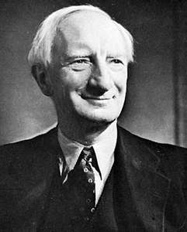

**William Beveridge**

* In 1942, William Beveridge wrote a report about the state of Britain. It said that people should be free of the ‘five giants’ that could ruin their lives. These were: disease, want (need), ignorance, idleness and squalor (poor living conditions).
* The report said that in order to improve quality of life the government had to take ‘*charge of social security from the cradle to the grave*’. It soon became a bestseller with over 100,000 copies sold in the first month of publication.
* However, the Second World War meant that little was done about the Beveridge Report at the time.
* At the end of the war a general election was held. The Labour Party won the election easily as they promised to follow Beveridge’s advice. Over the next few years they put many of his ideas into practice:
  1. The NHS was set up in 1948 to provide free healthcare for all.
  2. A weekly family allowance was introduced to help with childcare costs.
  3. The poor received financial help in the form of benefits.
  4. The school leaving age was raised to 15 and more free university places were created.
  5. Slum clearance continued and 12 new towns were created. 280,000 council homes were built each year.

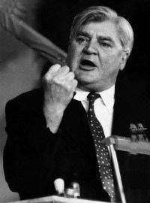

**Aneurin (Nye) Bevan**

* Nye Bevan was the Minister of Health who was appointed by the government to introduce the NHS.
* Originally it faced massive opposition from doctors who thought that they would see a decline in their income because they could no longer charge what they wanted for treatments. Out of 45,000 doctors nearly 41,000 did not want the NHS.
* However, Bevan won them over by promising them a salary and allowing them to treat private patients as well.
* The NHS has clearly helped improve the health of the British public. Life expectancy for women has risen from 66 to 83 since 1948 and for men it has risen from 64 to 79.
* However, the NHS is increasingly in the news due to all of the problems it is facing. There are rising costs, longer waiting lists and concerns over overworked doctors and nurses. Furthermore, headlines in newspapers often talk about dirty wards, crumbling hospitals or striking doctors.
* There is increasing strain placed on the NHS as people are living longer. Therefore, governments are questioning whether the NHS remains fit for purpose.
* Overall, the quest to improve 21st century public health still continues. There are many campaigns such as ones about healthy eating and stopping smoking. People are continually reminded to check for early signs of cancer and eat five portions of fruit and vegetables per day. Similar health campaigns will be likely to be introduced in the future.