Elizabethan England, c1568 – 1603

Part One – Elizabeth’s Court and Parliament

- Background and character of Elizabeth I. | Page 4
- Elizabeth, Parliament and her court – court life and key ministers. | Page 4
- The difficulties of a female ruler. | Page 5
- Elizabeth and the problems of marriage and succession. | Page 5
- Challenges to Elizabeth’s authority – Essex’s rebellion in 1601. | Pages 5 & 6

Part Two – Life in Elizabethan Times

- Living standards and fashions – the rise of the gentry. | Pages 6 & 7
- Elizabethan theatre and attitudes towards it. | Page 7
- Elizabethan ‘Golden Age’. | Pages 7 & 8
- The increase in poverty. | Page 8
- Attitudes and responses to poverty – government action and poor laws. | Pages 8 & 9
- Exploration – Sir Francis Drake (circumnavigation 1577-1580). | Page 9
- Exploration – John Hawkins. | Page 9
- Exploration – the role of Sir Walter Raleigh. | Page 10
- Exploration – how it made England rich and powerful. | Page 10

Part Three – Troubles at Home and Abroad

- The difference between Catholic and Protestant beliefs. | Pages 10 & 11
- Catholic Reaction and Rebellions. | Pages 11 & 12
- The Catholic Threat from Abroad. | Page 12
- Protestant and Puritan threats to Elizabeth. | Page 12
- Mary, Queen of Scots – the threat she posed to Elizabeth, her treatment, trial and execution. | Page 13
- The development of naval warfare. | Page 13
- Spanish Armada – causes, key events, tactics, technology and eventual defeat of the Armada. | Page 14

Part Four – The Historic Environment of Elizabethan England

- Overview of the historic environment component | Page 14

Overview of Elizabeth Content

Part One – Elizabeth’s Court and Parliament

- Background and Character of Elizabeth I

- Born in 1533 - Elizabeth was a disappointment for Henry VIII because he wanted a boy to carry on the Tudor family name.
- Despite seeing her mother beheaded she was well looked after as a child and was being prepared to be a member of the royal court.
- When her father died in 1547 – she went to live with her father’s sixth wife Katherine Parr and her new husband Thomas Seymour (Henry VIII’s uncle). Seymour was executed for plotting to marry Elizabeth after Katherine died in order to gain more influence over the young king Edward VI.
- When Elizabeth’s brother Edward VI died, her sister Mary I became queen. She saw Elizabeth as a threat and had her imprisoned in 1554.
- In 1558 Elizabeth became queen and was crowned aged 25.
- In 1562 she nearly died from smallpox but survived and ruled for 45 years.

- Elizabeth and her Court – Court Life and Key Ministers

- Government – consisted of officials chosen by Elizabeth however she had ultimate control as she had the final say about any issues (e.g. going to war, taxes or education).
- The government was divided into different bodies with their own jobs. These include the: Privy Council, Parliament, Lord Lieutenants and the Justices of the Peace (JPs).

William Cecil
Elizabeth’s most trusted advisor. He encouraged Elizabeth to take control of Catholic Ireland and fight Catholic rivals. Helped developed the poor laws.
Privy Council
Responsible for the day to day running of the country and giving Elizabeth advice. The council was called to discuss any issue that Elizabeth had including: foreign and military affairs, religion or the queen’s security. If all the council agreed it was hard for Elizabeth to ignore their viewpoint.
Parliament
Could only meet when Elizabeth said and only discuss the issues that she approved of. Elizabeth required Parliament to make laws however as they had to approve the bill. They were only called 13 times in her reign, 11 times to ask for money. They mainly dealt with taxes, religious laws and wars.

How was Elizabethan England Governed?

Lord Lieutenants
Settled disputes and collected taxes within a small region of the country. They had to also raise an army to fight for the queen if needed. Many Lord Lieutenants were also Privy Councillors. On the days that they were serving on the Privy Council their work would be carried out by a deputy.
Justices of the Peace (JPs)
The Justices of the Peace kept order. Each county had several JPs to ensure that laws passed by Parliament were properly enforced. They were always selected from the local gentry. A single JP could send a person to prison but several were required to sentence a person to death.

Francis Walsingham
Spymaster and Secretary of State. Helped establish England as a force at sea. Played a major role in the trial and execution of Mary, Queen of Scots.

- The royal court was made up of government officials, servants and advisors as well as the Privy Council who surrounded Elizabeth. It consisted of approximately 1000 people of different social status. Other positions like the JPs were external to it. She ensured loyalty of the most influential by giving patronage or banishing those she lost trust with.

- The Difficulties of a Female Ruler

  - Succession: Pressure on Elizabeth to marry and have children to carry on the Tudor family name. There was always concern over who would succeed her as in the past wars had broken out over this.
  - Mary, Queen of Scots: Without an heir, she was next in line to the throne as Elizabeth’s cousin. In 1568 she was exiled from Scotland to England. Catholics now had a potential replacement to Elizabeth to fight for.
  - Ireland: They disagreed with Elizabeth’s rule over them. A revolt broke out in 1559. She was spending thousands of pounds on wars and soldiers but nothing seemed to be working.
  - Taxation: People were very poor already, many suffering in poverty, but Elizabeth needed the money generated through taxes. Putting taxes up would be unpopular.
  - Religion: Elizabeth was Protestant but she didn’t want to copy the violence and mistakes made by her Catholic sister Mary I. She introduced a religious settlement to prevent anger amongst Catholics. However, some Catholics remained unhappy (e.g. the Jesuits) as did a growing number of extremist Protestants, the Puritans.
  - Foreign Policy: There were many threats from abroad, particularly from the Catholic countries Spain and France.

- Elizabeth and the Problems of Marriage and Succession

- One problem which never went away for the whole of Elizabeth’s reign was marriage. Unless she married she could not produce a child that would be a legitimate heir to the throne.

Reasons to Marry | Reasons not to Marry
- Could create alliances with powerful countries like Spain and France if she married a foreign king or prince.  - If she married an Englishman it could gain her the support of a powerful English family.  - She could produce an heir to succeed her and continue the Tudor line.  - Marrying could prevent a Catholic such as Mary, Queen of Scots from acceding the throne after her death. | - A foreign price could control England.  - An English husband could take away Elizabeth’s authority (legally the husband had the power over his wife).  - Elizabeth would remain independent and not have to answer to her husband.  - Giving birth after marrying could be risky – Elizabeth and the child could both die.  - Mary’s marriage to Philip of Spain had been a disaster and not even produced an heir by the time of her death.

- Elizabeth had many suitors who she could have married, each with their own advantages and disadvantages. These include:
- Robert Dudley – Childhood friend and favourite of Elizabeth. He was a Protestant but was accused of killing his wife. He was a Privy Councillor with great power and influence.
- Francis, Duke of Anjou and Alençon – Marriage could lead to Elizabeth having influence in France as he was the heir to the throne (as his brother was childless). However, when he proposed, Elizabeth was 46 and beyond having children. Also, he was Catholic and there was concerns that people were worried that he wanted to take control of England.
- Philip II, King of Spain – Incredibly powerful and wealthy. He had been married to Elizabeth’s sister Mary. He was a Catholic and not very tolerant of Protestants. One problem was the issue of which religion their children would be raised in.

- Pressure increased on Elizabeth as she got older, particularly from Parliament. In 1566 Parliament discussed potential suitors for Elizabeth. Elizabeth however saw this as unacceptable interference, and banned Parliament from discussing marriage again. However, Peter Wentworth (a politician) ignored this and argued that Parliament should discuss whatever they wanted. However, the rest of Parliament had him arrested, worried how the queen might react.
- Clearly Elizabeth considered marriage something she alone should make, without any interference from Parliament.

- Challenges to Elizabeth’s Authority – Essex’s Rebellion in 1601

- Elizabeth faced many rebellions throughout her reign, many of which focused on religion. However, Essex’s rebellion in 1601 was all about power and influence and actually posed very little threat to Elizabeth herself. However, she had to make the final decision about how Essex was dealt with after the rebellion was stopped.

1566 – Robert Devereux was born.
1573 – Became Earl of Essex when his father died.
1569 – His father helped put down the Northern Rebellion.
1587 – Introduced to the queen when his mother married the Earl of Leicester.

1598 – Argued with Elizabeth about Ireland. Turned his back on the queen and he was slapped. He then put his hand on his sword. Put under house arrest.
1595 – He became a Privy Councillor and was given monopoly of sweet wine.
1596 – Military success against the Spanish.
Essex develops a rivalry with Robert Cecil who was part of a powerful English family.

1599 – Became Lord Lieutenant of Ireland. Initially refused to go because he felt that Cecil would become more powerful. Failed to crush the Irish and instead made a truce with them, against the queen’s wishes. He knighted some of his army leaders, angering her further.
Sept 1599 – Returned to London and broke into her chamber catching her without her wig or properly gowned. She had expressly forbidden his return. She did not renew his wine monopoly. This left him with large debts. Facing financial ruin, he became determined to remove Robert Cecil from power.

Feb 1601 – He began to gather supporters, taking 4 Privy Council members hostage, then marched to London.
Essex and his remaining supporters were arrested. He was then put on trial for treason and executed on 25th February 1601. He identified other members of the rebellion, including his sister Penelope, which meant Elizabeth allowed him to be executed in private.
Robert Cecil quickly labelled Essex a traitor. Many of Essex’s 200 rebels abandoned his march.
Essex returned to his house but found most of his supporters had gone and the hostages had been freed.

- Although Essex’s rebellion did fail due to lack of support, it does show that even at the end of her reign that she still faced opposition to her rule.

Part Two – Life in Elizabethan Times

- Living Standards and Fashion – The Rise of the Gentry

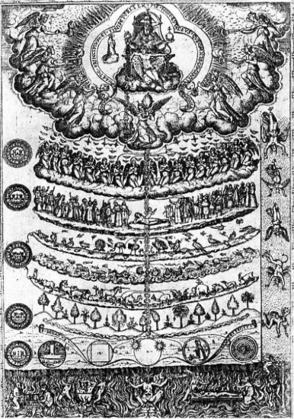
- Elizabethan society was based on the ‘Great Chain of Being’. God was at the top followed by his angels. Below the angels were human beings followed by animals and plant. The category of humans was further subdivided. Elizabeth was at the top, followed by the nobility, the gentry then the peasants.
- It was almost impossible to move between the different divisions.
- Land made money and raised social status. Anybody who made money through trade would use it to buy land as you could grow crops on it or build and rent houses on it.

- Nobility: They were the most respected members of society after the queen. This status was shown by a title (e.g. Duke was the highest) and by having a rich manor house in the countryside. A member of this group was either born in to it or awarded the title by the queen. Their average income was £6000 per year (£1 million today). They had special privilages like protection from torture or to be beheaded rather than hanged. The queen could however take power and influence away. Upon death, the title was passed down from father to son.
- Gentry: The landlords of the countryside. They lived on the rents of their tenants. Their income varied between £10 and £200 per year (between £1700 and £34,000 today). Some members were even richer than the poorest nobles (although were still below them in society). Many were JPs and/or served in Parliament. Titles included knight and esquire. The number of gentry increased during the Elizabethan reign because the country was more secure and stable.
- Peasantry: The poorest members of society. Most worked as farm labourers. During the Elizabethan period the number of peasants grew. This put even more pressure on jobs. Most experienced extreme poverty.

- Wealth was shown in many ways. Frequently the rich built manor houses (e.g. Hardwick Hall). However, food was often used to show status and wealth. Rich people had meals made almost entirely of meat and drink was predominantly wine. Banquets in particular showed how rich you were.
- Fashion was also important. Women paired fine clothes with whitened faces. White faces showed that they did not have to work outside and get a tanned face. A key element of fashion was the elaborate ruff worn around the neck. All of this shows that the rich Protestants and Catholics were free to enjoy their wealth whilst the country was secure and stable.

- Elizabethan Theatre and Attitudes Towards it
Very popular entertainment for both the rich and the poor.
Shakespeare: Was the principal writer for the Lord Chamberlain’s Men. He wrote 38 plays split into histories (e.g. Julius Caesar), tragedies (e.g. Romeo and Juliet) and comedies (e.g. A Midsummer Night’s Dream).
Shakespeare produced many new plays each year, performed by companies like the Admiral’s Men.

Each theatre company was named after the person who was the patron (provided funding).
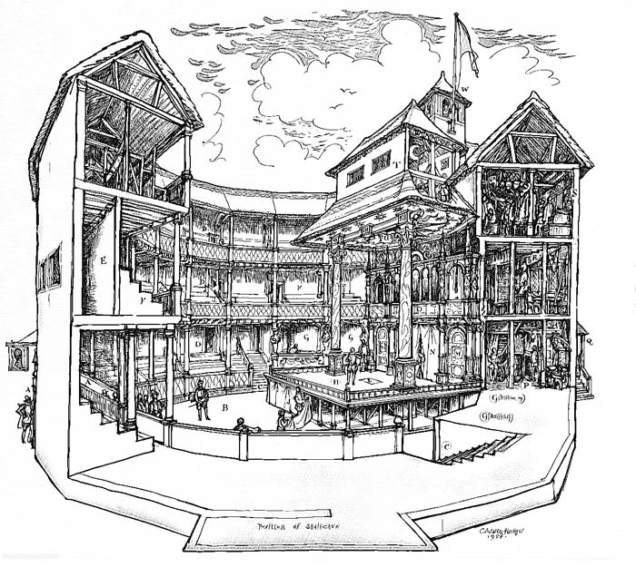

Burbage: One of the best-known actors. Leading member of the Lord Chamberlain’s Men who played Hamlet. Also, a theatre owner.
Actors were entirely male.

Purpose built theatres had been developed by the end of Elizabeth’s reign.
Performances began at 3:00pm and continued into the evening.

Being a patron of a theatre company was a good way to please the queen and show how cultured you were.
Prices varied depending on where you sat or stood. Pushing and shoving was common. Performance was more like a circus, heckling was not uncommon.

Could be a cheap afternoon’s entertainment.

The Globe was probably the best-known theatre, built in 1599.
The Puritans wanted theatres closed as they saw them as immoral and a distraction from praying to God and studying the bible. Other people opposed it as they thought disease might spread through large gatherings. Also, people were concerned about crime and drunkenness.

- Elizabethan ‘Golden Age’

- The Elizabethan era was full of great achievements in fields such as art, literature and medicine. It is often referred to as a golden age of English History. Certainly, at the time there were attempts to spread knowledge about the new advancements to improve Elizabeth’s position on the throne. This was known as Gloriana and was achieved through plays, festivals and printing pamphlets. The following are reasons Elizabeth’s reign can be seen as a golden age:
  - Art: Portraits were popular, especially miniature ones. Paintings contained lots of symbolism e.g. the Armada Portrait shows Elizabeth’s hand on a globe to show power. Decorative silverware and textiles were also highly collectable.
  - Exploration: New lands and peoples were discovered, making England a major power.
  - Theatre: Many theatres were built and plays produced which are still in use today.
  - Buildings: Stately homes were built in high numbers to impress the queen and other nobles. Houses were not designed specifically with defence in mind.
  - Literature: Poetry and plays became very popular. Many contained references to Ancient Greece and Rome. Shakespeare wrote many sonnets.
  - Education: Increasingly important in Elizabeth’s reign. It still focused on wealthy boys but some girls also received a limited education.
  - Science and Technology: Breakthroughs in navigation and astronomy took place and there was a growing understanding of how magnetism worked. Also, more effective printing presses which produced books and pamphlets, allowed ideas to spread much faster.
  - Peace, Power and Pride: England had been in chaos for many years before Elizabeth’s reign. She established peace and order, whilst military successes and the growing wealth made people proud to be English.

- However, some people argue that the idea of a golden age is a myth.
- Sports: Many brutal sports continued to take place including dog fighting and bear baiting.
- Torture: Cruel punishments such as using the rack were used against people who posed a threat to Elizabeth.
- Divided Society: Only a very small minority of people lived in luxury whilst most people suffered with extreme poverty and barely had enough to survive.
- Life Expectancy: Remained very low throughout her reign and illnesses were often fatal.
- Questionable Science: Much experimentation was questionable e.g. astrology (predicting the future using the planets) was common as was alchemy (attempting to turn cheap metal into gold).

- The Increase in Poverty

- For some, life was very hard. Those without work were known as paupers, and they had to rely on charity. This meant they either had to beg or go to the local church for help.
- There were many reasons that the number of poor people increased throughout the Tudor era. These reasons include:
  - Retinues: Retinues or (private armies) were limited by Henry VII to reduce the threat of a noble uprising. This left many soldiers without work.
  - Reformation: In Henry VIII’s reign he closed all of the monasteries and all the people who worked for the church were evicted becoming unemployed in the process.
  - Debasing: From 1542, Henry VIII began debasing coins. This meant that he mixed in less valuable metals with more precious gold and silver. This damaged trade and affected jobs. The cloth trade collapsed completely during Edward VI’s reign as a result.
  - Farm Harvests and Inflation: Food shortages as a result of poor harvests took place between 1594 and 1598 leading to poverty and starvation. Less food led to price inflation, meaning it was less affordable to the poor.
  - Farming Changes: A new method of farming called enclosure farming meant fewer workers were needed to tend a farm, leaving people jobless and homeless. Farms were used for sheep farming rather than crops which again required fewer workers to manage.
  - Rack Renting: In Elizabeth’s reign the population grew from 2.8 million to 4 million. This meant there was pressure on places to rent because the number of houses was limited. Some landlords unfairly increased rents, called rack renting.

- Attitudes and Responses to Poverty – Government Action and Poor Laws

- In Elizabethan society, as the number of poor people grew, they were categorised into two main groups:

Deserving Poor | Undeserving Poor
- Received charitable donations from the rich.  - It was recognised that this group wanted to work and help themselves, but there simply was not the jobs available.  - Almshouses (a charity building set up to provide food and rest for the poor) were established. For example Archbishop Whitgift established almshouses in Croydon, London. | - This group included untrustworthy beggars.  - They had no interest in honest work.  - They were seen as idle, lazy and unable to change their ways.  - In 1567 Thomas Harman published a book about their scams and tricks they used.  - The Clapper Dudgeon would cut himself deliberately and tie dirty bandages around the wound to gain sympathy and charity from people for example.

- Before Elizabeth’s time, people who were caught begging for the first time were punished through the use of stocks and public whipping. If they got caught a second time then they had a hole burned through their ear. A third offence would mean they were hanged. This became law from 1531.
- In 1576 there was an ‘Act for setting the poor on work’ which made it the responsibility of the local authority to find work for the poor.
- Different approaches were taken across the UK to deal with the problem of poverty:
York: York saw a huge increase in the number of poor coming from the countryside. In 1515 the York Corporation began issuing beggar licences (they had to wear a badge so they could be identified). In 1528 a Master Beggar was appointed to keep a check on the rest. Beggars were expected to take jobs involving weaving and spinning. Those who refused were send to the House of Correction (a prison), or were sent back to the village they had come from.

Norwich: In 1570 a survey found that 80% of the population lived in poverty. They split the poor into two categories the idle poor and the unfortunate poor. The idle poor were given work like knitting, the unfortunate poor were given food, care and support. The rich were taxed to pay for the care of the poor, and the numbers who received money was limited.
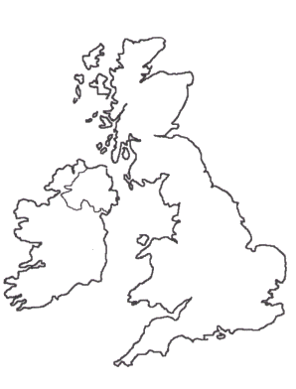

Ipswich: A licencing system for beggars was introduced in 1569. Also, a hospital specifically for the old and sick was opened there. A youth training scheme was introduced to help children learn a trade. The town was first to build a House of Correction (see York).

London: A hospital called Bedlam was established for the mentally ill, other hospitals were set up for orphans. Bridewell Palace was used as a homeless shelter. Conditions in these places were harsh however.

- Poor Law 1601: The Poor Law said that the wealthy should be taxed in order to pay for the care and support of the vulnerable. Different groups of poor people were treated in different ways:
  - The sick and the old (the helpless poor) were given food to live on and placed in special homes to be cared for.
  - The fit and healthy people (the able-bodied poor) should be given work and were given food and drink as payment, and occasionally somewhere to sleep.
  - People who were deemed able to work, but chose not to (the idle poor), were dealt with harshly. They were whipped and placed in a House of Correction.
- The poor law aimed to help those who were genuinely poor and continue to punish those who were considered lazy. Instances of begging did decrease but the Poor Law was inconsistently used. There was often arguments about which area paupers belonged to, and therefore who was responsible for caring for them. Consequently, some paupers were generally sent from one place to another. There were also many debates over who the genuine cases were and who were simply beggars and vagrants. However, the Poor Law remained in place until it was reviewed in 1834.

- Exploration – Sir Francis Drake (Circumnavigation 1577-1580)

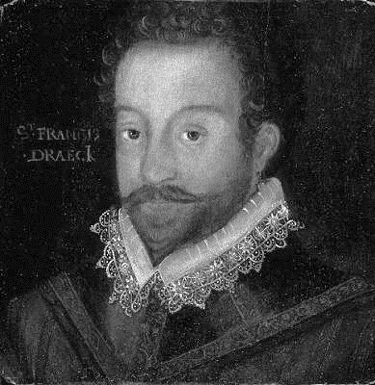 | - Circumnavigated the world between 1577 and 1580. He didn’t actually mean to do this, but he did it whilst chasing Spanish ships in revenge for an attack at San Juan de Ulúa, a Spanish Port where they were selling slaves.  - His voyages changed the whole understanding of the world. However, he started with 5 ships and 164 men but ended with just 1 ship and 58 men. This shows how dangerous voyages remained.  - Along with John Hawkins, he made one of the first voyages to Africa to capture slaves to sell in the New World (America).  - Drake became a privateer and was attacking enemy ships. They then took their cargo. This made him and Elizabeth a fortune.  - He was nicknamed El Draque (the Dragon) by the Spanish who saw him as a pirate.  - He was knighted in 1581.  - In 1588 he led the successful defeat of the Spanish Armada.

- Exploration – John Hawkins

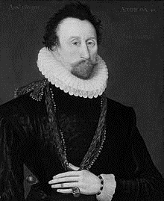 | - He was a key figure in Elizabeth’s court, even working as a spy against the Ridolfi Plot. His role involved passing information to the authorities.  - He built up the Royal Navy, and was a respected military leader, fighting in the Spanish Armada.  - He was also a privateer like Drake.  - In 1562 he helped with the African slave trade, capturing slaves and taking them to America.  - In 1564 with the authorisation of the queen, Hawkins kidnapped several hundreds of West Africans and sold them on the South American coast. This was the first time the whole process had been carried out by an Englishman.  - He brought tobacco to England, discovered on one of his voyages.

- Exploration – The Role of Sir Walter Raleigh

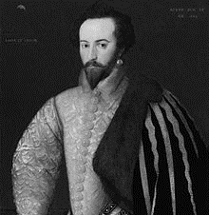 | - He was a Protestant and part of a family that faced huge persecution during the reign of Mary I.  - He was incredibly loyal to Elizabeth and spent years helping fight Irish, Catholic rebels.  - In 1584 he was given permission to explore and rule any land not ruled by a Christian.  - He went on voyages to South America to search for the legendary city of gold: El Dorado.  - He sent others to establish a colony in North America at Roanoke which did not last. A second colony also failed.  - He became a favourite of the queen when he returned to court. He however was banished in 1592 for 5 years after secretly marrying one of the queen’s ladies in waiting.

- Exploration – how it made England rich and powerful

- Ships built during Elizabeth’s reign were of higher quality than in previous periods. They had new lateen (triangular) sails which made them faster and easier to sail. Also improved defences and weapons made sailing through hostile waters much safer. Finally, the astrolabe allowed sailors to judge how far north or south they were, whilst new compasses made navigation more accurate.
- At first, the majority of English trade was with other European countries. However, better ships allowed Elizabeth’s explorers to embark on longer voyages so they could trade with other countries to get rich. In particular they wanted to trade with the Far East where spices could be bought.
- Initially, the English traders went through middlemen. These were people who bought the spices in the Far East and then sold them to the Europeans, thereby making a profit.
- England however went to set up their own direct routes to India to increase their own profits.
- The first attempts to set up a direct route to India and China were by Sir Martin Frobisher who tried on three occasions but failed each time.
- However, attempts to reach the East led to exploration of other areas including the Americas.
- The Muscovy Company was created in 1555 and was given the monopoly of trade with Moscow. This meant that no other company could trade in this area. Similarly, the Eastland Company (1579) was set up to trade with Scandinavia, whilst the Levant Company (1581) traded with both Turkey and the Middle East.
- In 1582, Ralph Fitch was sent to India and the Far East. Following this, the East India Company was established in 1600 to oversee trade in this area.
- By raiding Spanish ships, England became even richer.
- Despite Raleigh failing to help create a new English colony in America, in time England managed to build up more overseas territories and became richer as a result.

Part Three – Troubles at Home and Abroad

- The Difference Between Catholic and Protestant Beliefs
- There were many differences (and a few similarities) between Catholic and Protestant beliefs:
- Monarch is the
head of the church.
- English Bible and services.
- Priests allowed to marry.
- Churches kept plain and simple with little decoration.
- Bread and wine represent
the blood and body
of Jesus.
Similarities
- Pope is the head
of the church.
- Latin Bible and services.
- Priests should not marry.
- Church decorated with stained glass, paintings and statues.
- Bread and wine change (called transubstantiation).
Similarities
- Priests are people’s link with God.
- God created the world and everything in it.
- Jesus was God’s son.
- Those who challenge the true faith must admit their error or be punished by true believers.

Protestant
Catholic

.

- Henry VIII: The Reformation officially made the country Protestant, however Catholic practices were still followed.
- Edward VI: England became much more a Protestant country, seeing the introduction of the Book of Common Prayer.
- Mary I: Spent her reign returning the country to the Catholic faith, making the Pope again the head of the church. She brought back Latin mass and burned almost 300 Protestants alive for refusing to change.
- Elizabeth I: She was a Protestant but set about bringing both religions together. This was called a Religious Settlement. Priests were allowed to marry, services were held in English and she brought back the Book of Common Prayer (these were all Protestant religious practices). However, she made herself governor rather than the head of the Church. She also allowed Catholics to worship in their own way in private. Church services were redesigned to allow people of either faith to understand and participate. Finally, she appointed a moderate Protestant, Matthew Parker, as the Archbishop of Canterbury to oversee the English Church.

- Catholic Reaction and Rebellions

- Elizabeth’s religious settlement meant that many Catholics were relatively happy during her reign. They could continue to practice as a Catholic as long as it was in private, and they attended Protestant services.
- Recusancy fines for Catholics who failed to attend Protestant services were kept very low.
- However, in April 1570 the Pope (Pius V) issued a papal bull. This special message, excommunicated (officially removed) Elizabeth from the Catholic Church. It also called on all Catholics to bring an end to her rule.
- Initially, the excommunication was designed to coincide with the Northern Rebellion of 1569 but it was issued late. However, it did inspire other Catholic rebellions:

The Ridolfi Plot, 1571
This plot was led by Italian banker Roberto Ridolfi. The plan was for rebels from the Netherlands to invade England, at the same time as another northern rebellion. Elizabeth would then be murdered and replaced by Mary, Queen of Scots. She would then marry the Duke of Norfolk. However, a bag of gold coins with coded letters was discovered on its way north. The code was cracked using a cipher key. Norfolk confessed and was executed.
The Northern Rebellion, 1569
Elizabeth refused to allow the Duke of Norfolk to marry Mary, Queen of Scots. This inspired northern Catholic nobles Westmorland and Northumberland to lead a rebellion. They took control of Durham Cathedral and held an illegal Catholic mass. They then marched south with 4600 men. The Earl of Sussex raised an army and defeated the rebels. Northumberland was executed, Westmorland escaped and Norfolk was imprisoned.

Catholic Rebellions Against Elizabeth

The Babington Plot, 1586
This was the final attempt to murder Elizabeth and place Mary, Queen of Scots on the throne. It was led by Anthony Babington. Coded letters were found hidden in beer barrels by some of Sir Francis Walsingham’s spies. When the code was broken the message clearly showed that Mary was supporting the plot to kill Elizabeth. As a result Mary was put on trial and later executed, even though Elizabeth was hesitant to order this.
The Throckmorton Plot, 1583
This plot again aimed to murder Elizabeth and replace her with Mary, Queen of Scots. It was led by Sir Francis Throckmorton who also planned to get the French Catholic, Henry (Duke of Guise) to invade. He hoped this would cause an uprising of English Catholics. The plot also involved the Spanish ambassador. When the plot was discovered, Throckmorton was executed and Mary, Queen of Scots, was placed under even closer guard.

- The number of plots she faced from Catholics meant that Elizabeth had to change her approach.
- New laws were introduced to try to disrupt Catholic activities, and make it clear that rebellions would not be tolerated:

1558-1581: Elizabeth’s religious settlement (compromise between Protestants and Catholics).
1585: Catholic priests were considered traitors and sentenced to death.
1593: Law that Catholics could not travel more than 5 miles from home.
1581: Law making it illegal to attend Catholic mass.

1585: It became treason to have a Catholic priest in your home.
1581: Recusancy fines increased to £20. It also was treason to convert to Catholicism.
1558: Elizabeth is crowned queen.

- The Catholic Threat from Abroad

- In 1568 an English Cardinal called William Allen established a seminary (school where priests were trained) in Douai in the Spanish Netherlands. He had the full backing of the Pope. The aim was that missionaries would go to England and convert the Protestants to the Catholic faith. The first priests arrived in 1574.
- Allen was involved in several Catholic plots including the Throckmorton Plot as well as the Spanish Armada. If there was a successful conversion back to Catholicism, it was likely that he would be made the Archbishop of Canterbury.
- The Jesuits aimed to bring back Catholicism (called a counter-reformation). They arrived in England in 1580. Elizabeth saw the Jesuit priests as a threat to her rule and punished those arrested harshly. An act was published in 1585 which called for all Jesuits to be driven out of England and many were executed (called the Act against Jesuits and Seminary Priests).
- Outside of England, Spain and France began to support a Catholic challenge to Elizabeth’s reign. They both supported the Jesuit missionaries and gave financial support to those who wanted to get rid of the queen. Philip II (Spanish King) also helped support he seminary at Douai. However, neither France, nor Spain was in a position to launch a full-scale attack on England.
- In 1580 the Jesuits began a mission to England, led by Edmund Campion and Robert Parsons. In June 1580 Campion began to preach to the English people, disguised as a jewel merchant. Then he began to travel the country. He soon became a wanted man. He was arrested in July 1580 and taken to the Tower of London and questioned. He was also tortured on the rack, and then found guilty. He was hanged, drawn and quartered, Parsons escaped.

- Protestant and Puritan Threats to Elizabeth
In 1580 a separatist church was established in Norwich by Robert Browne. A second one was set up in London in 1592. Its leaders Henry Barrow and John Greenwood were hanged (unlike Browne who was released).
In the 1570s prophesyings (Protestant meetings criticising the English Church) were popular. Elizabeth saw them as a threat. She suspended Edmund Grindal (the Archbishop) for refusing to ban them.
Puritans wanted to remove all Catholic elements from the English Church and were not prepared to compromise.

Elizabeth appointed bishops who sympathised with the Puritans.

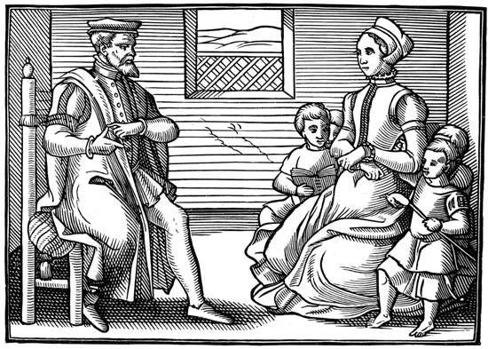
Bishops disliked having to wear a surplice (white gown) during services, preferring plain clothing. However, they ultimately accepted it because from 1566 it was made it clear they would lose their jobs if they did not wear it.
Many MPs were Puritans as were other people close to the queen. They included Robert Dudley and Sir Francis Walsingham. They helped limit the extent to which Elizabeth cracked down on them. However, once they died Elizabeth took a harsher approach towards Puritans.

In 1583, the Archbishop of Canterbury, John Whitgift: banned unlicensed preaching and increased recusancy fines.
Presbyterians refused conform to the compromises and wanted bishops removed and replaced with elders.

Puritans were also fined and imprisoned by the High Commission if they did not conform. Elizabeth also had Puritan publications punished as they were calling for the reorganisation of the Church. For example, John Stubbs had his right hand cut off for criticising marriage talks with a French Catholic prince.
- Mary, Queen of Scots – The Threat she Posed to Elizabeth, her Treatment, Trial and Execution

Background & Claim to the Throne: | - Elizabeth I’s cousin (grandmother was Henry VIII’s sister who married the King of Scotland).  - Became queen of Scotland from 1542 aged 8 days old.  - Brought up a strong Catholic.  - Married the heir to the French throne in 1558 making her queen of both Scotland and France and heir to the English throne.  - Returned to Scotland in 1560 and found the Protestant religion had become more popular.  - Accused of killing her second husband Lord Darnley and was forced to flee to England.  - Her infant son James was crowned King of Scotland in 1567.  - Mary became increasingly unpopular.
Threat to Elizabeth: | - Protestants were fearful of having Mary in England.  - Thought that if she became queen she would return to the burnings and horrors of Mary I’s reign.  - Parliament saw her as a threat to the security of Protestant England. Many called for the execution of Mary but Elizabeth was hesitant.  - Mary was moved around the country as Elizabeth’s prisoner for 19 years as Elizabeth did not want to make her a Catholic martyr. (She was treated well though).  - She was the centre of many plots against Elizabeth (Northern Rebellion and Ridolfi Plot for example).
Babington Plot: | - This was the final plot to involve Mary.  - The plot suggested that Mary was supporting a plot to kill Elizabeth and replace her as queen.  - Following the discovery of the plot, Parliament met with Elizabeth and called for her to have Mary arrested and placed on trial.
Trial: | - Mary was put on trial in October 1586 before a panel of 36 noblemen including Walsingham and William Cecil.  - She argued she could not be found guilty of treason as she was a foreign queen and an Englishwoman.  - However, she was sentenced to death on 25th October 1586.
Execution: | - The death warrant was signed by Elizabeth on 1st February 1587.  - Mary was executed on 8th February 1587 in private.
Impact: | - Even in death Mary remained a threat. She became a Catholic martyr and increased the belief that Elizabeth was a wicked heretic. Despite outrage, the French and Scottish kings took no action.

- The Development of Naval Warfare

- Navy Development: Henry VIII spent a fortune building a strong navy to make England powerful at sea. This was important because England was an island nation and therefore vulnerable to attack by sea. John Hawkins was placed in charge of building the navy. However, at the same time Philip II and Spain were building their navy too.
- Naval Tactics: The most common tactic was to raid ships and invade ports to steal supplies. In 1587 the English raided Cadiz in Spain, destroying dozens of Spanish ships. Surprise attacks worked better than head on attacks. Elizabeth gave licences to her sailors to act as privateers. Fireships were common weapons. An old ship was set on fire and pushed out into the middle of a fleet or harbour causing chaos. Also, the ‘line of battle’ tactic was to fire on the enemy. This meant that ships were lined up, end to end to allow them to fire together.

Accurate Navigation
The astrolabe allowed greater accuracy when planning voyages and working out the current location of the ship. This made it easier to explore areas and navigate through hostile waters. This all helped to enable more successful voyages to take place.
Powerful Weapons
It became easier to attack enemy ships using new cannons, rather than having to try board enemy ships. Ships were built specifically for battle and for use in the ‘line of battle’ tactic. Stronger ships allowed heavier and more powerful weapons to be carried.

Advances in 16th Century Naval Technology.

Faster Ships
The lateen (triangular sail) allowed much faster travel. It also helped to make ships more manoeuvrable. This was perfect for raids and battles.

- Spanish Armada – Causes, Key Events, Tactics, Technology and Eventual Defeat of the Armada

- Spain: Tensions with Spain increased through Elizabeth’s reign. Philip II expected to marry Elizabeth, uniting the two countries. Elizabeth kept Philip waiting.
- The Netherlands: In 1566 there was a Protestant uprising in several Dutch cities against Philip’s rule. Catholic icons were smashed (iconoclasm). Philip sent in Spanish soldiers to harshly punish the rioters. Elizabeth sent money to support the Protestant rebels and allowed English volunteers to go and help. Elizabeth also offered protection to the rebel ships known as the Gueux de Mer (sea beggars). Philip II sent a powerful army, led by the Duke of Alba, to crush the rebellion but it made the situation worse. England had strong trade links with the Dutch, particularly the cloth trade. Therefore, in 1585 Elizabeth was forced to send 7000 soldiers, led by Robert Dudley to support the rebels, which increased tensions with Spain further. This ultimately led to the Spanish armada in 1588.

The Armada
The Spanish fleet consisted of 151 ships, 7000 sailors and 34,000 soldiers. In addition, 180 priests and monks delivered mass every day and they had sufficient supplies for four weeks. The commander was the Duke of Medina-Sidonia. Most weapons on board were for the land attack.
The Plan
After gaining the Pope’s blessing, Philip II was going to send an Armada (fleet) of ships through the English Channel and anchor off the Dutch coast. They would be joined by Spanish soldiers in the Netherlands. From there they would travel to the Kent coast and march on London.

The Battle
After the first fireship attack, the Battle of Gravelines began. The English fired constantly causing damage but not sinking any ships. The Spanish, who could not properly defend themselves due to the lack of sea weapons, fled. The English gave chase and continued to fire using their cannons.
The English Strike
On 6th August 1588 the Armada reached the Dutch coast as planned. However, the troops were not there waiting to board. Instead the Duke of Parma had sent them away delaying the Armada. The English attacked first. Francis Drake sent 8 fireships which sent the Spanish into chaos, breaking their crescent formation.

Impact of the Defeat
Philip II was humiliated by the loss. For Elizabeth, she saw it as a great victory and evidence that God was on the side of the Protestants. Even many Catholics placed their loyalty with Elizabeth following the victory. For the rest of her reign Elizabeth continued to build the navy. Philip planned a second armada but it never happened.
The Defeat
The stormy weather helped batter the Spanish ships, blowing them off course. Their food was rotten and their water was polluted. Just 65 ships returned safely to Spain. Many of the captured survivors were slaughtered by the Scots, Irish and English soldiers.

- Why did it fail? A mix of factors led to the defeat of the Spanish Armada. These included:
  - The English tactics – such as the use of fireships and the constant bombardment by English cannons.
  - The Spanish mistakes – for example using slow ships and having the wrong cannonballs which were only suitable for using on land.
  - The weather – for instance the storms battering the ships.

Part Four – The Historic Environment of Elizabethan England

- Overview of the Historic Environment Component

- The topic will vary each year. Additional pages, specific to the historic site will be provided in lessons to cover this.

