KS3 Developing English Skills:

Exploring Fantastic Beasts, Amazing Animals, and Curious Creatures

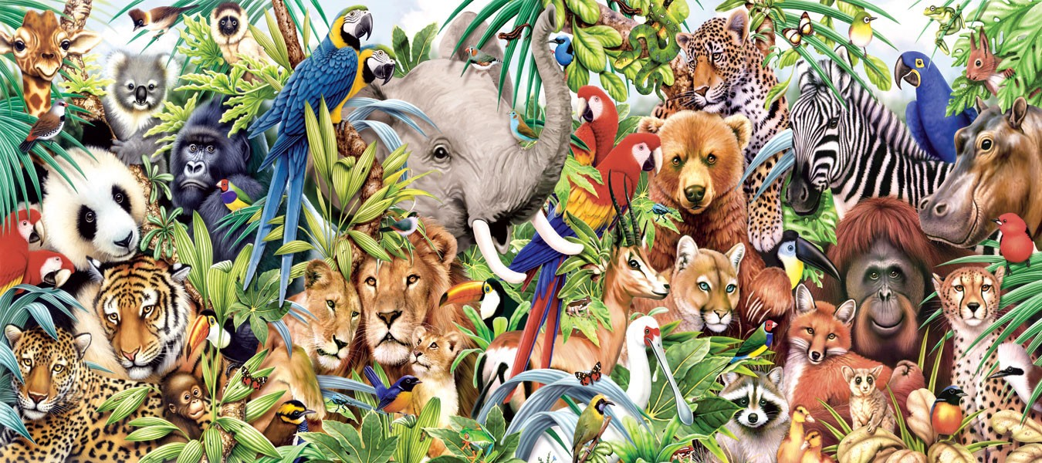
Guide for Completing Shadow Curriculum Work for this Unit
- You may be studying this unit or Macbeth
- This booklet is made of numbered tasks will involve reading a non-fiction extract and then answering questions on that task
- When working from home you need to choose a task that you haven’t done in school and complete the tasks/ questions which follow
Once you have completed one or two of these tasks…
- If you type ‘David Attenborough’ into ClickView (link on Moodle, or just type ‘ClickView’ into Google – your normal school log in) you will get a list of so many David Attenborough documentaries about animals. Choose one of these to watch.
- Then choose one of those animals to complete some further research on.
- Choose one of the following tasks
- Write an article which could be featured in a children’s nature magazine
- Write a letter to a local animal park persuading them to get some of these animals
- Write a series of diary entries from an expert who has gone to research these animals

1 | Autumnwatch presenter Chris Packham slams I'm A Celebrity... for 'killing animals and cruelty to bugs and insects' | Non-Fiction Skills  Language Skills

TV wildlife expert Chris Packham has blasted I'm A Celebrity Get Me Out of Here! for being cruel to bugs and insects. The host of BBC2's Autumnwatch, who controversially called for giant pandas to be allowed to die out, says he is appalled by how the show's bosses and celebrities abuse animals in the Aussie outback. The 48-year-old, who shot to fame on the BAFTA-winning BBC1 children's programme The Really Wild Show, says it is wrong that creatures are killed for entertainment purposes.
Chris told Yours magazine: "The people working on I'm A Celebrity Get Me Out of Here! have no regard for creatures' lives. If a celebrity trod on a cat it would be on the front page of every newspaper, but they jump up and down on as many cockroaches, spiders and bugs as they like.”
"From the first series I've been nothing short of appalled by the way they abuse animals. What sickens me more than anything is when people say ‘But they're only insects’. I happen to really like insects and more than anything I like life. There's not a single living organism on this planet that wants to die.” […]
“Other aspects of the programme like the physical trials can be entertaining but I don't find the treatment of creatures excusable at all. The insects are wriggling as they shove them into their mouths. Surely they have feelings? They do have nervous systems - for example witchety grubs and mealworms shy away from heat.”
“There is a lunatic divide whereby it's okay to slaughter as many bugs as we like but if it is anything cute and furry it immediately makes front page news. […] 'If a celebrity were genuinely starving I'd have no problems with it. But when they are doing it for entertainment it's no more than exploitation. I'd like to see the animal aspects of the programme taken out. I'm sure there are enough brains in the programming department to come up with different challenges that are equally exciting but don't involve killing creatures.”

GLOSSARY:
- Controversially = doing something in a way that causes a lot of shock or disagreement
- Appalled = shocked or disgusted by something
- Organism = a living thing
- Witchety grubs and mealworms = types of insects
- Lunatic = crazy; a term previously used for a mentally ill person
- Exploitation = to take advantage of something or someone, often to their detriment
- Read the statements below and decide if they are true or false:

Statement: | True or False?
- Chris Packham appeared on I’m a Celebrity … Get Me Out of Here!
- Chris has previously said that we should allow giant pandas to become extinct.
- Chris created the popular BBC1 children’s programme The Really Wild Show.
- Chris believes that people do not care about cruelty to cats.
- Chris is critical of the abuse of insects in British media.
- Chris believes it is acceptable to eat insects if there is a genuine need to do so.
- There is nothing Chris finds entertaining about I’m a Celebrity … Get Me Out of Here!
- Chris argues that TV can still be entertaining without causing pain to insects.

- What is the purpose of this article? Why has it been written? Suggest 3 ideas:

- ………………………………………………………………………………………………………….

- ………………………………………………………………………………………………………….

- ………………………………………………………………………………………………………….

- Select three words or phrases from the extract that you believe most effective convey/show how Chris Packham feels about this issue:

- Summarise this article in 3 pictures:

2 | Extract from Deadly Animals: savage Encounters Between Man and Beast by Gordon Giles | Non-Fiction Skills  Language Skills

One summer when I was a teenager the grasshoppers were everywhere. Every patch of weeds along the alley would erupt like a pan of popping corn if I set foot in it. When we drove the highway, we inadvertently slaughtered dozens. The collisions speckled our windshield with hemolymph. Their wings, coffee-colored fans striped with yellow at the outer edges, lodged in our wipers and fluttered in the onrushing air. Sometimes an entire grasshopper, or most of one, would lodge there as well, struggling to get free as the wind tore it to tatters.

They could be found in unaccustomed places that summer. For several mornings running I saw two or three swimming in the dog's water dish. The rosebushes took on the riddled look of lace, as though the grasshoppers had tasted the leaves and found them unappealing but serviceable. In the country, the cedar posts of barbed wire fences would seem at a glance to be shimmering with heat, like a water mirage on the highway, but a second glance would show the effect was not an optical illusion. The posts were simply crawling with grasshoppers moving up or down for no apparent reason. They seemed to be moving with great caution, edging past each other. When a stationary grasshopper got bumped, it would draw its legs in tighter and shift its footing, like a person uncomfortable on a crowded bus.

GLOSSARY:
- Inadvertently = without meaning to
- Hemolymph = fluid from insects, similar to blood
- Unaccustomed = not familiar, unusual, or out of the ordinary
- Riddled = having many holes

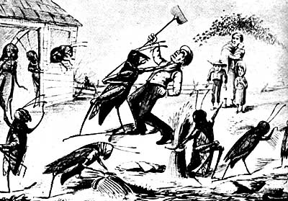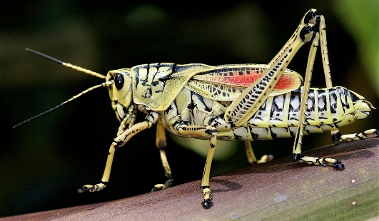

- Read the statements below and decide if they are true or false:

Statement: | True or False?
- Gordon Grice is describing an autobiographical experience with insects.
- Gordon Grice intentionally tried to kill to grasshoppers.
- The grasshoppers would usually hit the windscreens then fly away again.
- Gordon Grice would tear the grasshoppers’ wings to tatters.
- The grasshoppers were found in all the normal places they could usually be found.
- The grasshoppers would eat holes in many of the flowers.
- The grasshoppers moved quickly and would often bash into each other at speed.
- The grasshoppers did not seem to like being so close to each other.

- Re-read the first paragraph. List 3 facts relating to how the writer describes the grasshoppers and their actions:

- ………………………………………………………………………………………………………….

- ………………………………………………………………………………………………………….

- ………………………………………………………………………………………………………….

- In your own words, select 3 words that describe how the grasshoppers are presented in this extract:

- Summarise this extract in 3 pictures:

3 | A summary of Animal Farm by George Orwell | Fiction Skills  Literature Skills

Task: Read the following summary of Animal Farm. What moral lessons might come from this story? Highlight and label any details that help you come to a decision.

Manor farm is run by a cruel drunken farmer called Mr Jones. One day the animals, encouraged by the teachings of Old Major (a very clever pig), attack Mr Jones and chase him from the farm. The animals rename the farm Animal Farm and set up Seven Commandments to live by, the most important of which is ‘All animals are equal’.

Things start well and the animals enjoy their new freedom and equality. However, the pigs, the cleverest animals, become more and more powerful and discover that they enjoy being in power and that they enjoy the luxuries of living like a human. Led by Napoleon, the pigs take control of animal farm and use the other animals to make their lives easier. Napoleon uses the vicious dogs he has trained to chase the rival, Snowball, from the farm.

In the end, the pigs end up living in the farmhouse like humans while the other animals work harder and harder for less and less food until they are worse off than they were under Mr Jones. The Seven Commandments are replaced with one: ‘All animals are equal but some animals are more equal than others’.

Where has this idea been seen before in real-life history and even life today?

What type of leader is Napoleon if he needs to use “vicious dogs”?

4 | A summary of early twentieth century politics in the Soviet Union (modern-day Russia) | Non-Fiction Skills  Literature Skills

Task: Now look at this summary of twentieth-century events. What similarities can you find between Orwell’s story and the real-life events detailed here? Highlight and label any similarities with Animal Farm.

In 1917, Russia was governed by an extremely wealthy Tsar and his family. Most Russians were very poor and had few rights. The Bolsheviks (a Communist party inspired by the ideas of Karl Marx) took over Russia. They changed the name of Russia to the USSR (Union of Soviet Socialist Republics) and Lenin became the first leader. The USSR became a fairer and more equal country at first. Lenin died in 1924 and Stalin became the undisputed ruler of the USSR by ruthlessly removing any opposition. Stalin’s rival Trotsky fled in fear of Stalin’s secret police. Important members of the Communist Party led privileged while many ordinary Russians were as poor or poorer than they had been under the Tsar’s rule. Stalin is believed to be personally responsible for the deaths of 22 million Russians, making him the most effective mass murderer of all time.

GLOSSARY:

- Secret Police = a police force that works in secret to support a ruler, often using illegal or violent means to do so
- Tsar = an emperor/leader of Russia.

- What similarities can you identify between extract 3 and extract 4? List your ideas below:

- ………………………………………………………………………………………………………….

- ………………………………………………………………………………………………………….

- ………………………………………………………………………………………………………….

- Challenge: Why do you think Orwell wrote Animal Farm? What might he have wanted his readers to understand, believe, realise, or think?

…………………………………………………………………………………………………………………………………………………………………………………………………………………………………………

5 | An extract from Animal Farm by George Orwell | Fiction Skills  Literature Skills

This extract is taken from chapter 5 of Animal Farm, written by George Orwell in 1945. It describes how ones of the pigs on the farm, Napoleon, chases out a rival pig named Snowball.

At this there was a terrible baying sound outside, and nine enormous dogs wearing brass-studded collars came bounding into the barn. They dashed straight for Snowball, who only sprang from his place just in time to escape their snapping jaws. In a moment he was out of the door and they were after him. Too amazed and frightened to speak, all the animals crowded through the door to watch the chase. Snowball was racing across the long pasture that led to the road. He was running as only a pig can run, but the dogs were close on his heels. Suddenly he slipped and it seemed certain that they had him. Then he was up again, running faster than ever, then the dogs were gaining on him again. One of them all but closed his jaws on Snowball's tail, but Snowball whisked it free just in time. Then he put on an extra spurt and, with a few inches to spare, slipped through a hole in the hedge and was seen no more.

Silent and terrified, the animals crept back into the barn. In a moment the dogs came bounding back. At first no one had been able to imagine where these creatures came from, but the problem was soon solved: they were the puppies whom Napoleon had taken away from their mothers and reared privately. Though not yet full-grown, they were huge dogs, and as fierce-looking as wolves. They kept close to Napoleon. It was noticed that they wagged their tails to him in the same way as the other dogs had been used to do to Mr. Jones.

Napoleon, with the dogs following him, now mounted on to the raised portion of the floor where Major had previously stood to deliver his speech. He announced that from now on the Sunday-morning Meetings would come to an end. They were unnecessary, he said, and wasted time. In future all questions relating to the working of the farm would be settled by a special committee of pigs, presided over by himself. These would meet in private and afterwards communicate their decisions to the others. The animals would still assemble on Sunday mornings to salute the flag, sing Beasts of England, and receive their orders for the week; but there would be no more debates.

- Why are the dogs attacking Snowball? Who gave them these orders? [paragraph 1]

…………………………………………………………………………………………………………………………………………………………………………………………………………………………
…………………………………………………………………………………………………………………………………………………………………………………………………………………………

- How do the other animals react to the attack? Why? [paragraph 2]

…………………………………………………………………………………………………………………………………………………………………………………………………………………………
…………………………………………………………………………………………………………………………………………………………………………………………………………………………

- Who do you think gets to pick which pigs go on the committee? Is this a fair way to make decisions? [paragraph 3]

…………………………………………………………………………………………………………………………………………………………………………………………………………………………
…………………………………………………………………………………………………………………………………………………………………………………………………………………………

- Why would Napoleon describe decision-making meetings as “unnecessary’ and ‘wasted time’? [paragraph 3]

…………………………………………………………………………………………………………………………………………………………………………………………………………………………
…………………………………………………………………………………………………………………………………………………………………………………………………………………………

- Summarise this extract in 3 pictures:

Challenge: What message do you think Orwell wants to send to his readers about power and leadership? Be prepared to share your ideas.

6 | An extract from Animal Farm by George Orwell | Fiction Skills  Literature Skills

This following song, ‘Beasts of England’, is introduced to the other animals by Old Major and becomes the anthem of Animal Farm; it is later replaced by another song, titled ‘Comrade Napoleon’.

Beasts of England! Beasts of Ireland!
Beasts of land and sea and skies!
Hear the hoofbeats of tomorrow!
See the golden future rise!

How does the life of an animal pass?
In endless drudgery.
What's the first lesson an animal learns?
To endure its slavery.
How does the life of an animal end?
In cruel butchery.

Beasts of England! Beasts of Ireland!
Beasts of land and sea and skies!
Hear the hoofbeats of tomorrow!
See the golden future rise!

Now the day of beasts is coming,
Tyrant man shall lose his throne
And the shining fields of England
Shall be trod by beasts alone.

Pull the rings from out your noses
Tear the saddle from your back!
Bit and spur must rust forever,
Cruel whips no more shall crack.

Beasts of England, seize the prizes,
Wheat and barley, oats and hay,
Clover, beans and mangelwurzel
Shall be ours upon that day.

GLOSSARY:
- Drudgery = hard and boring work, often repetitive
- Tyrant = a cruel and oppressive ruler
- Mangelwurzel = a type of root vegetable

- In your own words, select 3 words that describe what animal life is currently like in this song:

- What is the purpose of this song? Why has it been written? Suggest 3 ideas:

- ………………………………………………………………………………………………………….

- ………………………………………………………………………………………………………….

- ………………………………………………………………………………………………………….

- An imperative is an order or a command. Find 3 examples on imperatives in the song:

- ………………………………………………………………………………………………………….

- ………………………………………………………………………………………………………….

- ………………………………………………………………………………………………………….

- Why have these imperatives been used?

……………………………………………………………….……………………………………………………………….……………………………………………………………….……………………………………………………………….……………………………………………………………….………

- Summarise this song in 3 pictures:

Challenge: Why do you think this song is later replaced with a new song – ‘Comrade Napoleon’? Be prepared to share your ideas.

7 | The Bereavement of the Lion-Keeper by Sheenagh Pugh | Fiction Skills  Literature Skills

for Sheraq Omar

Who stayed, long after his pay stopped,
in the zoo with no visitors,
just keepers and captives, moth-eaten,
growing old together.

Who begged for meat in the market-place
as times grew hungrier,
and cut it up small to feed him,
since his teeth were gone.

Who could stroke his head, who knew
how it felt to plunge fingers
into rough glowing fur, who has heard
the deepest purr in the world.

Who curled close to him, wrapped in his warmth,
his pungent scent, as the bombs fell,
who has seen him asleep so often,
but never like this.

Who knew that elderly lions
were not immortal, that it was bound
to happen, that he died peacefully,
in the course of nature,

but who knows no way to let go
of love, to walk out of sunlight,
to be an old man in a city
without a lion.

GLOSSARY:
- Pungent = having a strong smell

- Summarise the poem in your own words:

……………………………………………………………….……………………………………………………………….……………………………………………………………….……………………………………………………………….……………………………………………………………….………

- How does the lion-keeper feel about the lion? How do you know? Find at least 3 words/phrases from the poem that show the lion-keeper’s feelings towards the lion:

……………………………………………………………….……………………………………………………………….……………………………………………………………….……………………………………………………………….……………………………………………………………….…………………………………………….……………………………………………………………….………

- Why might the zoo have “no visitors”?

……………………………………………………………….……………………………………………………………….……………………………………………………………….……………………………………………………………….……………………………………………………………….…………………………………………….……………………………………………………………….………

- Summarise this poem in 3 pictures:

8 | A Case of Murder by Vernon Scannell | Fiction Skills  Literature Skills

1  5  10  15  20  25  30  35  40  45 | They should not have left him alone,  Alone that is except for the cat.  He was only nine, not old enough  To be left alone in a basement flat,  Alone, that is, except for the cat.  A dog would have been a different thing,  A big gruff dog with slashing jaws,  But a cat with round eyes mad as gold,  Plump as a cushion with tucked-in paws –  Better have left him with a fair-sized rat!  But what they did was leave him with a cat.  He hated that cat; he watched it sit,  A buzzing machine of soft black stuff,  He sat and watched and he hated it,  Snug in its fur, hot blood in a muff,  And its mad gold stare and the way it sat  Crooning dark warmth: he loathed all that.  So he took Daddy’s stick and he hit the cat.  Then quick as a sudden crack in glass  It hissed, black flash, to a hiding place  In the dust and dark beneath the couch,  And he followed the grin on his new-made face,  A wide-eyed, frightened snarl of a grin,  And he took the stick and he thrust it in,  Hard and quick in the furry dark,  The black fur squealed and he felt his skin  Prickle with sparks of dry delight.  Then the cat again came into sight,  Shot for the door that wasn’t quite shut,  But the boy, quick too, slammed fast the door:  The cat, half-through, was cracked like a nut  And the soft black thud was dumped on the floor.  Then the boy was suddenly terrified  And he bit his knuckles and cried and cried;  But he had to do something with the dead thing there.  His eyes squeezed beads of salty prayer  But the wound of fear gaped wide and raw;  He dared not touch the thing with his hands  So he fetched a spade and shovelled it  And dumped the load of heavy fur  In the spidery cupboard under the stair  Where it’s been for years, and though it died  It’s grown in that cupboard and its hot low purr  Grows slowly louder year by year:  There’ll not be a corner for the boy to hide  When the cupboard swells and all sides split  And the huge black cat pads out of it.

- Summarise the poem in your own words:

……………………………………………………………….……………………………………………………………….……………………………………………………………….……………………………………………………………….……………………………………………………………….………

- A theme is an idea that is repeated or presented as important/significant across the course of a text. From the options in the box below, select 4 ideas that could be considered a theme of this poem:
Guilt  Romance  Friendship  Loneliness | Redemption  Secrets  Equality  Marriage | Conflict  Family  Death  Violence

- Explain your choices:
Theme | I picked this theme because …

- Do you feel sympathy for the boy? Why/why not?

……………………………………………………………….……………………………………………………………….……………………………………………………………….……………………………………………………………….……………………………………………………………….………
9 | An extract from Alice’s Adventures In Wonderland by Lewis Carroll | Fiction Skills  Language Skills

‘When we were little,’ the Mock Turtle went on at last, more calmly, though still sobbing a little now and then, ‘we went to school in the sea. The master was an old Turtle—we used to call him Tortoise—’
‘Why did you call him Tortoise, if he wasn’t one?’ Alice asked.
‘We called him Tortoise because he taught us,’ said the Mock Turtle angrily: ‘really you are very dull!’
‘You ought to be ashamed of yourself for asking such a simple question,’ added the Gryphon; and then they both sat silent and looked at poor Alice, who felt ready to sink into the earth. At last the Gryphon said to the Mock Turtle, ‘Drive on, old fellow! Don’t be all day about it!’ and he went on in these words:
‘We had the best of educations—in fact, we went to school every day—’
‘I’ve been to a day-school, too,’ said Alice; ‘you needn’t be so proud as all that.’
‘With extras?’ asked the Mock Turtle a little anxiously.
‘Yes,’ said Alice, ‘we learned French and music.’
‘And washing?’ said the Mock Turtle.
‘Certainly not!’ said Alice indignantly.
‘Ah! then yours wasn’t a really good school,’ said the Mock Turtle in a tone of great relief. ‘Now at ours they had at the end of the bill, “French, music, and washing—extra.”’
‘You couldn’t have wanted it much,’ said Alice; ‘living at the bottom of the sea.’
‘I couldn’t afford to learn it.’ said the Mock Turtle with a sigh. ‘I only took the regular course.’
‘What was that?’ inquired Alice.
‘Reeling and Writhing, of course, to begin with,’ the Mock Turtle replied; ‘and then the different branches of Arithmetic—Ambition, Distraction, Uglification, and Derision.’
‘I never heard of “Uglification,”’ Alice ventured to say. ‘What is it?’
The Gryphon lifted up both its paws in surprise. ‘What! Never heard of uglifying!’ it exclaimed. ‘You know what to beautify is, I suppose?’
‘Yes,’ said Alice doubtfully: ‘it means—to—make—anything—prettier.’
‘Well, then,’ the Gryphon went on, ‘if you don’t know what to uglify is, you are a simpleton.’
Alice did not feel encouraged to ask any more questions about it, so she turned to the Mock Turtle, and said ‘What else had you to learn?’
‘Well, there was Mystery,’ the Mock Turtle replied, counting off the subjects on his flappers, ‘—Mystery, ancient and modern, with Seaography: then Drawling—the Drawling-master was an old conger-eel that used to come once a week: he taught us Drawling, Stretching, and Fainting in Coils.’
‘What was that like?’ said Alice.
‘Well, I can’t show it you myself,’ the Mock Turtle said: ‘I’m too stiff. And the Gryphon never learnt it.’
‘Hadn’t time,’ said the Gryphon: ‘I went to the Classics master, though. He was an old crab, he was.’
‘I never went to him,’ the Mock Turtle said with a sigh: ‘he taught Laughing and Grief, they used to say.’
‘So he did, so he did,’ said the Gryphon, sighing in his turn; and both creatures hid their faces in their paws.
‘And how many hours a day did you do lessons?’ said Alice, in a hurry to change the subject.
‘Ten hours the first day,’ said the Mock Turtle: ‘nine the next, and so on.’
‘What a curious plan!’ exclaimed Alice.
‘That’s the reason they’re called lessons,’ the Gryphon remarked: ‘because they lessen from day to day.’
This was quite a new idea to Alice, and she thought it over a little before she made her next remark. ‘Then the eleventh day must have been a holiday?’
‘Of course it was,’ said the Mock Turtle.
‘And how did you manage on the twelfth?’ Alice went on eagerly.
‘That’s enough about lessons,’ the Gryphon interrupted in a very decided tone: ‘tell her something about the games now.’

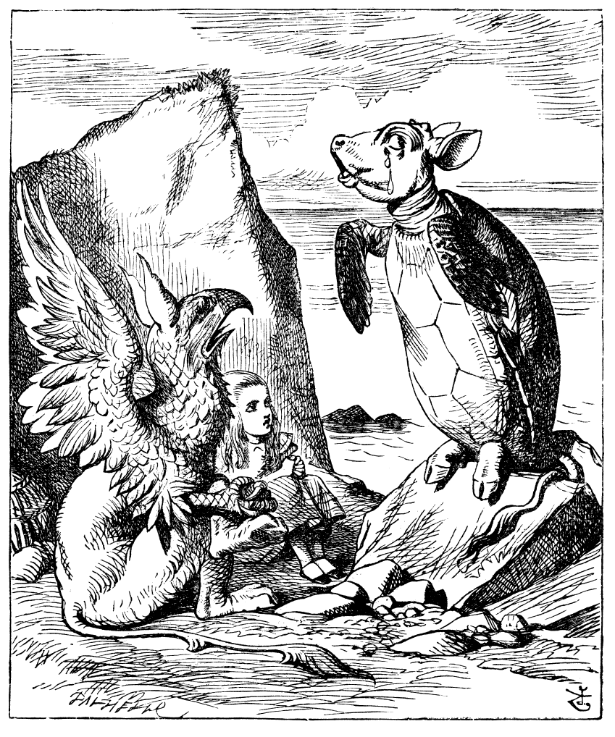
Writing to Analyse (PEA) Sentence Starters

Point:

This should be a clear and concise statement about the text.

- The writer presents … … as … … .
- Through the use of [technique], the writer … …
- The writer uses [technique] to … …
- In the text, the writer aims to … …

Evidence:

This is where you use quotations from the text to support your point. You should aim to select fairly short pieces of evidence. Remember to use quotation marks.

- This is shown when the writer writes “… …”
- For example, “… …”
- The writer states that “… …”

Challenge: Aim to embed your quotations. This means that they become part of your sentence. For example:

- My quotation for this is “a stampede of children”. (Not embedded)
- The writer describes the children as a “stampede”. (Embedded)

Analysis:

This is the most important part of your PEE paragraph. Here you explain how your evidence supports your point, and provide as much detail as possible. Use at least two of the following sentence starters per paragraph:

- This suggests that … …
- This gives the impression that … …
- This creates an image of … …
- The word “… … …” in particular has connotations of … …
- This creates a sense of … …
- The writer may have wanted to persuade/argue/show/present/convince … …
- This makes the reader think/feel/question/wonder/realise/support … … because … …

