NAME
TUTOR GROUP
LESSON DAY AND TIME
TEACHER

Notes, ideas, scribbles, thoughts and doodles
RESPECT
The Law

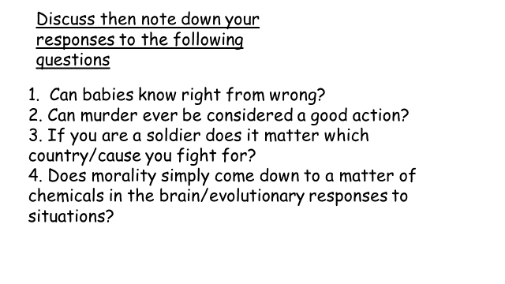

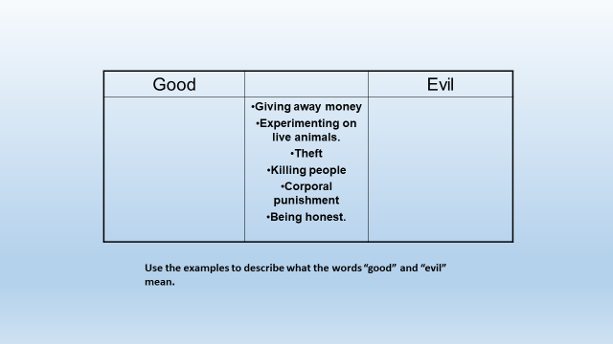
Criminal Law And Civil Law

Criminal | Civil

Good Laws/Bad Laws

It is still an offence to beat or shake any carpet rug or mat in any street in the Metropolitan Police District, although you are allowed to shake a doormat before 8am. SIt is illegal to keep a pigsty in front of your house (Unless duly hidden).
It is illegal to erect a washing line across any street.
It is illegal to sing any profane or obscene song or ballad in any street.
It is illegal to wilfully and wantonly disturb people by ringing their doorbells or knocking at their doors
It is illegal to order or permit any servant to stand on the sill of any window to clean or paint it.
It is an offence for the keeper of a place of public resort to permit drunkenness in the house.
The Easter Act 1928 provides that, in the United Kingdom, the Channel Islands and the Isle of Man, Easter Day shall be a fixed day in each year, viz. the first Sunday after the second Saturday in April
Under the Metropolitan Police Act 1839 no person (other than persons acting in obedience to lawful authority) is to discharge any cannon or other firearm of greater calibre than a common fowling-piece within 300 yards of any dwelling house to the annoyance of any inhabitant thereof. Maximum penalty: £200 fine. (LCSLPR*)
An employer cannot give a (subjective) bad reference as this may constitute libel.
The Metropolitan Streets Act 1867 prohibits the driving or conducting of any cattle through any street between the hours of 10.00 in the morning and 7.00 in the evening (except with the permission of the Commissioner of Police). The maximum penalty is a £200 fine for each head of cattle. (LCSLPR*)
It is illegal to eat Mute Swan unless you’re the Queen of Great Britain.
It is illegal to use a television in Britain without a license.
It is an offense to be intoxicated (drunk) and in charge of a cow in Scotland.
Under the terms of the Protection of Wrecks Order 2003: A person shall not enter the hull of the Titanic without permission from the Secretary of State.
Under the terms of the Polish Potatoes (Notification) in England Order – 2004: No person shall, in the course of business, import into England potatoes which he knows to be or has reasonable cause to suspect to be Polish potatoes.
It is apparently an offense to activate your burglar alarm and leave the property if you haven’t nominated a key-holder who can access your house to switch off your siren should it go off.
Under the terms of a bye-law it is illegal to “Jump” the queue in the tube ticket hall.
All beached whales and sturgeons must be offered to the reigning monarch.
A horn should not be sounded when stationary on a road at anytime, other than at times of danger due to another vehicle on or near the road.
In London, it is illegal for a person (knowingly) with the plague to flag down a taxi or try and ride on a bus.
A person shall be guilty of an offence if he uses for trade an automatic rail-weighbridge to which there is affixed a disqualification sticker.
It is illegal for a cab in the City of London to carry rabid dogs or corpses.
It is illegal to avoid telling the tax man anything you do not want him to know, but legal not to tell him information you do not mind him knowing.
It is illegal under the terms of the Prohibition and Inspections Act of 1998 to cause a nuclear explosion.

In your teams you must decide on three laws to keep and three to get rid of. You must be persuasive and give clear reasons in each case.
NOTES TO HELP

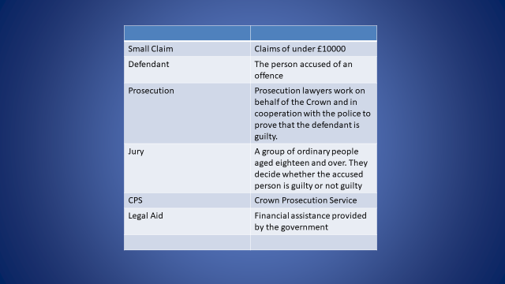

KEY LEGAL PRINCIPLES

Crimes against property | Crimes against people’s health and safety

ultracop

Policing the mean streets of Cirencester was never easy. Now it’s even harder. Funding cuts mean one police officer per town, with no back up, no police station and no rules. What does your Ultracop look like?

What happens
next?
You’re nicked!

1. When you're arrested
If you’re arrested, you’ll usually be taken to a police station, held in custody in a cell and then questioned.
After you’ve been taken to a police station, you may be released or charged with a crime.

Your rights in custody
The custody officer at the police station must explain your rights. You have the right to:
- get free legal advice
- tell someone where you are
- have medical help if you’re feeling ill
- see the rules the police must follow (‘Codes of Practice’)
- see a written notice telling you about your rights, eg regular breaks for food and to use the toilet (you can ask for a notice in your language) or an interpreter to explain the notice
You’ll be searched and your possessions will be kept by the police custody officer while you’re in the cell.

Young people under 18 and vulnerable adults
The police must try to contact your parent, guardian or carer if you’re under 18 or a vulnerable adult.
They must also find an ‘appropriate adult’ to come to the station to help you and be present during questioning and searching. An appropriate adult can be:
- your parent, guardian or carer
- a social worker
- another family member or friend aged 18 or over
- a volunteer aged 18 or over
The National Appropriate Adult Network provides appropriate adult services in England and Wales.

Your rights when being questioned
The police may question you about the crime you’re suspected of - this will be recorded. You don’t have to answer the questions but there could be consequences if you don’t. The police must explain this to you by reading you the police caution:
“You do not have to say anything. But, it may harm your defence if you do not mention when questioned something which you later rely on in court. Anything you do say may be given in evidence.”

The police arrest procedure
If you’re arrested the police must:
- identify themselves as the police
- tell you that you’re being arrested
- tell you what crime they think you’ve committed
- explain why it’s necessary to arrest you
- explain to you that you’re not free to leave
If you’re under 17 the police should only arrest you at school if it’s unavoidable, and they must inform your headteacher.
The police must also contact your parents, guardian or carer as soon as possible after your arrival at the police station.

Police powers to use reasonable force
If you try to escape or become violent, the police can use ‘reasonable force’, eg holding you down so you can’t run off.
You can also be handcuffed.
The police have powers to search you when you’re arrested.

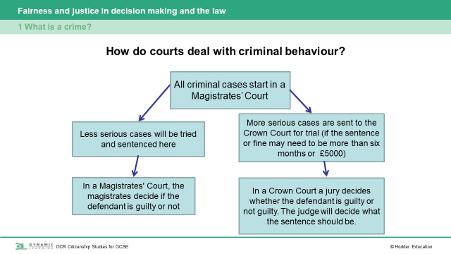

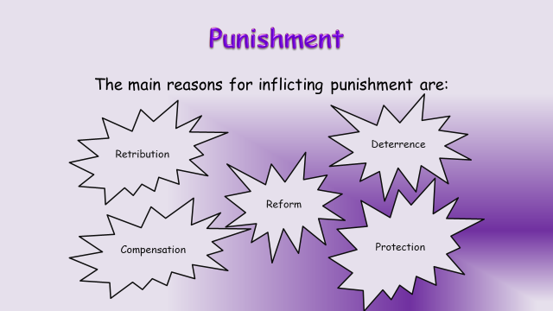
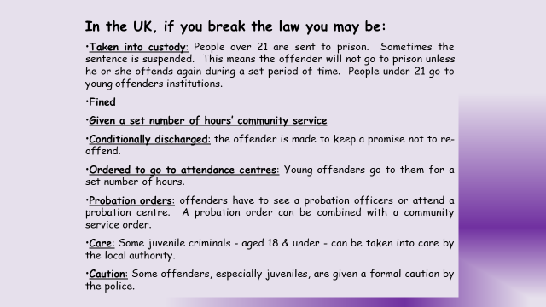
Crime | Punishment
A mother of two small children who was guilty of drug dealing?
Two youths who steal cars and joyride.
A serial killer who shows no remorse.
A young man who has committed credit card fraud.
A man who has sexually abused children.

Notes, ideas, scribbles, thoughts and doodles

Notes, ideas, scribbles, thoughts and doodles
