What is worship?

Things we “worship”… | FOR | AGAINST

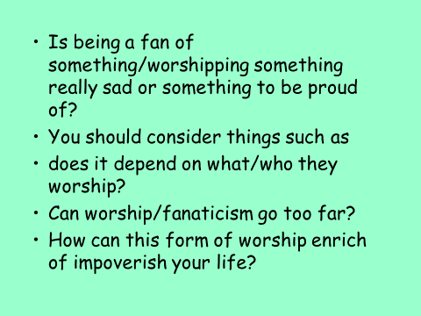

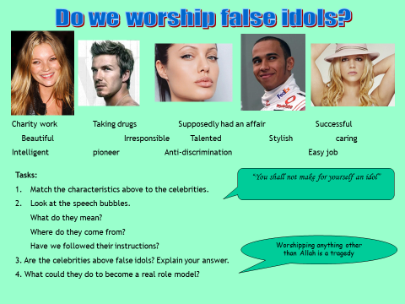
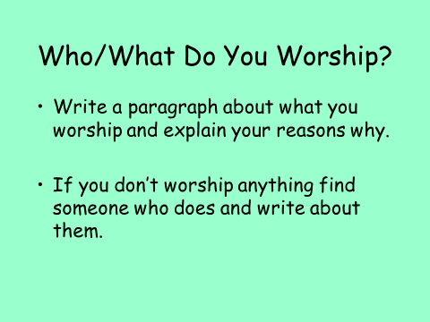

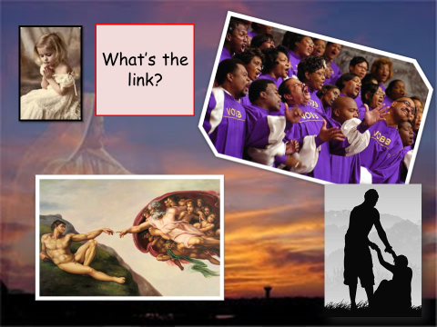
The link is…

What is Christian Worship?
What makes somewhere special to you?
Where are your special places?

The Features Of A Christian Church. (Write in the names).
THE FEATURE | IT LOOKS LIKE… | ITS PURPOSE
 | A big table in the front of the church.  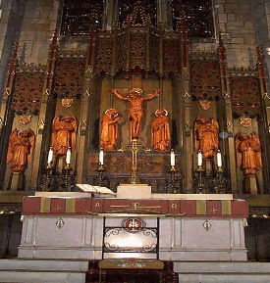 | To remind the worshippers of the last supper, where Jesus ate with his friends shortly before his sacrifice. This is where they come to get their bread and wine.
 | It is the symbol of Christianity  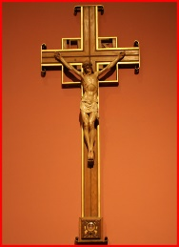 | To focus the minds of the worshippers on Jesus’ death and the way he beat death to come back three days later.
 | A book stand, often made in the shape of an eagle.  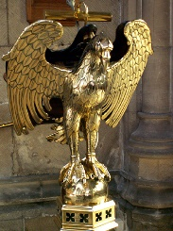 | A focal point for readings from the bible. The eagle represents St John, taking the words of the bible around the globe.
 | A raised platform.  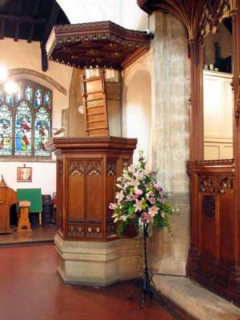 | It is where the priest/vicar stands to give the sermon which is the main teaching of the service.
 | A big bowl of water.  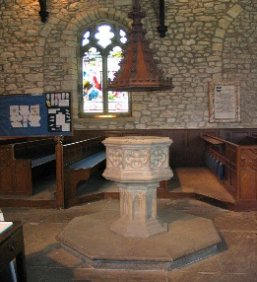 | This is where babies are baptised to welcome them into the church community. It is often near the door as a general welcoming sign.
 | Pretty.  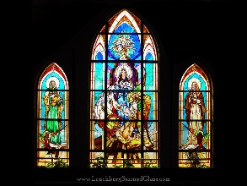 | They are coloured windows that show pictures from the lives of Jesus and the Saints. They inspire worshippers.
 | Long wooden benches or seats  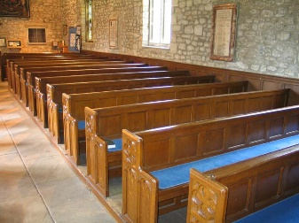 | This is where the worshippers (known as the congregation) sit. Often they are provided with kneelers – cushions to kneel on during prayers.
 | A bell, sometimes hidden in a tower.  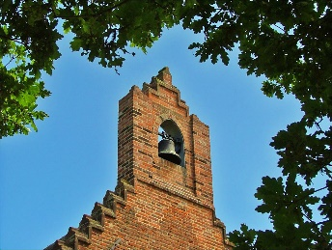 | This calls the worshippers to the church when it is time for a service. It is also used during the service itself.
The names of the features are…
Church Bell The Font The Altar The Cross The Lectern Stained Glass Windows The Pulpit The Pews

