Section A: Urban issues and challenges
Key idea: A growing percentage of the world’s population lives in urban areas.

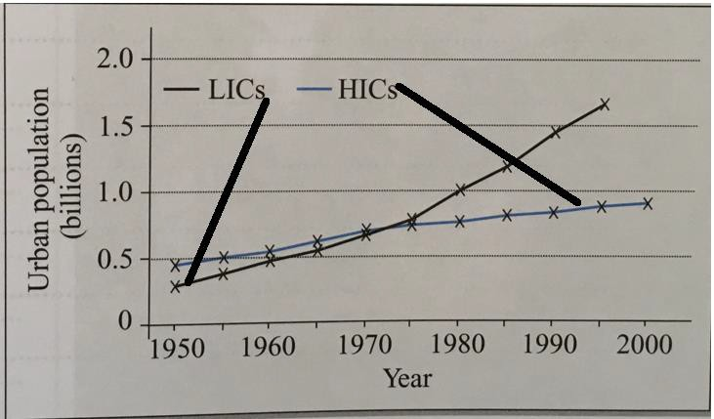
- Complete the graph to show that the urban population of LICs in 2000 was 2 billion.

- Describe the trends shown by the graph.
Trend: the pattern or overall result.

Aim to use descriptive language (e.g. increasing/decreasing, slow, steady, rapid, exponential, equal, overtake) and data (numbers).

- The paragraph below is about urban growth in HICs and LICs. Using the vocabulary provided, fill in the blank spaces. Vocabulary: development, rural, minimally, already, slow, varies, manufacturing, China, Germany, proportion, 50%, Industrial Revolution, World Bank, Ethiopia, highest, trebled.
Urbanisation refers to the growth in the (percentage) of a country’s population living in urban areas. Urbanisation is happening all over the world, and over of the world’s population now live in urban areas (and this is increasing). However, urbanisation is happening at different rates in places at different levels of . In high-income countries (HICs) like , urbanisation happened during the (in the 19th Century) meaning that today, most people live in urban areas. This means that rates of urban growth are in HICs because almost everybody in the country already lives there! (For example, in Germany, between 1960 and 2016 the proportion of people living in urban areas rose from 71% to 76%.) In LICs such as , urbanisation is happening more rapidly. LICs are less economically developed, meaning that it is only in recent years that many LICs have begun to develop industries such as in the urban areas, which encourages people to move from areas in search of work. Consequently, urban growth rates are in LICs. (For example, in Ethiopia, between 1960 and 2016 the proportion of people living in urban areas more than , from 6% to 20%) ( data). Newly emerging economies (NEEs) are countries where economic growth is happening rapidly, e.g. Brazil, , and Nigeria. In these countries, urban growth .

- Migration affects the rate of urbanisation, and push-pull theory helps to explain this. For each of the factors below, say whether it is push or pull, and explain how it causes migration. An example has been done for you.
Remember: a push factor is something that encourages someone to leave an area; a pull factor is something that encourages someone to move to an area

Factor | Push or pull? | How does it cause migration? | Common in HICs, LICs or  both?
Natural disasters
Mechanisation of agriculture
Family members living abroad
Better employment opportunities
Desertification
Improved quality of life
Improved health care and education
Conflict or war

- Define ‘natural increase’.

- What is the minimum population required for a city to be classed as a megacity?
- Study the map showing the world’s largest megacities. Using the map, answer questions 7a-7c.

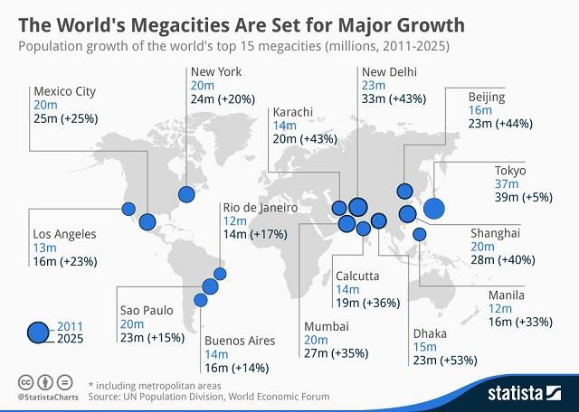
7a. Which megacity is predicted to have the greatest overall
population increase by 2025?

7b. Which megacity is predicted to have the greatest rate of urban growth of the fifteen megacities shown?

7c. Which region is predicted to experience the greatest urban growth by 2025? Shade one oval.
- North America
- Europe
- Asia

- Explain how natural increase leads to the growth of megacities.
Key idea: Urban growth creates opportunities and challenges for cities in LICs and NEEs.

The specification says that you need to use ‘an example of how urban planning is improving the quality of life for the urban poor.’ Make sure your example is based in an LIC or NEE.

The specification says that you need to use ‘an example of how urban planning is improving
the quality of life for the urban poor.’ Make sure your example is based in an LIC or NEE.
Example alert!
- Complete the template below to help you remember your urban planning example.

AN EXAMPLE OF HOW URBAN PLANNING IS IMPROVING THE QUALITY OF LIFE OF THE URBAN POOR
My example: Favela Bairro – Rio de Janeiro (pg162)
What are the problems? (Say why the QOL needs to be addressed in your chosen location. Try to include statistics.) | Which urban planning strategies are being used? (Describe them, and say how they address QOL issues.) | How effective are the strategies?

The specification says that you need to know ‘A case study of a major city in an LIC or NEE’ to illustrate the location & importance of the city, causes of growth, and how urban growth has created opportunities and challenges. As a case study, you need to know about many aspects of your chosen city. It is possible that an entire 9-mark question will be based on one key idea, so take the time to research and revise each section.

The specification says that you need to know ‘A case study of a major city in an LIC or NEE’ to illustrate the location & importance of the city, causes of growth, and how urban growth has created opportunities and challenges. As a case study, you need to know about many aspects of your chosen city. It is possible that an entire 9-mark question will be based on one key idea, so take the time to research and revise each section.

- To help you learn/revise this case study, complete the template below. (You should also do further research to help you remember place specific detail. Looking up YouTube clips about your chosen city is one useful way. Finding relevant images of the city and creating a visual brainstorm with annotations is another.)

A CASE STUDY OF A MAJOR CITY IN AN LIC OR NEE
My example: Rio de Janeiro
Map showing the location of the major city (either a sketch map or printed map) | Why is the city important? (You should discuss its importance within the country and within the world more broadly.)
Which migration factors are contributing to the city’s growth? (Push-pull factors; try to include statistics and place-specific detail). | How is natural increase contributing to the city’s growth? (How and why has natural increase changed in recent decades?)
What are the opportunities resulting from the urban growth? (Social opportunities e.g. access to services & resources + economic opportunities?) | What are the challenges resulting from the urban growth? (Managing urban growth, service and resource provision? Ec/soc/en)
Remember- an evaluate/assess element is possible in case study questions… think about which factors are the most significant in causing urban growth, and also about whether the opportunities or challenges are greater…

EXAM-STYLE QUESTIONS

- Explain how an urban planning scheme in an LIC or NEE has had a positive effect on people living in the area. (4)

- Using a named example of a city in an LIC or NEE, discuss the challenges created by urban growth. (9 + 3 SPaG)

Key idea: Urban change in cities in the UK leads to a variety of social, economic and environmental opportunities and challenges.

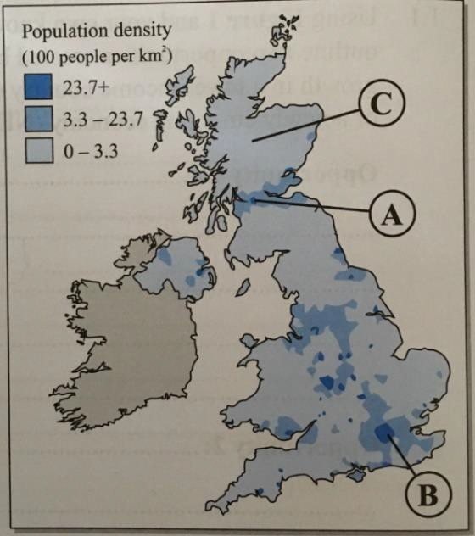
- Study Figure 1, a map showing the population density of the UK.

  - Describe population distribution in the UK.

- Name the cities labelled A and B on the map, and state which countries each city is located in.
A: The city is and is located in the country of
B: The city is and is located in the country of

- Suggest why the population density in areas B and C vary so much.

The specification says that you need to know ‘A case study of a major city in the UK’ to illustrate the location & importance of the city, impacts of migration on the city’s character and growth, and how urban growth has created opportunities and challenges. As a case study, you need to know about many aspects of your chosen city. It is possible that an entire 9-mark question will be based
on only one key idea, so take the time to research and revise each section in depth.

- To help you learn/revise this case study, complete the template below. (You should also do further research to help you remember place specific detail. Looking up YouTube clips and documentaries about your chosen city is one useful way. Finding relevant images of the city and creating a visual brainstorm with annotations is another. Looking up online articles about the city can help to shed light on the character of the city, especially if you look at newspapers from the city itself.)

A CASE STUDY OF A MAJOR CITY IN THE UK
My example: Bristol
Identify the location of the major UK city on the map. | Why is the city important? (You should discuss its importance within the UK and the wider world.)
What are the impacts of national and international migration on the growth of the city? (Try to use statistics.) | What are the impacts of national and international migration on the character  of the city?
What are the opportunities resulting from the urban growth? (e.g. soc/ec opps such as cultural mix, recreation and entertainment, employment, integrated transport systems, and environmental opps like urban greening?) | What are the challenges resulting from the urban growth? (soc/ec e.g. urban deprivation & inequalities; environmental e.g. dereliction, waste disposal; and the impact of urban sprawl etc.)

- Outline some of the problems experienced by the environment as a result of the growth of commuter settlements.

- EXAM-STYLE QUESTION: Using a named example, explain how urban change can cause inequalities in housing. (4)

The specification says that you need to use ‘an example of an urban regeneration project’ to show reasons for regeneration and the features of the project. Make sure your example is based in the UK.

The specification says that you need to use ‘an example of an urban
regeneration project’ to show reasons for regeneration and the features of the project. Make sure your example is based in the UK.
Example alert!

- Complete the template below to help you remember your urban regeneration project example.

AN EXAMPLE OF AN URBAN REGENERATION PROJECT
My example: Temple Quarter 182-185
Why did the area need regeneration? (Try to identify soc/ec/en issues and include statistics.) | What did the project involve?

Key idea: Urban sustainability requires management of resources and transport.

Cramming millions of people into relatively small spaces (cities) can take a huge toll on the environment, but strategies exist to make urban living more sustainable. Before you think about the strategies, you need to ensure that you know what ‘sustainable’ means!
Sustainability refers to a way of doing things that enables a balance of economic, social and environmental concerns, with a view to the long-term ‘health’ of people, the economy and the environment. If a government prioritises only economic growth at the expense of citizens and the natural environment, its approach is very unsustainable. Similarly, if a government only focuses on protecting the environment but does nothing about inequality, this is also unsustainable. If something is sustainable, it can continue well into the future. In both examples, the approaches could not continue for very long- they cannot be sustained.
- Decide whether each urban strategy below is sustainable (S) or unsustainable (U). Write an S or U next to each and give a reason/s for your decision.

Strategy | Sustainable (S) or Unsustainable (U) | Reason/s
City A has rapidly growing water needs. The government decides to transport water from the sparsely populated farming regions to use in the densely populated south.
City B has rapidly growing water needs. The government offer subsidies so that people and councils that install rainwater tanks do not have to pay the full cost of installation.
The population of City C generates a lot of waste. The government decides to build three new recycling plants to turn the waste into new products.
One of the councils in City D has approved the building of a business centre on one of its main parks. It’ll generate many jobs, but it will remove children’s play areas and habitats for
urban wildlife.

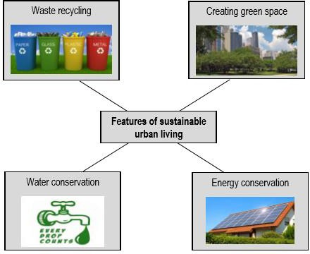
- Select one of the strategies to the right and assess the contribution that it can make towards sustainable urban living.

- Describe how traffic congestion can cause environmental and social problems in urban areas.

- Identify and explain one urban transport strategy to manage traffic congestion.

Strategy:

