Rivers Revision

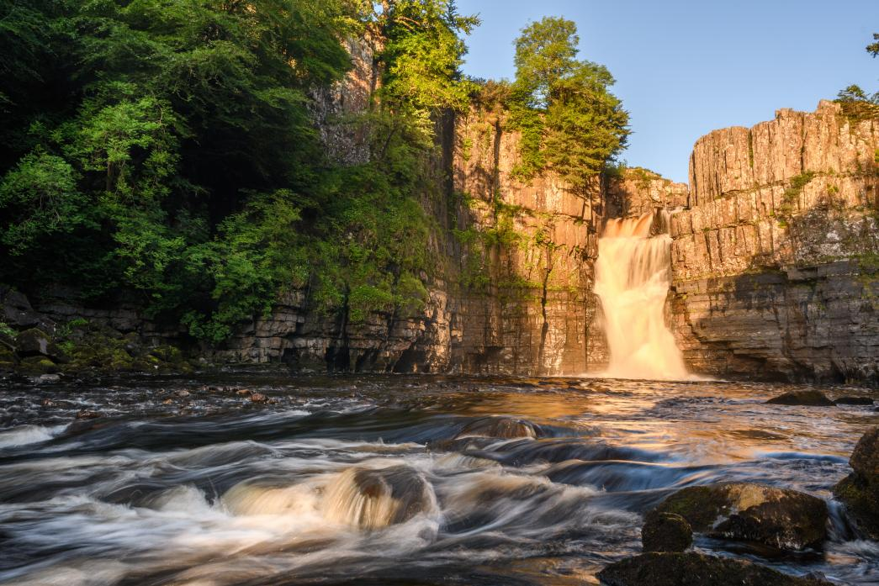

Instructions

- Use your exercise and text books to answer each task.
- Use processes and details when answering the 6 mark questions.
- You must develop your points using phrases such as ‘this means
that’ and ‘therefore’
- Use connectives to link ideas and use key terminology.

Answer the three questions below. (3) Name two types of erosion
How many meters does it have to be to be classified as a upland area?

Name two rivers in the UK
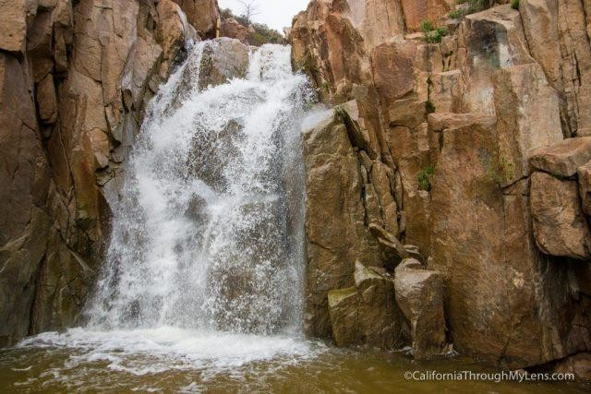
In the box below; annotate the image to show how it forms (3)

fig.1
List two types of river transportation.

1.
2.
Explain the the processes involved in the formation of the landforms shown in figure 1. (6 marks)
Plan

Answer the three questions below. (3)

Where would you find a meander (upper/middle/lower)? State one reason why a river might deposit its load.
What feature forms on the outside of a meander?
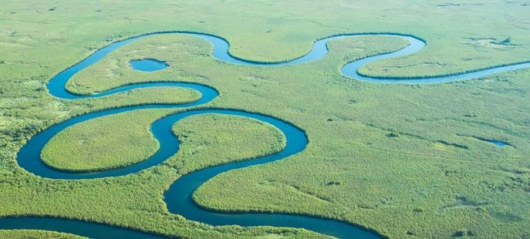
Annotate the photo using keywords to explain its formation (3)

Explain the formation of an oxbow lake using keywords (6 marks)
Describe the shape of the long profile of a river in the upper and lower course. (2)
1.
2.
Plan

Answer the three questions below. (3) Name one upland area in the UK
Name one change to a river as you move downstream

Define lowland area.
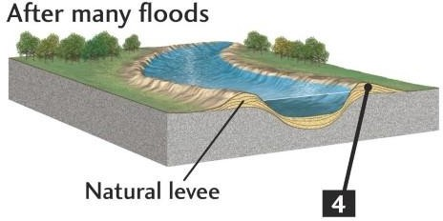
Annotate the photo to show how the landform is formed.) (3)

Explain the formation of a levee (6 marks)
Name two landforms you would find in the lower course of a river(2)
1.
2.
Plan

Answer the three questions below. (3)

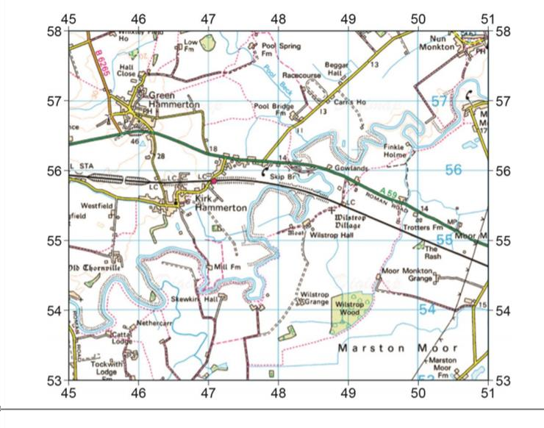
Name one physical factor that can affect a hydrograph

What type of transportation rolls large boulders at high velocity?

What type of erosion involves the sediment colliding together and breaking into smaller particles?
State the 4 figure grid reference for Mill Fm (1)
State the 6 figure grid reference for Mill Fm (1)
State one characteristic/landform of the River Ouse in grid square 4754 (1)
Plan
List two human factors that affect a hydrograph. (2)
1.
2.
To what extent is flooding caused by human or physical factors? (6 marks)

Answer the three questions below. (3)

What is our example of a river and its landforms?
State one way a river can be managed via hard engineering Define soft engineering

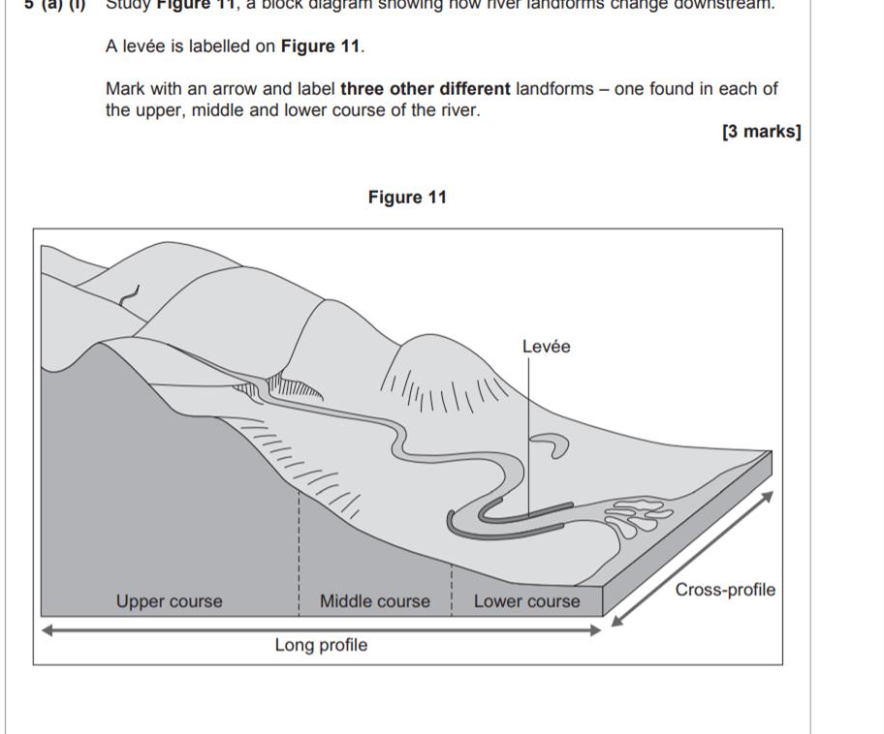
List two ways a river can be managed using soft engineering (2)
1.
2.
Plan
Using an example, explain how a river can be managed using both hard and soft engineering. (6 marks)

Answer the three questions below. (3) List one economic effect of flooding Name one cause of a flood
What happens to the velocity of a river as you move downstream
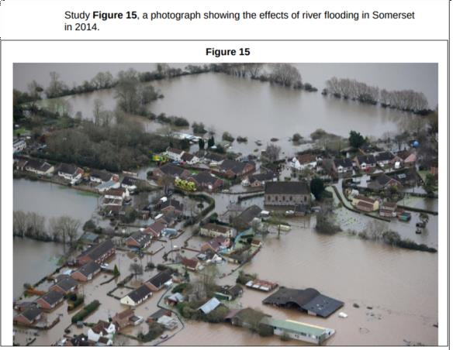
Annotate the image to show the impacts of flooding (3)

Explain using figure 15 above, the economic effects of flooding (6 marks)
List two features of a hydrograph. . (2)

1.
2.
Plan

