Name___________

Geography

Natural Hazards

Revision Guide

2021

Paper 1: Living with the physical environment
Section A: The challenge of natural hazards

Tectonic hazards

1a. A natural hazard is a natural event that has a social impact. Natural hazards include: |  |  |  | 1b. Hazard risk is the chance or probability of being affected by a natural event. |  | 2. The structure of the earth comprises:  Crust:  - Thin, outermost layer up to 60km thick.  - Solid; which is split into ‘slabs’ called plates which move due to convection currents.  - 2 types of crust:  - Oceanic – thin, dense  - Continental – thick, less dense  - 3 types of plate margin:  - Constructive  - Destructive  - Conservative  Mantle:  - Widest section – approximately 2900km.  - Made of semi-molten rock called magma.  - Convection currents are present.  - Made of iron and magnesium.  - Can reach temperatures of 3800°C  Core:  - Innermost part of the earth.  - Very hot – up to 5500°C  - Made of iron and nickel.  - Sometimes split into inner core and outer core.  - Inner core is solid, outer core is liquid.
Atmospheric  Rain  Lightning  Snow  Drought  Hurricanes  Tornadoes  Winds | Geological  Volcano  Landslide  Mudflow  Earthquake  Avalanche  Tsunami | Flooding  Flooding  - River  -Coastal |  | 3a. Earthquakes and volcanoes are the result of tectonic activity at plate margins.  - Earthquakes occur at plate margins when the movement of plates builds up pressure which is then suddenly released.  - Volcanoes occur when molten rock (magma) from deep within the earth rises to the surface. This occurs at either constructive or destructive plate margins. They may also occur at hot spots where the crust is thin. Hawaii is a good example.
1c. More people are at risk of natural events because of:
- Urbanisation – Poverty – Farming – Climate change
3b. Three main types of plate margin:
Constructive: 2 plates move apart leading to earthquakes and volcanoes; typically broad & flat shield volcanoes. E.g. Mid-Atlantic Ridge, Iceland.
Destructive: 2 plates move towards one another. If oceanic and continental plates subduction will occur leading to strong earthquakes and powerful volcanic eruptions from composite volcanoes. E.g. Nazca & South American Plate, Andes. If 2 continental plates there is no subduction but instead collision leading to earthquakes & formation of fold mountains like the Himalayas.
Conservative: 2 plates move past each other with the resulting friction leading to earthquakes. E.g. San Andreas Fault, California.
4a. Primary effect of an earthquake – caused directly by the shaking and ground movement. Includes deaths, injuries and damage to buildings & infrastructure.  Secondary effects occur as a result of the primary effect. Includes tsunamis, fires & landslides. |  |  | 4b. There are two different responses to natural disasters such as earthquakes:  Immediate responses – search & rescue keeping survivors alive by providing medical care, food, water & shelter.  Long term responses – re-building & reconstruction to return to normal & reduce risk. |  |  | 5. People live in tectonically active areas due to the following reasons:  - Poverty – people lack choice  - Awareness (lack of)  - Benefits in volcanic areas (Iceland):  - Fertile soils  - Rocks for building  - Mineral deposits  - Hot water  - Favourable areas  - Ports  - Water – reaches surface; important in desert areas  - Monitoring – reduces the threat  - Building design – reduces the threat  - Timescale (happen rarely)  Iceland is a good example to use:  - Geothermal energy – volcanic rocks for construction – tourism – hot water for heating homes & greenhouses for agriculture.
6a. The 4 main management strategies for reducing the risk from tectonic hazards.  Monitoring –  Watching the volcano  Prediction –  Best estimate when the tectonic event will occur.  Protection –  Building design & regulations.  Planning –  Identifying and avoiding areas most at risk. |  |  | 6b. Earthquake proof building design includes:  - Walls reinforced with steel & concrete to reduce movement.  - Rolling weights on roof to counteract shock waves.  - Automatic shutters to prevent falling glass.  - Shock absorbers to absorb shaking.  - Sprinklers  - Cross bracing to limit twisting  - Open areas for evacuation.
Effects and responses to tectonic hazards vary between areas of contrasting levels of wealth
Chile earthquake, 27 Feb 2010, richer country.  Richter scale 8.8  Destructive plate margin – Nazca & South American Plate, off the coast of Central Chile in the Pacific.  Cost of earthquake US$30 billion. |  |  |  |  | Nepal earthquake, 25 April 2015, poorer country.  Richter scale 7.9  Destructive plate margin (collision) – Indo-Australian & Eurasian Plate, 80km north-west of capital Kathmandu.  Cost of earthquake US$5 billion.
Chile primary effects  - 500 killed  - 12,000 injured  - 800,000 affected  - 220,000 homes destroyed  - 4,500 schools destroyed  - 53 ports destroyed  - 56 hospitals destroyed  - Port of Talcahuanao damaged  - Santiago airport damaged |  |  |  |  | Nepal primary effects  - 9,000 killed  - 20,000 injured  - 8 million affected  - Homes destroyed of 3 million people  - 7,000 schools destroyed  - 50% of shops destroyed
Chile secondary effects  - 1,500km roads damaged, mainly by mudslides.  - Remote communities were cut-off.  - Tsunamis destroyed coastal towns.  - Fire at a chemical plant in Santiago. |  |  |  |  | Nepal secondary effects  - Landslides & avalanches blocked roads; hampering relief efforts.  - Avalanches on Mount Everest killed 19 people.
Chile immediate responses  - Emergency services acted swiftly (domestic).  - International assistance with field hospitals, satellite phones & floating bridges.  - Power & water restored to 90% of homes within 10 days.  - 30,000 small emergency shelters provided by international appeal. |  |  |  |  | Nepal immediate response  - International search & rescue teams required to provide water & medical support. Help was sent from UK, India & China.  - 500,000 tents required to shelter the homeless.  - 300,000 migrated from Kathmandu to seek shelter with family & friends.  - Helicopters used to access isolated areas.
Chile long term responses  - Government plan to rebuild 200,000 households put in place 1 month after the earthquake.  - Chile’s strong economy based on copper exports was robust & did not need foreign aid.  - Recovery could take 4 years according to the President. |  |  |  |  | Nepal long term response  - Roads repaired & landslides cleared.  - Homeless to be re-housed & damage houses repaired.  - 7,000 schools to be rebuilt.  - International conference held to discuss what support could be provided by other countries.  - Everest climbing routes & base camp re-opened to help tourism.  - Heritage sites reopened to boost tourism & help the economy.

Weather Hazards

1a. Key terms:  Storm surge: abnormal rise of the sea along a shore as the result of low pressure and high winds. The storm surge of Typhoon Haiyan (2013) was 5m at Tacloban.  Coriolis Effect: Causes the spin of a tropical storm due to the earth’s rotation.  Mandatory evacuation: Commanded by the authorities.  El Nino: a warming of the ocean surface of the western coast of South America.  Natural cycle: series of events in nature that are repeated.  Latitude is used to identify how far a location is north or south of the equator.  Longitude is used to identify how far a location is east or west of the Prime Meridian.  When quoting latitude and longitude, latitude always comes first (it’s alphabetical).  The UK is located about 55$°$N. |  |  |  |  |  |  |  | - 1b. Global atmospheric circulation transfers heat from the Tropics to the Poles. Think of it as a conveyor belt.  - In each hemisphere north and south of the equator there are three cells. From the equator to the Poles these are the Hadley cell, Ferrel cell and Polar cell.  - In these cells air circulates through the entire depth of the troposphere.  - The troposphere is the name given to the vertical extent of the atmosphere from the surface, right up to between 10 and 15 km high. It is the part of the atmosphere where most of the weather takes place.  - The UK at about 55°N is between the Ferrel cell bringing warm wet winds from the south west and the Polar cell bringing cold polar winds from the north.
1c. High pressure areas are formed where the air is sinking – Poles, sub-tropics (desert areas).
Low pressure areas are formed where the air is rising – Equator (tropics), sub-polar low.

Winds on the ground are formed by air moving from areas of high pressure to low pressure.
Winds on the ground are distorted by the rotation of the earth. This is the Coriolis Effect. Winds appear to be deflected to the right in the northern hemisphere.
2a. Three ingredients needed for a tropical storm to form:  - Warm ocean water: Tropical storms form in the Tropics because they need warm oceans (27 °C). This explains hurricane season being in the summer and autumn when ocean temperatures are at their warmest.  - Warm rising air (low pressure): caused by the intense heat of the tropics & normally signified by thunderstorms.  - Rotation (Coriolis Effect): Tropical storms do not form directly on the equator (from 0-5 degrees north and south) as the Coriolis Effect is too weak (spin).  Tropical storms do not extend (with much intensity) inland into continental land masses as they need warm water to fuel them. |  |  |  |  |  |  |  | 2b. Sequence of tropical storm formation:  - Several thunderstorms drift over warm seas in a low pressure area.  - Warm air from sea surface causes evaporation of water which is drawn upwards.  - The rising water vapour combines with and adds to the thunderstorms as warm air continues to rise.  - Coriolis Effect from the earth’s rotation acts upon the Trade Winds and so the rising air starts to spin.  - As the air rises it cools, condenses into cloud and releases energy.  - The tropical storm develops as warm air rises and cold air is sucked downwards to form the eye which is relatively calm.  - Wind speeds reach more than 120kph.  - The tropical storm gains strength as it crosses more warm water  - On reaching land the storm’s energy supply (evaporated water) is cut off and so the storm loses strength.
3a. Primary effects of a tropical storm are the impacts of the strong winds, heavy rain and storm surge. They include:  - Fatalities  - Damage to buildings and infrastructure  - Destruction of crops. |  |  |  | 3b. Secondary effects of a tropical storm are the longer term impacts that are a consequence of the primary effects. They include:  - Homelessness  - Unemployment  - Spread of disease  - Looting  - Insurance costs |  |  |  |  |  |  |  | 3c. Effects of a tropical storm can be further divided into:  - Physical and environmental – damage to buildings, loss of animal habitats.  - Social – disease, looting, unemployment.  - Economic – Businesses closed, loss of income, insurance claims.
3d. Tropical storms cause damage due to:  - High winds  - Torrential rain which causes flooding  - Storm surge which can cause the highest loss of life. |  |  |  |  |  | 3e. Hurricanes are measured using the Saffir-Simpson scale.  - Category 1 status is reached when wind speeds exceed 119km/h.  - Category 5 (strongest) is reached when wind speeds exceed 252km/h
4a. ‘Super’ Typhoon Haiyan, November 2013, Philippines
- Saffir-Simpson category 5, wind speeds up to 275km/h
- 15m high waves
- 5m high storm surge
4b. What happened – why the storm was so powerful  Wind speeds peaked as it hit the Philippines coast, particularly in the province of Leyte & city of Tacloban.  Tacloban destroyed by a 5m high storm surge  Coincidence of favourable circumstances for a super typhoon. |  |  |  |  |  |  |  |  | 4c. Why the Philippines are vulnerable tropical storms and their effects.  Over 7000 islands situated in some of the warmest waters on the planet.  High population density.  Newly emerging economy with millions of people living in poverty.
4d. Monitoring, prediction and preparation
Did not predict level of storm surge.
Many Filipinos were not concerned as they are used to typhoons.
Preparations were not adequate.
4e. Primary effect  - Over 6000 dead (6300) – most drowned from storm surge  - Weak buildings swept away by storm surge  - Infrastructure destroyed  - 40,000 homes destroyed  - 30,000 fishing boats destroyed  - Crops destroyed |  |  |  |  |  |  |  | 4f. Secondary effect  - 14 million people affected  - Resettlement crisis  - 6 million people lost their source of income as agriculture and fishing industries (main source of employment) destroyed  - Landslides from flooding cut off communities  - Shortages of food, water & shelter led to outbreak of disease  - Looting & violence in Tacloban
4g. Immediate response  - Medical services worked around the clock.  - US Military deployed a Strike Battlegroup for search, rescue and aid delivery  - NGOs such as Save the Children deployed.  - 1200 evacuation centres set up for the homeless  - International field hospitals set up  - Philippines Red Cross delivered basic food aid |  |  |  |  |  |  |  | 4h. Long term response  - Relief effort will need to continue for years  - Rebuild homes destroyed – families salvaging what they can and building by themselves  - Homes to be rebuilt away from flood risk areas  - Infrastructure to be rebuilt  - Cash for work programmes – people paid to help with clear up & rebuilding effort  - Rice farming & fishing re-established  - Cyclone shelters built
5a. The effects of tropical storms can be reduced by: + Monitoring + Prediction + Protection + Planning
5b. Monitor  Monitoring tropical storms allows predictions to be made. Satellites, aircraft & drones are used. | 5c. Predict  This is still an inexact science. Supercomputers will be used to produce forecast maps with a track cone predicting the path and intensity. The cone of uncertainty represents the probable track of the centre of a tropical storm. Historically the centre of a tropical storm stays inside the cone of uncertainty 66% of the time. |  |  |  |  |  | 5d. Protection  In the USA the Federal Emergency Management Agency (FEMA) advises homeowners to:  - Install hurricane straps (galvanised metal) between the roof and wall.  - Install storm shutters on windows.  - Install an emergency generator.  - Tie down windborne objects such as garden furniture.  - Reinforce garage doors.  - Remove trees close to buildings. |  |  |  |  |  |  | 5e. Planning  Involves raising individual and community awareness. In the USA the National Hurricane Preparedness Week educates people about the dangers of the next hurricane season.  - Prepare disaster supply kits.  - Have fuel in vehicles.  - Know where the official evacuation shelter is located.  - Store loose objects.  - Plan with family members what to do.
5f. Change in the future  - Opinion is divided as to whether the frequency, distribution, intensity and duration of tropical storms will change as a result of climate change.  - Distribution. Increase in sea temperatures beyond the tropics could mean tropical storms could form in areas outside of the current hazard zone.  - Frequency and intensity. Some scientists have predicted the frequency of storms could reduce but the intensity could increase.  - Duration. Tropical storm season may be extended as the oceans are warmer for longer throughout the year. |  |  |  |  |  |  |  |  |  | 6a. Weather is the description of the day-to-day conditions of the atmosphere. This includes temperature, amount of cloud, the strength and direction of the wind and the amount of precipitation.  Climate is the average weather over a long period of time. Data collected over a 30-year period is used to describe the climate of a place.
6b.  - The UK is at a meeting point of different air masses which can each bring different weather conditions.  - These air masses largely dictate the changeable nature of our weather.  - Although the UK has a moderate climate it can still experience extreme weather events. |  | 6c. When extreme weather causes damage to societies this then become a weather hazard. The UK is subjected to:  - Thunderstorms  - July 2014 electrical storms  - Boscastle flash flood August 2004  - Prolonged rainfall  - Winter 2013-14 Somerset floods  - Strong winds  - Storm Doris 94mp/h winds February 2017  - Drought & extreme heat  - 2003 heat wave  - Heavy snow & extreme cold  - Winter of 2010-2011 |  |  |  |  |  |  |  |  |  |  | 6d. Four different types of flood associated with extreme weather in the UK. These include:  - Coastal flooding  - River flash flooding  - Slow-onset river flooding  - Surface water flooding (pluvial).
7a. Somerset Levels floods 2014  Somerset Levels are an extensive area of low-lying farmland drained by several river including the River Tone and River Parrett. Flooding has occurred here for centuries. |  |  | 7b. Causes of the 2014 Somerset Levels floods (human & physical)  - Wettest January since records began in 1910 (physical  - Series of depressions form the Atlantic brought the prolonged rainfall (physical)  - 350mm of rain fell in January & February – 100mm above average (physical)  - High tides and storm surges from the Bristol Channel prevented outflow of river water (physical)  - Rivers had not been dredged for 20 years and were clogged with sediment (human).
7c. Impacts of flooding can be categorised as social, economic or environmental
7d. Social impact  - 600 houses flooded  - 16 farms evacuated  - Residents evacuated to temporary accommodation for several months  - Disruption to daily life as villages like Moorland were cut off  - Power supplies cut off |  |  |  |  | 7e. Economic impact  - More than £10 million of damage  - 14000 hectares of agricultural land submerged & degraded  - 1000 livestock evacuated  - Local residents cut off  - Bristol to Taunton railway line closed at Bridgewater |  |  |  |  |  |  |  | 7f. Environmental  - Floodwaters contaminated with sewage & other pollutants including oil & other chemicals  - Debris needed to be cleared  - Stagnant water needed to be reoxygenated before it could be pumped back into rivers
7g. Immediate response  - Local level response with community volunteers – transport in small boats & sand bags for protecting homes  - Many locals became angry about the lack of help that came from the Government  - Pumps were brought in from as far away as the Netherlands to help clear the floodwater  - The Army were called in to help deliver supplies, evacuate people and build temporary flood defences. |  |  |  |  |  |  |  |  |  |  | 7h. Longer-term response  - £20 million 20 year flood action plan  - Rivers Tone & Parrett dredged to increase carrying capacity  - Road levels raised  - River banks being raised  - More pumping stations to be built  - Possible tidal barrage at Bridgewater

Climate Change

1a. The Earth was formed approximately 4600 million years ago (4.6 billion years).  Earth scientists describe the history of the earth using the geological time scale which has stratified divisions of time.  Geologically speaking we are currently in:  - Cenozoic era: 65 million years (age of mammals)  - Quaternary period: 2.6 million years ago (age of ice ages). The Quaternary has not only been colder, it has also been a time of big climate variation compared with earlier geological periods. The Quaternary period is split into two epochs, the Pleistocene and the Holocene.  - We are currently in the Holocene epoch which started approximately 12000 years ago. | 1b. It is believed that there has been five major ice ages in the earth’s history. Technically speaking, we’re living during an ‘Ice Age’ today – in the sense that we have a world with glaciers and ice sheets. However, the present time is a relatively warm phase within a period of geological time when glaciers and ice sheets have typically been larger and more extensive than now.  Today the major ice sheets are the Antarctic Ice Sheet and the Greenland Ice Sheet. However, during the Last Glacial Maximum (LGM) ice sheets covered a far greater area than they do today.  Glacial periods – cold spikes  Inter-glacial periods – warmer periods within an ice age. We are currently in an inter-glacial period
 | 1c. The Holocene epoch is the relatively warmer phase (interglacial) we are in now. The invention of farming and civilisation has happened during the Holocene. Before the Holocene epoch was the Pleistocene epoch. Our species (Homo sapiens) was evolved during the Pleistocene epoch. During the Pleistocene huge glaciers and ice sheets covered huge parts of planet earth.
2a. Evidence for climate change  Observations:  - Shrinking glaciers and melting ice  - Rising sea level  - Seasonal changes  - More extreme weather events  Reliable instrument records. In the UK the Met Office has recorded the climate at various locations since 1910 using:  - Weather stations  - Satellites  - Weather balloons  - Radar  - Ocean buoys.  To know what the climate was like before these instrument records we must use Proxy recordings:  - Historical recordings - Diary entries, observations, pictures, prices.  - Geomorphology - the interpretation of features in the landscape.  - Sedimentology - the characteristics of rocks, sands and soils.  - Ecology - the study of fossil or sub-fossil organisms. Fossilised pollen is useful.  - Dendrochronology - Each ring marks a complete cycle of seasons, or one year, in the tree's life. A wider ring in a favourable year and a narrower ring in an unfavourable year.  - Ice cores - records go back 800000 years. |  |  | 2b. Since 1880 the average global temperature has increased by 0.85°C. Most of this has occurred since the mid-1970s  Global effects of climate change:  - Glaciers & ice caps shrinking  - Arctic sea ice is reducing  - Sea levels may rise by 1m by 2100 flooding coastal areas  - Low-lying islands under threat from sea level rise (Maldives).  The effects can be positive as well as negative. We can further subdivide them into social, economic and environmental effects.
3. The greenhouse effect is a naturally occurring phenomenon that keeps the Earth warm enough for life to exist. It is thought that without the greenhouse effect, the Earth would be approximately 33°C colder and therefore life would not exist as we know it today. Short-wave (high energy) solar radiation enters the Earth’s atmosphere. The heat is reflected from the Earth’s surface as long-wave radiation (low energy). The natural layer of greenhouse gases allows some heat to pass out of the Earth’s atmosphere, but some of the Earth’s infrared heat is trapped, which keeps the Earth warm enough. The enhanced greenhouse effect, sometimes referred to as climate change or global warming, is the impact on the climate from the additional heat retained due to the increased amounts of carbon dioxide and other greenhouse gases that humans have released into the Earth’s atmosphere since the industrial revolution.
4. Natural causes of climate change:  Geological records stretching back millions of years indicate a number of large variations in Earth’s past climate. In particular the Quaternary period involved dramatic changes of climate which occurred before humans could have any environmental impact.  - Orbital changes as noted by Milankovitch a Serbian geophysicist. These result in cycles of temperature change. In particular the 100,000 year eccentricity cycle coincides closely with the alternating cold (glacial) and warm (inter-glacial) periods of the Quaternary:  - Eccentricity (100,000 year cycle) – circular to elliptical orbit around the sun. Earth is warmer if orbit is more circular  - Axial tilt (41,000 year cycle) – the angle of the Earth’s axis around which it spins. Greater variation in seasons if a greater tilt.  - Precision (26,000 year cycle) – the ‘wobble’ of the Earth as it spins. Has an impact on seasons.  - Solar activity – Sunspots are dark patches that appear on the surface of the sun. When sunspot activity is at a maximum the Sun gives off more heat. The sunspot cycle of minimum activity to maximum activity and back to minimum again occurs over an 11 year cycle.  - Volcanic activity – ash, gases & liquids forced into the atmosphere lower global temperatures. Not cyclical and hard to predict. |  | 5. Human causes of climate change:  Many scientists believe humans have caused climate change (global warming) by releasing additional greenhouse gases into the atmosphere. This has led to the enhanced greenhouse effect. Humans have added to the different greenhouse gases in the following ways:  - Carbon dioxide accounts for 60% of the enhanced greenhouse effect.  - Car exhausts  - Burning fossil fuels for industry and in power stations  - Deforestation & burning wood  - Nitrous oxides are 300x more potent at trapping heat than carbon dioxide.  - Car exhausts  - Agricultural fertilisers  - Sewage treatment  - Power stations producing electricity  - Methane accounts for 20% of the enhanced greenhouse effect.  - Farm livestock  - Rice farming  - Burning biomass for energy  - Decaying organic matter in landfill and compost heaps
6a. Managing the impacts of climate change can be done by two different methods – mitigation or adaptation.
6b. Mitigation is the action of reducing the severity, seriousness, or painfulness of something. Climate change can be mitigated by:  - Using alternative energy sources that do not emit large quantities of CO2. The UK aims to produce 15% of its energy from renewable sources by 2020. Alternative energy sources include:  - Hydro-electricity  - Nuclear power  - Solar  - Wind  - Tides  - Carbon capture and storage technology. It is possible to capture up to 90% of CO2 released from power stations. This can then be stored safely in underground reservoirs.  - Planting trees which act as a carbon sink.  - International agreements which seek to limit greenhouse gas emissions. The 2015 Paris Agreement aims to limit temperature increase below 2°C. |  | 6c. Adaptation responds to the impacts of climate change and tries to make populations less vulnerable. Adaptation strategies are local rather than global. We can adapt to climate change by:  - Changing agricultural techniques to adapt to changing climate such as drought resistant crops in the Gambia.  - Managing water supply to protect against possible water shortages. In the Himalayas the loss of water storing glaciers have been replaced by a series of embankments and channels which hold water so it freezes as an artificial glacier.  - Managing sea level rise in low lying coastal areas at risk. The low lying Maldives are being protected by:  - 3m high sea walls  - Houses built on stilts  - Artificial raised islands  - Restoration of mangrove swamps  - Possible relocation of the population

What do I need to revise?
Natural hazards
I can define a natural hazard and give some examples of the different types.
I can explain the different factors that affect risk.
Tectonic hazards
I can describe the distribution of earthquakes and volcanoes.
I explain the differences between destructive, constructive and conservative plate margins.
I know the main features of an earthquake and two different ways of measuring earthquakes.
Using named examples (Chile and Nepal) of a tectonic hazard in both rich and poor countries. I can:
- Explain why the tectonic hazard happened there,
- Describe the effects that resulted from the earthquakes both primary and secondary.
- Describe what was done after the earthquake (responses), both in the long and short term.
I can explain why earthquakes cause more loss of life in poor than in rich countries.
I can explain why people continue to live in areas at risk of tectonic hazards.
I can explain how monitoring, planning and prediction of tectonic hazards can reduce their effects.
Weather hazard
I can describe the global atmospheric circulation model.
I can explain how the global atmospheric circulation model affects weather around the world.
I can describe the distribution of tropical storms.
I can explain the causes of a tropical storm.
Using a named example I can describe and explain the primary and secondary impacts of tropical storms.
I can evaluate the immediate and long term responses to a named example of a tropical storm.
I can explain how tropical storms might be affected by global warming.
I can explain how monitoring, planning and prediction of tropical storms can reduce their effects.
I can explain the cause of an extreme weather event using an example (Somerset floods).
I can describe and explain the social, economic and environmental impacts of the Somerset floods..
I can identify evidence of the weather becoming more extreme.
I can explain how extreme events can be managed to reduce the impacts.
I can assess and evaluate the impact that weather conditions have upon people homes, lives, agriculture, health and transport.
Climate change
I can explain the evidence both for and against climate change.
I can explain both the natural and human causes of climate change.
I can assess and evaluate the economic, social, environmental and political impacts of climate change both on the world and the UK.
I can describe and evaluate the mitigation strategies used to reduce the impact of global climate change on a
local, national and international level.
I can describe and evaluate the adaption strategies used to reduce the impact of global climate change on a local, national and international level.

The Challenge of Natural Hazards: Workbook

Natural hazards pose major risks to people and property.

1. Define the term natural hazard. Give some examples.

________________________________________________________________
________________________________________________________________
________________________________________________________________
________________________________________________________________

2. Complete the table below

Events: earthquake, volcanic eruption, tsunami, tropical storm, hurricane/typhoon/cyclone, climate change

Event | Meaning
 | Lava erupts from a vent in the earth’s crust. This occurs at destructive and constructive plate boundaries.
 | Changes to the earth’s atmospheric patterns, especially rainfall and temperature. These changes vary region to region, but in many places they involve increases in temperature.
 | Different names are given to tropical storms depending on where they occur.
 | Shaking of the ground due to tectonic movement. This occurs at all plate boundary types.
 | A series of fast moving, long and high waves resulting from tectonic movement under the ocean floor.
 | A powerful storm that moves at more than 74 miles per hour. They form over water and spin in an anticlockwise direction, gathering power as they move over water & losing power when they reach land.

3. Would the hazard risk be greater for A or B? In the final column give reasons for your choice. An example has been done for you.

Question | A | B | Greater risk
Where will economic cost be greatest? | Volcanic eruption in a rural area | Volcanic eruption in an urban area | B | Urban areas have more buildings and businesses so insurance and reconstruction costs would be higher. Replacement of belongings is costly for individuals.
Where will economic cost be greatest? | Earthquake in an urban area in a HIC | Earthquake in an urban area in a LIC
Where will human cost be greatest? | A tsunami strikes a densely populated  coastline | A tsunami strikes a sparsely populated  coastline
Where will human cost be greatest? | Rising sea levels- mountainous region | Rising sea levels- small Pacific islands

Tectonic hazards

Earthquakes and volcanic eruptions are the result of physical processes.

4. Look at the map below. What is a plate margin?

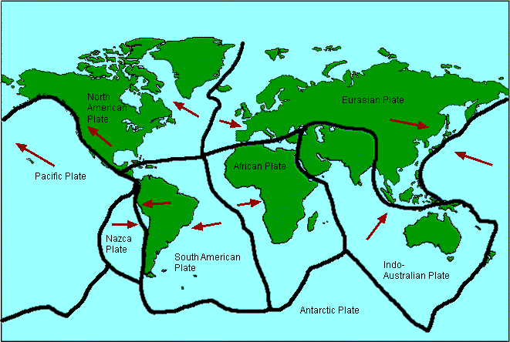
________________________________________________________________
________________________________________________________________
________________________________________________________________
5. Which areas are more likely to experience tectonic hazards? Circle the correct answers.

a. On or near plate margins – far from plate margins
b. Coastal areas – inland areas
c. The western coast of North America – the east coasts of North America
d. Southern Africa – south and east Asia

6. There are three main types of plate margin.
For each draw a diagram showing plate movement.
Write a sentence describing what happens.
Indicate the type of hazard that occurs as a result.
Give an example of where this occurs (use the map).

a. Destructive margin
________________________________________________________________
________________________________________________________________
________________________________________________________________

b. Constructive margin

________________________________________________________________
________________________________________________________________
________________________________________________________________

c. Conservative margin

________________________________________________________________
________________________________________________________________
________________________________________________________________

The effects of, and responses to, a tectonic hazard vary between areas of contrasting levels of wealth.

7. Below are some effects of and responses to tectonic hazards. Code as:
PE (primary effect)
SE (secondary effect)
IR (immediate response)
LR (long-term response)

Building collapse People are made homeless Evacuation
Disease spreads Tents given out by NGOs Looting
People are killed Water contaminated Homes rebuilt
Search and rescue Building regulations improved Crops lost

8, Why do people continue to live in areas at risk from a tectonic hazard?
Vocabulary you could use: fertile, tourism, geothermal, resources, knowledge
________________________________________________________________
________________________________________________________________
________________________________________________________________
________________________________________________________________
________________________________________________________________
________________________________________________________________

9. Think about examples of monitoring, prediction, protection and planning. How do they each reduce the risks from a tectonic hazard?

a. Monitoring and prediction
Seismometers, volcano observatory, thermal imaging, lasers, gas emissions, groundwater, temperature changes, groundwater changes, tilt meters
Monitoring helps to reduce hazard risk by…_____________________________
________________________________________________________________
________________________________________________________________
________________________________________________________________

b. Protection
Building design, embankments, explosives
Protection helps to reduce hazard risk by…_____________________________
________________________________________________________________
________________________________________________________________
________________________________________________________________

c. Planning
Training people (drills), communication systems, evacuation, location of buildings, hazard maps
Planning helps to reduce hazard risk by…_____________________________
________________________________________________________________
________________________________________________________________
________________________________________________________________

Weather hazards

Global atmospheric circulation helps to determine patterns of weather and climate.

10. On the blank global atmospheric circulation model below, label:
Polar cells
Ferrel cells
Hadley cells
North-east trade winds
South-westerley winds (affecting UK)
Areas of rising air and low pressure
Areas of sinking air and high pressure
(remember winds are named after the direction the blow from)
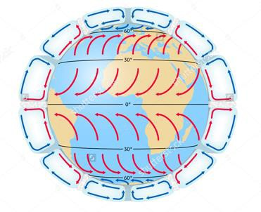

11. Using the map below, describe the global distribution of tropical storms.

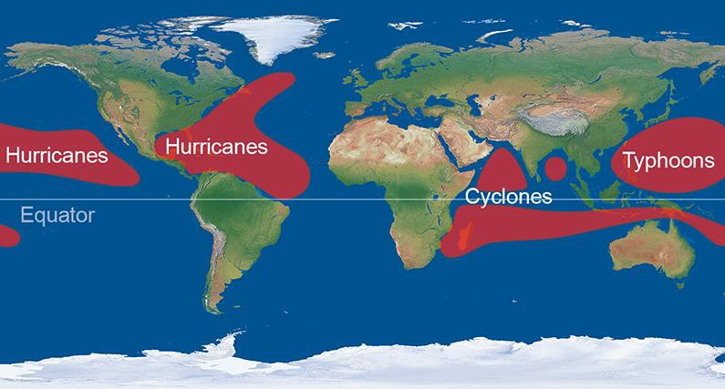
________________________________________________________________
________________________________________________________________
________________________________________________________________
________________________________________________________________
________________________________________________________________

12. Why do tropical storms only form in these areas?
Think about air pressure, sea temperature, sea depth, prevailing winds.
________________________________________________________________
________________________________________________________________
________________________________________________________________

13. Describe the lifecycle of a tropical storm. Use the phrase “wind, rain, eye, spin, move die” to help.
________________________________________________________________
________________________________________________________________________________________________________________________________
________________________________________________________________
________________________________________________________________

14. The paragraph below is about the structure and features of tropical storms. Using the vocabulary provided fill in the blank spaces.
Vocabulary: descending, winds, circular, less, speed, clockwise, high, smaller, eye, eyewall, rain, anticlockwise, increases, hundreds, 7-14, 50km, rain, low.

Tropical storms are in shape, of kilometres wide and usually last days. They spin in the southern hemisphere and in the northern hemisphere. The centre of the storm is called the . It is up to across and is caused by air. In the eye there is very pressure, light winds, no clouds, no and a temperature. The eye is surrounded by the . Here there is spiralling rising air, very strong (around 130 kilometres per hour), storm clouds, torrential and a low temperature. Towards the edges of the storm the wind falls, the clouds become and more scattered, the rain becomes intense and the temperature .
15. On the aerial image of a tropical storm label:
a. the eye b. the eyewall
c. the edge of the storm d. the strongest winds

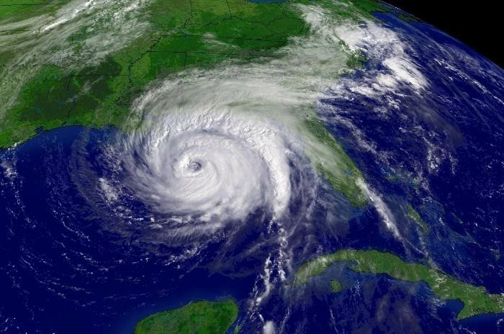
16. Many experts are worried that climate change will increase the intensity, frequency and distribution of tropical storms. Explain reasons for this concern.

One reason why the intensity of TS’s may increase:

One reason why the frequency of TS’s may increase:

One reason why the distribution of TS’s may increase:

Tropical storms have significant effects on people and the environment

NAMED EXAMPLE OF A TROPICAL STORM
Place Year
EFFECTS |  | RESPONSES
PRIMARY | SECONDARY | IMMEDIATE | LONG-TERM

17. Annotate each bubble below with examples and say how they can help to reduce the effects of tropical storms.
For example, for ‘Protection’, you could write ‘Afforestation absorbs much of the storm’s energy when it hits the coastline, reducing the impact on protecting people, property and the environment further inland’. You should have at least two examples for each bubble.

The UK is affected by weather hazards

18. Complete the table below with facts and figures.

EXAMPLE OF A RECENT EXTREME WEATHER EVENT IN THE UK
Weather event type Place
When
CAUSES | IMPACTS | MANAGEMENT
 | Social | Which management strategies were used (before, during and/or after)?
 | Economic | Did they reduce risk? If so, how? If not, why not?
 | Environmental

19. Give two examples of weather events that demonstrate that UK weather is becoming more extreme. You already have one for rainfall (Somerset flooding in 2013/14)
a. High temperature________________________________________________
________________________________________________________________

b. Snowfall and low temperatures_____________________________________
________________________________________________________________

Climate Change

Climate change is the result of natural and human factors and has a range of effects.

20. Some evidence for climate change is found using data collected from tree rings, ice core samples, pollen analysis and temperature records. Select one of these and say how it provides evidence that climate change is occurring.

______________ provides evidence that climate change is occurring because
________________________________________________________________________________________________________________________________
________________________________________________________________

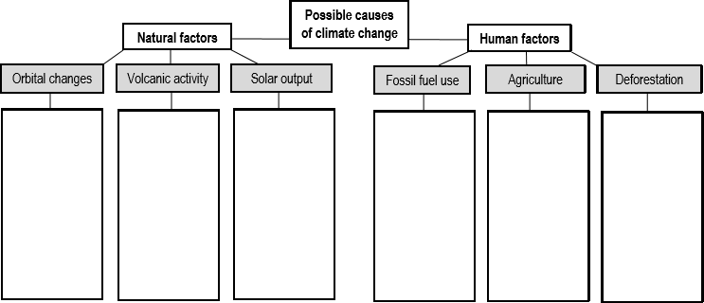
21. The diagram shows some of the possible causes of climate change. Fill it in and explain how each is thought to cause climate change.
22. Outline the effects of climate change on people and the environment. Write a paragraph for each. Try to refer to specific places in your answer.
________________________________________________________________
________________________________________________________________
________________________________________________________________
________________________________________________________________
________________________________________________________________

Managing climate change involves both mitigation (reducing causes) and adaptation (responding to change).

23. Mitigation means reducing the causes (of climate change). There are lots of ways that climate change can be mitigated. The table below shows four mitigation strategies. You need to fill in the gaps so that each strategy is described (say what it is) and explained (say how it reduces the causes of climate change).

STRATEGIES TO REDUCE THE CAUSES OF (MITIGATE) CLIMATE CHANGE
 | ALTERNATIVE ENERGY PRODUCTION | CARBON CAPTURE | PLANTING TREES | INTERNATIONAL AGREEMENTS
DESCRIBE THE | This means producing |  | Planting trees can take | International agreements
STRATEGY | energy from sources that |  | place on a small or large | such as the Kyoto Protocol
 | are not fossil fuels. For |  | scale. Individuals can plant | and the Paris Agreement
 | example, wind, solar and |  | extra trees around their | encourage governments to
 | wave energy are all |  | home, local organisations | set carbon emissions
 | renewable energy sources |  | can organise volunteers to | targets, to increase their
 | that provides alternatives to |  | plant trees in the local area, | alternative energy
 | the ‘dirty’ fuels of coal, oil |  | and governments can pay | production, and to reduce
 | and gas. |  | councils to mass-plant | their greenhouse gas
 |  |  | across the country. | emissions.
EXPLAIN HOW |  | Capturing carbon reduces the
IT REDUCES |  | amount of carbon in the
THE CAUSES |  | atmosphere. Carbon thickens
OF CLIMATE |  | the atmosphere and traps the
CHANGE |  | sun’s radiation, so reducing
 |  | the amount of carbon in the
 |  | atmosphere will reduce the
 |  | amount of heat that becomes
 |  | trapped, thereby reducing one
 |  | of the key causes of climate
 |  | change.

24. There are many adaptation strategies to help us manage climate change and reduce risk. Below say which strategy should be prioritised and how it helps to manage climate change.
Options: 1- Changing agricultural systems, 2- Managing water supply, 3- Reducing risk from rising sea levels

Chosen option:____________________________________________
________________________________________________________________
________________________________________________________________
________________________________________________________________
________________________________________________________________
________________________________________________________________
________________________________________________________________
________________________________________________________________
________________________________________________________________
________________________________________________________________
________________________________________________________________
________________________________________________________________
________________________________________________________________

