Name___________

Geography

Living World

Revision Guide

Paper 1: Living with the physical environment
Ecosystems

- An ecosystem is the living (biotic) and non- living (abiotic) components of an environment and the interrelationships (connections) that exist between them.
- Ecosystems can be any size.
  - At a local level an ecosystem is known as a habitat. A good example of this scale is a pond.
  - A regional ecosystem would be England’s Lake District Moorland.
  - At a global level ecosystems are known as biomes; an example is South America’s tropical rainforest.
Ecosystems depend on input of light from the Sun and rain from the atmosphere. | Important interrelationships link together the biotic and abiotic parts of the ecosystem:  - Physical linkages (animals eating other organisms)  - Chemical linkages (acids from rainwater leading to decay of material) |  | Biotic – the living features of an ecosystem such as plants & animals  Abiotic – Non-living environmental factors of an ecosystem such as light, climate, soil.
The grazing food web comprises:  - Plants or primary producers: green plants that use photosynthesis and take nutrients from the surrounding environment and convert this into sugars (glucose).  - Herbivores or primary consumers: plant eating animals.  - Carnivores or secondary consumers: animals that feed on herbivores.  - Top carnivores: the most powerful predators that hunt and eat other animals in the system. These are known as the apex predator.  Depending on the amount of energy transfers in an ecosystem there may be primary, secondary, tertiary, quaternary (and so it continues) consumers. These represent the trophic levels. At each trophic level the biomass will get smaller. |  | The detrital food web comprises decomposers that break down plant and animal material and return it to the environment. Decomposers include:  - Bacteria and fungi which cause decay of complex compounds by releasing enzymes. These are known as decomposers.  - Detritivores are larger organisms that speed up decay by feeding on dead material (detritus); these include earthworms, maggots, woodlice and carrion crow. These are referred to as scavengers.  The detrital food web is linked to the grazing food web.
Ecosystems are incredibly vulnerable to change. Ecosystems can adapt to slow natural changes but rapid changes can have serious impacts.  Invasive species can out-compete native species, an example in freshwater and pond ecosystems in the UK is the Signal (North American) crayfish. This is a voracious predator that is bigger and stronger than the native species. It also carries disease. This has led to a reduction in native crayfish populations as well as displacement of other native species such as the water vole.  Agricultural fertilisers can lead to eutrophication of lakes whereby nitrates increase the growth of algae which deplete the oxygen and so fish die. |  | Biomes are large scale ecosystems defined by the dominant type of vegetation due to abiotic factors such as climate and soils. The world's major biomes include rainforest, desert, savannah, grassland and tundra.  Climate affects biome distribution. Climate and therefore biome distribution is affected by the following factors:  - Latitude – the most important factor. This explains the broad belts of biomes north and south of the equator.  - Ocean currents.  - Altitude.  - Mountain ranges (rain shadow).
Food chain – shows the direct links between producers and consumers in the form of a simple line diagram.
Food web – Shows all the connections between producers and consumers in a complex way.
Nutrient cycle – the ongoing movement of organic and inorganic matter between living organisms and the environment.

Tropical Rainforests

Location of tropical rainforests:  - South America  - Central America  - West Africa  - Central Africa  - South East Asia  - Northern Australia |  | The largest area of tropical rainforest is found in South America. This is called the Amazon rainforest.  In Africa much of the rainforest is located around the Congo Basin.  In South East Asia the countries of Indonesia and Malaysia are tropical rainforest biomes. |  |  |  |  | The equator passes through the middle of the tropical rainforests.  The rainforests lie within the tropics of Cancer and Capricorn at 23.5 degrees north and south of the equator.  Tropical rainforests have the largest number of species of any biome.
Climate of tropical rainforests:  - Warm & wet conditions  - Temperature is high & constant throughout the year averaging 27°C.  - High rainfall over 2000mm per year  - Distinct wet season lasting about 6 months |  |  |  |  | Tropical rainforest nutrient cycling is rapid. The hot, damp conditions on the forest floor allow for the rapid decomposition of dead plant material. This provides plentiful nutrients that are easily absorbed by plant roots. However, as these nutrients are in high demand from the rainforest's many fast-growing plants, they do not remain in the soil for long and stay close to the surface of the soil. If vegetation is removed, the soils quickly become infertile and vulnerable to erosion. Heavy rainfall can carry away the nutrients; this is called leeching.
The four layers (stratification) of the rainforest include:
- Emergent.
- Main canopy/continuous canopy – majority of plant & animal species are found in the canopy.
- Under canopy.
- Shrub layer and ground layer.
Plant adaptations in a tropical rainforest cope with heavy rainfall & competition for sunlight::
- Emergents - Fast-growing trees such as the Kapok out compete other trees to reach sunlight.
- Leaves with flexible bases so they can turn to face the sun.
- Drip tip leaves to allow heavy rain to drip off the leave.
- Epiphytes live on the branches of other plants high in the canopy to seek sunlight.
- Lianas – woody creepers rooted to the ground but grow up the trunks and branches of other trees to seek sunlight higher up in the canopy.
- Smooth bark on the trees to allow smooth flow of water.
- Buttresses – massive ridges help support the base of the tall trees and help transport water. Increased surface area could also help O2/CO2 exchange.
Causes of deforestation in Malaysia, South East Asia.  Deforestation is the cutting down of trees often on a very large scale. The motivating factor for this is often monetary profit:  - Logging – Malaysia was the largest exporter of tropical wood in the 1980s. Clear felling leads to the total destruction of forest habitats.  - Energy development – Rivers are dammed for HEP. The Bakun dam (2011) flooded 700km² of forests and farmland.  - Mineral extraction – Habitats are cleared to extract valuable resources such as tin, oil & gas.  - Commercial farming – Palm oil is widespread in Malaysia. Plantation owners receive 10 year tax incentives which has encouraged the establishment of these plantations for the oil used in many products found in the supermarket.  - Population pressures – Transmigration of many urban poor into the rural areas to establish plantations.  - Subsistence farming – Traditional ‘slash and burn’ farming techniques are sustainable on a small scale. It is not sustainable if more people follow these methods and allow the fires to burn out of control.  - Road building – Network of roads require clearance of trees. The roads then open up the tropical rainforest for further exploitation. |  |  |  | Impacts of deforestation in Malaysia:  - Soil erosion – removal of trees exposes the soil to heavy rain & wind. In addition lack of roots mean the soil is no longer held together and so is easily removed. The land is then infertile.  - Loss of biodiversity: Tropical rainforests are the most biodiverse ecosystem in the world. Deforestation destroys the habitats and reduces biodiversity. Some species could be lost forever; some without ever having been recognised by humans. Species such as the Orangutan are in danger of extinction due to habitat loss.  - Contribution to climate change: During photosynthesis trees absorb CO2 which is a greenhouse gas. Deforestation removes this store and so can lead to global warming. At the local level deforestation reduces transpiration and so the climate becomes drier and hotter.  - Decline of indigenous tribes: Indigenous tribes such as the Penan in Borneo live in a sustainable way; taking all they need from the rainforest. They are unable to do this if their land is instead used to generate profit by plantation owners, mineral extraction or loggers. This can lead to conflict.  - River pollution: Water quality is being degraded and the water poisoned as commercial interests move in and exploit the rainforest.
Economic gains from deforestation:  - Job creation in mining, farming, energy and all of the support industries (multiplier effect).  - Tax revenue can be used to invest in public services (health, education) & infrastructure.  - Improved transport infrastructure can open areas up for industrial development & tourism.  - Palm oil and rubber extraction helps boost industry.  - HEP is cheap and once established does not emit greenhouse gases.  - Mineral extraction such as gold is very valuable. |  |  |  |  |  | Economic losses from deforestation:  - Water shortages due to river pollution & direr climate.  - Fires from clearance or accidents create further destruction.  - Increase in temperatures and drier climate could devastate established commercial farms.  - Medicinal plants could be lost before their properties are fully realised.  - Opportunity for sustainable ecotourism lost.  - Costs incurred due to climate change.
Deforestation rates:  - An area of tropical rainforest the size of China has been lost due to deforestation.  - Every 2 seconds an area of tropical rainforest the size of football field is destroyed. | The case of Brazil:  - Historically Brazil has had rapid rates of deforestation.  - Much of the clearance was to create large cattle ranches.  - Fortunately since 2004the rate of deforestation has fallen by 80% and is now at the lowest levels on record (although deforestation still occurs). Reasons for this reduction include:  - Government crackdown on illegal clearance.  - Brazil is leading the way on conservation with 50% of the Amazon now protected.  - Brazil is committed to reducing carbon emissions & tackling climate change.  - Consumer pressure not to use products from deforested areas.
Reasons to protect the tropical rainforest:  - Biodiversity – Tropical rainforests are home to half of the plants & animals in the world. Some may become extinct before they have even been discovered and recorded.  - Medicine – Around 25% of medicines come from rainforest plants. More than 2000 tropical rainforest plants have anti-cancer properties.  - Resources – Tropical rainforests contain valuable hardwoods as well as fruits, nuts & rubber. Deforestation will mean these resources are lost forever.  - Water – Important source of clean fresh water. 20% of the world’s fresh water comes from the Amazon Basin.  - Indigenous tribes – Live in harmony with the tropical rainforests; using the resources sustainably.  - Oxygen – Tropical rainforests are the ‘lungs of the world’ producing 28% of the world’s oxygen.  - Climate – Tropical rainforests prevent the climate from becoming too hot and dry.  - Climate change – Tropical rainforests absorb and store carbon dioxide which is a greenhouse gas. |  |  | Sustainable management strategies:  The aim of sustainable management is:  - Protect the rainforests for future generations.  - To allow the use of valuable rainforest resources in a manner that does not harm the environment.  Strategies for sustainable management occur at three different levels – local, national & international.  The strategies can take two main forms:  - Logging is allowed in a sustainable manner.  - Areas are protected with no logging/clearance allowed  Sustainable management methods include:  - Selective logging & replanting – The process begins with a study of the area to identify which trees can be felled. These are clearly identified and marked with a direction the tree should be felled to minimise damage to other trees. The trees are felled by licence-holders and the cleared areas are then checked by the authorities. Prosecution can result if illegal felling has occurred. Once the trees are removed forestry officials will decide on the best time to plant replacement trees. Cycle repeats after 30-40 years.  - Ecotourism – Uses the beauty of the environment to generate income through educating visitors to the area.  - Conservation & education – Nature reserves & national parks can be set up to preserve designated areas of land which can then be used for education & research.  - International agreements  - The Forest Stewardship Council ensures trees are felled and products are sources in a sustainable manner. Products sourced in this way carry the FSC label.  - CITES blocks the illegal trade in rare and endangered animals and plants such as the Orangutan.  - HICs agree to write-off debt to LICs in return for a guarantee of protecting areas of tropical rainforest.

Hot Deserts

Hot desert characteristics:  - A desert received less than 250mm of rainfall per year.  - Hot deserts are located 30° north and south of the equator where there are belts of high pressure.  - The high pressure explains lack of cloud cover resulting in low levels of precipitation, high daytime temperatures and cold temperatures on winter nights. |  | Hot desert soils:  - Sandy or stony.  - Lack organic matter as limited leafy vegetation.  - Dry but soak up water rapidly.  - Evaporation draws salts to the surface.  - Not very fertile. |  | Plant adaptation to hot deserts:  - Horizontal root systems just below the surface to soak up rain as soon as it has fallen.  - Seeds that can stay dormant for years but germinate rapidly after rain.  - Succulents which store water in their roots, stems, leaves or fruit.  - Water loss reduced through:  - Small leaves  - Glossy & waxy leaves  - Spines  - Long taproots (7-10m) to reach groundwater.
Desert animal adaptations:  - Nocturnal rodents that burrow underground during the day.  - Reptiles with waterproof skin to reduce water loss.  - Reptiles that produce minimal urine.  Camel adaptations:  - Large, flat feet to spread their weight on the sand.  - Thick fur on the top of the body for shade, and thin fur elsewhere to allow easy heat loss.  - A large surface area to volume ratio to maximise heat loss.  - The ability to go for a long time without water (they don't store water in their humps, but they lose very little through urination and sweating).  - The ability to tolerate body temperatures up to 42°C.  - Slit-like nostrils and two rows of eyelashes to help keep the sand out. |  |  |  |  |  | Thar Desert:  - Major hot desert.  - Located in north-west India and into Pakistan.  - 200000km² mostly in the Indian state of Rajasthan.  - Most densely populated desert in the world.  - Infertile & sandy soils.  - Rainfall is low – between 100 & 240mm per year.  - Summer temperatures can reach 53°C.
Thar Desert development opportunities:  - Mineral extraction  - Gypsum for plaster & cement  - Feldspar for ceramics  - Phospherite for fertiliser  - Kaolin for whitening paper  - Limestone used in steel industry  - Marble  - Energy  - Coal deposits  - Thermal energy plant  - Oilfield in Barmar district  - Wind power – Jaisalmer Wind Park is India’s largest wind farm.  - Solar  - Farming  - Subsistence farming is the main way of life for most people in the Thar Desert  - Commercial farming of wheat, cotton, maize, sesame & mustard is possible die to irrigation following the construction of the Indira Gandhi Canal in 1958.  - Tourism provides jobs for the locals  - Tourists come to see the beautiful landscape & go on camel safaris.  - Annual desert festival attracts tourists. |  |  | Challenges for development in the Thar Desert:  - Extreme heat of over 50°C in the summer.  - Tough conditions to work in (farmers).  - Livestock (cattle & goats) require shade.  - Water supply  - Water is a scare resource  - low precipitation  - high temperature and strong winds (increased evaporation)  - Rivers are intermittent.  - Underground aquifers are salty.  - Demand has increased due to population pressure, farming & industry.  - Accessibility  - Extreme weather & barren landscape has limited the road network which are vulnerable to being covered in sand or tarmac melting.
Indira Gandhi Canal
- Built in 1958
- 650km long
- Source of fresh water has transformed extensive areas of the Thar Desert especially around the cities of Jodhpur & Jaisalmer
Desertification is the process by which fertile land becomes desert, typically as a result of drought, deforestation, or inappropriate agriculture.  - Land on the edges of an existing desert is most vulnerable as these are ecologically fragile.  - Causes can be classed as natural or human:  - Natural – drought. In the Sahel (southern fringes of the Sahara) climate change is resulting in drier conditions. On average it now rains less than it did 50 years ago.  - Human – poor land management (deforestation, overgrazing, and over-cultivation) which is often linked to population pressure.  - Once the land/soil is exposed to the weather it will be eroded by the wind & rain.  - One billion people live in areas at risk from desertification.  - Can affect rich & poor countries alike. In Europe Spain is vulnerable to desertification. |  |  |  |  | Desertification in Badia, Jordan  - Dry rocky desert in eastern Jordan.  - Rainfall less than 150mm per year.  - Summer temperatures exceed 40°C.  - Land traditionally grazed by nomadic Bedouin who constantly move their herds of sheep, goats and camels.  - Following 1991 Gulf War influx of refugees with sheep herds from Iraq moved into the area. Overgrazing led to desertification.
Commercial farming using too much irrigation can lead to salinisation. Salinisation occurs when the water in soils evaporates in high temperatures, drawing salts from the soil to the surface. These salts are toxic to many plants and make the land unusable. This has consequences such as low yields, poor profits and even starvation.
Reducing desertification in hot deserts
Reforestation | Planting trees can help return land to its natural state, making it more fertile and stable thus reducing wind and water erosion and ultimately land degradation.  - In the Badia, Jordan, Atriplex shrubs have been planted. Atriplex shrubs are adapted to desert conditions, bind the soil together and provide grazing for goats. This has improved soil conditions.  - In the Thar Desert, India the Prosopis cineraria has been widely planted to stabilise the soil, provide shade and grazing for animals, firewood, and building material.
Earth dams | Dams collect and store water in the wet season. The stored water can then be used to irrigate crops in the dry season.
Low stone walls | Work in a similar way to earth dams – slow down & collect water to be used for irrigation. This been done in the Badia, Jordan. The water is used to irrigate the newly planted Atriplex shrubs.
Coppicing | People have been taught to 'harvest' the trees and not remove them completely. By coppicing the trees, people can still use them for fuelwood, as they continue to grow and protect the soil.
Terracing | Involves steps being cut into the hillside to reduce the slope. This allows the water to infiltrate the ground, preventing soil from being washed down slope.
Crop rotation | Educate farmers on their farming methods, so they use the land in a productive way and protect it. Allow soil time to regenerate using crop rotation, using different areas every two years.
Stone lines | Stones are laid across the land to stop surface run-off following heavy rainstorms. Allowing the water time to infiltrate instead of being lost through surface-runoff. ‘Magic stones’ have been used in Burkina Faso, West Africa.
Animal husbandry | Reducing the number of farm animals on land and fencing off vulnerable areas helps to prevent overgrazing, allowing the protective vegetation time to grow back.
Earth bunds | Earth bunds (low embankment) catch water flowing down the hill and stop the soil from drying out so less is blown away.
Shelter belts | Areas of forest or hedge are left untouched to protect farmland from the effects of water and wind erosion. Shelter belts will often appear around the outside of fields.
Irrigation | It is possible to water areas of land that have become arid to try and improve the productivity of the soil. However, if water is not used sustainably then irrigation can cause land degradation (salinisation).
Population control | If we can control population growth then we can limit the amount of agricultural land we need and the intensity of our farming.
GM Crops | Growing genetically modified crops can be a solution as these types of crops can withstand poor soil and water shortages. By growing some types of vegetation you may be able to add nutrients back to the soil.
National Parks | Set aside areas protected from intense using use and therefore desertification.  - The Desert National Park, Thar Desert, India established 1992 to protect 3000km² of desert.  - The Zion National Park, near Las Vegas, USA, established 1919.

The Living World
Using an example (pond ecosystem) from the UK, I can explain the interrelationship within the natural system.
I can define and give UK examples of producers consumers, decomposer, food chain, food web and nutrient cycle
I can explain their interdependence of each of the above and explain how changes might affect each other.
I can describe the distribution and characteristics of global ecosystems (biomes) around the world.
Tropical rainforests (core content)
I can describe the physical characteristics of the tropical rainforests
I can explain the interdependence of the climate, water, soils, plants, animals and people in a tropical rainforest
I can explain how plants and animals have adapted to the physical conditions of tropical rainforests.
I can describe and explain the problems and issues with changing biodiversity within the tropical rainforest.
I can describe and explain the changing rates of deforestation.
I can use a case study (Malaysia) to explain the causes of deforestation
subsistence and commercial farming,
- Logging,
- Road Building
- Mineral Extraction
- Energy Development,
- Settlement
- Population Growth
I can use a case study (Malaysia) to explain the impacts of deforestation
- Economic development
- Soil erosion,
- Contribution to climate change.
I can explain the importance and value of the tropical rainforest on a local, national and international scale.
I can explain why it is important the tropical rainforest should be managed sustainably.
I can explain how the tropical rainforest can be managed sustainably using a range of methods
- Selective logging and replanting
- Conservation and education
- Ecotourism
- International agreements about the use of tropical hardwoods,
- Debt reduction.
Hot deserts (option)
I can describe the physical characteristics of the hot desert
I can explain the interdependence of the climate, water, soils, plants, animals and people in a hot desert
I can explain how plants and animals have adapted to the physical conditions of hot deserts
I can describe and explain the problems and issues with changing biodiversity within the hot desert.
I can use a case study (Thar Desert) to explain the causes of desertification
subsistence and commercial farming,
- Mineral Extraction
- Energy Development
- Farming
- Tourism
I can use a case study (Thar Desert) to explain the challenges of desertification
- Extreme temperature
- Water supply
- Inaccessibility
I can define and describe desertification
I can explain the causes of desertification both human and natural
I can explain a how desertification can be managed using:
- Water and soil management
- Tree planting
- Using appropriate technology
The Living World: Workbook

Ecosystems exist at a range of scales and involve interaction between biotic and abiotic components.

1. Read the paragraphs below to help you revise ecosystems. Highlight or underline key terms and important information.

An ecosystem consists of the biotic (living e.g. plants and animals) and the abiotic (non-living e.g. soil, climate, rock) in an area as well as the links between them. The organisms in an ecosystem can be classed as producers, consumers or decomposers.
A producer is an organism that uses sunlight energy to produce food (e.g. a banana tree). A consumer is an organism that gets its energy by eating other organisms (e.g. a monkey eats a banana). A decomposer is an organism that gets its energy from breaking down dead material, including dead producers, dead consumers or fallen leaves (e.g. bacteria and fungi break down dead monkeys or banana peels).
When dead material is decomposed, nutrients are released into the soil. The nutrients are then taken up from the soil into plants. The plants may be eaten by consumers. When the plants or consumers die, the nutrients return to the soil. This transfer of nutrients is called nutrient cycling.

2. Draw a food chain or food web in the space provided. Label each component as either producer, consumer or decomposer.

3. Using the information above and your own knowledge, explain how changing one component can impact an ecosystem. Use the correct terms and think about our example; a pond.
Remember to think about the biotic and abiotic parts of an ecosystem.
________________________________________________________________________________________________________________________________________________________________________________________________________________________________________________________________4. Complete the table below to help you learn and revise your example of a small scale UK ecosystem.

My example: A pond in the UK
What is the ecosystem like? (Abiotic characteristics such as climate and soils, biotic features such as plant and animal types, location etc.) | Diagram or picture of the ecosystem
What are some of the producers, consumers and decomposers in the ecosystem? | Explain how nutrient cycling takes place in the ecosystem.
Diagram of a food chain or food web in the ecosystem | Explain how changes to one component impacts the ecosystem.  e.g. an invasive species or water removal

5. For each of the major global ecosystems below, complete summary notes in the empty boxes.
ECOSYSTEM | IMAGE | LOCATIONS | BIOTIC FEATURES | ABIOTIC FEATURES
Savannah grassland | 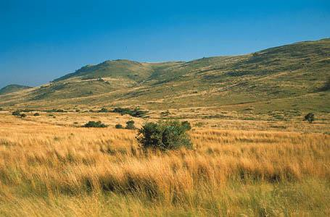
Hot desert | 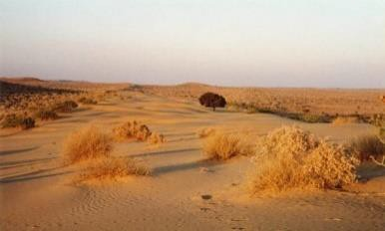
Temperate deciduous forest | 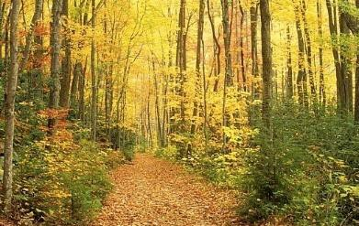
Tropical rainforest | 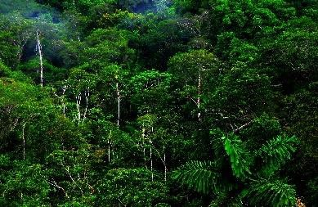
Tundra | 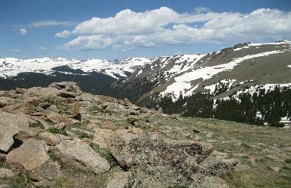
Polar | 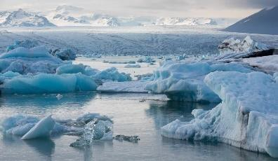

Tropical rainforests

Tropical rainforest ecosystems have a range of distinctive characteristics.

6. Create a mind map to show the physical characteristics of a tropical rainforest. You should refer to features such as the layers of TRFs, the climate (precipitation and temperature), locations around the world etc.

7. Explain how in tropical rainforest ecosystems, climate, water, soils, plants and animals are part of the nutrient cycle.
________________________________________________________________________________________________________________________________________________________________________________________________________________________________________________________________________________________________________________________________________________________________________________________________

8. Plants and animals adapt to the physical conditions of tropical rainforests. Identify one plant and one animal below, and describe how each has adapted to live in the ecosystem.
Chosen plant:________________________
________________________________________________________________________________________________________________________________________________________________________________________________________________________________________________________________
Chosen animal:_______________________
________________________________________________________________________________________________________________________________________________________________________________________________________________________________________________________________

9. Define biodiversity. Why is the rainforest so biodiverse?
________________________________________________________________________________________________________________________________________________________________________________________________

10. Explain how human activities have reduced biodiversity in tropical rainforests. Use the Malaysia case study on pages 60-61 to answer the question.
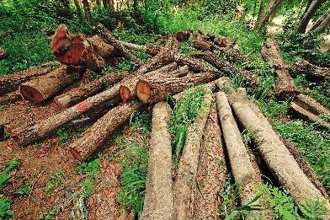
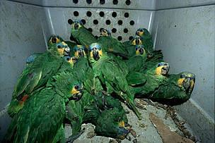
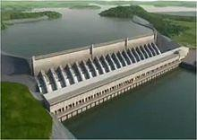
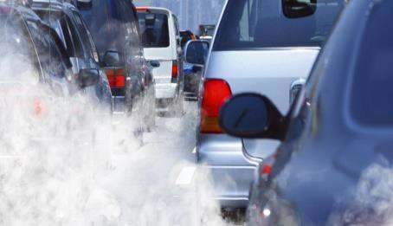
________________________________________________________________________________________________________________________________________________________________________________________________________________________________________________________________
________________________________________________________________________________________________________________________________________________________________________________________________

Deforestation has major economic and environmental impacts.

11. Describe the general pattern of deforestation rates between 1950-2009.

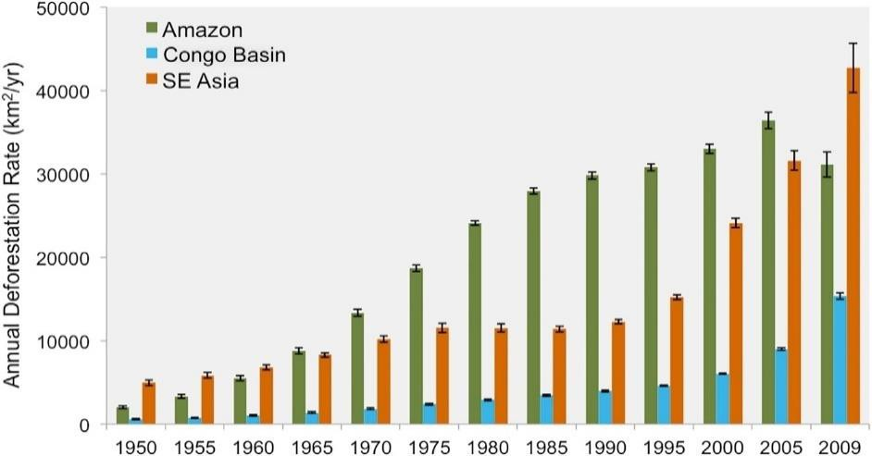
________________________________________________________________________________________________________________________________________________________________________________________________________________________________________________________________
12. Compare rates of deforestation in the three regions shown.
________________________________________________________________________________________________________________________________________________________________________________________________________________________________________________________________

Tropical rainforests need to be managed to be sustainable.

13. Why do tropical rainforests need to be managed? Your answer should outline their importance to people and the environment.
________________________________________________________________________________________________________________________________________________________________________________________________________________________________________________________________
________________________________________________________________________________________________________________________________________________________________________________________________________________________________________________________________

14. There are many strategies to manage the rainforest sustainably. In each box below, describe each strategy, then summarise key advantages and disadvantages.

STRATEGIES | IMAGE | BRIEF DESCRIPTION | ADVANTAGES | DISADVANTAGES
Selective logging | 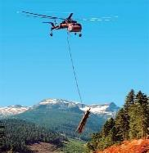
Afforestation | 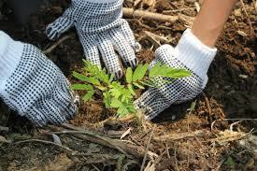
Conservation and education | 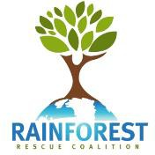
Ecotourism | 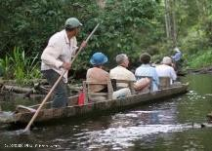
International hardwood agreements
Debt reduction

Hot deserts

Hot desert ecosystems have a range of distinctive characteristics

15. Complete the brainstorm below on the physical characteristics of a hot desert by adding brief notes to each box.
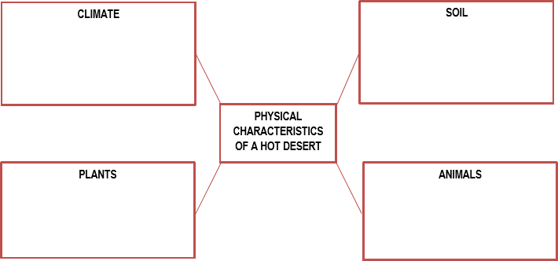

16. Using the figure below, describe and explain the interdependence of climate, water, soils, plants, animals and people in a hot desert.
________________________________________________________________________________________________________________________________________________________________________________________________________________________________________________________________
________________________________________________________________________________________________________________________________________________________________________________________________________________________________________________________________

17. Referring to one plant or animal species found in a hot desert, summarise how the species has adapted to the climate.
Chosen species:_________________________
________________________________________________________________
________________________________________________________________
________________________________________________________________________________________________________________________________________________________________________________________________________________________________________________________________

Development of hot deserts environments creates opportunities and challenges.

Development opportunities refers to the options that exist to improve income and quality of life. Challenges of developing
refers to the difficulties that are encountered in trying to develop.

18. Complete the template below to help you learn and revise your case study of a hot desert.

A case study of a hot desert
The Thar Desert
DEVELOPMENT OPPORTUNITIES IN A HOT DESERT | Tourism | LOCATION | Draw or stick in a map showing the location of your chosen hot desert.
 | Energy
 | Farming | CHALLENGES OF DEVELOPING IN A HOT DESERT | Explain how the following challenges make development difficult. Link the challenges to the opportunities you’ve already mentioned.  - Extreme temperatures  - Water supply  - Inaccessibility
 | Mineral extraction

Areas on the fringes of hot deserts are at risk of desertification.

19. Annotate each box with 1-2 sentences explaining how each factor causes desertification.

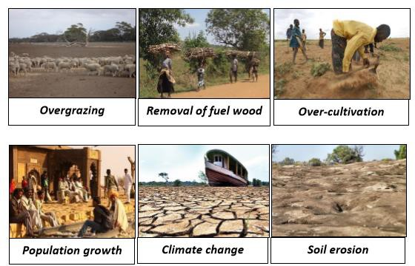

20. There are several strategies to reduce the risk of desertification.

a. Water management – ponding banks
It helps to reduce the risk of desertification by
_________________________________________________________
_________________________________________________________
Its disadvantages/difficulties are
_________________________________________________________
_________________________________________________________

b. Soil management - Atriplex
It helps to reduce the risk of desertification by
_________________________________________________________
_________________________________________________________
Its disadvantages/difficulties are
_________________________________________________________
_________________________________________________________

c. Tree planting (Prosopsis Cineraria)
helps to reduce the risk of desertification by
_________________________________________________________
_________________________________________________________
Its disadvantages/difficulties are
_________________________________________________________
_________________________________________________________

d. Use of appropriate technologies (magic stones)
It helps to reduce the risk of desertification by
_________________________________________________________
_________________________________________________________
Its disadvantages/difficulties are
_________________________________________________________
_________________________________________________________

