GCSE Coasts Revision
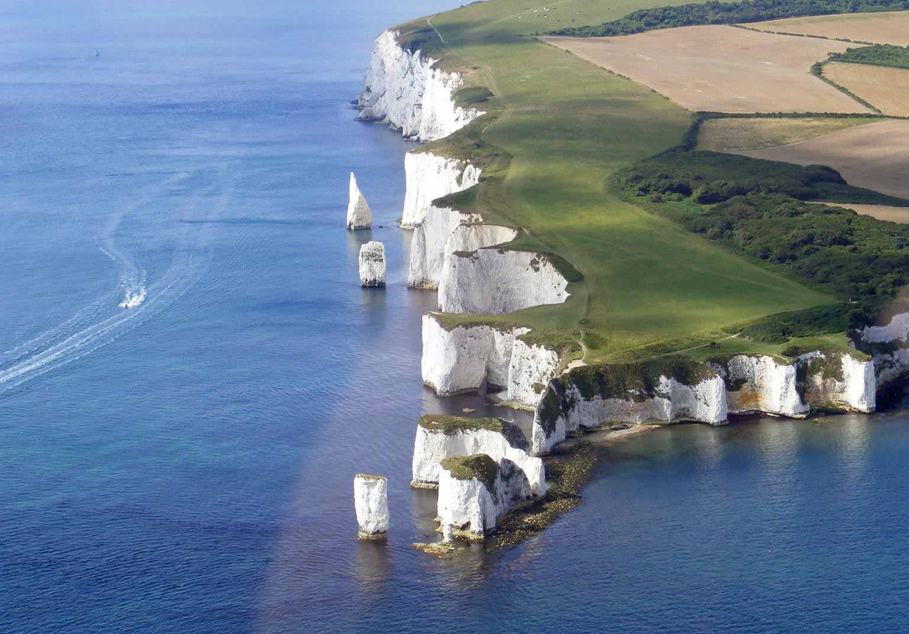

Instructions

- Use your exercise and text books to answer each task.
- Use processes and details when answering the 6 mark questions.
- You must develop your points using phrases such as ‘this means
that’ and ‘therefore’
- Use connectives to link ideas and use key terminology.

Answer the three questions below.
Name two types of erosion
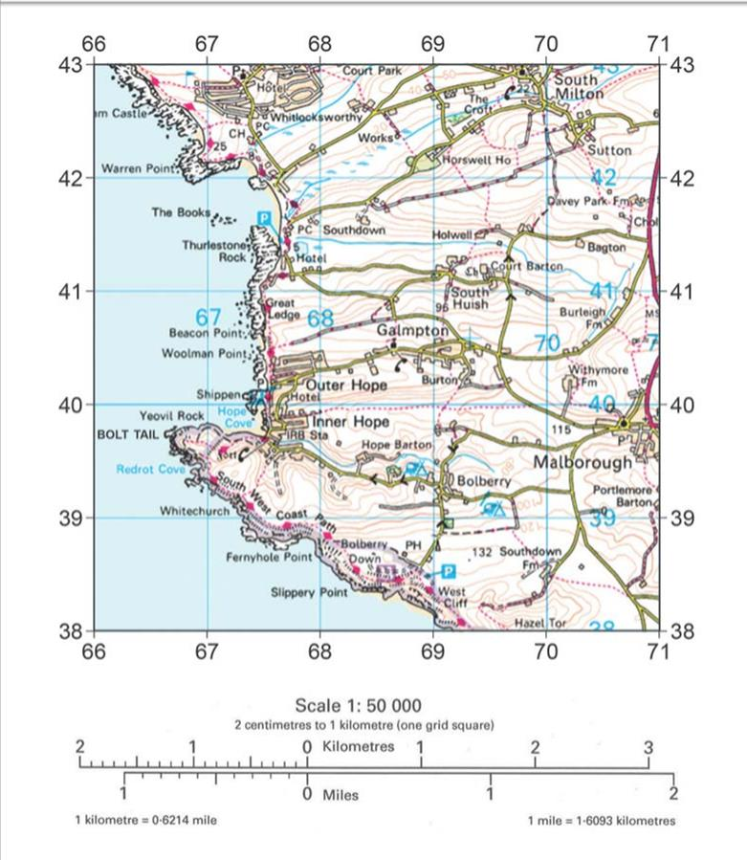
How is material moved along the coastline?
State the 4FGR for Southdown

State the 6FGR for the campsite at Hope
Burton

Which is the correct grid reference for a wave cut platform shown in fig 1.
A 673398 B 669421 C 668428

How do waves approach and return from a beach?

List two landforms that result from deposition.

1.
2.
Plan
Explain the the processes involved in the formation of a stack. (6 marks)

Answer the three questions below.
Name one reason why a coastline may be an uneven shape State two landforms that result from erosion on the coast. State the two types of waves found on a coast
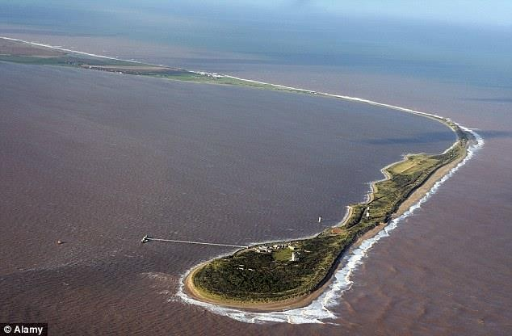
Annotate the photo using keywords to explain its formation (3)

Figure 1
Describe the difference between headlands and bays. (2)
Plan
Using Figure 1 and your own knowledge, explain how different landforms may be created by the transport and deposition of sediment along the coast. (6 marks)

Answer the three questions below. (3) State one example of a coastline in the UK
Name one way the coastline could be managed.

What is the next in sequence after the formation of a cave.
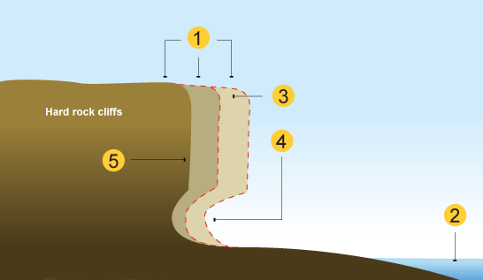
Annotate the diagram to show how the landform is formed.) (3)

How do sand dunes form behind beaches? (6)
Define hard and soft engineering (2)
1.

1.
Plan

Answer the three questions below. (3) Name one disadvantage of a sea wall What type of sea defence will prevent LSD
What type of erosion involves rocks being hurled at the cliff?

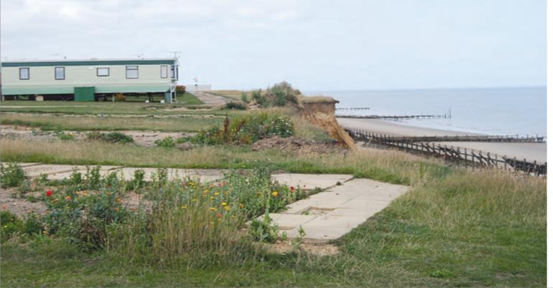
Annotate the image to show the evidence that coastal erosion has taken place (3)
List one advantage and disadvantage of beach replenishment. (2)
1.
2.
Plan
Sea wall / rock armour / groyne - Choose which method you think is the best at protecting the coast from erosion and justify your choice. (6 marks)

Answer the three questions below. (3)

What type of rock is found at Swanage Bay?
What types of rock are found to the north and south?
State one method of coastal protection that has been used at Lyme Regis?

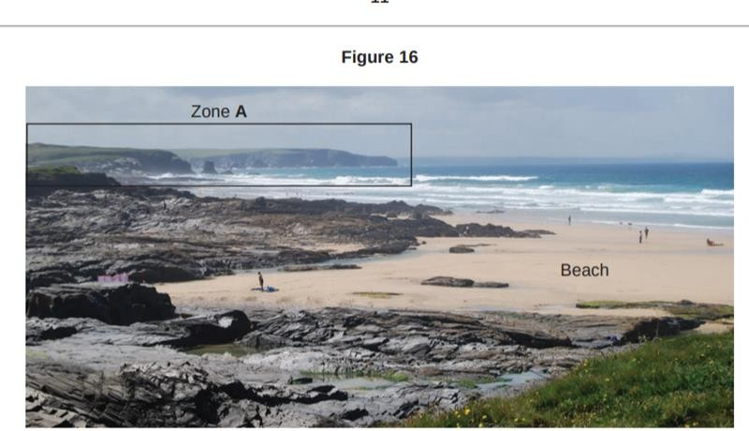
Annotate the photo to show the landform s found in zone A (3)

List two advantages of soft engineering(2)

1.
2.
Plan
To what extent is managed retreat the best method at protecting the coastline - . (6 marks)

Answer the three questions below. (3)
List one characteristic of a destructive wave What are bars?
Are headlands made out of more or less resistant rock?
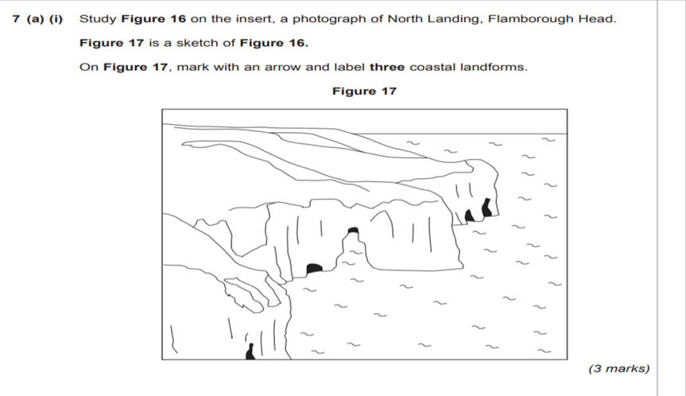
Annotate three coastal landform(3)

List two reasons why the Lyme Regis coastline needs protecting . (2)
1.
2.
Plan
Using an example explain why coastal management is needed in that area.(6 marks)

