Fff

**GCSE PHYSICAL EDUCATION**

Kingshill PE DEPARTMENT

|  |  |  |
| --- | --- | --- |
|  | **Chapter 3a** |  |
|  |  |
|  | | |
| **Fitness** | | |

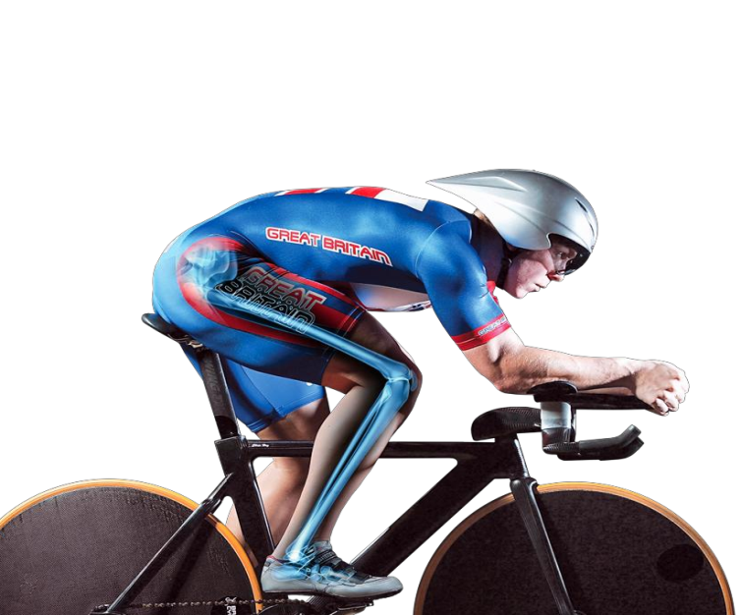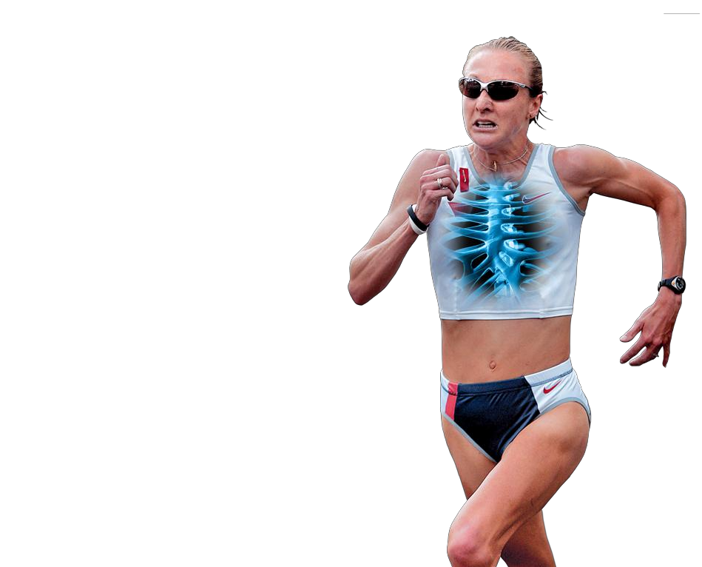

|  |
| --- |
| **NAME:** |
| **TARGETS:** |
| **FEEDBACK:** |
| **MODULE TEST RESULT:** |

|  |  |
| --- | --- |
| **fitness** |  |
| **You need to be able to…** |  |



|  |  |
| --- | --- |
| **Effective use of warm up and cool down** | |
| **Warming up and cooling down** | The constituent parts of warming up and cooling down.  The benefits of warming up:  • effect on body temperature  • range of movement increased  • gradual increase of effort to full pace  • psychological preparation  • practice of movement skills through the whole range of movement  • injury prevention.  The benefits of cooling down:  • allowing the body to recover  • the removal of lactic acid/CO2/waste products  • prevent (delayed onset of) muscle soreness/DOMS. |
| **The relationship between health and fitness and the role that exercise plays in both:** | |
| **Health and fitness** | • Definitions of health and fitness. |
| **The relationship between health and fitness** | • Decreased fitness because of ill health, ie poor health can result in an inability to train, lowers fitness.  • Increased fitness despite ill health, ie unhealthy but able to train, increases fitness. |
| **The components of fitness, benefits for sport and how fitness is measured and improved.** | |
| **The components of fitness** | Definitions of the following components of fitness:  • agility  • balance  • cardiovascular endurance (aerobic power)  • coordination  • flexibility  • muscular endurance  • power/explosive strength (anaerobic power)  • reaction time  • strength (maximal, static, dynamic and explosive)  • speed |
| **Demonstration of how data are collected for**  **fitness testing** | Understanding of how test scores are measured/recorded (e.g. in seconds, levels, centimetres, numbers). Definitions of the terms qualitative and quantitative, in relation to the collection of fitness testing data. Understanding that the quantitative data collected during fitness testing can be compared to national averages. |
| **Linking physical activity to components of fitness** | Understand and justify why the components of fitness (as stated above) may or may not be needed when performing certain physical activities and sports. |
| **Measuring the components of fitness** | Knowledge of the main procedures of the tests used to measure the following components of fitness:  • agility – Illinois Agility Test  • balance – Stork Balance  • cardiovascular endurance (aerobic power) – Multi Stage Fitness Test  • coordination – Wall Toss Test  • flexibility – Sit and Reach Test  • muscular endurance – Sit-Up Bleep Test  • power/explosive strength (anaerobic power) – Vertical Jump Test  • reaction time – Ruler Drop Test  • maximal strength – One Rep Max Test  • speed – 30 Metre Sprint Test  • strength – Handgrip Dynamometer Test.  Testing procedures refers to ‘how each test is carried out’ and includes reference to how the test is organised (when applicable) in relation to the following:  • the facilities and the equipment needed to set it up  • the procedures that have to be followed – the tasks and the rules  • the measurements that are used to score the performance  • the way conclusions are drawn from the scores/results.  Evaluate whether or not these tests are relevant to performers in different sporting activities. |
| **Reasons for and limitations of fitness testing** | Reasons for fitness testing:  • to identify strengths and/or weaknesses in a performance/the success of a training programme  • to monitor improvement  • to show a starting level of fitness  • to inform training requirements  • to compare against norms of the group/national averages  • to motivate/sets goals  • to provide variety to a training programme.  Limitations of fitness testing:  • tests are often not sport specific/too general  • they do not replicate movements of activity  • they do not replicate competitive conditions required in sports  • many do not use direct measuring/submaximal  – therefore inaccurate/some need motivation/some have questionable reliability  • they must be carried out with the correct procedures to increase validity |
| **Understanding the short and long term effects of exercise** | | |
| **Immediate effects of exercise (during exercise)** | • hot/sweaty/red skin  • increase in depth and frequency of breathing  • increased heart rate | |
| **Short-term effects of exercise (24 to 36 hours**  **after exercise)** | • tiredness/fatigue  • light headedness  • nausea  • aching/delayed onset of muscle soreness (DOMS)/cramp | |
| **Long-term effects of exercise (months and years**  **of exercising)** | • body shape may change  • improvements in specific components of fitness  • build muscle strength  • improve muscular endurance  • improve speed  • improve suppleness  • build cardio-vascular endurance  • improve stamina  • increase in the size of the heart (hypertrophy)  • lower resting heart rate (bradycardia).  Students should be taught the components of fitness to understand the long term effects of exercise. | |

|  |  |  |
| --- | --- | --- |
| **warming up & cooling down** | |  |
| **Learning outcomes:** | Be able to   * Describe the parts of a warm up and a cool down * Describe the benefits of warming up and cooling down | |

|  |
| --- |
| **Overall aim –**  **Parts of a warm up** |
| **Overall aim –**  **Parts of a cool down** |
| **BENEFITS of warming up** |
|  |
| **BENEFITS of cooling down** |
|  |

[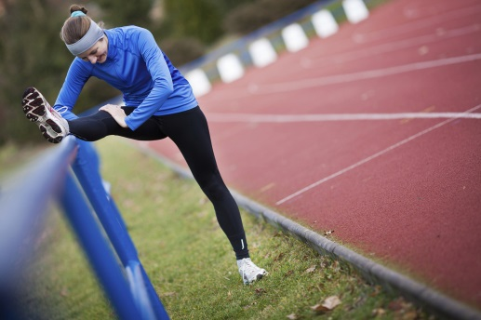](http://www.google.co.uk/url?sa=i&rct=j&q=&esrc=s&source=images&cd=&cad=rja&uact=8&ved=0ahUKEwjMutC5wrPRAhWBNxQKHTMmD8sQjRwIBw&url=http://gymlion.com/do-you-need-warm-up-exercises/&psig=AFQjCNFc6txfWNMkDSklfYRIO1J2r_SfPA&ust=1483998238755920)[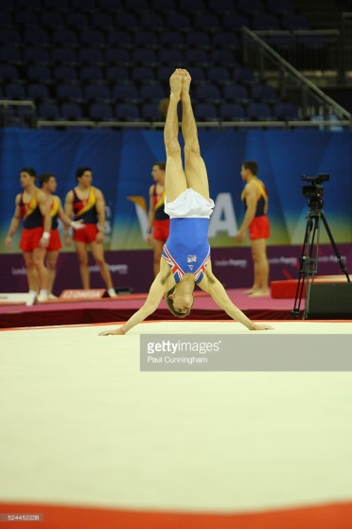](http://www.google.co.uk/url?sa=i&rct=j&q=&esrc=s&source=images&cd=&cad=rja&uact=8&ved=0ahUKEwju85G7w7PRAhUFuBQKHdSAAVYQjRwIBw&url=http://www.gettyimages.co.nz/detail/nachrichtenfoto/visa-international-gymnastics-max-whitlock-of-great-nachrichtenfoto/524452238&bvm=bv.142059868,d.ZGg&psig=AFQjCNFt6jOp08bhFQMLSVRA5Tw2DbGPiw&ust=1483998512230951)[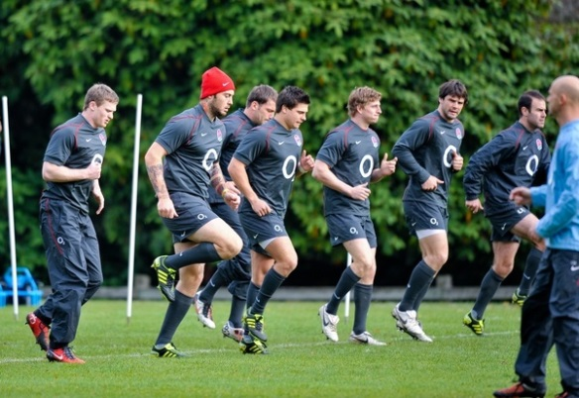](http://www.google.co.uk/url?sa=i&rct=j&q=&esrc=s&source=images&cd=&cad=rja&uact=8&ved=0ahUKEwiT9rbqwrPRAhXJ1xQKHQGVDPMQjRwIBw&url=http://www.therugbyblog.com/rugby-fitness-warm-up-drills-to-avoid-injury&psig=AFQjCNGs6oOqIxfTDemuFFvG1PpEdhjVZg&ust=1483998335368709)

|  |  |  |
| --- | --- | --- |
| **health and fitness** | |  |
| **Learning outcomes:** | Be able to   * Define the terms health and fitness and describe the relationship between them | |

**HEALTH**

[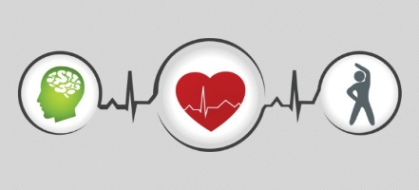](https://www.google.co.uk/url?sa=i&rct=j&q=&esrc=s&source=images&cd=&cad=rja&uact=8&ved=0ahUKEwiftPvEpLPRAhVKOBQKHfTkAhMQjRwIBw&url=https://web.iit.edu/shwc&psig=AFQjCNH3R_18oRHrlYP8w01rbBtC10hAnw&ust=1483990220066138)[](http://www.google.co.uk/url?sa=i&rct=j&q=&esrc=s&source=images&cd=&cad=rja&uact=8&ved=0ahUKEwj3wt-4pLPRAhXE6RQKHQoLDbAQjRwIBw&url=http://continu.org.uk/best-of-health/&psig=AFQjCNGmV3dx7b0kMNJQnEBsQL4fC0VNlQ&ust=1483990189508483)

**FITNESS**

[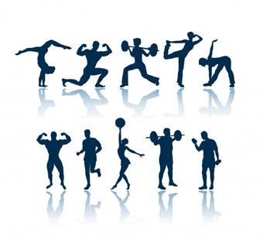](http://www.google.co.uk/url?sa=i&rct=j&q=&esrc=s&source=images&cd=&cad=rja&uact=8&ved=0ahUKEwjIjbn9pbPRAhXEQBQKHWZ7B7EQjRwIBw&url=http://intranet.tdmu.edu.ua/data/kafedra/internal/i_nurse/classes_stud/bsn%20(4year)%20program/full%20time%20study/Second%20year/Health%20promotion/1Developing%20and%20Assessing%20physical%20fitness.htm&psig=AFQjCNF3LD-N9ZS7nKjexWvwhhSry5bwCQ&ust=1483990598912591)[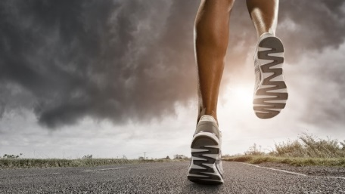](http://www.google.co.uk/url?sa=i&rct=j&q=&esrc=s&source=images&cd=&cad=rja&uact=8&ved=0ahUKEwihm6PRpbPRAhUDtBQKHY_HA9UQjRwIBw&url=http://usa.pioneeringooh.com/fitness-enthusiasts-ooh-insights-and-media-behavior/&bvm=bv.143423383,bs.2,d.Y2I&psig=AFQjCNEgwRZpouRD8EUqb3oYgH-i5fwspA&ust=1483990440637309)

**TASK –** which of the following pictures represent ‘health’ and which ones represent ‘fitness?

[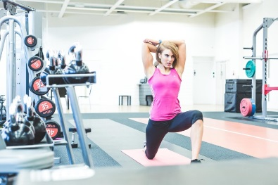](http://www.google.co.uk/url?sa=i&rct=j&q=&esrc=s&source=images&cd=&cad=rja&uact=8&ved=0ahUKEwiL_ubnpbPRAhXLWBQKHalCBfIQjRwIBw&url=http://jazzybfitness.co.uk/&psig=AFQjCNF5qAoJ8eWhMo3Utt8cUQHmsXpBSw&ust=1483990542701117)[](http://www.google.co.uk/url?sa=i&rct=j&q=&esrc=s&source=images&cd=&cad=rja&uact=8&ved=0ahUKEwjJsdydpLPRAhUBbhQKHcyhDXIQjRwIBw&url=http://goodrelations.co.uk/specialisms/health-wellbeing/&psig=AFQjCNEZGvGKD4qKaxBtuN_yXEN2u7guHw&ust=1483990119669612)[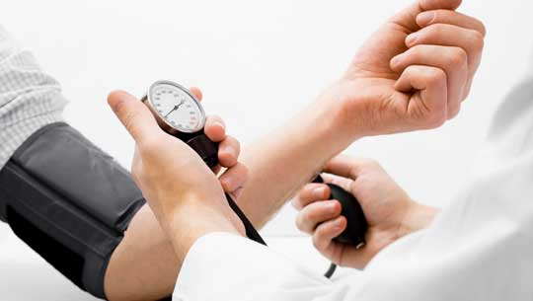](http://www.google.co.uk/url?sa=i&rct=j&q=&esrc=s&source=images&cd=&cad=rja&uact=8&ved=0ahUKEwip6MbhpLPRAhWG7RQKHZESBkIQjRwIBw&url=http://www.creation-perles-art.com/health/&psig=AFQjCNGyFytNsUbiQI3oEL-OFz8almzLig&ust=1483990260651038)

**RELATIONSHIP BETWEEN HEALTH AND FITNESS**

When you are fit you are physically healthy. Being unhealthy doesn’t necessarily mean you are unfit.

|  |  |  |
| --- | --- | --- |
| **fitness components** | |  |
| **Learning outcomes:** | * Define each of the fitness components * Apply each of the fitness components to a sporting example | |

**Fitness Components**

**Fitness Components**

|  |  |  |
| --- | --- | --- |
| **data** | |  |
| **Learning outcomes:** | * Identify two types of data * Describe how data can be collected for fitness testing | |

**Data**

|  |  |  |
| --- | --- | --- |
| **fitness testing** | |  |
| **Learning outcomes:** | * Describe the fitness tests for agility and balance. * Evaluate if the fitness tests are relevant to performers in different sporting activities. | |

|  |  |
| --- | --- |
| **Measuring agility…** | |
| **Objective**  To test how quickly a person can change position of their body while maintaining control. | |
| **Organisation** (method and equipment)  [Image result for illinois agility test](https://www.google.co.uk/url?sa=i&rct=j&q=&esrc=s&source=images&cd=&cad=rja&uact=8&ved=0ahUKEwijiejgtJDVAhXPbVAKHZ1YCHwQjRwIBw&url=https://www.brianmac.co.uk/illinois.htm&psig=AFQjCNE3NZ3wtV4KFEyYNNWL0ZbBfMn3zA&ust=1500384158018744) | **Evaluations**  This fitness test would be useful for  This fitness test is not as useful for |

|  |  |
| --- | --- |
| **Measuring balance…** | |
| **Objective**  To measure a person’s ability to maintain a state of balance on one leg. | |
| **Organisation** (method and equipment)  [Image result for stork balance test](http://www.google.co.uk/url?sa=i&rct=j&q=&esrc=s&source=images&cd=&cad=rja&uact=8&ved=0ahUKEwjjnfb5hLvRAhVI0xQKHbHOABQQjRwIBw&url=http://www.nettyejohnson.com/2012/07/health-tip-strengthen-your-balance.html&bvm=bv.143423383,d.ZGg&psig=AFQjCNHR_zi0yqmjiP02Uw8dTf-jdn22dg&ust=1484256611303668) | **Evaluations**  This fitness test would be useful for  This fitness test is not as useful for |

|  |  |  |
| --- | --- | --- |
| **fitness testing** | |  |
| **Learning outcomes:** | * Describe the fitness tests for cardiovascular endurance and coordination. * Evaluate if the fitness tests are relevant to performers in different sporting activities. | |

|  |  |
| --- | --- |
| **Measuring cardiovascular endurance…** | |
| **Objective**  To measure a person’s cardiovascular endurance. | |
| **Organisation** (method and equipment)  [Image result for multi stage fitness test](http://www.google.co.uk/url?sa=i&rct=j&q=&esrc=s&source=images&cd=&cad=rja&uact=8&ved=0ahUKEwiNraqhhbvRAhUBlRQKHa-wABQQjRwIBw&url=http://www.tpfp.org/a_shuttle.php&bvm=bv.143423383,d.ZGg&psig=AFQjCNGEhTVzYWHgYhpHAIuE6g1ziUb3dA&ust=1484256675425838) | **Evaluations**  This fitness test would be useful for  This fitness test is not as useful for |

|  |  |
| --- | --- |
| **Measuring coordination…** | |
| **Objective**  To avoid dropping the ball to measure hand-eye coordination. | |
| **Organisation** (method and equipment)  [Image result for coordination wall toss test](http://www.google.co.uk/url?sa=i&rct=j&q=&esrc=s&source=images&cd=&cad=rja&uact=8&ved=0ahUKEwj0g_mC-cnRAhXErRoKHRQrCUQQjRwIBw&url=http://www.konkura.com/challenge/?uid%3D22975f3a-1563-42d3-ac3d-47ab25bdf130&psig=AFQjCNEJef_lRdRsSW6igG-BJ75c9Hmoqg&ust=1484768791952848) | **Evaluations**  This fitness test would be useful for  This fitness test is not as useful for |

|  |  |  |
| --- | --- | --- |
| **fitness testing** | |  |
| **Learning outcomes:** | * Describe the fitness tests for flexibility and muscular endurance. * Evaluate if the fitness tests are relevant to performers in different sporting activities. | |

|  |  |
| --- | --- |
| **Measuring flexibility…** | |
| **Objective**  To test the flexibility of the muscles in the lower back and hamstring group. | |
| **Organisation** (method and equipment)  [Image result for sit and reach test](http://www.google.co.uk/url?sa=i&rct=j&q=&esrc=s&source=images&cd=&cad=rja&uact=8&ved=0ahUKEwj5prfb-cnRAhWG2hoKHRQTCrgQjRwIBw&url=http://www.seriousgoalkeeping.net/FitnessTests/SitAndReachTest.aspx&psig=AFQjCNE2rwRJkrB-t5UM9S6rG9YjHRSdKA&ust=1484768975001162) | **Evaluations**  This fitness test would be useful for  This fitness test is not as useful for |

|  |  |
| --- | --- |
| **Measuring muscular endurance…** | |
| **Objective**  To measure the muscular endurance of the abdominal muscles. | |
| **Organisation** (method and equipment)  [Image result for sit up bleep test](https://www.google.co.uk/url?sa=i&rct=j&q=&esrc=s&source=images&cd=&cad=rja&uact=8&ved=0ahUKEwit4Oq9-cnRAhXMuBoKHfhxAjsQjRwIBw&url=https://www.youtube.com/watch?v%3Dnem-y1qGWeo&psig=AFQjCNG9EN8FYSao9FuKO6GXbApUTi6riA&ust=1484768883224947) | **Evaluations**  This fitness test would be useful for  This fitness test is not as useful for |

|  |  |  |
| --- | --- | --- |
| **fitness testing** | |  |
| **Learning outcomes:** | * Describe the fitness tests for power/explosive strength and reaction time. * Evaluate if the fitness tests are relevant to performers in different sporting activities. | |

|  |  |
| --- | --- |
| **Measuring power/explosive strength…** | |
| **Objective**  To measure the power and explosive strength by measuring the height of the vertical jump. | |
| **Organisation** (method and equipment)  [Image result for vertical jump test](http://www.google.co.uk/url?sa=i&rct=j&q=&esrc=s&source=images&cd=&cad=rja&uact=8&ved=0ahUKEwibqpn8-cnRAhXCtxoKHdX0DjAQjRwIBw&url=http://fitnesstestingnino.blogspot.com/p/fitness-tests-for-components-of-fitness.html&psig=AFQjCNH63sEBItJ7-e1tFtf8Tqwo4Fxoyw&ust=1484769042342045) | **Evaluations**  This fitness test would be useful for  This fitness test is not as useful for |

|  |  |
| --- | --- |
| **Measuring reaction time…** | |
| **Objective**  To measure reaction time by measuring the ability to catch a falling ruler. | |
| **Organisation** (method and equipment)  [Image result for ruler drop test](http://www.google.co.uk/url?sa=i&rct=j&q=&esrc=s&source=images&cd=&cad=rja&uact=8&ved=0ahUKEwjbsdqHi97RAhULGBQKHQNCAJQQjRwIBw&url=http://sport.maths.org/content/reaction-timer&psig=AFQjCNHdRcxALIheTkZIYeHicGHpFk1-RQ&ust=1485460844805864) | **Evaluations**  This fitness test would be useful for  This fitness test is not as useful for |

|  |  |  |
| --- | --- | --- |
| **application** | |  |
| **Learning outcomes:** | Be able to   * Apply knowledge of the fitness components and fitness testing. * Reflect on your progress so far this term in terms of knowledge, understanding and recall. | |

|  |  |
| --- | --- |
| https://encrypted-tbn1.gstatic.com/images?q=tbn:ANd9GcTpoJWCz4KQmdseIt1GPSNwhCSKQ8sZjjvfAZ8e-otk9Rt8Pvdp | **Apply it!** |
| Provide a definition and a specific sporting example for the following fitness components. |

|  |  |  |
| --- | --- | --- |
| **Fitness Component** | **Definition** | **Specific sporting example** |
| Agility |  |  |
| Balance |  |  |
| Cardiovascular endurance (aerobic power) |  |  |
| Coordination |  |  |
| Flexibility |  |  |
| Muscular endurance |  |  |
| Power/explosive strength (anaerobic power) |  |  |

|  |  |
| --- | --- |
| https://encrypted-tbn1.gstatic.com/images?q=tbn:ANd9GcTpoJWCz4KQmdseIt1GPSNwhCSKQ8sZjjvfAZ8e-otk9Rt8Pvdp | **Apply it!** |
| Complete the following exam style questions: |

1. Identify and explain **two** components of fitness that would be useful for an 800m track runner. (4 marks)

|  |
| --- |
|  |
|  |
|  |
|  |
|  |

1. Describe how to carry out the Illinois Agility Test. Evaluate the effectiveness of this fitness test for two sporting activities. (6 marks)

|  |
| --- |
|  |
|  |
|  |
|  |
|  |
|  |
|  |
|  |

**REFLECTION**

WWW EBI

|  |  |  |
| --- | --- | --- |
| **fitness testing** | |  |
| **Learning outcomes:** | * Describe the fitness tests for strength and maximal strength. * Evaluate if the fitness tests are relevant to performers in different sporting activities. | |

|  |  |
| --- | --- |
| **Measuring strength…** | |
| **Objective**  To measure grip or forearm muscle strength. | |
| **Organisation** (method and equipment)  [Image result for dynamometer test](http://www.google.co.uk/url?sa=i&rct=j&q=&esrc=s&source=images&cd=&cad=rja&uact=8&ved=0ahUKEwjrks7Qjd7RAhVLuhQKHUJhCgcQjRwIBw&url=http://www.universalservicesuk.co.uk/fitness/fitness-testing/takei-5001-analogue-hand-grip-dynamometer&bvm=bv.145063293,d.ZGg&psig=AFQjCNHFED7LSaHVFqk0MLOs4UR3GP1kEg&ust=1485461538174337) | **Evaluations**  This fitness test would be useful for  This fitness test is not as useful for |

|  |  |
| --- | --- |
| **Measuring maximal strength…** | |
| **Objective**  To test the maximal strength that can be lifted in one repetition by a particular muscle or muscle group. | |
| **Organisation** (method and equipment)  [Image result for one rep max test](https://www.google.co.uk/url?sa=i&rct=j&q=&esrc=s&source=images&cd=&cad=rja&uact=8&ved=0ahUKEwj35urbi97RAhXK7RQKHVydAo8QjRwIBw&url=https://www.youtube.com/watch?v%3D1SQYEVbFuFA&psig=AFQjCNH_sBsI31Yl6Fwxm9p0eak18d_u6w&ust=1485460991290204) | **Evaluations**  This fitness test would be useful for  This fitness test is not as useful for |

|  |  |  |
| --- | --- | --- |
| **fitness testing** | |  |
| **Learning outcomes:** | * Describe the fitness tests for speed. * Evaluate if the fitness test is relevant to performers in different sporting activities. | |

|  |  |
| --- | --- |
| **Measuring speed…** | |
| **Objective**  To test your acceleration and maximum speed. | |
| **Organisation** (method and equipment)  [Image result for 30m sprint test](https://www.google.co.uk/url?sa=i&rct=j&q=&esrc=s&source=images&cd=&cad=rja&uact=8&ved=0ahUKEwiF78Cczt_RAhVDiRoKHUuZBKYQjRwIBw&url=https://www.youtube.com/watch?v%3DgOw_tOuk97c&bvm=bv.145063293,d.bGs&psig=AFQjCNFOYH3I5qpFQQHjD8d6EMybxujX5w&ust=1485512936559378) | **Evaluations**  This fitness test would be useful for  This fitness test is not as useful for |

|  |  |
| --- | --- |
| https://encrypted-tbn1.gstatic.com/images?q=tbn:ANd9GcTpoJWCz4KQmdseIt1GPSNwhCSKQ8sZjjvfAZ8e-otk9Rt8Pvdp | **Apply it!** |
| Evaluate whether or not the fitness tests are relevant to performers in different sporting activities. |

Fitness Tests that **ARE NOT** relevant

Fitness Tests that **ARE** relevant

[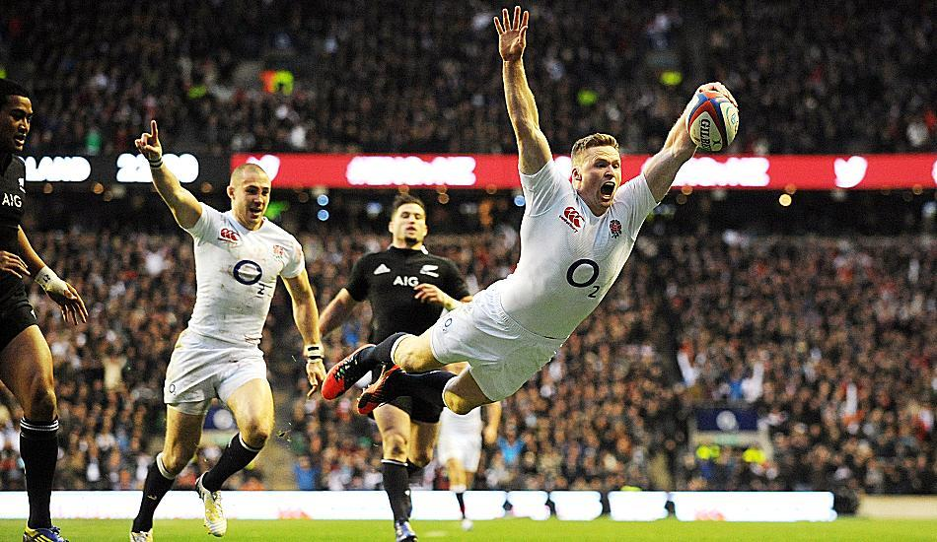](https://www.google.co.uk/url?sa=i&rct=j&q=&esrc=s&source=images&cd=&cad=rja&uact=8&ved=0ahUKEwi959iyyPLNAhUkCcAKHeThDm8QjRwIBw&url=https://www.thesun.co.uk/archives/rugbyunion/304340/england-38-er-new-zealand-21/&bvm=bv.126993452,d.ZGg&psig=AFQjCNGieUMupoSoqHf0D5CabTCJybcBkA&ust=1468572291662263)

Fitness Tests that **ARE** relevant

Fitness Tests that **ARE NOT** relevant

[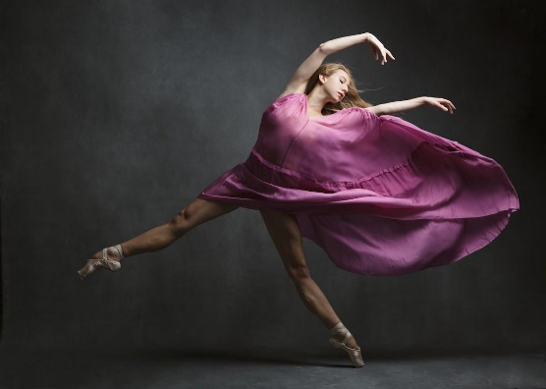](http://www.google.co.uk/url?sa=i&rct=j&q=&esrc=s&source=images&cd=&cad=rja&uact=8&ved=0ahUKEwiylKv3yPLNAhWlC8AKHaIbA_4QjRwIBw&url=http://www.forbes.com/sites/meggentaylor/2016/05/06/what-anyone-can-learn-from-isabella-boylston-the-youngest-principal-at-the-american-ballet-theatre/&bvm=bv.126993452,d.ZGg&psig=AFQjCNFOQy1JElmdYDneu4ks-o2yl8csrA&ust=1468572425414646)

Fitness Tests that **ARE** relevant

Fitness Tests that **ARE NOT** relevant

[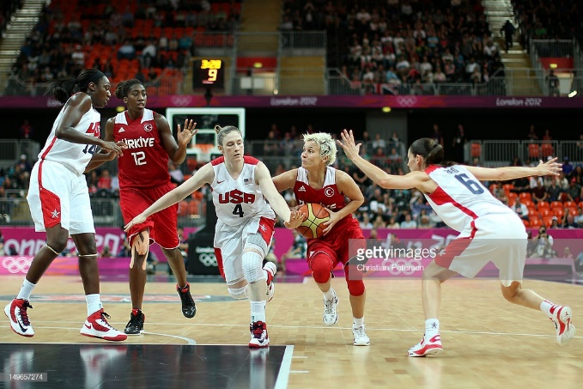](http://www.google.co.uk/url?sa=i&rct=j&q=&esrc=s&source=images&cd=&cad=rja&uact=8&ved=&url=http://www.gettyimages.co.uk/detail/news-photo/isil-alben-of-turkey-drives-to-the-basket-in-the-womens-news-photo/149657274&bvm=bv.126993452,d.ZGg&psig=AFQjCNG0uAFXkIoP7nkvGgowGsWScSDEag&ust=1468572576692009)

|  |  |  |
| --- | --- | --- |
| **practical** | |  |
| **Learning outcomes:** | * Record your fitness test data on the table and bar chart and compare it to national averages. | |

|  |  |  |
| --- | --- | --- |
| **Fitness test** | **Student data** | **Comparison to national average** |
|  |  |  |
|  |  |  |
|  |  |  |
|  |  |  |
|  |  |  |
|  |  |  |

**TASK** – rate yourself in each of the fitness components (from 1 to 10, with 10 being high and 1 being low). Create a bar chart with your data and label it clearly. Justify your results underneath.

**Justification**

_______________________________________________________________________________________

_______________________________________________________________________________________

_______________________________________________________________________________________

_______________________________________________________________________________________

_______________________________________________________________________________________

_______________________________________________________________________________________

_______________________________________________________________________________________

_______________________________________________________________________________________

_______________________________________________________________________________________

_______________________________________________________________________________________

|  |  |  |
| --- | --- | --- |
| **Reasons & limitations of fitness testing** | |  |
| **Learning outcomes:** | * Describe the reasons and limitations of fitness testing. | |

|  |
| --- |
| **Reasons for fitness testing** |
| [https://i.ytimg.com/vi/_NkAh3WavUs/maxresdefault.jpg](https://www.google.co.uk/url?sa=i&rct=j&q=&esrc=s&source=images&cd=&cad=rja&uact=8&ved=0ahUKEwjOg8i3w_LNAhVECsAKHcjlDK8QjRwIBw&url=https://www.youtube.com/watch?v%3D_NkAh3WavUs&bvm=bv.126993452,d.ZGg&psig=AFQjCNEHmw0wpgTfdGPnFD4K8MA7AyX_aA&ust=1468570967892624)[http://www.physicalcompany.co.uk/fitness-images/takei-a5401-digital-hand-grip-dynamometer-product-large-2801.jpg](http://www.google.co.uk/url?sa=i&rct=j&q=&esrc=s&source=images&cd=&cad=rja&uact=8&ved=0ahUKEwi2-vT0w_LNAhVMK8AKHSgRDlUQjRwIBw&url=http://www.physicalcompany.co.uk/takei-a5401-digital-hand-grip-dynamometer-pid2801.html&bvm=bv.126993452,d.ZGg&psig=AFQjCNERj15Bz1kUAXBZxxAOGlxi8bks0Q&ust=1468571103529450)[http://www.904fitness.com/wp-content/uploads/2013/07/July-2013-271.jpg](http://www.google.co.uk/url?sa=i&rct=j&q=&esrc=s&source=images&cd=&cad=rja&uact=8&ved=0ahUKEwjGg6_Yw_LNAhUsAcAKHcyPBw8QjRwIBw&url=http://www.904fitness.com/whats-your-vo2max/&bvm=bv.126993452,d.ZGg&psig=AFQjCNGSe3lg_pN0BJ1f14tKSglQx0TPDw&ust=1468571026216303) |
| **Limitations of fitness testing** |
|  |

|  |  |  |
| --- | --- | --- |
| **Short term & long term effects of exercise** | |  |
| **Learning outcomes:** | * Describe the immediate effects of exercise during exercise * Describe the short term effects of exercise (24-36 hours after exercise) * Describe the long-term effects of exercise (months & years of exercising) – linked directly to the components of fitness. | |

**Identify the immediate/short term effects of exercise during exercise. Can you explain why this happens?**

|  |
| --- |
| Image result for jogging png  **IMMEDIATE** |

|  |
| --- |
| Image result for jogging png  **SHORT TERM** |

**Identify the long term effects of exercise during exercise. Can you explain why this happens?**

|  |
| --- |
| Image result for jogging png  **LONG TERM** |

**FITNESS – MIND MAP**

Identify all specification points, trigger words, key terms, examples and practical performance application