Fff

Kingshill PE DEPARTMENT

**GCSE PHYSICAL EDUCATION**

|  |  |  |
| --- | --- | --- |
|  | **Chapter 3b** |  |
|  |  |
|  | | |
| **Training** | | |

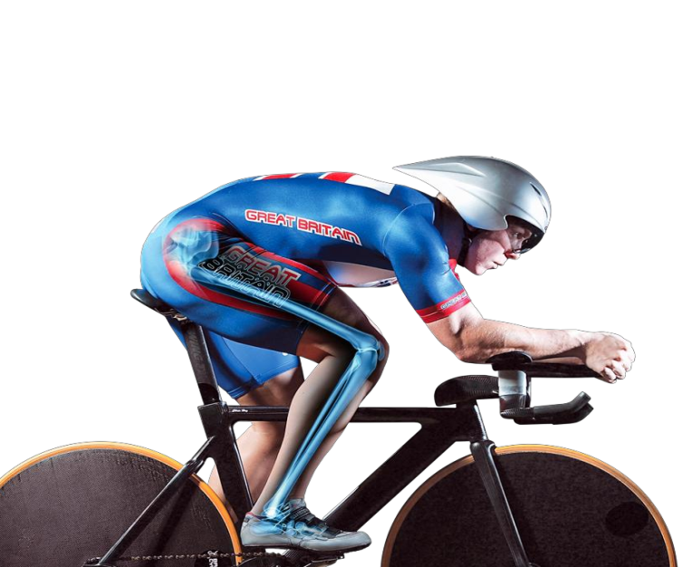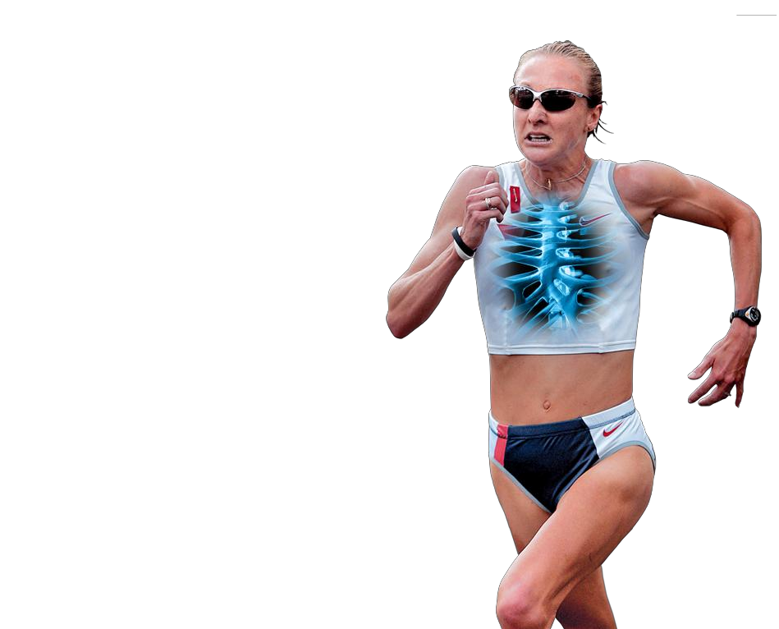

|  |
| --- |
| **NAME:** |
| **TARGETS:** |
| **FEEDBACK:** |
| **MODULE TEST RESULT:** |

|  |  |
| --- | --- |
| **physical training** |  |
| **You need to be able to…** |  |



|  |  |
| --- | --- |
| **Training** | |
| **Warming up and warming down** | The constituent parts of warming up and cooling down.  Warming up should include:  • gradual pulse raising activity  • stretching  • skill based practices/familiarisation  • mental preparation  • increase amount of oxygen to the working muscles.  Cooling down should include:  • maintain elevated breathing and heart rate, e.g. walk, jog  • gradual reduction in intensity  • stretching.  Students should be taught to understand and justify appropriate elements of a warm up and a cool down for different sporting activities.  The benefits of warming up:  • effect on body temperature  • range of movement increased  • gradual increase of effort to full pace  • psychological preparation  • practice of movement skills through the whole range of movement  • injury prevention.  The benefits of cooling down:  • allowing the body to recover  • the removal of lactic acid/CO2/waste products  • prevent (delayed onset of) muscle soreness/DOMS. |
| **Types of training** | Understand the distinctions between different types of training.  • Circuit training – consider space available, equipment available, number of circuit stations, work:rest ratio, the content/demand of the circuit can be altered in order to improve different components of fitness.  • Continuous training – sustained exercise at a constant rate (steady state) without rests, involving aerobic demand for a minimum of 20 minutes, eg running, swimming, rowing, cycling.  • Fartlek training – varying speed, terrain and work:rest ratios.  • Interval training/high intensity interval training – periods of exercising hard, interspersed with periods of rest or low intensity exercise.  • Static stretching – a way to stretch to increase flexibility, held (isometric) for up to 30 seconds, using correct technique, advisable to avoid over stretching.  • Weight training – choice of weight/exercise depends on fitness aim, eg strength/power training or muscular endurance, the importance of safe practice/lifting technique, the need for spotters.  • Plyometric training – use of plyometric exercises, e.g. bounding, depth jumping, to increase power. Basic physiological understanding (eccentric contraction followed by larger concentric contraction).  Any training (and practice) method must take account of the following:  • The training purpose(s), training thresholds/training targets/training zones (see calculating intensities below  • Rest/recovery. |
| **Identification of the advantages and**  **disadvantages (the effects on the body) of training types linked to specific aims** | The advantages and disadvantages (the effects on the body) of each type of training method stated above.  Students should be taught to select and evaluate appropriate training methods for various (aerobic and anaerobic) fitness needs and make links to sporting activity, eg continuous training is fully appropriate to marathon runners. |
| **The principles of training and their application to personal exercise/training programmes:** | |
| **The principles of training and overload** | Key principles of training.  SPORT to include:  • specificity  • progressive overload  • reversibility  • tedium.  Key principles of overload.  FITT to include:  • frequency  • intensity  • time  • type.  Students should be taught the terms and what they mean. |
| **Application of the principles of training** | How the principles of training can be applied to bring about improvements in fitness.  Application of the principles to sporting examples. |
| **Calculating intensities to optimise training**  **effectiveness** | Definition of training threshold.  Calculate the aerobic/anaerobic training zone:  • calculate maximum heart rate (220 minus age)  • calculate aerobic training zone (60–80% of maximal heart rate)  • calculate anaerobic training zone (80–90% of maximal heart rate).  For circuit training, altering the time/rest/content of the circuit will determine the fitness aim.  How to calculate one repetition maximum (one rep max) as part of weight training and how to make use of one rep max, with reference to:  • strength/power training (high weight/low reps – above 70% of one rep max, approximately three sets of 4–8 reps)  • muscular endurance (low weight/high reps – below 70% of one rep max, approximately three sets of 12–15 reps). |
| **Considerations to prevent injury** | The training type/intensity should match the training purpose (eg aerobic or anaerobic).  Where applicable, the following factors should be taken into account in order to prevent injury:  • a warm up should be completed  • over training should be avoided, e.g. appropriate weight  • appropriate clothing and footwear should be worn  • taping/bracing should be used as necessary  • hydration should be maintained  • stretches should not be overstretched or bounce  • technique used should be correct, e.g. lifting technique  • appropriate rest in between sessions to allow for recovery. |
| **Specific training techniques – high altitude**  **training as a form of aerobic training** | How high altitude training is carried out:  • train at high altitude  • there is less oxygen in the air and oxygen carrying capacity is reduced  • the body compensates by making more red blood cells to carry oxygen.  Students should be taught to evaluate the benefits and the limitations of altitude training for different sports performers.  Students do not need to be taught how to calculate intensities for altitude training. |
| **Seasonal aspects** | Names of the three training seasons:  • pre-season/preparation  • competition/peak/playing season  • post-season/transition.  An understanding of what each of the seasons entails (aims):  • pre-season/preparation – general/aerobic fitness, specific fitness needs  • competition/peak/playing season – maintain fitness levels, work on specific skills  • post-season/transition – rest and light aerobic training to maintain a level of general fitness.  An understanding of the benefits of each season to the performer.  Students should be taught to apply and justify the characteristics of the seasonal aspects to different sporting activities. |

|  |  |  |
| --- | --- | --- |
| **types of training** | |  |
| **Learning outcomes:** | Be able to   * Identify seven different types of training. * Explain which fitness components would be developed from the different types of training. | |

**Types**

**of**

**Training**

**Types**

**of**

**Training**

**Types**

**of**

**Training**

|  |  |  |
| --- | --- | --- |
| **circuit training** | |  |
| **Learning outcomes:** | Be able to   * Describe the format of circuit training * Describe the advantages and disadvantages of circuit training * Evaluate the appropriateness of circuit training for different sporting activities. | |

[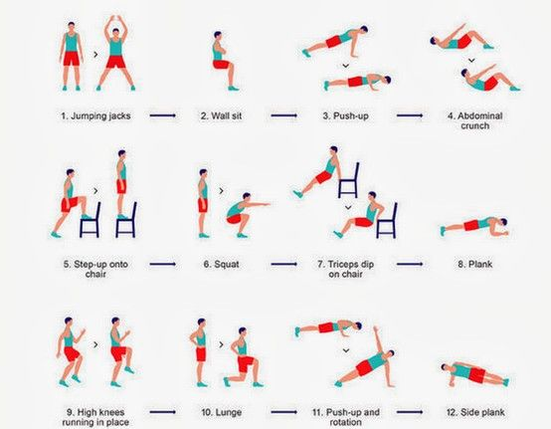](https://www.google.co.uk/url?sa=i&rct=j&q=&esrc=s&source=images&cd=&cad=rja&uact=8&ved=0ahUKEwili8nEppzSAhWItxoKHamrADMQjRwIBw&url=https://www.pinterest.com/pin/80220437087300684/&psig=AFQjCNGWQG5i3ZBsVI_uBf_zwEbVex767A&ust=1487598500468991)

Other station ideas…

|  |  |
| --- | --- |
| Circuit Training | |
| **Description** | |
| **Organisation** | |
| **Advantages** | **Disadvantages** |
| **Evaluation of the appropriateness for different sporting activities** | |

**TASK** – design a circuit of 8 stations, which is aimed at improving two specific fitness components

**1**

**3**

**2**

**4**

**2**

**8**

**3**

**7**

**6**

**4**

**5**

|  |  |  |
| --- | --- | --- |
| **weight training** | |  |
| **Learning outcomes:** | Be able to   * Describe the format of weight training * Describe the advantages and disadvantages of weight training * Evaluate the appropriateness of weight training for different sporting activities. | |

[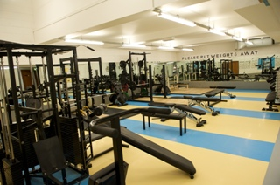](http://www.google.co.uk/url?sa=i&rct=j&q=&esrc=s&source=images&cd=&cad=rja&uact=8&ved=&url=http://www.strath.ac.uk/sport/facilities/weightsroom/&bvm=bv.126993452,d.ZGg&psig=AFQjCNGESlNfS-5TNPtj0IwB8xzi-jUyWA&ust=1468581278582601)

**SETS:**

**REPS:**

**Safety Considerations…**

|  |  |
| --- | --- |
| Weight Training | |
| **Description** | |
| **Organisation** | |
| **Advantages** | **Disadvantages** |
| **Evaluation of the appropriateness for different sporting activities** | |

**TASK** – design a whole body weight training session that consists of free weight and resistance machines.

|  |  |  |
| --- | --- | --- |
| **Station** | **Muscles being used** | **Reps and sets** |
|  |  |  |
|  |  |  |
|  |  |  |
|  |  |  |
|  |  |  |
|  |  |  |

**Extension** – add information about antagonistic muscle action in the ‘muscles being used’ column

|  |  |  |
| --- | --- | --- |
| **interval training** | |  |
| **Learning outcomes:** | Be able to   * Describe the format of interval training and high intensity interval training * Describe the advantages and disadvantages of interval training and high intensity interval training * Evaluate the appropriateness of interval training and high intensity interval training for different sporting activities. | |

[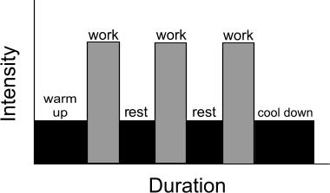](http://www.google.co.uk/url?sa=i&rct=j&q=&esrc=s&source=images&cd=&cad=rja&uact=8&ved=0ahUKEwipu72j5_LNAhWpDsAKHZOYBJMQjRwIBw&url=http://www.howtorow.com/workouts/interval-workouts&bvm=bv.126993452,d.ZGg&psig=AFQjCNEHcRFQwHkEDKogRc5gOSy5NMRf7A&ust=1468580590892813)

**High Intensity Interval Training**

|  |  |
| --- | --- |
| Interval training | |
| **Description** | |
| **Organisation** | |
| **Advantages** | **Disadvantages** |
| **Evaluation of the appropriateness for different sporting activities** | |

|  |  |  |
| --- | --- | --- |
| **the principles of training** | |  |
| **Learning outcomes:** | Be able to   * Identify and describe the four principles of training * Explain how each principle of training can be applied to bring about improvements in fitness across different sporting activities * Describe how overload can be achieved, using the mini FITT principle | |

The reason for training is to improve your ability to take part in physical activity and exercise.

If you don’t follow certain principles improvements will **NOT** be made.

**S**

**P**

**O**

**R**

**T**

[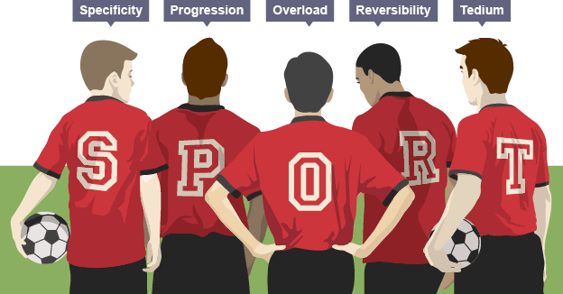](http://www.google.co.uk/url?sa=i&rct=j&q=&esrc=s&source=images&cd=&cad=rja&uact=8&ved=0ahUKEwjikcTSrpzSAhWGAxoKHWn6DzYQjRwIBw&url=http://www.bbc.co.uk/education/guides/zcqpbk7/revision/5&psig=AFQjCNEsZnUEYB9jzoUVGwVK8NkHHndmtg&ust=1487600683298049)

**Specificity**

[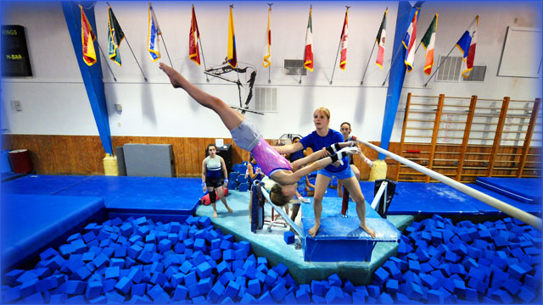](https://www.google.co.uk/url?sa=i&rct=j&q=&esrc=s&source=images&cd=&cad=rja&uact=8&ved=0ahUKEwjYlfH1sJzSAhWL1RQKHQhwBKsQjRwIBw&url=https://za.pinterest.com/explore/gymnastics-camp/&psig=AFQjCNG32C_8NsuejOJ7LF-s4PI1wFDOQg&ust=1487601244314105)[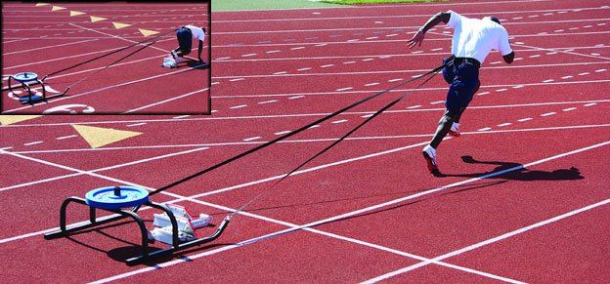](http://www.google.co.uk/url?sa=i&rct=j&q=&esrc=s&source=images&cd=&cad=rja&uact=8&ved=0ahUKEwj5xPGTsZzSAhUHuBQKHbBOB6oQjRwIBw&url=http://www.advantageathletics.com/store/sprints/resistance.htm&bvm=bv.147448319,d.ZGg&psig=AFQjCNHcsx6UMp2c9rzbQFGNmqW6CN8OKw&ust=1487601381742836)

**Progressive Overload**

[](http://www.google.co.uk/url?sa=i&rct=j&q=&esrc=s&source=images&cd=&cad=rja&uact=8&ved=0ahUKEwiJwefusZzSAhXBuRQKHcvJDqkQjRwIBw&url=http://www.memrise.com/mem/4629632/progressive-overload/&bvm=bv.147448319,d.ZGg&psig=AFQjCNFfOPsdcmj_vxsCPfmqTgU4UBOv-w&ust=1487601519066574)[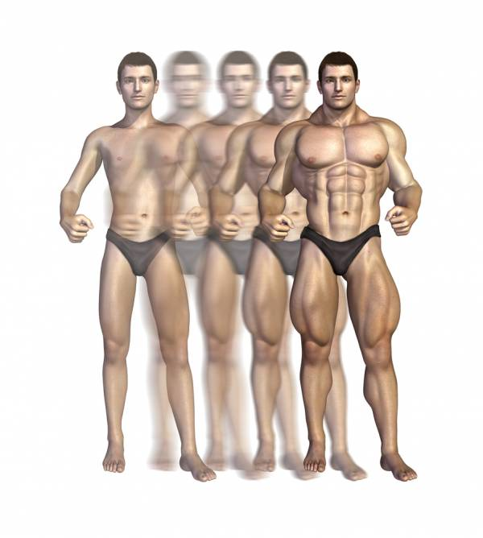](https://www.google.co.uk/url?sa=i&rct=j&q=&esrc=s&source=images&cd=&cad=rja&uact=8&ved=0ahUKEwjiwNiOspzSAhXDvBQKHbb3DqkQjRwIBw&url=https://breakingmuscle.com/learn/hypertrophy-is-not-a-bad-word-functional-hypertrophy-training&bvm=bv.147448319,d.ZGg&psig=AFQjCNFfOPsdcmj_vxsCPfmqTgU4UBOv-w&ust=1487601519066574)

**Reversibility**

[](http://www.google.co.uk/url?sa=i&rct=j&q=&esrc=s&source=images&cd=&cad=rja&uact=8&ved=0ahUKEwi95NiFs5zSAhVHwxQKHRlWDqoQjRwIBw&url=http://mypypeline-triathlon.blogspot.com/2009/01/principles-of-training.html&bvm=bv.147448319,d.ZGg&psig=AFQjCNEh04YcSkofrA1TNQJVNMhbfAV0iQ&ust=1487601861079081)[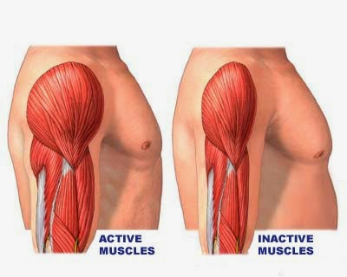](http://www.google.co.uk/url?sa=i&rct=j&q=&esrc=s&source=images&cd=&cad=rja&uact=8&ved=0ahUKEwjm15vLspzSAhVJbhQKHQqoAKIQjRwIBw&url=http://www.motivateamazebegreat.com/2014/07/be-successful-in-any-field-with-this-7.html&bvm=bv.147448319,d.ZGg&psig=AFQjCNFhpRj1WPtV2y9PEN50YvQtcdk4oA&ust=1487601757519930)

**Tedium**

[](https://www.google.co.uk/url?sa=i&rct=j&q=&esrc=s&source=images&cd=&cad=rja&uact=8&ved=0ahUKEwiWy-e8tJzSAhWHiRoKHT7lDDQQjRwIBw&url=https://duckduckgrayduck.com/2012/05/10/how-to-make-your-dog-yawn/&bvm=bv.147448319,d.ZGg&psig=AFQjCNFIHdLrY-6vdBCbR-uphi3kaZRgpg&ust=1487602245473145)

The **FITT principle** is used to increase the amount of work the body does in order

to achieve overload

**FITT Principle**

|  |  |  |
| --- | --- | --- |
| **continuous training** | |  |
| **Learning outcomes:** | Be able to   * Describe the format of continuous training * Describe the advantages and disadvantages of continuous training * Evaluate the appropriateness of continuous training for different sporting activities. | |

[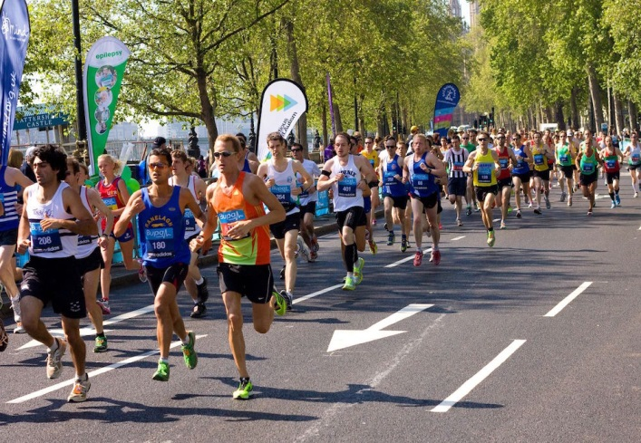](http://www.google.co.uk/url?sa=i&rct=j&q=&esrc=s&source=images&cd=&cad=rja&uact=8&ved=0ahUKEwj8ivvZupzSAhWEPhQKHU7wD68QjRwIBw&url=http://watchfit.com/exercise/sprinting-vs-long-distance/&psig=AFQjCNGBbUYQuGm_z6lYNB_ys_Nvuof4Sw&ust=1487603944506191)[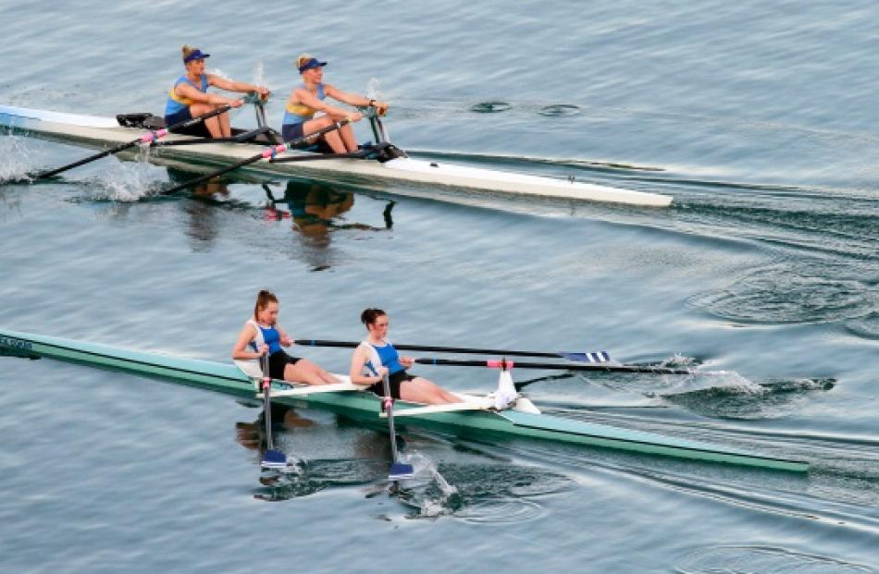](https://www.google.co.uk/url?sa=i&rct=j&q=&esrc=s&source=images&cd=&cad=rja&uact=8&ved=0ahUKEwi1zcjpupzSAhUBxRQKHem-AqcQjRwIBw&url=https://www.odt.co.nz/sport/rowing/photo-slideshow-cromwell-clyde-rowing-race&bvm=bv.147448319,d.d24&psig=AFQjCNHzs61Np3bSKClqIVDiuAgkgYBBeQ&ust=1487603972639975)

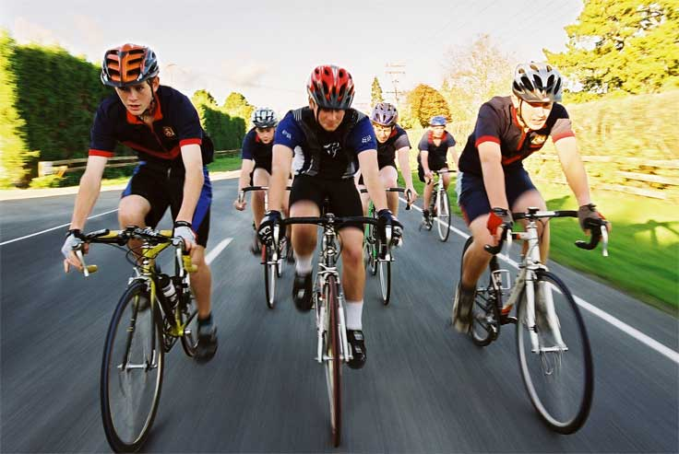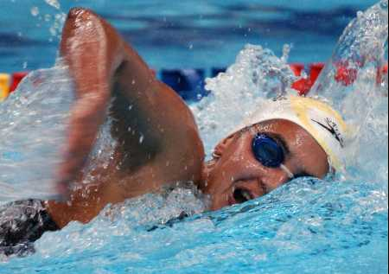

What component of fitness do you think this will develop?

Can you apply this to sporting situation?

|  |  |
| --- | --- |
| Continuous Training | |
| **Description** | |
| **Examples of continuous training** | |
| **Advantages** | **Disadvantages** |
| **Evaluation of the appropriateness for different sporting activities** | |

|  |  |  |
| --- | --- | --- |
| **fartlek training** | |  |
| **Learning outcomes:** | Be able to   * Describe the format of fartlek training * Describe the advantages and disadvantages of fartlek training * Evaluate the appropriateness of fartlek training for different sporting activities. | |

[](http://www.google.co.uk/url?sa=i&rct=j&q=&esrc=s&source=images&cd=&cad=rja&uact=8&ved=0ahUKEwjUr9mYvJzSAhWCbhQKHbxGDKkQjRwIBw&url=http://www.mapsofworld.com/flags/sweden-flag.html&bvm=bv.147448319,d.d24&psig=AFQjCNHKahe0s1BK6YYwO1LndtcB9Oc0yQ&ust=1487604344791405)

[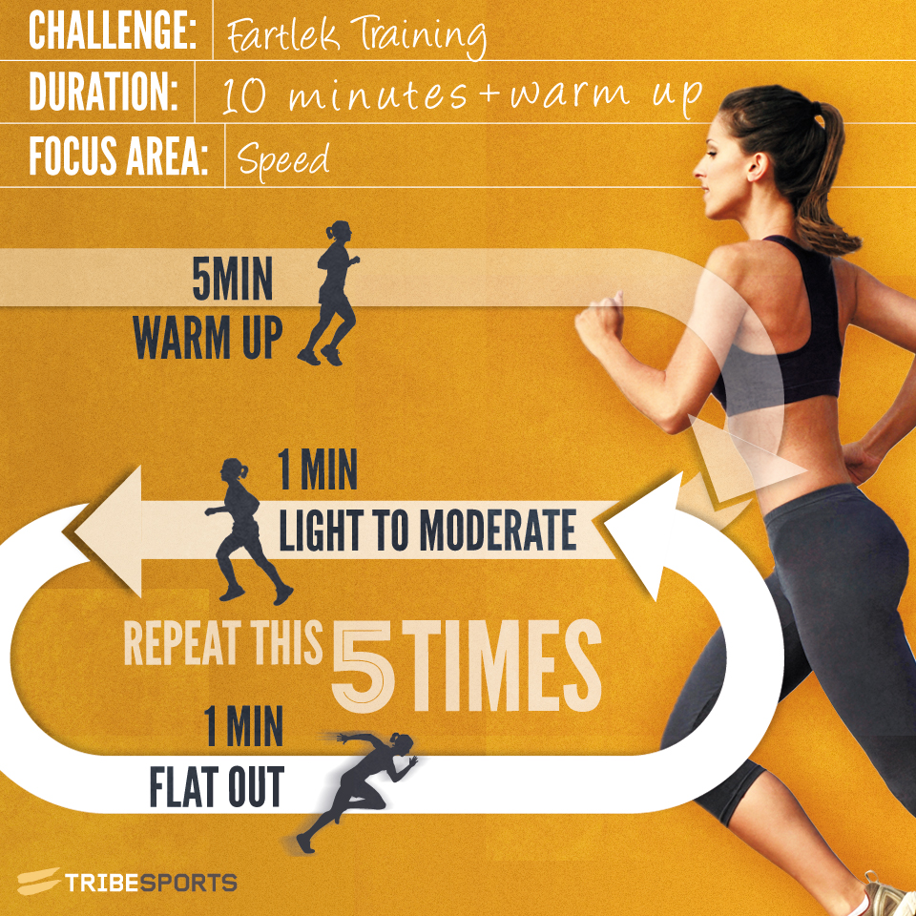](http://www.google.co.uk/url?sa=i&rct=j&q=&esrc=s&source=images&cd=&cad=rja&uact=8&ved=0ahUKEwjbp-b-5_LNAhWrCMAKHQpWChEQjRwIBw&url=http://community.tribesports.com/blog/fartlek-training-the-simple-way-to-improve-race-times&bvm=bv.126993452,d.ZGg&psig=AFQjCNGLPnCUcZu6sh-R2GgPOI4XGFwwXQ&ust=1468580794929682)

|  |  |
| --- | --- |
| Fartlek Training | |
| **Description** | |
| **Organisation** | |
| **Advantages** | **Disadvantages** |
| **Evaluation of the appropriateness for different sporting activities** | |

|  |  |  |
| --- | --- | --- |
| **static stretching** | |  |
| **Learning outcomes:** | Be able to   * Describe the format of static stretching * Describe the advantages and disadvantages of static stretching * Evaluate the appropriateness of static stretching for different sporting activities. | |

[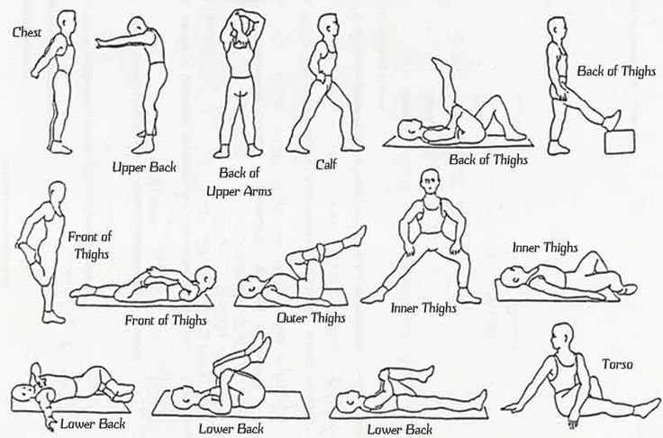](https://www.google.co.uk/url?sa=i&rct=j&q=&esrc=s&source=images&cd=&cad=rja&uact=8&ved=0ahUKEwj6ltn06PLNAhWHDMAKHap_B18QjRwIBw&url=https://www.pinterest.com/pin/239324167675745902/&bvm=bv.126993452,d.ZGg&psig=AFQjCNGou3jwvmUvA26zR7Feg3bV4bgvww&ust=1468581003950215)

[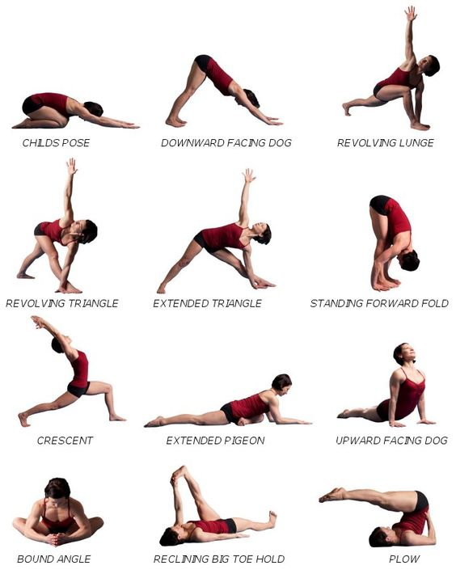](https://www.google.co.uk/url?sa=i&rct=j&q=&esrc=s&source=images&cd=&cad=rja&uact=8&ved=0ahUKEwiT4PbYvZzSAhXLXBQKHa62AKgQjRwIBw&url=https://www.pinterest.com/pin/116601077822878832/&bvm=bv.147448319,d.d24&psig=AFQjCNHvyh2V4j2rdle5iXQs6KXBC9O4Dw&ust=1487604741665808)

|  |  |
| --- | --- |
| Static Stretching | |
| **Description** | |
| **Organisation** | |
| **Advantages** | **Disadvantages** |
| **Evaluation of the appropriateness for different sporting activities** | |

|  |  |  |
| --- | --- | --- |
| **Optimising training** | |  |
| **Learning outcomes:** | Be able to   * Define training threshold * Calculate the aerobic and anaerobic training zones * Describe how circuit training can be adapted to suit various fitness aims * Describe how weight training can be adapted to develop muscular strength or muscular endurance | |

|  |  |
| --- | --- |
|  | **Training Threshold** |
|  |

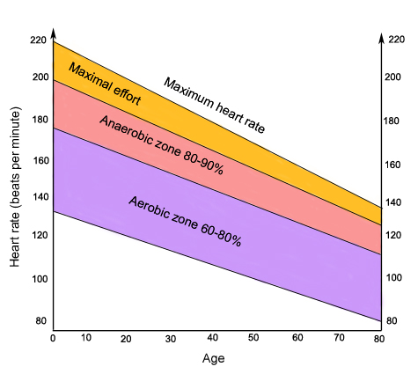

|  |  |
| --- | --- |
|  | **Anaerobic Training Zone** |
|  |

|  |  |
| --- | --- |
|  | **Aerobic Training Zone** |
|  |

|  |  |
| --- | --- |
| https://encrypted-tbn1.gstatic.com/images?q=tbn:ANd9GcTpoJWCz4KQmdseIt1GPSNwhCSKQ8sZjjvfAZ8e-otk9Rt8Pvdp | **Apply it!** |
| Name *three* activities that would predominantly work in:   * The aerobic zone * The anaerobic zone |

|  |
| --- |
| **TASK 1**   * Calculate your resting heart rate |

|  |
| --- |
| **TASK 2**   * Calculate your maximum heart rate |

|  |
| --- |
| **TASK 3**   * Calculate your aerobic training zone |

|  |
| --- |
| **TASK 4**   * Calculate your anaerobic training zone |

|  |  |
| --- | --- |
| https://encrypted-tbn1.gstatic.com/images?q=tbn:ANd9GcTpoJWCz4KQmdseIt1GPSNwhCSKQ8sZjjvfAZ8e-otk9Rt8Pvdp | **Apply it!**  Explain whether the performers below would be working within the aerobic zone and/or the anaerobic zone.  Tip - you may need to clarify at which point they may work within each zone. |
| |  |  | | --- | --- | |  | | | xinsrc_092080516225095365477 |  | | [Image result for rugby player england](http://www.google.co.uk/url?sa=i&rct=j&q=&esrc=s&source=images&cd=&cad=rja&uact=8&ved=0ahUKEwip7cLEiJ3SAhVF1hoKHa5SBjUQjRwIBw&url=http://www.dailymail.co.uk/news/article-2294208/Birth-certificate-secret-Owen-Farrell-star-carrying-Englands-hopes-todays-rugby-showdown.html&bvm=bv.147448319,d.d24&psig=AFQjCNFHsyit8AS6J6cun_N7XY-ahwbMDw&ust=1487624836179149)  [Image result for gymnast floor routine simone biles](http://www.google.co.uk/url?sa=i&rct=j&q=&esrc=s&source=images&cd=&cad=rja&uact=8&ved=0ahUKEwiUn6SEiZ3SAhUGQBoKHRrjBTYQjRwIBw&url=http://www.chicagotribune.com/sports/international/ct-simone-biles-floor-exercise-olympics-20160816-story.html&bvm=bv.147448319,d.d24&psig=AFQjCNFENg9QSv8fv4WopyCF8aQF8u-reA&ust=1487624898791761)  [Image result for cross country skier gb olympics](http://www.google.co.uk/url?sa=i&rct=j&q=&esrc=s&source=images&cd=&cad=rja&uact=8&ved=0ahUKEwjaqZHkiZ3SAhWDOBoKHRciCzMQjRwIBw&url=http://www.bbc.co.uk/sport/23258250&bvm=bv.147448319,d.d24&psig=AFQjCNGWXv2fsaxleS6LOeHMxMW8VFVLIA&ust=1487625080525961) | | | |

**How can training methods be altered to suit various fitness aims?**

**weight training**

**circuit training**

|  |  |  |
| --- | --- | --- |
| **preventing injuries** | |  |
| **Learning outcomes:** | Be able to   * Describe why training should match the training purpose * Identify factors that can prevent injuries from occurring | |

|  |
| --- |
| **How can the type of training and/or intensity match the training purpose?** |

**Factors that can prevent injuries from occurring**

|  |  |  |
| --- | --- | --- |
| **high altitude training** | |  |
| **Learning outcomes:** | Be able to   * Describe how high altitude is carried out * Evaluate the benefits and the limitations of altitude training for different sports performers | |

[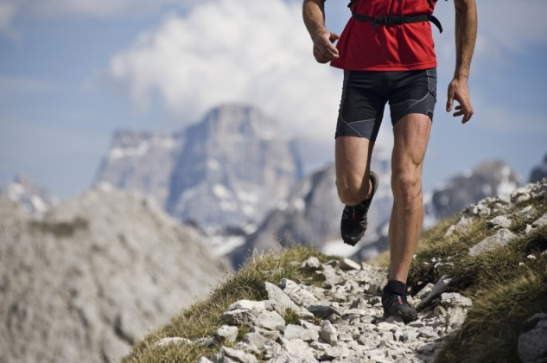](http://www.google.co.uk/url?sa=i&rct=j&q=&esrc=s&source=images&cd=&cad=rja&uact=8&ved=0ahUKEwjY9evBjp3SAhXCWBoKHQp7BNkQjRwIBw&url=http://www.drpeterlarkins.com/2012/04/altitude-training-what-are-the-benefits/&bvm=bv.147448319,d.d24&psig=AFQjCNECgzXXwf9rwxdkf6yU70YdSg5i4A&ust=1487626442515107)[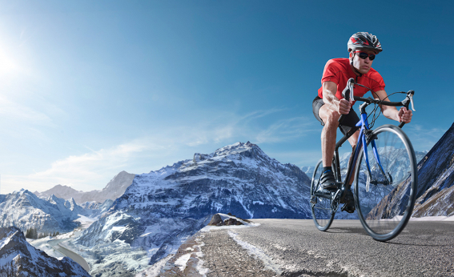](https://www.google.co.uk/url?sa=i&rct=j&q=&esrc=s&source=images&cd=&cad=rja&uact=8&ved=0ahUKEwis3pnpjp3SAhXEuRoKHdgbCDYQjRwIBw&url=https://www.altitudecentre.com/buy/consumer/community/new-news/&bvm=bv.147448319,d.d24&psig=AFQjCNECgzXXwf9rwxdkf6yU70YdSg5i4A&ust=1487626442515107)

|  |  |
| --- | --- |
| Description | |
| **Evaluation of altitude training for different sports performers…** | |
| Benefits | Limitations |

|  |  |  |
| --- | --- | --- |
| **training seasons** | |  |
| **Learning outcomes:** | Be able to   * Identify the three training seasons * Describe each of the training seasons * Describe the benefits of each training season * Apply the training seasons to different sporting activities | |

[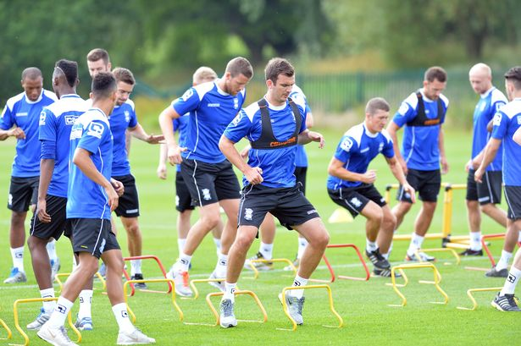](http://www.google.co.uk/url?sa=i&rct=j&q=&esrc=s&source=images&cd=&cad=rja&uact=8&ved=0ahUKEwj7pqqnkZ3SAhXD1hoKHXEmDDYQjRwIBw&url=http://www.birminghammail.co.uk/sport/football/football-news/look-birmingham-city-stars-return-7348737&bvm=bv.147448319,d.d24&psig=AFQjCNF3V9bHC0E-299LZv7MPFuamN9s6Q&ust=1487627183070986)

[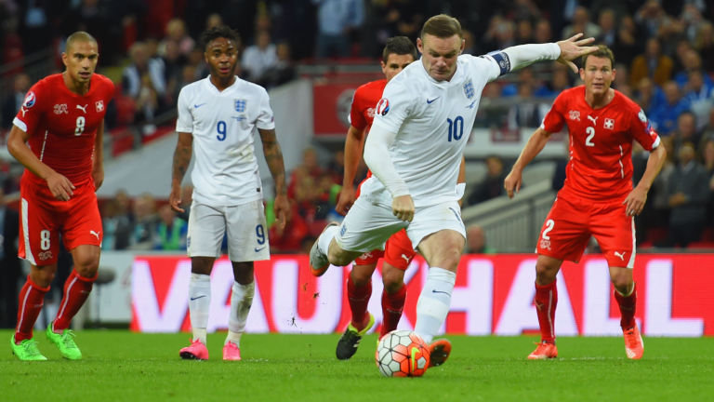](http://www.google.co.uk/url?sa=i&rct=j&q=&esrc=s&source=images&cd=&cad=rja&uact=8&ved=0ahUKEwiFhIfGkZ3SAhVFSRoKHUIxCzQQjRwIBw&url=http://www.skysports.com/football/news/12016/10275952/england-to-use-new-ifab-rulebook-in-pre-euro-2016-friendly-matches&bvm=bv.147448319,d.d24&psig=AFQjCNHyEuGnrrtSAHFT5_BxO3IZdQxDAQ&ust=1487627256382542)

[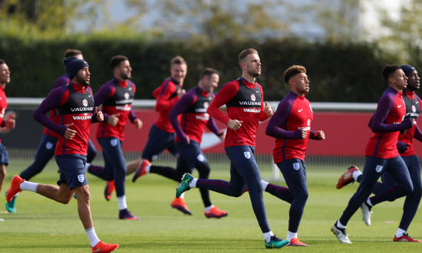](http://www.google.co.uk/url?sa=i&rct=j&q=&esrc=s&source=images&cd=&cad=rja&uact=8&ved=0ahUKEwiu2eytkp3SAhUFXhoKHdF2DT4QjRwIBw&url=http://www.fourfourtwo.com/performance/training/three-drills-help-football-endurance&bvm=bv.147448319,d.d24&psig=AFQjCNHb9tx-_Z2tKZYGgNEa6Bvlq_YpMw&ust=1487627465921494)

**Description Benefits**

**Description Benefits**

**Description Benefits**

|  |  |
| --- | --- |
| https://encrypted-tbn1.gstatic.com/images?q=tbn:ANd9GcTpoJWCz4KQmdseIt1GPSNwhCSKQ8sZjjvfAZ8e-otk9Rt8Pvdp | **Apply it!**  Choose three sporting activities and apply the training seasons to them  Extension – describe how the training seasons may have an impact on the type and level of training you do |

|  |  |  |  |
| --- | --- | --- | --- |
| **Sport** | Pre-season/preparation | Competitive/peak/ playing season | Post-season/transition |
|  |  |  |  |
|  |  |  |  |
|  |  |  |  |

|  |  |  |
| --- | --- | --- |
| **plyometric training** | |  |
| **Learning outcomes:** | Be able to   * Describe the format of plyometric training * Describe the advantages and disadvantages of plyometric training * Evaluate the appropriateness of plyometric training for different sporting activities. | |

[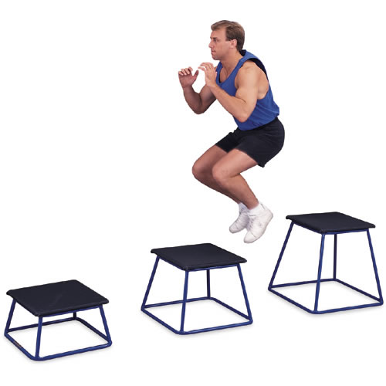](http://www.google.co.uk/url?sa=i&rct=j&q=&esrc=s&source=images&cd=&cad=rja&uact=8&ved=0ahUKEwjphKPV7PLNAhUrLMAKHft2D-QQjRwIBw&url=http://www.thefitindian.com/10-best-plyometric-exercises-to-burn-calories/&bvm=bv.126993452,d.ZGg&psig=AFQjCNGu6-uwXsusvb6_S6ga7yWoU_bqIg&ust=1468581919108132)[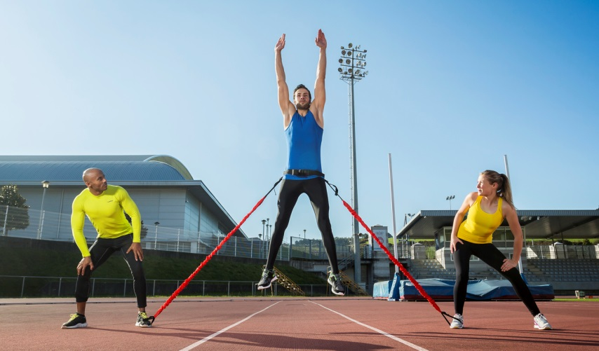](http://www.google.co.uk/url?sa=i&rct=j&q=&esrc=s&source=images&cd=&cad=rja&uact=8&ved=0ahUKEwiKiICp7PLNAhVlJMAKHVwWA0EQjRwIBw&url=http://www.atreq.com/blog/plyometric-training/&bvm=bv.126993452,d.ZGg&psig=AFQjCNGu6-uwXsusvb6_S6ga7yWoU_bqIg&ust=1468581919108132)

[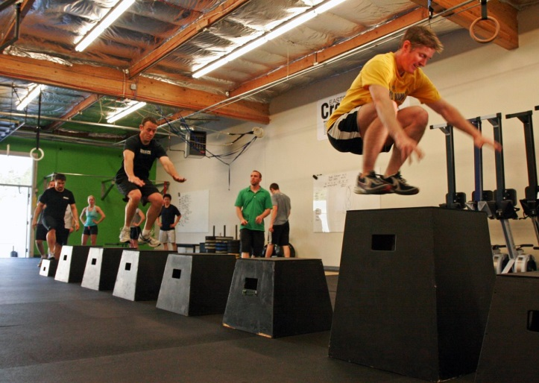](http://www.google.co.uk/url?sa=i&rct=j&q=&esrc=s&source=images&cd=&cad=rja&uact=8&ved=0ahUKEwjU6q7lgp3SAhWBvRoKHTo6ADQQjRwIBw&url=http://fitnesspainfree.com/training-program-include-plyometrics-jumping/&bvm=bv.147448319,d.d24&psig=AFQjCNERliQramkt-GCsYnpZYkrXLCagdw&ust=1487623271942496)[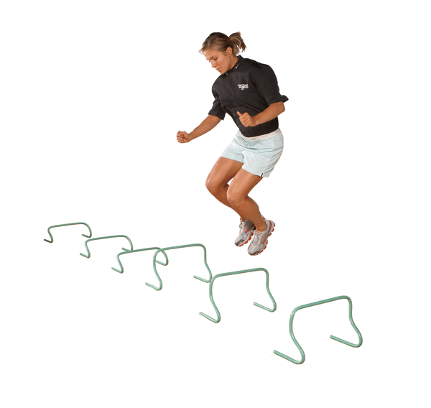](https://www.google.co.uk/url?sa=i&rct=j&q=&esrc=s&source=images&cd=&cad=rja&uact=8&ved=0ahUKEwiBm-CSg53SAhXBWBoKHWT6ATUQjRwIBw&url=https://www.performbetter.com/webapp/wcs/stores/servlet/PBOnePieceView?storeId%3D10151%26catalogId%3D10751%26pagename%3D96&bvm=bv.147448319,d.d24&psig=AFQjCNHSf4z6YyL3J5PE9uxqztg7b6F9Jg&ust=1487623381452135)[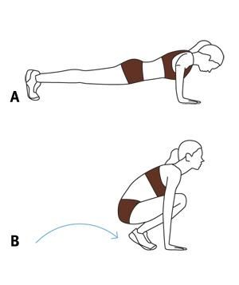](https://www.google.co.uk/url?sa=i&rct=j&q=&esrc=s&source=images&cd=&cad=rja&uact=8&ved=0ahUKEwjnwce6g53SAhVImBoKHbcDATYQjRwIBw&url=https://www.pinterest.com/mrs00/plyometrics/&bvm=bv.147448319,d.d24&psig=AFQjCNGT6_keDa5NnmadcCuonCHHhNR1OA&ust=1487623419270699)

|  |  |
| --- | --- |
| Plyometric Training | |
| **Description** | |
| **Organisation** | |
| **Advantages** | **Disadvantages** |
| **Evaluation of the appropriateness for different sporting activities** | |