Fff
GCSE PHYSICAL EDUCATION
KINGSHILL PE DEPARTMENT

PRACTICAL
Performance Analysis Assessment

NAME:
PRACTICAL ACTIVITY:

FEEDBACK:

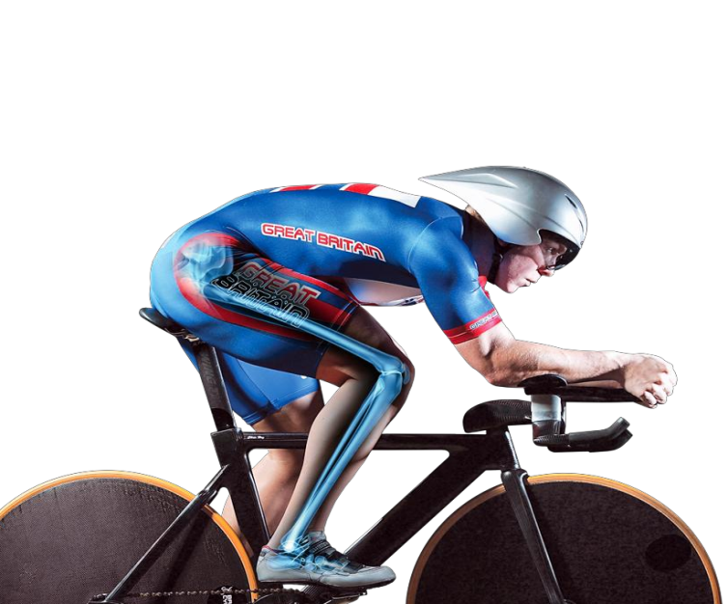
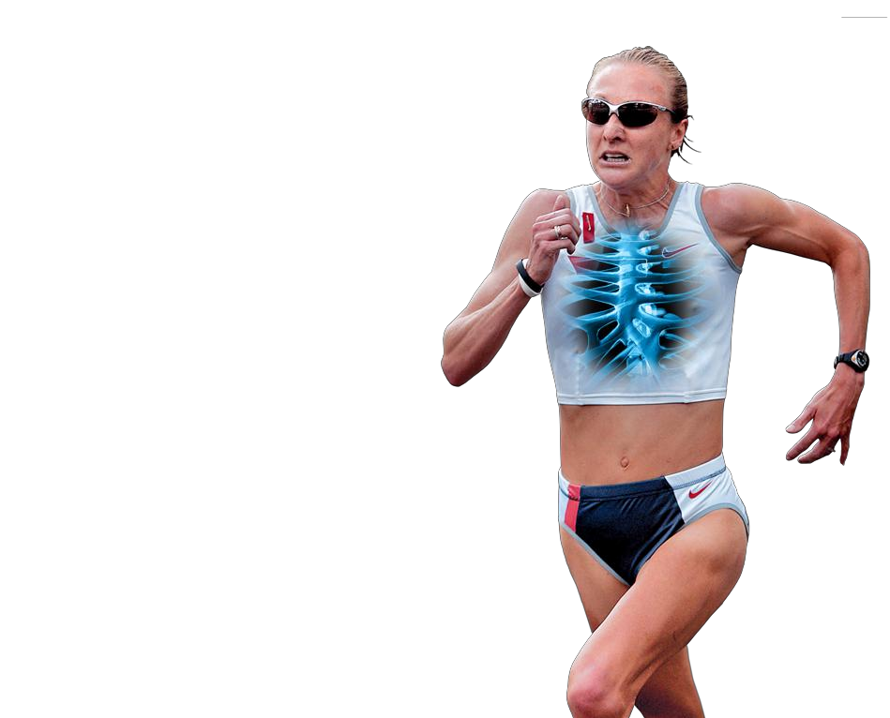

pERFORMANCE ANALYSIS ASSESSMENT

INFORMATION:
- Produce a detailed written piece of work
- 25% of your practical mark
- The performance analysis assessment must be completed on one of the practical activities that you submit to the examination board.
- It includes an analysis and evaluation of yourself in one sport to bring about improvement in that activity.

SECTION 1 – Analysis of strengths and weaknesses (15 marks)
Students are required to analyse a performance in one activity from the specification in order to identify and justify suitable strengths and weaknesses in that performance.

Strengths

- One strength should be a fitness component (relevant to their chosen activity). Reference should be made to an appropriately relevant and developed fitness component, justifying how it has benefited performance.
- One strength should be a specific skill/technique (from those listed in the activity criteria) or tactic/strategy/aspect of choreography, which has been used when performing their chosen activity. If a skill is chosen, reference should be made to the technique used and how that technique benefited performance. If a tactic/strategy is chosen, reference can be made to a description of the student’s role within that tactic/strategy and how it benefited performance.
- In choosing these strengths, students must fully justify their choices, making reference to the impact and benefit they provided in a recent, fully competitive performance.

Weaknesses

- With reference to recent competitive performance(s) in the chosen activity, students should identify two weaknesses.
- One weakness should be a fitness component (relevant to their chosen activity) where improvement is needed. Reference should be made to an appropriately relevant and developed fitness component, justifying how it has negatively affected performance.
- One weakness should be a specific skill/technique (from those listed in the activity criteria) or tactic/strategy/aspect of choreography (as appropriate) where improvement is needed. If a skill is chosen, reference should be made to the technique used and how that technique hindered performance. If a tactic/strategy is chosen, reference can be made to a description of the student’s role within that tactic/strategy and how it hindered performance.
- In choosing these weaknesses, students must justify their choices, making reference to how a competitive performance(s) has been negatively affected.
Inform

SECTION 2 – Evaluation of the theoretical principles that could cause improvement (10 marks)
Using appropriate theoretical content included in the specification, students should produce an overall plan of action that suggests ways to improve upon the weaknesses that they have identified as part of their analysis.

Action plan for improving a fitness weakness:

• An identification of an appropriate training type to improve the fitness weakness.
• A full description of one training session that provides an example of what could be used for the performer.
• An explanation of how prolonged use of the identified training type could improve the fitness weakness.

Action plan for improving a skill/technique or tactic weakness:

• An identification of one other relevant part of the specification (not another training type) which, when applied, could bring about improvement in the skill/tactic/strategy/aspect of choreography weakness.
• An explanation of how the additional specification content selected could lead to improvement of the identified weakness.

Theoretical content chosen must be justified in relation to the identified personal weaknesses with an indication of how improvement is likely to occur.

Students will not be assessed on whether improvement actually occurs.

MARKING
Section A (10-15 marks)  The student has an excellent knowledge and appreciation of the demands of their chosen activity. He/she is fully conversant with the specific movements and terminology used when referring to the activity.  The student fully appreciates their own strengths and weaknesses. They are able to provide a clear, detailed and in-depth self-analysis for both strengths and weaknesses.  All of the strengths and weaknesses are fully justified with detailed reference to appropriate competitive/performance situations.  The student’s chosen fitness strength and weakness are fully relevant to the activity (and positional role if relevant) and he/she is able to provide strong justification of how they have impacted upon their performance(s). | Section B (9-10 marks)  The student has chosen an appropriate training type to eradicate their fitness weakness, providing a strong, well detailed justification which fully evaluates their choice.  The relevance of the chosen training type is fully applied to the personal needs of the performer. It is wholly personal (not general) and includes detailed and relevant safety considerations.  The explanation of how training will be undertaken is detailed and appropriate, providing a thorough explanation of an example session. Suitable intensities have been calculated, fully justified and linked to the needs of the performer.  The other theoretical area chosen is relevant, explained in detail and strongly justified in relation to how it could be applied to the performer.  The student proposes in detail how improvement can take place using both the training type and the other theoretical area.

planning – ANAYLSIS

Analysis of strengths and weaknesses (15 marks)

Analyse your own fitness by completing the table…

Fitness component | 10 (very strong) – 1 (very weak)
Agility
Balance
Cardiovascular endurance
Coordination
Flexibility
Muscular endurance
Power
Reaction time
Strength
Speed

Question 1
Identify one components of fitness that is your strongest.
Define the component.
Explain the positive impact this has on you, your team mates and your opposition.
Examples of when you have used this before in a competitive situation and what was outcome.
(Ensure it is detailed! Compare to role models)

_______________________________________________________________________________

________________________________________________________________________________

________________________________________________________________________________

________________________________________________________________________________

________________________________________________________________________________

________________________________________________________________________________

_______________________________________________________________________________

________________________________________________________________________________

________________________________________________________________________________

________________________________________________________________________________

________________________________________________________________________________

Question 2
Identify one components of fitness that is your weakest.
Define the component.
Explain the negative impact this has on you, your team mates and your opposition.
Examples of when you have used this before in a competitive situation and what was outcome.
(Ensure it is detailed! Compare to role models)

_______________________________________________________________________________

________________________________________________________________________________

________________________________________________________________________________

________________________________________________________________________________

________________________________________________________________________________

________________________________________________________________________________

________________________________________________________________________________

_______________________________________________________________________________

________________________________________________________________________________

________________________________________________________________________________

________________________________________________________________________________

________________________________________________________________________________

________________________________________________________________________________

________________________________________________________________________________

Identify the skills/techniques that are required in your chosen sport. | Identify the tactics/strategies used in your chosen sport.

Question 3
Identify one skills/technique or tactics you are particularly good at.
Explain the positive impact this has on you, your team mates and your opposition.
Examples of when you have used this before in a competitive situation and what was outcome.
(Ensure it is detailed! Compare to role models)

_______________________________________________________________________________

________________________________________________________________________________

________________________________________________________________________________

________________________________________________________________________________

________________________________________________________________________________

________________________________________________________________________________

________________________________________________________________________________

______________________________________________________________________________

________________________________________________________________________________

________________________________________________________________________________

________________________________________________________________________________

________________________________________________________________________________

________________________________________________________________________________

________________________________________________________________________________

Question 4
Identify one skills/technique or tactics you are not particularly good at.
Explain the negative impact this has on you, your team mates and your opposition.
Examples of when you have used this before in a competitive situation and what was outcome.
(Ensure it is detailed! Compare to role models)

_______________________________________________________________________________

________________________________________________________________________________

________________________________________________________________________________

________________________________________________________________________________

________________________________________________________________________________

________________________________________________________________________________

________________________________________________________________________________

_______________________________________________________________________________

________________________________________________________________________________

________________________________________________________________________________

________________________________________________________________________________

________________________________________________________________________________

________________________________________________________________________________

________________________________________________________________________________

WRITE UP – ANAYLSIS

Strength 1 : fitness component (Question One Above)
Strength 2: A specific skill/technique or tactic / strategy (Question THREE Above)
Weakness 1: fitness component (Question TWO Above).
Weakness 2: A specific skill/technique or tactic / strategy (Question FOUR Above)
planning – EVALUATION

Evaluation of the theoretical principles that could cause improvement (10 marks)

Question 1
Identify the fitness weakness you are going to improve and why.
(define, and provide a detailed explanation in relation to your game and position Similar to analysis section)

Question 2
Identify an appropriate training type
Define that training type
Explain why it would improve your fitness weakness
Justify your choice.

________________________________________________________________________________

________________________________________________________________________________

________________________________________________________________________________

________________________________________________________________________________

________________________________________________________________________________

________________________________________________________________________________

________________________________________________________________________________

________________________________________________________________________________

________________________________________________________________________________

________________________________________________________________________________

________________________________________________________________________________

Question 3
Describe one training session that you would use in your action plan.

Activity and equipment needed:

Activity: | Time spent on activity | Description | Why is this important?
Safety Considerations |  | Clothing, footwear, safety of environment, weather, fitness levels etc. MUST be personal to you and NOT generic.
Exercise Intensity levels |  | Maximum Heart Rate:  Training Zone? Is this session Aerobic (60-85% of MHR) OR Anaerobic (80% -90% of MHR)  How will you monitor your Heart Rate?
Warm-up: |  | Pulse raising exercises (heart raising exercises – jogging etc):  Stretches (muscles):  Mobility Exercises (bones / joints);
Activity 1 |  | Main aim of the Drill:  (include diagrams)  How will you make the drill harder / more challenging?
Activity 2 |  | Main aim of the Drill:  (include diagrams)  How will you make the drill harder / more challenging?
Conditioned Game / Game situation / Performance practice / Routine |  | This is the main part of the session. What do you want to achieve?
Cool Down: |  | What stretches / mobility exercises and aerobic exercises are you going to do?

Question 4
Explain how this type of training could improve your fitness weakness if used over a long period of time. Consider using regular fitness testing to monitor improvements.

________________________________________________________________________________

________________________________________________________________________________

________________________________________________________________________________

________________________________________________________________________________

________________________________________________________________________________

________________________________________________________________________________

________________________________________________________________________________

________________________________________________________________________________

________________________________________________________________________________

________________________________________________________________________________

________________________________________________________________________________

________________________________________________________________________________

________________________________________________________________________________

________________________________________________________________________________

________________________________________________________________________________

________________________________________________________________________________

________________________________________________________________________________

________________________________________________________________________________

________________________________________________________________________________

________________________________________________________________________________

Question 5

Identify your skill/technique or tactic weakness you are going to improve
(define, and provide a detailed explanation in relation to your game and position Similar to analysis section)

Question 6
Identify one other theoretical principle (not training type) that could help to improve the skill/technique or tactic, e.g. types of guidance, types of feedback, use of goals, use of technology
Define that element
Explain why it would improve your skill/tactic
Justify your choice.

________________________________________________________________________________

________________________________________________________________________________

________________________________________________________________________________

________________________________________________________________________________

________________________________________________________________________________

________________________________________________________________________________

________________________________________________________________________________

________________________________________________________________________________

________________________________________________________________________________

________________________________________________________________________________

________________________________________________________________________________

________________________________________________________________________________

Question 7
Explain, and justify, how this aspect could help to improve the skill/technique or tactic. Provide competitive scenarios.

________________________________________________________________________________

________________________________________________________________________________

________________________________________________________________________________

________________________________________________________________________________

________________________________________________________________________________

________________________________________________________________________________

________________________________________________________________________________

________________________________________________________________________________

________________________________________________________________________________

________________________________________________________________________________

________________________________________________________________________________

________________________________________________________________________________

________________________________________________________________________________

________________________________________________________________________________

________________________________________________________________________________

________________________________________________________________________________

________________________________________________________________________________

________________________________________________________________________________

________________________________________________________________________________

________________________________________________________________________________

WRITE UP – EVALUATION

Identification training type to improve the fitness weakness (Question ONE and TWO)
Description of one training session (Question THREE)
An explanation of how prolonged use of the identified training type could improve the fitness weakness (Question FOUR)
An identification of one other relevant part of the specification (not another training type) which, when applied, could bring about improvement in the weakness of the: skill/tactic/strategy (Question FIVE and SIX)
An explanation of how the additional specification content selected could lead to improvement of the identified weaknesses (Question SEVEN)

