Question 5:

- Copy the link below into your web browser and make notes, watch the videos and complete the tests to help you improve your writing skills
You only need to answer ONE of the writing questions.
Think carefully about which one you are going to choose and then PLAN your answer!
https://www.bbc.co.uk/bitesize/guides/z8mktyc/revision/1
This question is a creative writing task. You will need to produce an interesting, well-organised and accurately written piece.

The question will always give you a specific purpose, audience and form.
You need to show that you have adapted your writing style accordingly.

You are going to enter a creative writing competition.
You will be judged by a panel of your teachers.
Either:
Write a description suggested by this picture

Or:
Write the opening part of a short story about…
(24 marks content and organisation
16 marks for technical accuracy)
[40 marks]
One of the tasks might ask you to respond to a picture prompt

Only choose ONE!
PICTURE
This is worth a half of the whole paper so you need to make sure your answer is long, detailed and well-planned.
You are assessed on what you write, how you structure it and how accurate it is so make sure you proof read your work!

AO5 Content and Organisation
Level 4  19-24 marks | Compelling and convincing | Content:  Thoroughly matched to the form, audience and purpose.  Interesting and compelling for the audience.  Extensive and ambitious vocabulary with consistent use of linguistic devices.  Organisation:  Varied and imaginative use of structural devices. Sophisticated and fluent paragraphs that incorporate complex ideas and discourse markers.
Level 3  13-18 marks | Consistent and clear | Content:  Consistent match to the audience, purpose and form. Increasingly sophisticated and ambitious use of vocabulary, chosen for effect. A range of successful linguistic devices.  Organisation:  Effective use of structural features, using a clear structure. Writing is engaging with clear connected ideas. Clear use of paragraphs and discourse markers.
Level 2  7-12 marks | Some success | Content:  Some sustained attempt to match form, audience and purpose. Some conscious use of vocabulary and linguistic devices.  Organisation:  Some attempt to use structural features with increasing links between ideas. Some use of paragraphs and discourse markers.
Level 1  1-6 marks | Simple and limited | Content:  Simple awareness of form, audience and purpose. Simple use of vocabulary and some simple linguistic devices.  Organisation:  One or two relevant ideas, which might be simply linked. Random or no paragraph structure.
A06 Technical Accuracy
Level 4  13-16 marks | Ambitious use of vocabulary. Confident use of a wide range of punctuation. Accurate use of grammar.
Level 3  9-12 marks | Mostly suitable vocabulary with variety and thought. Mostly correct grammar and a range of mostly accurate punctuation.
Level 2  5-8 marks | Attempt to vary vocabulary punctuation and grammar. This is sometimes successful and appropriate.
Level 1  1-4 marks | Simple vocabulary, grammar and punctuation that is inaccurate throughout.
Here’s what the examiners want and how they’ll mark your writing…

One of the best ways to improve your own writing is by reading, but also anaylysing other writing and what has been done well or not so well.
- Let’s look at an example…

Q5: Your school wants you to enter a creative writing competition.
EITHER: Write a description suggested by this picture
OR: Write the opening of a story set in a graveyard.

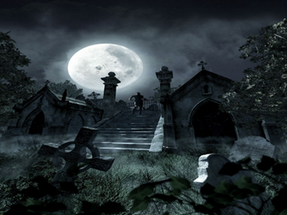
- Copy out all the language techniques in the response. Can you identify what techniques have been used?

Sunday 6th November, 1885. I remember it as clear as yesterday. I arrived at the cemetery gates, with a wreath in hand, ready to lie at my Mother’s grave, late that evening. I always found the cemetery a peaceful place at that time. It was a particularly cold November; my hands shivered clutching the wreath. However, something felt different that night; as I left the bystreet and approached the entrance, there was an atmosphere brewing in the air. The milky green patchwork sky doomed down on me as darkness fell. While the wind teased the rusty iron gates open, the gloomy clouds edged away; a sudden light hit my eyes -The full moon was exposed in all its haunting glory.
Suddenly, a rush of clouds crowded the sky and the unmerciful rain fell from the heavens. As I stepped inside, a boom of thunder followed me in. The lightening lit up the cemetery grounds and all the graves were visible, and then disappeared as quickly as they came. I ran to take shelter under a large Oak Tree. The tree was bare and naked; the fallen leaves crunched loudly under my feet. Crash! Another lightning bolt shot through the ground and as I stumbled forward in an attempt to locate my Mother’s grave, a distorted silhouette appeared in the moonlight.
The wind began to cut through me, my chapped lips quivered and my mind became a whirlwind of fear. The silhouette began to dart around the graves, edging closer to me. The rain was harsher now; it blistered my skin as it hammered down oppressively. My vision became warped. The acid rain clutched to my lashes and my eyes were miniature storm strewn oceans. I forced them open in a bid to answer my questions. Was this what I thought it was? Can it be real?
The mysteries surrounding the shadow unfolded before me; my apprehensions were confirmed. A ghost! Her long dark hair trailed down to her waist and her pasty dull skin looked haggard and scarred. My body froze to the ground, leaving me in a state of paralysis - stationary, stuck. My emotions overthrew my mind and the panic and dread set in, this was it; an unprepared eventuality. Unexpectedly, a surge of wind stole the wreath from my hands and swept it in her direction. As her hand lashed out towards me, the wreath propelled back and tore at my face, leaving scarlet like tears dripping down my cheek. I stumbled backwards, falling to the ground, now vulnerable.
As she edged closer to me her face became more recognisable, it was hard to be sure but her face was strangely familiar, and yet I couldn’t quite put my finger on why? Then she spoke; the eerie and piercing sound of her voice echoed at me. Who was she? What could she want?
- Now, using the table below to help you, make notes under each of the subheadings to see if you think this answer was successful.
Convincing:
Is the writing clear?

Does the writing make you feel like the story is real? If so, how?
Compelling:
Does it keep you interested as a reader?

If so, why?
Ambitious:
Has the writer tried hard to use a range of words?

Can you identify some examples of high level vocabulary?

Extensive Vocabulary:
Have they used a range of language techniques?

Can you identify an example and say what technique has been used?

- Now it’s time to have a go at creating some of your own extended pieces of creative writing.
- Firstly, have a go at trying to develop your descriptive writing.
- Whether you choose narrative and descriptive you need to PLAN first
- Below this are some example questions with planning guides to have a go at

Descriptive writing structured plan
Task: Around the image below, use your imagination to build ideas you could use to describe the setting
Taste:
Touch:
Sight
Smells:
Sounds:

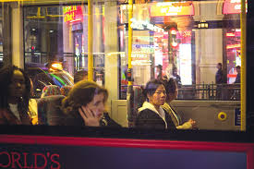
Language techniques checklist:
- Metaphor
- Onomatopoeia
- Oxymoron
- Simile
- Senses
- Questions
- Alliteration
- Personification
- Pathetic fallacy
- Sibilance
Punctuation checklist:
- Ellipses
- Question mark
- Exclamation mark
- Semi colon
- Colon
- Brackets
- Double dashes

Paragraph 1 focus:
E.g. atmosphere/emotions

Paragraph 4 focus:
E.g. Choose a person to describe
Paragraph 3 focus:
E.g. describe outside the window
Paragraph 2 focus:
E.g. describe inside the bus

Descriptive writing structured plan
Task: Around the image below, use your imagination to build ideas you could use to describe the setting
Taste:
Touch:
Smells:
Sight
Sounds:

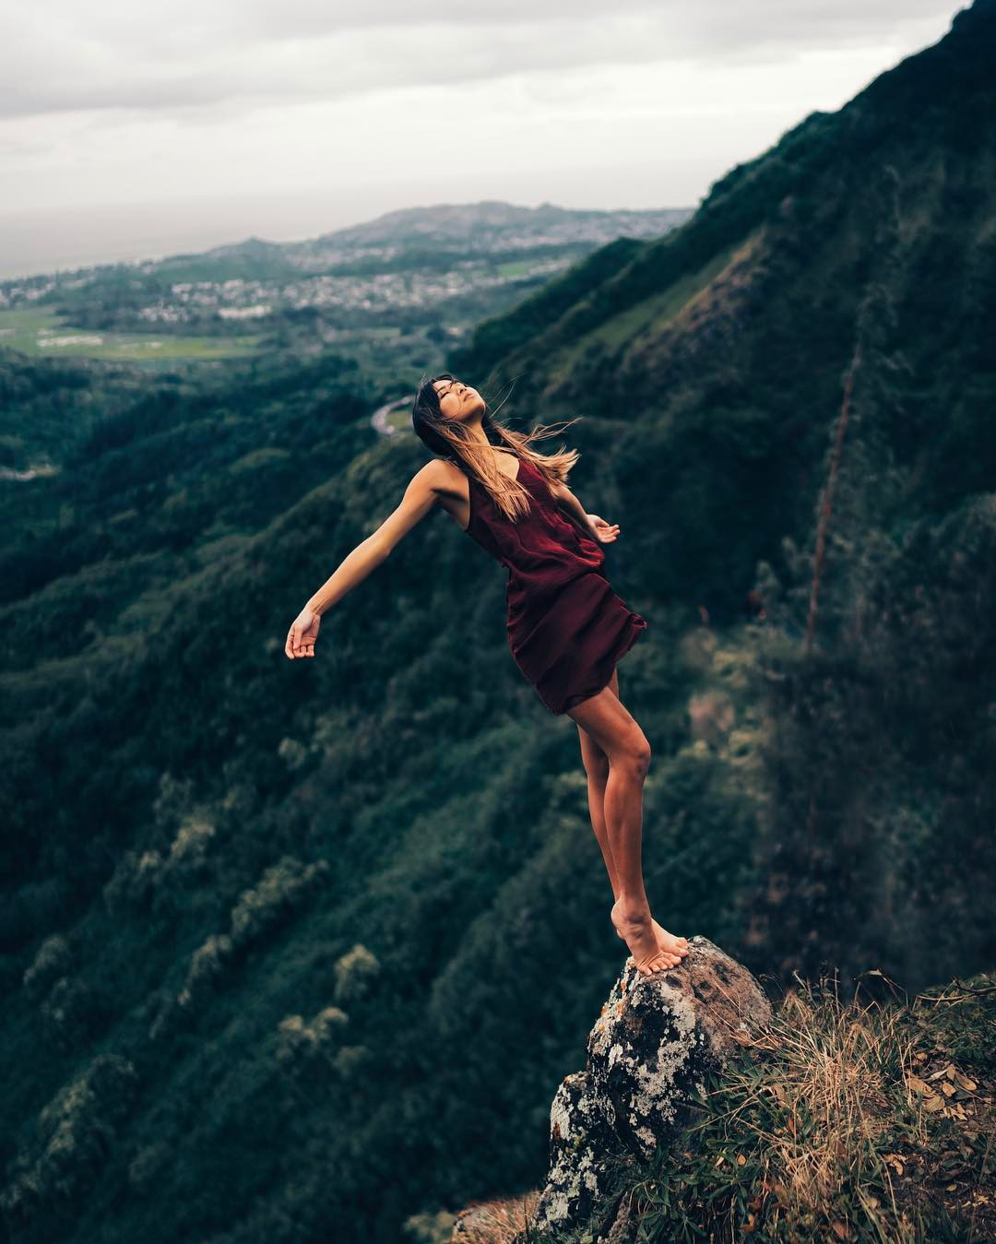
Language techniques checklist:
- Metaphor
- Onomatopoeia
- Oxymoron
- Simile
- Senses
- Questions
- Alliteration
- Personification
- Pathetic fallacy
- Sibilance

Punctuation checklist:
- Ellipses
- Question mark
- Exclamation mark
- Semi colon
- Colon
- Brackets
- Double dashes

Paragraph 1 focus:
E.g. surrounding area

Paragraph 4 focus:
E.g. Person
Paragraph 3 focus:
E.g. Mountains
Paragraph 2 focus:
E.g. atmosphere/emotions

