Year 7 Reading Recommendations

**You should be reading at least twenty minutes a day, so why not have a look at some of these and find your next favourite book?!**

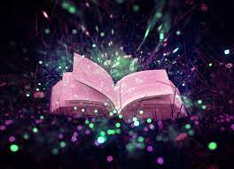

**Magic and fantasy:**

* The *Harry Potter* series by JK Rowling
* *Tom’s Midnight Garden* by Philipa Pearce
* *The Dark is Rising* by Susan Cooper
* *A Wrinkle in Time* by Madeleine L’Engle
* *Northern Lights* by Phillip Pullman



**Comedy:**

* *The Secret Diary of Adrian Mole* by Sue Townsend
* *Only You Can Save Mankind* by Terry Pratchett
* *Holes* by Louis Sacher
* David Walliam’s books
* Roald Dahl’s books

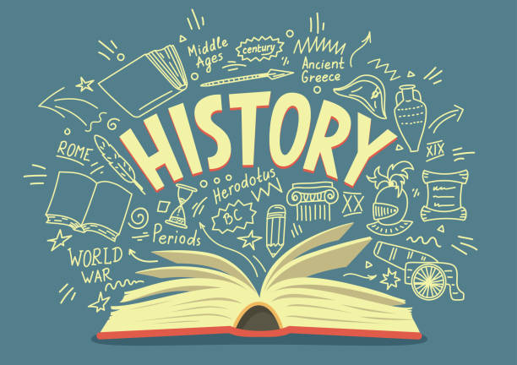

**History:**

* *War Horse* by Michael Morpurgo
* *Anne Frank’s Diary* by Anne Frank
* *The Eagle of the Ninth* by Rosemary Sutcliffe
* *The Sword in the Stone* by T.H White
* *Boy* and *Going Solo* by Roald Dahl



**Adventure:**

* *Swallows and Amazons* by Arthur Ransome
* *Peter Pan* by J.M Barrie
* *The Hunger Games* by Suzanne Collins
* *The Chronicles of Narnia* by C S Lewis
* *The Famous Five* by Enid Blighton



**Unusual circumstances:**

* *The time of the Ghost* by Dianna Wynne Jones
* *Wonder* by R J Palacio
* *Pig Heart Boy* by Malorie Blackman
* *Stig of the Dump* by Clive King
* *Across the Barricade* by Joan Lingard



**Teen life:**

* *The Princess Diaries* by Meg Cabot
* *Angels Unlimited* by Annie Dalton
* *Angus, Thongs and Full Frontal snogging* by Louise Renison
* *Cartwheeling in Thunderstorms* by Katherine Rundell
* *The Goldfish Boy* by Lisa Thompson

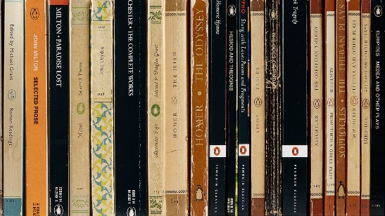

**Books to stand the test of time:**

* *Little Women* by Louisa May Alcott
* *The Book Thief* by Markus Zusak
* *Black beauty* by Anna Sewell
* *The Box of Delights* by John Masefield
* *Oliver Twist* by Charles Dickens

This list has been compiled by pupils.

Do you have any recommendations to add? We’d love to know!