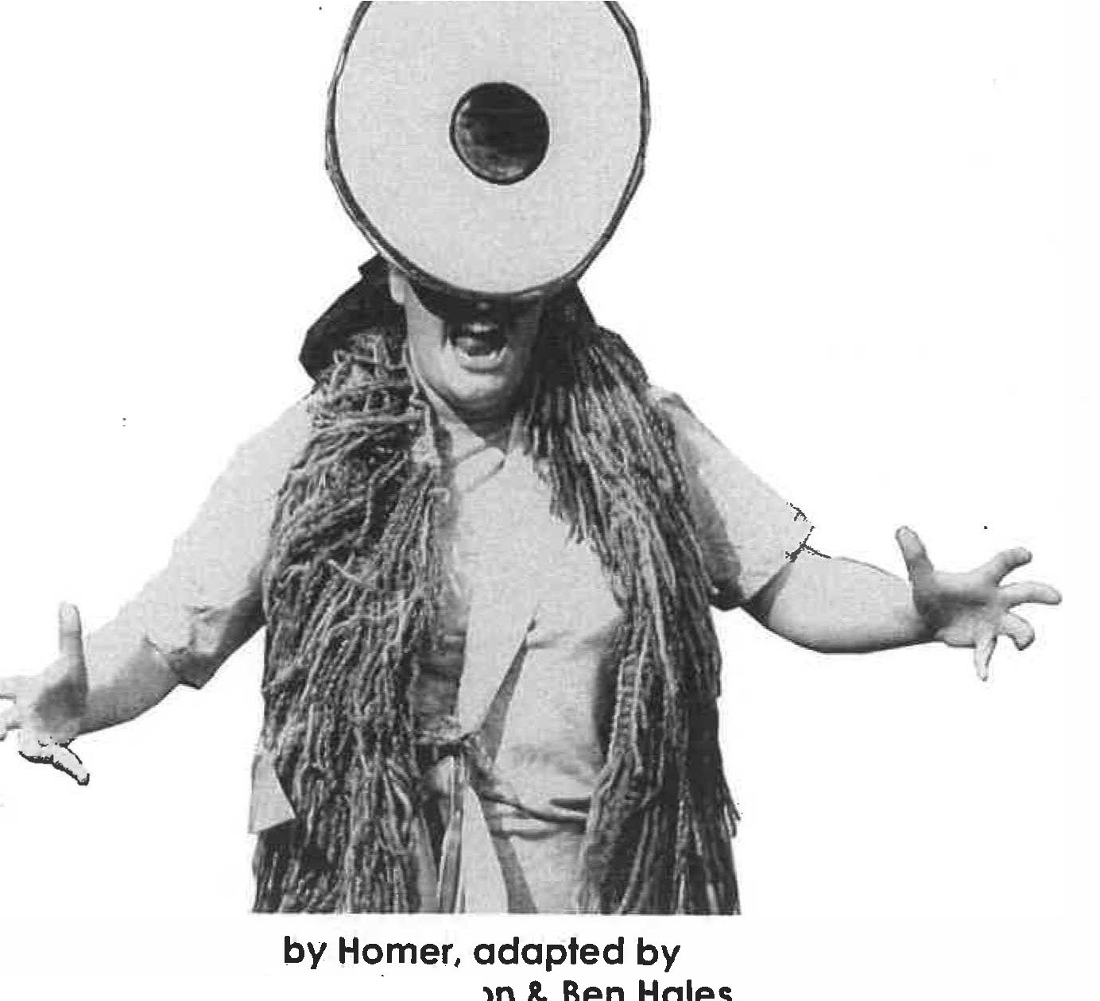
1

Splendid Pro d u c ti on s'
THE

ODYSSEY

by Homer, adaptedb

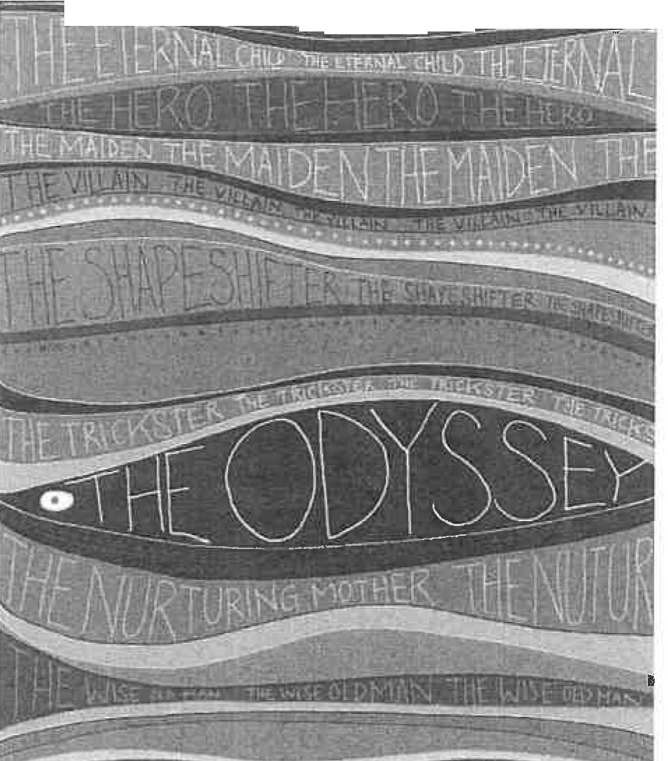
.·····-·....·····........................

................ . . . . ..............
by Homer
adapted by Kerry Frampton & Ben Hales songs by Kerry Frampton & Ben Hales

INTRODUCTION
'The Odyssey' that we know today is clearly the sum of many versions and many contributors who have shaped it over the course of its three thousand year history. Even if we accept that there was an individual called Homer in ancient Greece, it seems extremely unlikely that he alone was the originator of the entire epic (and that of its 'prequel' The Iliad). The story would have been old and legendary even to him, and the truth of the events stretched and embellished over generations of retelling, no doubt becoming more and more exciting and sensational each time.

How the tale became attributed to one teller is a mystery, but the popularity of the story is not surprising at all. A charismatic hero, an epic journey; gods, monsters, death, murder, sorrow and loss, and the ultimate blood-spattered happy ending. Odysseus is an archetypal hero, and The Odyssey is an archetype of storytelling. The title itself has become our word for fateful adventure (although Odysseus might object when it gets applied to a 'shoe shopping odyssey', for example).

Losing Odysseus
As a theatre company working in a Brechtian style, archetypes are interesting to us. Odysseus may be courageous, wise, strong and a beloved leader, but he is also a murderer, an adulterer and a constant taker of crazy risks. His portrayal is a reflection of Homer's world view, which accepts that Odysseus and his Greek companions are inherently more powerful and civilised than any other culture they encounter.

Not being Ancient Greeks ourselves, we wondered if there was a way to look at the same story from a different angle. What if Odysseus is not our hero? What happens if we get rid of him and his legendary presence, and focus instead on the effect he has on everyone around him? Not only does this chime with Penelope's experience, which is defined by the absence of Odysseus, it also clears the way to hear from some of the other characters, like the socially awkward cyclops Polyphemus (who was happy looking after his sheep with his one eye and doing no harm to anyone before Odysseus turns up and robs him of both), or the Laestrygonian giants who respond to the Greeks' lack of courtesy in exactly the same way as the Greeks do to the 'lesser beings' they meet - by murdering everybody.

The problem with removing the protagonist from the centre of the story is that it means we are forced to relate the events rather than demonstrate them, especially as Odysseus's companions are gradually reduced to zero. One of the challenges in building the piece was finding opportunities for things to happen

'actively' in front of the audience that didn't need Odysseus in the middle. Initially this is done by Odysseus's men, the Warriors, who generally share Odysseus's desire for battle and treasure, but begins to switch to Odysseus's adversaries and companions.

Although they all act as narrators of their parts of the story, we tried to find as many different forms as we could for the storytelling to take - the shared chorus of the lotus eating warriors, the split-focus of the Cyclops scene, the 'interview' of
the Laestrygonian giants, lots of songs, and three different style.s of monologue
from the three women in the piece. Interspersed with these are moments in which the audience are literally active, creating storms and taking part in the terrifying obstacle course. Odysseus himself becomes a well-defined area of negative space in the centre of an energetic, ever-changing world, like the chalk outline of the body at a murder scene.

The Old Man of the Sea
Another crucial starting point echoed Augusto Baal's idea that you should consider yourself the 'star in your own movie', rather than a bit part in someone else's. How could we make the audience feel that their lives are as much an adventure as Odysseus's? He is famous because of the stories that are told about him. If that is essentially all that is required to be 'legendary', then surely
everyone is at the centre of their own legend? This led us to the idea of the chorus of the Old Man of the Sea, whose main diet seems to consist of collecting and retelling stories.

The Old Man of the Ssa is a mythic creature mentioned very briefly in The Odyssey. He is a mythical creature who lives in the sea with his precious flock of seals, taking care to count each one onto the beach at night, and then each one into the sea each morning. But it's known that if you can pin him down, he is obliged to tell you the future. However, if you try to capture him he will rapidly change shape, becoming all manner of terrifying creatures in an attempt to shake you off.

The elements of shape-shifting, sooth-saying and incredible attention to detail made the Old Man of the Sea an obvious choice of character to act as chorus for our production. To our Old Man of the Sea, the audience is both his flock of seals and his harvest of future legends. He is choosing to tell the story of Odysseus, but who knows whose story is next? His love is for the story rather than the protagonist; reducing Odysseus to the size (and shape) of a wooden spoon is not to diminish his importance, more to put his outsize legend into the correct perspective. The archetypes he pegs to the line ('words spoken' about Odysseus) track Odysseus's journey but, being archetypes, they can also apply to us all.

Use of chorus
Our Old Man is a single being played as a 'chorus of character', and another challenge we set ourselves was to use as many other choral techniques as we could find. Although The Odyssey is not a play, we wanted to refer to the tradition of Greek theatre, and also to bring in a sense of moral questioning that the original story lacks. The obstacles are framed as direct questions designed to link the story to the audience, and to reattach the mythic Odysseus to the real world. What do you do if you've made a mistake?

The Old Men of the Sea are a Greek-style chorus, acting as point of contact with the audience. They are a single character, of one mind, but able to speak individually. The lotus-eating warriors are pure technical chorus whose effect relies on the precision of the simultaneous speech and movement, even down to choral mistakes. The Suitors give us a choral point of focus and a chorus of reaction, and in the Song of the Cows there is choral singing combined with choral emotion.

Absent Friends
Perhaps inevitably there was a bit too much Odyssey for the hour-long duration we'd set ourselves, which meant that not all of the choral ideas we developed ended up in the final version. These included the physical embodiment of a Bag of Wind, a choral prophet Tiresias whose voice was made of three different tonalities, and a much more detailed choral description of the events of the Trojan War at the beginning.

We had also intended to bring in the idea of home in more frequently, and hear directly from Telemachus and the old maid Eurycleia, but in the end we felt that Penelope represented the idea of home more strongly. We had already decided that our adaptation would not follow the structure of Homer's version, and would follow Odysseus in a chronological order, and we knew there were a lot of elements we would have to leave out entirely (such as Telemachus's journey, and the story of how Odysseus made it back to Ithaca and found his way into the palace), but there were some cuts made fairly late in the rehearsal process, such as Tiresias, whose warning about the cows we gave to Circe. The story of the Odyssey is very much like the washing line that formed the backdrop to the production, it is a bunch of almost arbitrary episodes that occur without cause or effect, so it was quite straightforward to just unpin some bits without affecting the shape as a whole - which was lucky because quite a lot had to be unpinned.

One of the reasons for the lack of cause and effect was our decision to remove the gods from our version of the story. In Homer's version, as in all classical Greek stories, the gods are looking qown from Mount Olympus and taking a special interest in the activities of kings and heroes, regularly intervening in their stories.
This imposes a kind of moral framework (for example the Sea God Poseidon is
m

often enraged by Odysseus and sends storms to punish him), but these events are generally the result of personal enmity {Polyphemus the cyclops is Poseidon's son) rather than a judgement on Odysseus's behaviour. After all, none of the gods punishes Odysseus for seven years' infidelity with Calypso.

Odysseus is the favourite of the goddess Athene, and she is largely responsible for giving him the extra luck he needs, or important information that he wouldn't have got otherwise. (Again this is inconsistent. She sends Hermes to tell Odysseus how to avoid Circe's pig-medicine, but it is pure unexplained good fortune that Odysseus chooses not to anchor his ship along with the rest at the harbour of the Laestrygonians). For us, it's much more interesting if it's the humans who are responsible for their actions instead of arbitrary interventions from heaven. Why shouldn't we do what we want, when we want, all of the time?

Using the audience
But as all seafarers know, there are catastrophic storms at sea, and as Odysseus and his crew are at the mercy of the wind, it is plausible enough that all of his misfortunes are down to random acts of weather. The idea of using the audience to create the storms came very early on in the process, as it is exactly the kind of joyful chaos we like to encourage.

The way we include the audience within the story is a key component to every production, and with The Odyssey we wanted them to feel part of Odysseus's journey as well as the star of their own, hence the audience are primed to row, cry or create storm sound effects, while there are other moments where audience members ore required to stand in for Odysseus. For us it's a crucial part of the liveness of the experience that there are sections of the performance where we have no idea what is going to happen. Like the choice for the Old Man of the Sea to wear impractically long beards, these sections are theatrical problems we set ourselves to solve in the moment in every performance.

Just like in real life, it's how you overcome the obstacles that's the really interesting part. And as all storytellers know, from Homer in 750BCE to today, it's no fun if it's too easy.

Kerry Frampton & Ben Hales January 2016 .

iv

ABOUT THE SCRIPT
The script that follows is based on the final version we used for Splendid's tour of The Odyssey, September 2015 to April 2016.
The stage directions include a lot of the specific action in our production, so here are some explanatory notes.

SET, LIGHTS & COSTUMES
There are no lighting cues and no backstage in our productions, so each scene runs directly into the next. Costume changes are incorporated into the introduction to each scene, or 'stop'.
The set consisted of a rope line suspended between two uprights positioned upstage. The line represented Odysseus's journey from the WAR (a sign on the stage right upright) to HOME (a sign on the stage left upright). As the journey went along various signs and objects were hung on the line, including the archetypes you'll see in the text - eg. [ARCHETYPE: ODYSSEUS THE KILLER]. These were written on strips of brown paper, along with a small painted icon for each stop (a lotus flower for the second stop, a skull and crossbones for the sixth etc), and attached with clothes pegs.
Other significant moments were represented with ribbons (blue for storms or red for deaths) or objects (Cyclops' cardboard eye, sunken paper boats), and the Odysseus spoon itself moved along as a marker of his progress whenever he was not called upon to be in the scene.
The line itself extended loosely on either side to be used to create waves, or ships, or just to be coiled up in a seamanlike fashion. There were also three small stools for sitting or standing on, and there were three sticks (broomhandles) for the Old Man of the Sea. Finally, there were the audience items (see pl) plus a toy wooden boat filled with wooden men, and all the protective equipment needed for the volunteer in the sixth stop.

The Old Man of the Sea is a single creature played by three people, so they wore identical outfits, including very long knitted beards. From the outset, twelve brown-paper origami boats are pegged to the beards, and these diminished throughout the voyage as the ships were destroyed. The beards were removed for changes of character and hung up from the uprights.
There was no 'neutral' state for the actors between characters, and they would always return to their beards (and the Old Man of the Sea character) in between. Underneath the beards each actor wore a triangular scarf that was worn in many different ways to denote characters - a sash for Warriors, a headscarf for Penelope, a weird snood/cravat for the Suitors - but could also be attached to the sticks to crea te,a sail, or waved as a white flag.

V

GESTUS
There are some examples of what Bertolt Brecht called 'gestus', which are heightened, theatrical moments intended to highlight characters attitudes, and this can be in movement, speech or song. You will see 'gestic moments' referred to in the script, particularly when the word 'home' appears. In these moments, there would be a pause, a look to the HOME sign, and a longing in-breath. Other gestic moments included signature character 'moves' such as the Warriors' shout of 'Yeah!', or the Suitors' 'Yoh!', which also help to identify characters as they appear.

The Song of the Cows is intended as a 'gestic song', where each verse is sung displaying a single, specific attitude {anger, sadness, fear), to leave the audience in no doubt as to what the singers are feeling.

CHORUS AND THE OLD MAN OF THE SEA
There are many moments of choral (simultaneous, identical) speech throughout the text, and these are marked In bold.
The Old Man of the Sea is a 'chorus of character', whereby the three actors are portraying the same being. Although there are lots of moments where the Old Man talks to himself ('Good question myself'), you will find many speeches divided between his 'selves' that should be considered single continuous thoughts, and the grammar and punctuation is arranged to reflect this.

vi

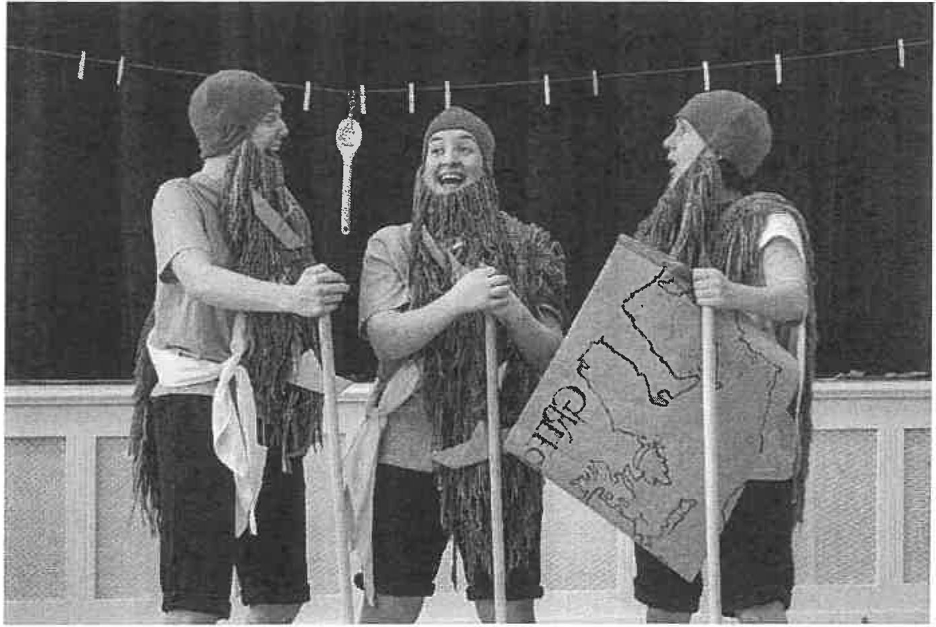

CHARACTERS
Old Man of the Sea 1 Warrior l, Sheep 1, Antiphates the Giant Chief,
Circe, Suitor 1

Old Man of the Sea 2 Warrior 2, Penelope, Sheep 2, Giant Chief's wife,
Suitor 2

Old Man of the Sea 3 Warrior 3, Cyclops, Giant Chief's Daughter,
Calypso, Suitor 3

ORIGINAL CAST
(September 2015 - April 2016)
Old Man of the Sea 1 Genevieve Say
Old Man of the Sea 2 Kerry Frampton
Old Man of the Sea 3 Cordelia Stevenson

vii

PRE-SAILING PREPARATIONS
As the audience arrive, they are met by the Old Man of the Sea - one person in three bodies, each wearing a massive woollen beard full of paper boats. The Old Man of the Sea (OMS) is very happy to see everyone and greets them warmly as exciting new friends, or perhaps returning legends.

OMS 1 OMS2

OMS3

OMS2
Welcome. Welcome . Are you ready to set sail?

Exceptional humans every last one of you, I will count you in and count you out.

So brave to take to the sea like this. Unique and precious with your own journey to make and your own story to tell.

Come, come take your seats. Do not be afraid.

Before the journey can start, there are preparations that need to be made. The following tasks are given to audience-members:

Audience-counter: Must count the total number in the audience, including newcomers. This number will be referred to throughout the performance, and is inserted where you see [NUMBER] in the text.

Epic-namer: Must visit the audience giving out Homeric Epic Names (see Epic Name Generator on p2) so that they feel appropriately heroic.

Death Toll-keeper: Must keep track of the number of Odysseus's men that perish on the journey. They will be called upon throughout the performance.

Map-holder: Must keep hold of the Old Man of the Sea's map and give his location when asked.

Storm Orchestra: Must provide the tempestuous sound effects for the storms using the provided instruments (sea drum, thunder tube, rain stick).

Panic Person: Must wear a rain poncho and run around the audience spreading panic during storms.

Storms: The remaining audience must choose an activity to undertake during the storm, including rowing furiously, waving blue ribbons, clinging onto imaginary ropes, or holding a friend tightly and weeping in terror.

(It is advisable to practice the storm procedure in advance, not forgetting to explain how the audience will know the storm has passed.)

Note: As with all audience-participation, it is important to approach them warmly and generously. Everything they choose to do is right, and with individuals in particular it is not essential that they perform all their tasks perfectly- that's just another theatrical obstacle to be overcome.

The Epic Name Generator
Ask your audience-member to choose two numbers between 1 and 20 and put their name between the options below. The outcome is their unique Homeric Epic name.

1. | Admirable | 1. | Of The Strong Arms
2. | Nimble-Witted | 2. | Child of The Sea
3. | Keen-Witted | 3. | Of the Loud War Cry
4. | Lion-Hearted | 4. | Daughter/ Son of The Earth
5. | Patient | 5. | Of The Lovely Hair
6. | Bright -Haired | 6. | Of The Soft Cheeks
7. | Famous | 7. | Child of The Mountains
8. | Brave | 8. | Of The Lovely Voice
9. | Resourceful | 9. | Of The Powerful Brain
10. | Heaven-Born | 10. | Daughter/ Son of The Wind
1 1. | Formidable | 11. | Leader of People
12. | Glorious | 12. | Of the Gleaming Eyes
13. | Powerful | 13. | The Trickster
14. | Heroic | 14. | The Kindest of Hearts
15. | Generous | 15. | The Great Defender
16. | Cunninq | 16. | The Animal Whisperer
17. | Noble | 17. | Of The Brilliant Mind
18. | Dependable | 18. | The Spinner of Stories
19. | Divine | 19. | Of the Friendly Face
20. | Trustworthy | 20. | The Dynamic Mover

INTRODUCTION

OMS OMS 1 OMSJ OMS2 ALL OMSJ OMS2

OMS2 OMSJ OMSl
I am The Old Man of the Sea and I see everything.

What is past, what is present,
and what obstacles lie ahead.

I sail the world on a sea of stories.

My [NUMBER) friends, we are all stories in the making.

Each of us on a unique journey, with obstacles to face and overcome.

Me Me Me

The old men look at.each other fondly, and then at the audience.

ALL OMS2 OMS 1 OMSJ ALL
You.

But this story, this journey
is that of the Greek legend

Odysseusl

Odysseus, in the form of a wooden spoon, is revealed.

OMS 1 OMS2
Here he is, he's being played by a spoon. Unexpected!

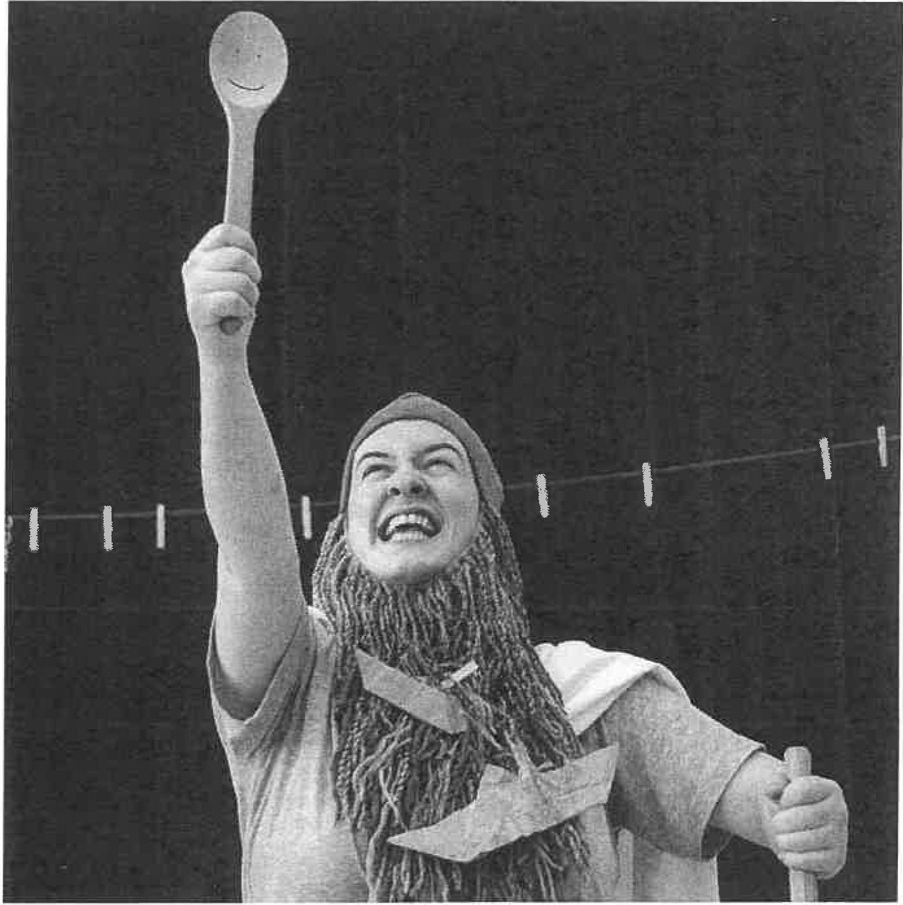

OMS3

OMS2 ALL OMS 1 ALL
And this is his voice. {Ludicrous high-pitched puppet voice)
"I'm a king! Born to win!" Odysseus was a king of the bountiful Greek island of Ithaca. (gestic moment) Home.
And his long journey homewards is a story that's been told for

thousands of years.

OMS 1 ALL OMS3 OMS2 ALL
His story begins with a war.

(gestic moment) War!

A war that lasted for ten years.

A war that Odysseus and his Greek army won.

(as the Greeks) Winners!

[ARCHETYPE: ODYSSEUS THE HERO]

OMS 1 OMS3 ALL

OMS2 ALL OMS2 ALL OMS2 OMS3

OMS2 OMS 1

OMS3

OMS2

Odysseus, one war hero leads twelve ships
(counting the paper boats on their beards) One, two, three, four, five, six, seven, eight, nine, ten, eleven... twelve ships!

That set sail across the wine dark sea towards

(gestic moment) home.

But

Life has a habit of throwing obstacles In your path.

Like this one:

Obstacle. Why can't we do what we want, when we want, all of the time?

(impressed) Good question, myself.

Six hundred triumphant men sail with Odysseus, winner of wars,
.setting out on an epic journey homewards.

However, they clearly haven't had enough war, so they decide to invade the small coastal town of Cicones on their way.

First stop, the small coastal town of Cicones.

FIRST STOP: THE COASTAL TOWN OF CICONES
OMS2 Here we shall witness thousands of innocent people being murdered. Behold! Odysseus the killer.

[ARCHETYPE: ODYSSEUS THE KILLERJ

Enter the Warriors.

Warrior 1&3 Yeah! Brothers! Warriors!

Warrior 1 Look at us warriors, sailing on our massive ship away from war.

Warrior 3 With Odysseus at our helm.

Warrior 1 Yeah!

Warrior 3 Triumphant warriors with Odysseus our leader. We're amazing!

Warrior 1 Yeah!

Warrior 3 We can do anything we want!

ALL We can do everything we want!

Warrior 2 See that seagull? (He pulls out imaginary bow and arrow and shoots it, sound effect of dying seagull.} Dead!

Warrior 3 See that whale? (He harpoons it with imaginary harpoon,
sound effect of dying whale) Dead!

Warrior 1 See that small coastal town? Let's invade!

Warrior 2 Let's rape! Warrior 3 Let's murder! ALL Let's... WINI

Song 1: The Song of the Winners

Warriors

ALL

Warrior 2

Warrior 1 Warrior3 Warrior 1 Warrior2

ALL

Warrior 2

Warrior 3

Warrior 1 ALL
We see it, we want it, we storm it, we take it Don't get in our way
We'll smash it, we'll grab it, we'll slash it and stab it Prepare for judgement day

We're born to be the winners We sat on a winner's knee Naturally we'll win again We're bred for victory Everyone loves a winner
The famous and the brave
You won't survive for we've arrived To put you in your grave

Yeah!

Did you see Odysseus out there? He was knee deep in Ciconian guts.

What a killer!

Yeah, but now he's saying we have to leave Cicones! What? That's ridiculous, we've just won. Again.
Men, I say, we stay here and celebrate another comfortable victory.

Yeah!

All the men have been slaughtered and the young women have been herded up.

.Come on lads! We deserve them. We'll show them what real men are! YEAH!

Their faces change as they see a large terrifying army in front of them

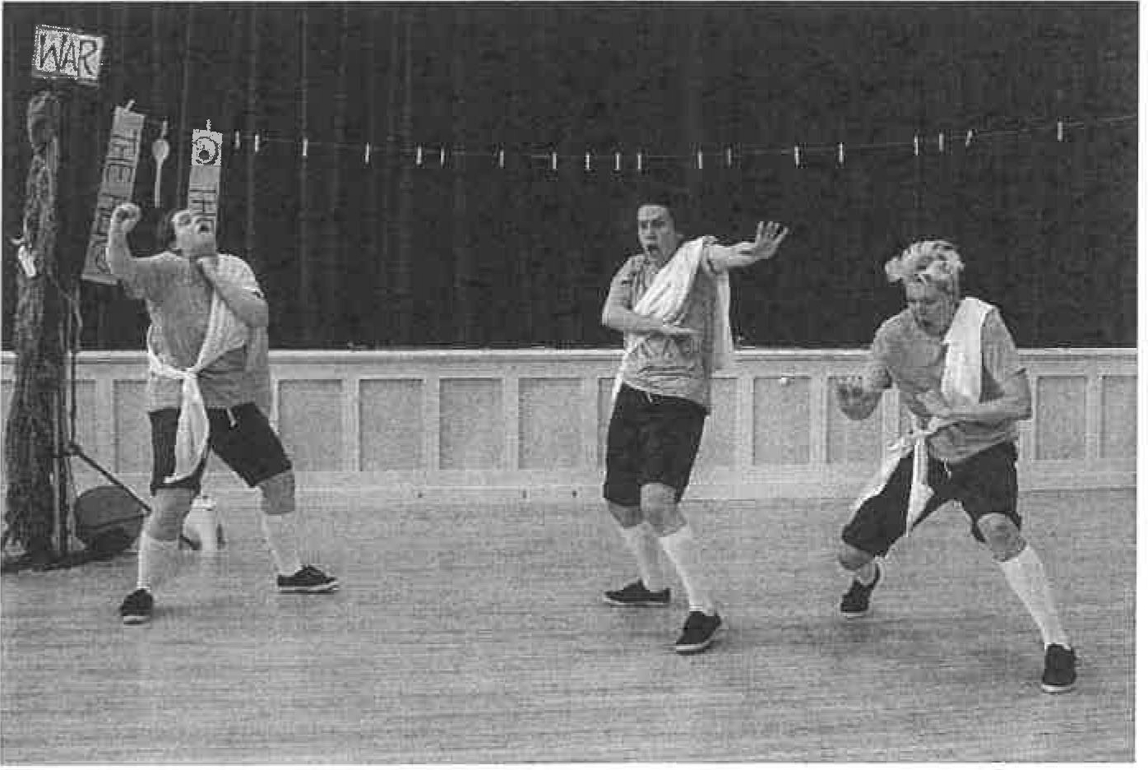

ALL Oh no, where did that massive army come from?

They turn and run in slow motion. We see them being cut down in various gruesome ways. Being very manly they make light of their mortal wounds ('It's just a spear, I'm fine!'. 'Does anyone have a plaster?'. 'I'm still better than you!' etc).

The final surviving warrior sings a reprise of the 'Winners' song with a deep sadness.

Warrior 2

OMS3 OMS 1
(sings) We're the winners not the losers We write our own history
Who cares about the losers yeah? Their life's a tragedy

The neighbours of the Cicones' assemble a skilled army and fight the six hundred invaders.

Seventy-two of Odysseus's men are overpowered and killed. That's six men per ship dead.

OMS2

OMS 1 ALL OMS3 ALL
Five hundred and twenty-eight survivors sail away with heavy hearts, grieving for the loss of their dear companions, though rejoicing in their own escape.

That's life and death, myself.

Life and death.

Look out!

STORM!

STORM 1 {see pl)

OMS3 OMS 1 OMS2

OMS3 OMS2 OMS 1 ALL OMSl OMS3
(eventually) The storm has passed. Where were we?
Barbaric Odysseus and his men have been chased off Cicones by a very angry army

and the storm has blown them far far
far

off their course.

Where are we now myself? I'll check the map.

They consult with the map-holder in the audience.

OMS3 It's the second stop, the Land of the Lotus Eaters.

SECOND STOP: THE LAND OF THE LOTUS EATERS

[ARCHETYPE: ODYSSEUS THE POWERFUL LEADER]

OMS2 OMS3

OMS2
Where we will see Odysseus the powerful lead er.

One land filled with Lotus-eating people who eat the Lotus Flower.

Twelve ships land and some of the men go ashore. Obstacle. How can I make all of my troubles go away?

Enter the Warriors. This scene is conducted in tight chorus. The Warriors' enthusiasm for the fruit grows with each section.

Warrior 1 Yeah! (Seeing the audience and speaking loudly and slowly)
Greetings, strangers. We are important and lost.

Warrior 1&3 We've just landed In your country and wondered what type of human beings you are.

Warriors You seem friendly. What's that? You want to give us fruit?
(Accepting the fruit) OK. Thank you.
{To each other, curious) So they're called Lotus Flowers, but they're not flowers? (They sniff the fruit)
Ooooohhhh.
Just one then. Just to try it. (They eat the fruit)
Mmmm! Flavoursome!
(Accepting another) Just one more then... If you Insist.

(Neutral) Time passes.

The Warriors march smartly to another part of the stage.

Warriors (eating fruit) Mmmml
We love this (mispronounced) mythical fruit.
(Correcting themselves) Mythical fruit. That's really hard to say! More please. {They eat)
Gosh, I can't even remember why I'm here. (They eat)
I'm feeling much happier In myself. I want to have more.
(Dangerously) f:low.

Warriors (Neutral) Time passes.

The Warriors hold hands and move dreamily to another part of the stage.

Warriors (happily} What Is a 'home'? I forget.
Why would we ever want to leave here?

(Neutral) Time passes.

The Warriors move to another part of the stage in an unruly conga line.

Warriors (greeting Odysseus as if mid-party) Waheyl It's our powerful leader Odysseus!
(Sad) No sir we do not want to leave. It's nice. They're nice.
(Folding arms) We're not coming.
You'll have to drag us away kicking and screaming. (Being dragged away) Don't drag us away kicking and screaming! We don't want to go!

They weep profusely

Warriors OMS3

OMS1

OMS3 OMSl OMS3 OMS 1
OMS3
Odysseus Is the worst leader ever. We hate him... so powerful...

At Odysseus's command, the ships set sail once again towards home. {Gestic moment) Home... (To the Death Toll-keeper) What's the death toll now? (He gets the answer) That means there are seventy-two men who won't be returning home.

(gestic moment) Home. Where we love is home. A safe place where we begin and end.

Waiting for Odysseus at home are Penelope, his loyal wife

.and Telemachus, his loyal son.

Plus
one hundred and eight uninvited guests. Suitors.

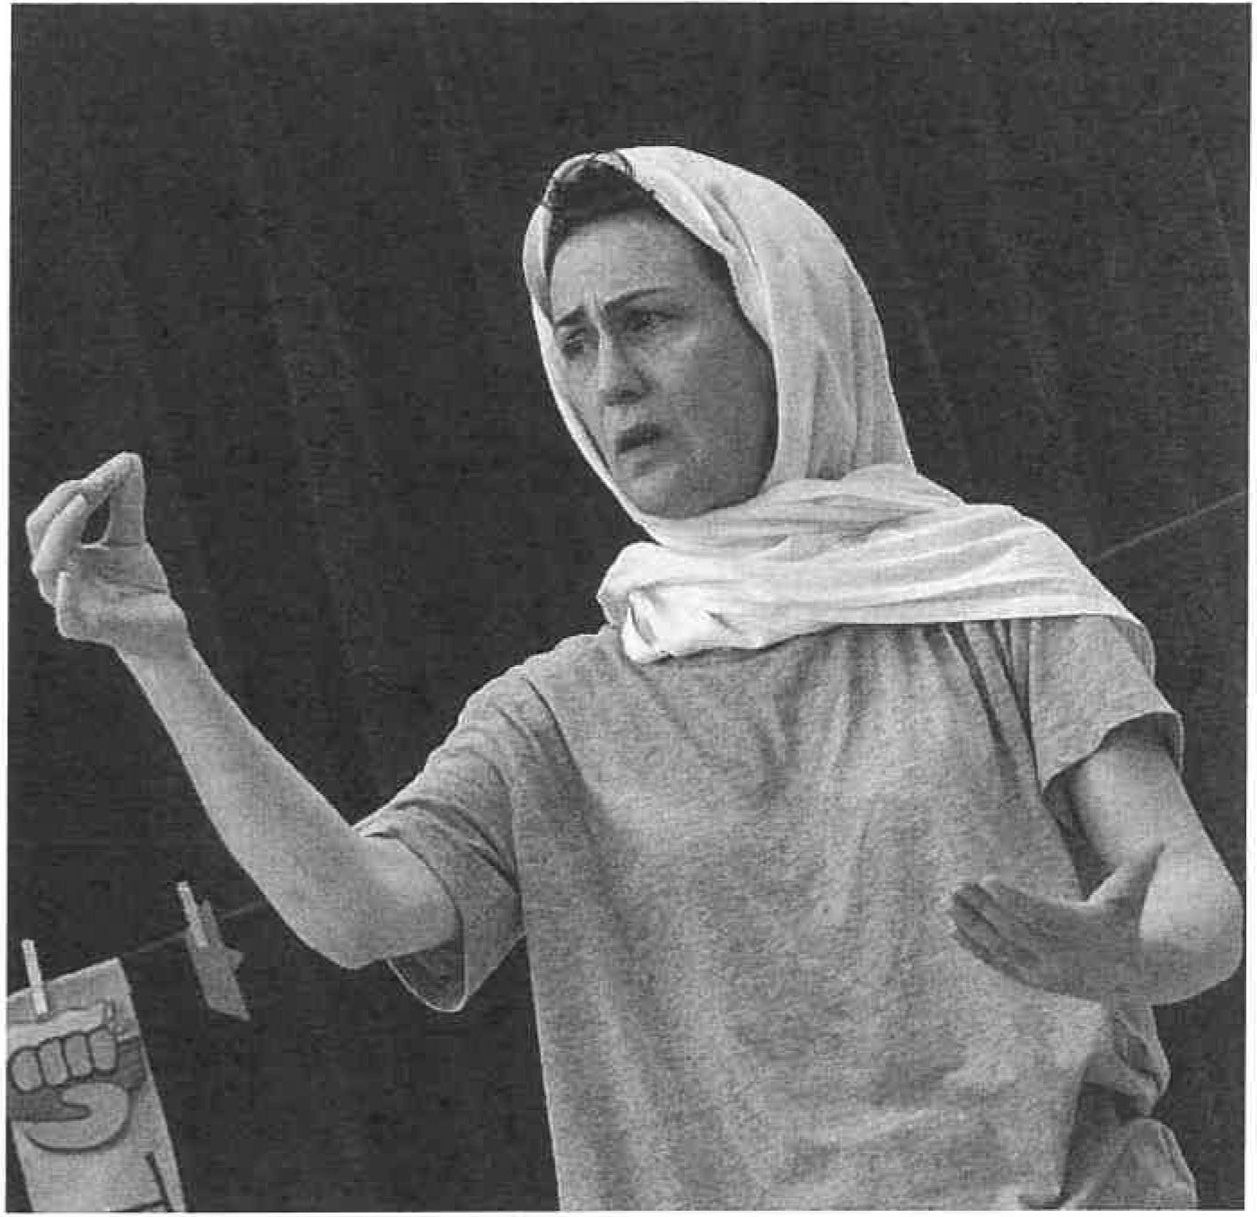

OMS 1

OMS3

OMS 1
OMS3 OMSl
Aristocratic thugs who wish to marry Penelope and who are a continual threat to the life of Telemachus, her son.

Don't you worry, these Aristocratic thugs will all be dead by the end of the story.

Oh good.
Obstacle. Why does the past take up so much of the present? Let's hear from Penelope herself, a woman.

[ARCHETYPE: ODYSSEUS THE ABSENT HUSBAND]

Penelope 1 This is the story of my absent husband. When he went away to fight I was fifteen years old. I can still remember his last words to me before he left. Telemachus was tiny then, Odysseus could hold him in one hand. We stood here in the great hall, the three of us, and he said: "My darling wife. I do not think we will all return home from war safely; I may die on foreign soil. But know that if I survive I will come back home to you."

"I will come back home to you."
I believe that if my husband were dead, I would know.

It must have been ten years ago that the first of the liars turned up at the palace, wanting to trade false information for real gold. Odysseus spotted in a foreign palace, or in a land of giants, or sailing west away from home.

After that came the suitors, our 'esteemed guests', trying to tactfully suggest I should give up hope of Odysseus's return and marry one of them. One hundred and eight suitors! There's only so much wooing a woman can take. That's why I gave them this ultimatum: I will choose a new husband when I have finishe9 weaving this shroud.

You might wonder how it has taken me so many years to finish one piece of fabric. But if I complete it then I have moved on and conceded that Odysseus is gone. So late at night I unpick the threads by candlelight. Then I begin constructing again in the morning.

I do, I undo, I redo.

I believe that if my husband were dead, I would know.
. So I must believe that he will keep his promise. I do, I undo, I redo.

1 In our version, during this speech Penelope stitched herself and various audience members together with a long invisible thread, before carefully unpicking them.

OMS 1

OMS3

OMS2 OMS 1
There is a woman who survives on memories alone.
(Drastic shift of tone) Now then my epic friends! Most stories are told through one pair of eyes. But what if you only have
one eye? Does that make your story half as true?

Your version of an event (points to one audience member) might be different to yours (picks another member of the audience}, but they can both be the truth.

And the truth is a slippery fish.

Third stop, the Island of the Cyclops.

THIRD STOP: THE ISLAND OF THE CYCLOPS
[ARCHETYPE: ODYSSEUS THE LIAR]

OMS 2 Here you will witness Odysseus being The Liar.

OMS 1 One one-eyed monster, a cyclops, living in one cave on one picturesque island.

OMS 2 One contrary wind drives twelve ships towards picturesque island.

OMS 1 Odysseus and twelve of his crew go ashore and help themselves to all the island has to offer.
OMS 1&2 Obstacle. Why do we fear what we do not know? Cyclops enters. He is not particularly terrifying and seems a bit shy. Cyclops (nervously, to audience) Hello... Um...
Shepherding is great. It's quiet... there's sheep... there's fresh
air... It's rewarding. (Calling) Come by!

Two sheep arrive and gather around Cyclops.

Cyclops I counts my sheep in at night, one two three four five, and I counts them out in the morning, five four three two one.
I spends my days hiking in the mountains, milking my flocks and then cheeses-making! It's a simple life but I enjoy it.·

I live apart from the other cyclopses. Now, it's not that I don't like other folk, I just prefer my own company... and the sheep, of course. (Sending the sheep away) Away!

- (Embarrassed } Scuses! I haven't introduced myself! My name is Polyphemus. I'm a cyclops, a one-eyed giant. You might have noticed the one eye. (Picking out an audience member) I been seeing you staring. Don't worry, it's all right to ask. I think having two eyes is a bit greedy, personally. {Mock horror) You weirdies!

Two Warriors appear

Warriors Warrior2 Warrior 1
Warrior 2

Warrior 1

Warrior 2

Warrior 1 Warriors Warrior 2
Yeah!

Here we are again on our massive ship! Cyclopes! They're a lazy lot.
One-eyed.

Lawless.

Brutal.

Cruel.

Not like us!

Going ashore!

They leave their imaginary ship and survey the island.

Warriors Warrior 1
Warrior 2

Warrior 1
Yeah!

Look! A Cyclops Cavel

We approach the cave mouth with due c aution. Knock, knock? The beast is not at home. Come on men!

The Warriors enter the cave. It is very big.

Warriors Warrior 2
Warrior 1

Warrior 2 Warriors
Wow!

With no immediate threat, we make ourselves at home. Let's light a fire, and feast on some of this cheese.
There's loads of it!

(eating cheese) Mmmmnnn! Cheese! Delicious!

They hear Cyclops calling the sheep in the distance.

Warrior 2 Warriors
Quick, the Cyclops is coming.

Hide!2

Cyclops counts his sheep, and re-enters his cave.

Sheep Cyclops
The master blocks the entrance to our cave with a big rock.

That's got us nice and safe for the night. I'm looking forward to putting my feet up and having some of that cheese.

He spots the tiny men in his cave.

Cyclops Sheep Cyclops

Sheep Cyclops
(shocked) What's that? Strangers!

Strangers!

What are you doing here? You 'men' are uninvited... Liars! Liars!

Men are not to be trusted.

Men are not to be trusted. They come with gifts and lies and then they stick a flag in your land claiming it's theirs. I will protect what's mine!

He rolls up imaginary sleeves and prepares for attack, as described by the Warriors

Warrior 2

Warrior 1
The ferocious beast picks up two of our heroic comrades, smashes their skulls against the rock and devours them hungrily!

.That was horrific! Why would he do that?

2 In our version, Cyclops and Warriors remained on different sides of the stage, playing outwards and keeping their own sense of relative scale, eg. Warriors passing up massive drinks that look tiny in Cyclops' hand, a full-sized spear becoming a tiny stick in Cyclops' eye.

Warrior 2

Warrior 1

Warrior 2

Warrior 1 Warriors

Warrior 2
And where are his manners?

(to Cyclops) We would smash your brains out here if it weren't for that massive rock blocking our one means of escape!

Yeah!

He's coming!

Two more men! (They call out two men's names, possibly at random)

And then Cyclops takes up two more men, that's six crew members in total eaten up.

Weeping and sighing.

Warriors Warrior 1
Warrior 2 Warriors

But!

Odysseus hatches an exceptional plan. An exceptional plan in song form.

Get. The one-eyed. Monster. Drunk.

They hand Cyclops some drinks. Cyclops drinks.

ALL Cheers!

Song 2: Get the One-Eyed Monster Drunk

Warriors We got the one-eyed monster drunk (Sloshed, smashed, sozzled, stewed) Drunk as a massive one-eyed skunk (Sloshed, smashed , sozzled, stewed) Got his brains all muddled fuddled Vulnerable and helpless
With yummy scrummy in my tummy Delicious boozy booze

Cyclops Top up the golden liquid now
(Sloshed, smashed, sozzled, stewed) So more-ish dee-lish tast-ee wow! (Sloshed, smashed, sozzled, stewed) Got my brains all muddled fuddled Vulnerable and helpless
ALL With yummy scrummy in my tummy Delicious boozy booze
With yummy scrummy in his tummy Delicious boozy booze

Cyclops (drunkenly) Thanks for the drink! What's your name stranger?

Sheep He says his name is 'Nobody'.

Cyclops 'Nobody'? That's a curious name... Well, I will eat you last, 'Nobody'. That is my gift to you. Cheers!

Sheep The master burps. Topples. Sleeps.

Warrior 1 Come on men!

Warrior 2 We sprang forward and attacked the slumped, sleeping
.Cyclops, driving a fiery stick into his colossal eye.

Cyclops howls in pain.
Warrior 1 That'll teach you to eat our brothers! They attack again.

Warriors More power! More fury!

They brutally jab the stick into the monster's eye.

Cyclops (in agony) My eye! You brutal monsters!
(Calling to his neigbours) Help me! Help me! Treacherous Nobody has blinded me! Please! Nobody invaded my cave. Nobody attacked me... What I'm saying is, Nobody has blinded me!

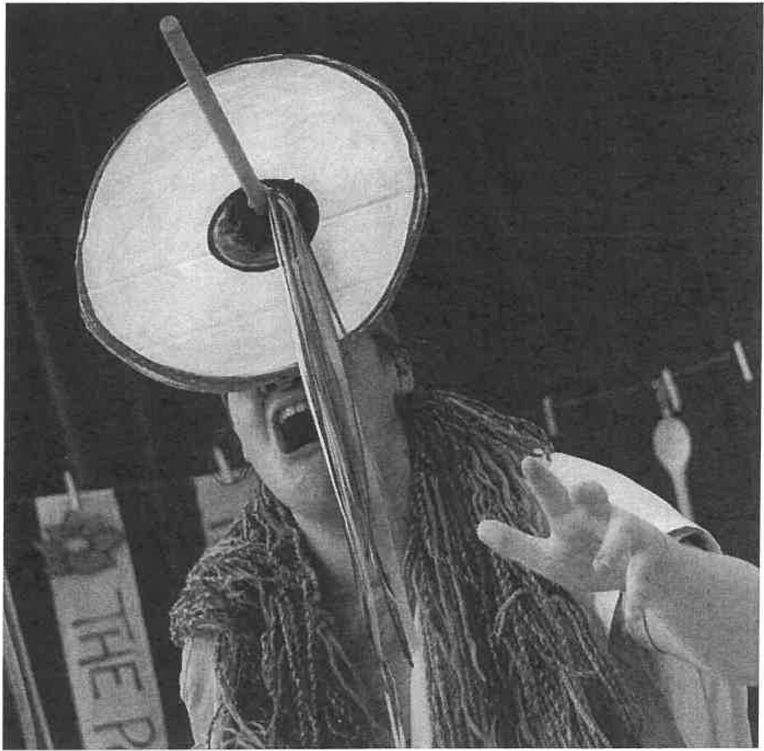

Sheep 1 To escape, the men strapped themselves to our bellies.

Sheep 2 With rope.

Sheep 1 And we were herded out of the cave by our poor master.

Cyclops (counting the sheep as they leave) Away, away!
Save yourselves! ·

Sheep 2 The men under our tummies were very heavy.

Sheep 1 Once we were out of the cave the men cut themselves loose and we were herded onto their massive ship as they laughed at our poor blind master.

Cyclops The bastards stole my flock . My girls! And then their lying leader and cocky-doo-dah shouted back at me.

OMS 2 (puppeting the spoon) "Cyclops, you dumb brute! It wasn't 'Nobody ' who blinded you, your eye was put out by none other than me! Odysseus, King of Ithaca, the winner!"

Cyclops Curse you! Curse you, mighty Odysseus! May you never reach your home of Ithaca. (Shouts out to sea) And if you do get that far, may you lose all your comrades to a terrible death. Man is not to be trusted... (Vengeful} May a storm come and drown you all!

OMS 1&2 Look out! STORMI STORM2

OMS3 OMS2

OMS3
(eventually) The storm has passed!

(proud of the audience) You did it! You unleashed a mighty tempest that blew Odysseus and his treacherous warrior s back out to sea.

In tears, and far away from their native land the men are in a state of great gloom, with their spirits sunk.

OMSl

OMS3

OMS2

OMS 1
Obstacle. What do you do when you've made a mistake?

My [NUMBER] friends. Do you believe that you have power over what happens to you?

Or are you a rudderless ship waiting for a wind to catch your sail?

Where are we now myself?

They consult once again with the map-holder.

OMS2

ALL
It's the fourth stop, the Land of the Laestrygonian

Giants!

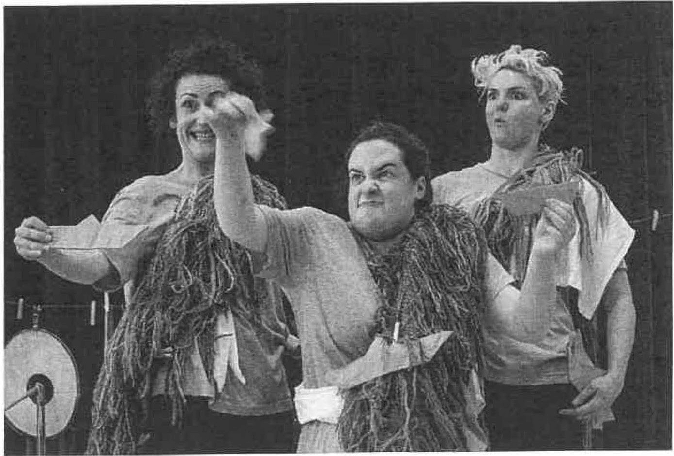
)

FOURTH STOP: LAND OF THE LAESTRYGONIAN GIANTS
[ARCHETYPE: ODYSSEUS THE VICTIM]

OMS3 OMS 1

OMS2 OMS3 OMS2 ALL OMS3 OMS 1
Where Odysseus is The Victim.

Six days and nights of sailing. Five hundred and twenty two exhausted men.

Eleven ships anchor in a safe-looking harbour. Odysseus's ship waits around the corner. (whispering) One land of
larger than normal people. (Shouting) Giants!

One story, told through the eyes of Giant Chief of the Laestrygonians...

Old Man of the Sea becomes the giants. They are gathered together as if being interviewed on camera.

Antlphates Aaaadaan-tiphates!

Wife His wife...

Daughter ... and their daughter.

ALL (as if posing for a photo) Cheese!

Daughter Basically, there were three little men that came to the palace asking for help.

Antlphates " The wife went out to greet them, cos she's good like that.

Wife Well, someone's got to do the welcoming Tiph, it's what civilised people do.

Antiphates But upon seeing my beautiful wife, those men were out-and­ out offensive. "She's a woman of mountainous proportions!" shouted one.

Wife (upset) The other bawled "What is it? She's hideous!" To my face. No shame.

Daughter The third one just let out a weedy yelp, backed into the corner, cried and shat himself, didn't he mum?

Wife Yes he did.

Antiphates My gorgeous woman was left in a right state, sobbing and shaking with it all. She could barely speak to me.

Wife I couldn't.

Antiphates Well I lost my rag with those little men! I admit I might hove gone over the top.

Daughter Dad grabbed the nearest man in his giant fist and ate him, it was brilliant.

Wife He was just looking after me, we don't normally eat our guests.

Antiphates I wasn't going to let them get away with that, Shirl. I hollered out of the window to get some help from the neighbours.
I reckoned there might be more of them little fellas, and it was bound to kick off because they don't like it when you eat them.

Wife So Tiph and our neighbours chased the other two reprobates down to the sea.

Antiphates Those teeny-tiny scumbags had eleven miniature scumbag ships anchored in our harbour!

Daughter Basically there were loads of them.

Antiphates We snatched up lumps of rock and we pelted their floating army from the surrounding cliffs.

They re-enact the attack using paper boats.

Daughter Dad had the victims trapped!

Wife One by one them little boats was sun k.

Daughter The screaming men were pleading for their lives. I heard them. "Don't kill us! Please!"

Antlphates Some of us big boys got right in amongst it and speared the toerags out of the water like fish. We did eat well that day.

Wlfe They won't be coming back.

Daughter {destroying the final boat) No, they won't be coming back.

OMS 1 One massacre of the harbour.

OMS 2 Eleven of the twelve ships sunk.

OMS 3 Four hundred and seventy-seven men killed, some of those eaten. Odysseus and his crew of forty-five men escape
to safety, ·

OMS 1 running and not fighting.

OMS 2 Leaving all of their friends to perish.

ALL Obstacle. Have you ever lost something you love?

Song 3: The Song of Loss

Warriors The sun comes up again today And burns across the sky
My heart still beats My eyes still ee
But I can't tell you why

But do I keep my love for you? ldoldoldo
And do I fear I'm losing you? ldoldoldo

Penelope There is an empty part of me
That never can be filled
The empty space where you should be The empty rituals

But do I keep my love for you? ldoldoldo
But do I fear I'm losing you? It's true it's true it's true ldoldoldo

Penelope I do
I undo
I redo. I hope

OMS3 We're at the fifth stop, Aeae, the home of the beautiful, powerful Circe.

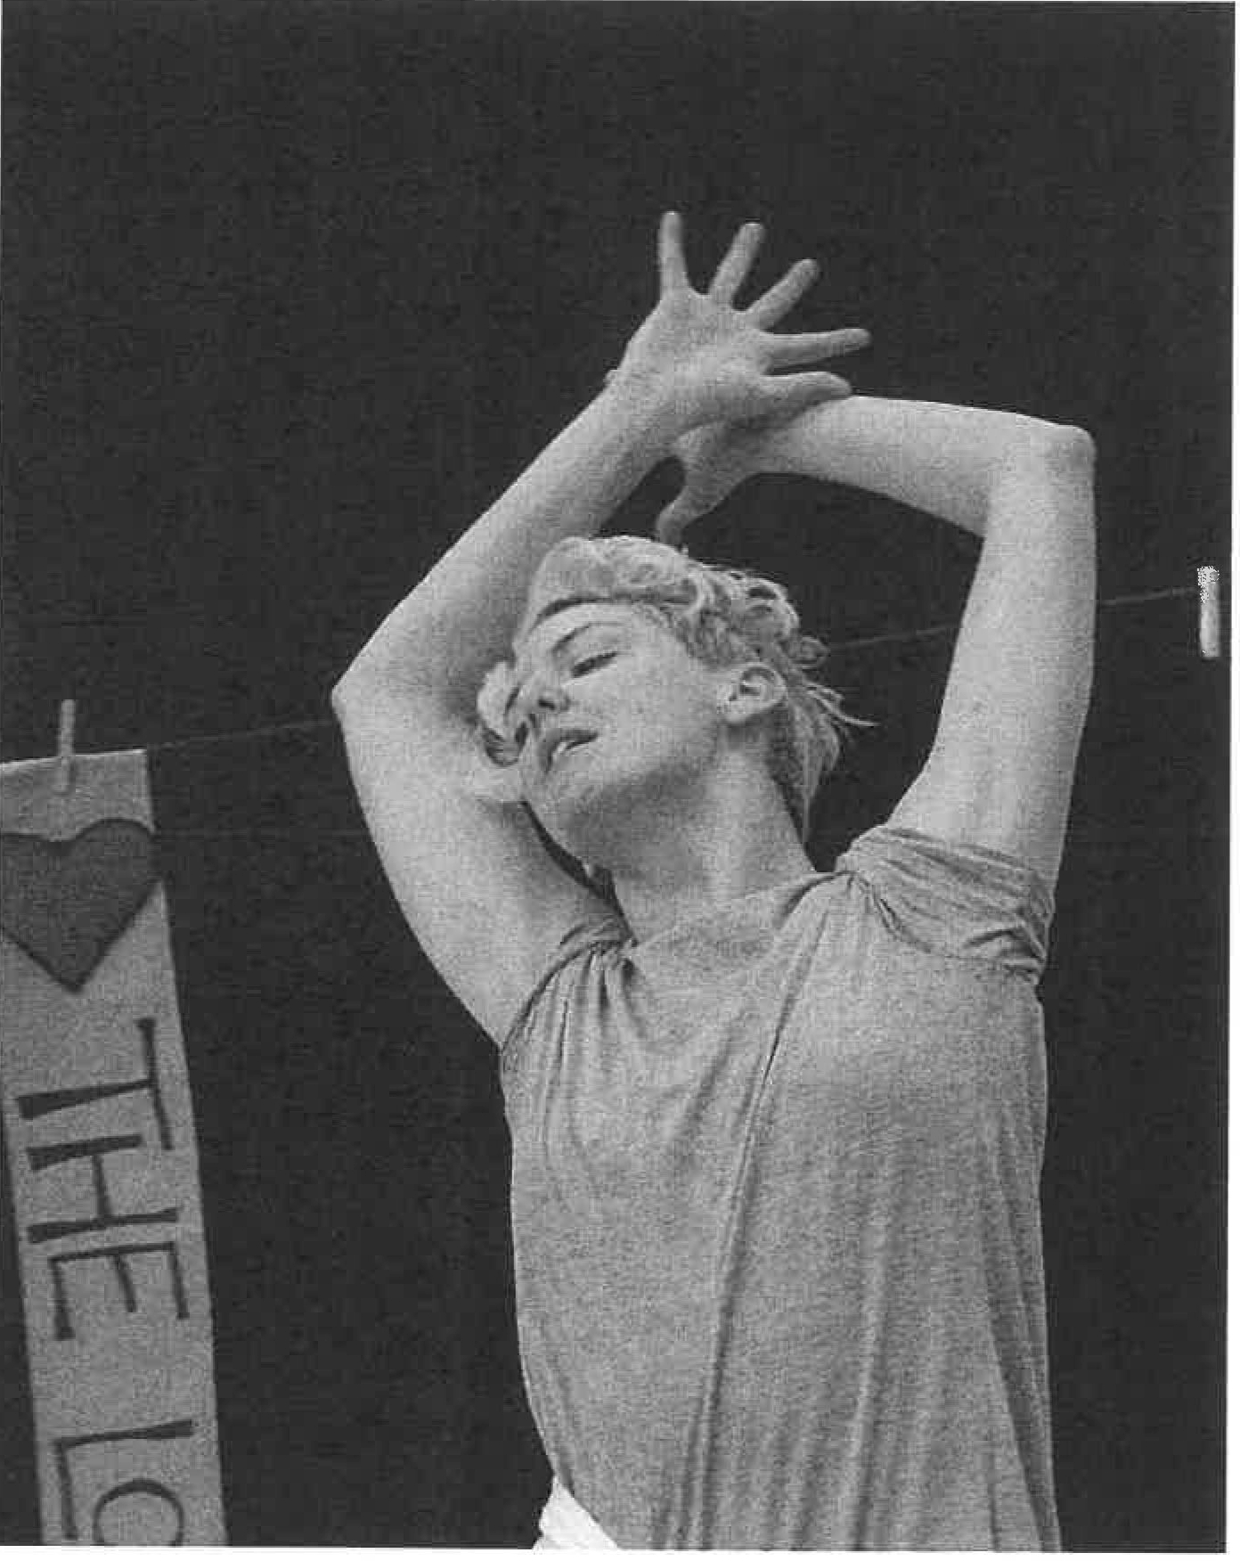

FIFTH STOP: CIRCE

[ARCHETYPE: ODYSSEUS THE LOVER]

OMS1

OMS3

OMS 1 OMS3 OMS2

OMS3

OMS2

OMS3

Circe3
Where we are about to see Odysseus The Lover. Forty-six comrades-in-suffering land on Aeae.

Whipped by the fear of death, they spend two days and nights grieving for four hundred and seventy-seven dead brothers.
Zero desire to continue living.

Obstacle. How do you get up when you have fallen down? Good question myself.
When we have fallen what we need is someone who loves us to take us by the hand and help us to our feet. And that is what Odysseus did for his men. We've got one grandiloquent Odysseus about to speak winged words of hope!

{puppeting the spoon) "Men! Remember the war? Remember Cyclops? This too will be a memory for us one day!"

With those words of wisdom, the men throw off their blankets. Half the crew are sent to explore Aeae.
That's twenty-two men about to meet one formidable woman, Circe.

Let's hear from Circe, shall we? A woman.

Oh yes, heaven-born, lion-hearted Odysseus. Quite a man. He was my lover. He and his men lived with me for an entire year. I didn't command him to stay.
He just liked it.

His kinsmen came to see me first, and I did what I normally do when outnumbered by strange hungry-eyed males.
I welcomed them into my home. Fed them. Gave them honeyed wine, which turned them into pigs.

3 Our Circe physicalised this speech as a kind of tango for one.

Circe

OMS3 OMS2

OMS3
I beat the pigs with a stick and drove them into the piggy pen outside. They didn't expect that, poor little sausages.

Then 'he' turned up with his big bronze sword and massive bow slung over his shoulders. Those impressive shoulders.

I welcomed him into my home. Fed him. Gave him honeyed wine, which had no effect whatsoever, not even a curly tail.
I went to strike him with my stick, but he grabbed me and held the sword to my throat, his face inches from my own.
His eyes fixed on me, and I invited him to bed.

"How can you strip me naked when you have turned my friends into pigs here in your house?" he said. "Release them and swear that you have no further mischief in store for me." I at once swore and he surrendered. Easil y.

It was bliss.

Twelve months of pleasure and delight.
I swear he would have stayed forever, he longed for me, but his men longed for home and dragged him away.

{As she.leaves) Odysseus, a warning! On your way from here you will reach the Island of the Sun. There you will find fine cattle. Do not touch these animals. There are many perils ahead of you, but none more deadly than this.

Do not touch the cows, Odysseus, or all your men will drown. Quite a warning, that.
Do not touch the cows. Remember that.
Now then, between one Odysseus and one Island of the Sun lie
.three deadly obstacles that must be faced and overcome! It's the sixth stop everybody, the Day of Certain Death.

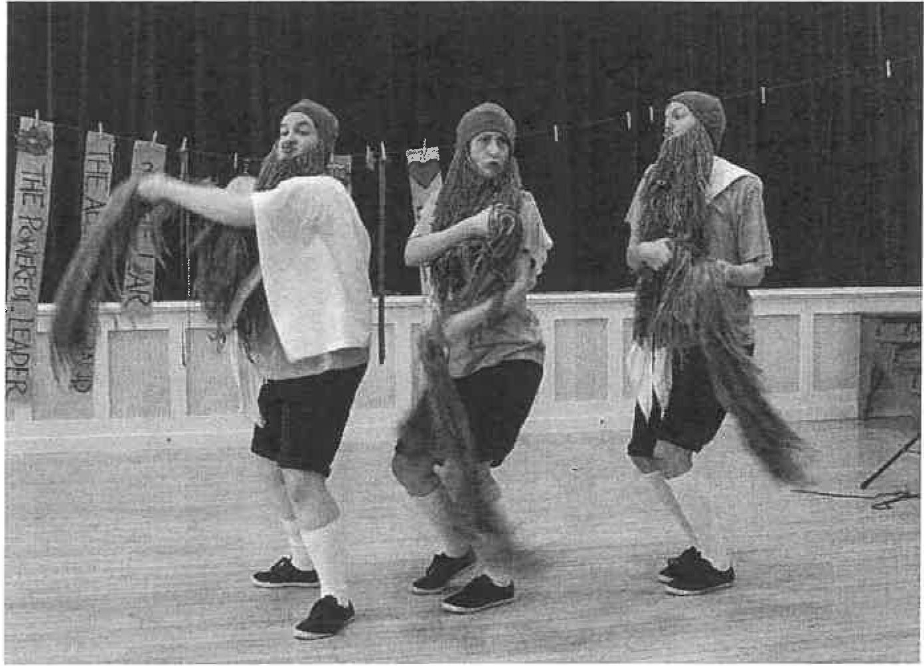

SIXTH STOP: THE DAY OF CERTAIN DEATH
[ARCHETYPE - ODYSSEUS THE SURVIVOR]

OMSl OMS2

OMS3

OMS 1

ALL

OMS3

Odysseus The Survivor!

We shall now recreate each of the three deadly obstacles, and to do this we're going to use myself and you and some props. Are you ready epic friends? Of course you are!

One hero with one ship and forty-four men on the Day of Certain Death!

Obstacle one: the Sirens. These women will lure you towards the rocks with their beautiful singing.

Do not listen!

Plug your ears and sail swiftly onwards.

OMS2 OMS 1

OMS2

ALL
Myself will be the sirens, because I am alluring, and you will be Odysseus's men.

(taking the spoon into the audience) Will someone please hold spoon Odysseus? He will want to listen to the Sirens, so hold him tight.

To overcome this obstacle, you must not hear one second of the honey-sweet song of the Sirens. If you do, you will

perish! Cover your ears now!

The old men of the sea play about with singing silently and doing provocative dancing.

OMS2 OMSl OMS2 ALL OMS2
(eventually) Uncover your ears now. Did you hear anything? No?
You did it!

You survived!

(to the.spoon-holder) How's spoon Odysseus? Did he survive? Bring him forwards for us.

The volunteer brings the spoon on stage.

OMS2 (to the spoon) What's that, spoon Odysseus? You have words of inspiration for all of the survivors? In your funny high spoon­ voice?

The audience member may or may not say something, either way everyone is very pleased and the volunteer can sit back down.

OMS2 OMS1 OMS3
(delighted) Legendary!

Wise words from the main man there. But wait! Now there's a choice between

OMSl obstacle two: Scylla.
The monsters are enacted by Old Man of the Sea 24•

OMS3

OMSl OMS3

ALL

OMS2
Scylla: a ferocious beast with twelve grabbing arms, six heads on six scrawny necks with three rows of fangs in each slavering mouth. She will pluck your men from the boat and eat them.
Or you might prefer obstacle three: Charybdis.
Charybdis: an enormous swallowing and vomiting hole which devours ships down in one gulp. No one has survived. Ever.

No one has survived. Ever.

Now we ask for a volunteer. Who here is brave enough to take spoon Odysseus and his boatful of men through the final two obstacles?

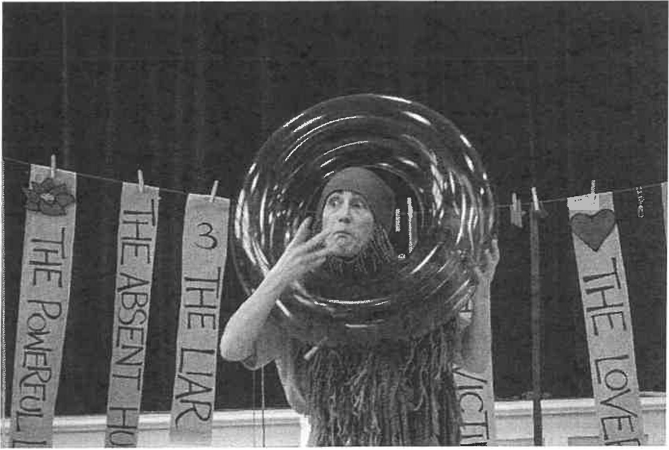

4 Not necessarily very well. Our Scylla was some pound shop litter pickers and Charybdis a big blue rubber ring.

The volunteer is given the spoon. a little wooden boat full of wooden men, and protective clothing 'because they will get wet!'.

OMS2

OMS3 OMSl

ALL
Our brave volunteer just has to get from the start to the finish, without dropping Odysseus or any of his men.
Are you ready? What could possibly go wrong?
Apart from maybe this! (Sprays the volunteer in their protected
face with a water pistol)

On your marks, get set, go!

Each obstacle 5 is tackled and overcome; one word instructions are given to the volunteer. who gets across the obstacle course safely.

OMSl

OMS3
(to the volunteer} What an incredible journey you have been on. (Counting up the lost wooden men - the actual number is not important) You lost [NUMBER] men.

But you did manage to save spoon Odysseus and thirty-nine of his men!

Audience member is applauded and given something nice.

OMS3

OMSl

OMS2

OMSl

ALL
(to the Death Toll-keeper) What's the current death toll?
(He gets the answer.)

Six comrades lost to Scylla. Five hundred and sixty-one in total dead.

Thirty-nine drained and weary men survive the Day of Certain Death.

Seventh stop, the Island of the Sun.

Do not eat the cows!

5 Our obstacle course included The Waves of Despair (climbing under an undulating rope), The Ridge of Uncertainty 0umping over a stick), The Falling Rocks of Intolerance (lightweight balls thrown by the audience), then the litter pickers of Scylla and the thrown rubber ring of Charybdis before reaching The Stool of Safety.

SEVENTH STOP: THE ISLAND OF THE SUN
[ARCHETYPE: ODYSSEUS THE POWERLESS LEADER]

OMS2 OMS 1 OMS3 OMSl ALL
Here you will see Odysseus being The Powerless Leader. One Island of the Sun.
One warning from Circe completely ignored. One rule from one hero to his thirty-nine men: DO NOT EAT THE COWS!

The Warriors arrive.

Warriors Yeah!

Song 4: The Song of the Cows

Each verse of the song is sung with a very clear attitude.

Warriors

Warriors Warrior 3

Warrior 2
(angry) Oh oh oh Odysseus Why don't you pity us?
We've got to go and rest on the shore Charybdis been shaking us
And Scylla's been breaking us We just cannot take it no more

(sadness) Oh oh oh Odysseus You know this is serious
The wind keeps on blowing the wrong way And now we're all stranded here
There's not enough food I fear We're not gonna last one more day

(breaking out of the song, starving) Winners.. .!
I do not want to drown. I don't want to starve.

Warrior 1 ALL
Come on men, Odysseus is powerless to stop us!

(going to attack) Kill. Cows. Now! ... MEAT!

Realising what they have done. the Warriors sing again .

Warriors (scared)Oh oh oh Odysseus
We think we just made it worse We went out and killed us a cow We know you said not to
But we wanted hot beef stew
What the hell are we gonna do now?

Weeping and sighing.

Warrior 1

Warrior 2 OMS3

OMS2

ALL STORM3
(to audience) What could we do? It was drown or starve.
Obstacle. What if there are no good choices?
One Odysseus and his crew of thirty-nine men, with thirty-nine full bellies, make their way back to their one black ship.

Forty men sail away in the knowledge that through their actions they have condemned themselves to drown in the
wine-dark sea.

Look out! STORM!

During this storm the swallowing of the boat by Charybdis and the survival of Odysseus are enacted.

OMS 1 OMS3 OMS2
One man. Odysseus, survives.
Nine days spent drifting at sea holding onto one ship's keel. Leaving thirty-nine men at the bottom of the ocean.
(To the Death To/1-keeper)How many people are dead now? That's all of them. Six hundred dead.
Well. We're at the eighth stop, the Distant Island of Ogygia.

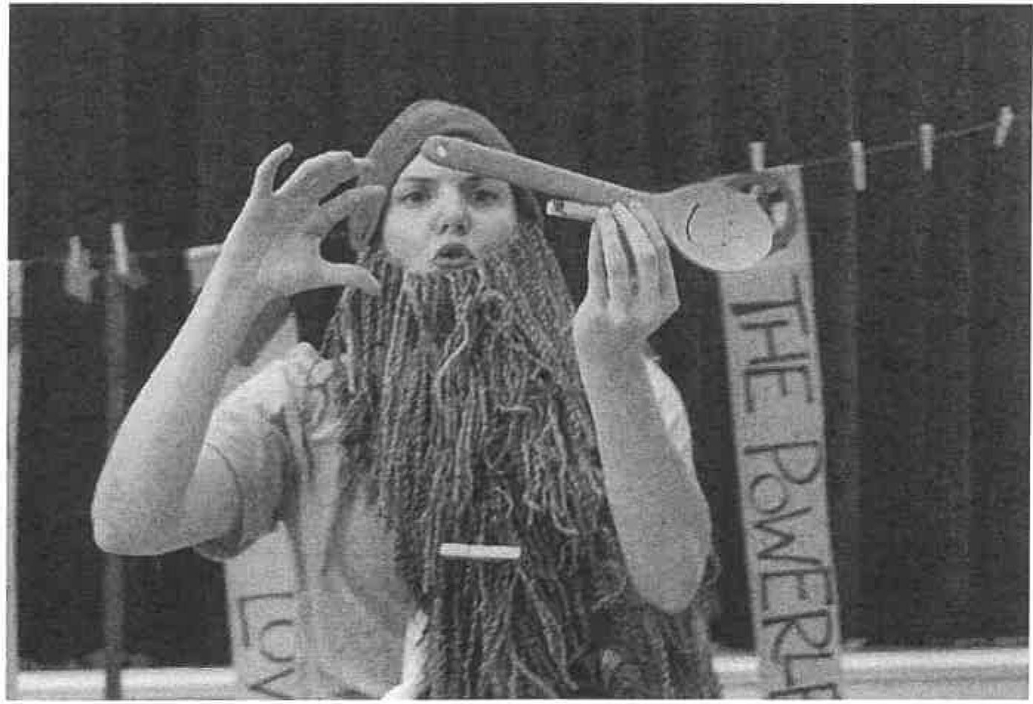

EIGHTH STOP: THE DISTANT ISLAND OF OGYGIA

[ARCHETYPE: ODYSSEUS THE HEARTBREAKER]

OMS 1 Where we're about to see Odysseus The Heartbreaker.
One woman, the divine Calypso rescues one hero.

OMS 2 One Calypso lives with Odysseus for seven years and falls desperately in love with him.

OMS 1 Odysseus surrenders his body but not his heart.

OMS 2 Seven years of unrequited love by woman.

OMS 1 Seven years of pining for home by man.

OMS 2 Let's hear from Calypso shall we?

OMS 1&2 A woman.

Calypso appears.

Calypso Odysseus was swept here by the wind and the waves to my island of solitude. I found him, washed up on my beach.
I, Calypso rescued him from death, and welcomed him with open arms. Tended to him until he was well and then made my home his.

We have lived side by side for seven years.

(seeing Odysseus in the distance)
The man I love Does not love me.
He sits and watches the sea And hopes.

The man I love and saved Does not love me.
He sits and watches the barren sea And dreams of home.

When I'm with him I'm alone.
He grieves for everything I am not.
I am noJ Enough.
My love is not enough of a home for him.

The man I love Does not love me.
He sits and watches the sea With eyes of longing.

(As if next to Odysseus) King of Ithaca, ingenious Odysseus, I see that your wife is never out of your thoughts.
I release you. You may leave at once for home. Go home. (Gestic moment) Home.

I wish you every happiness my love.

Exit Calypso.

OMS2 | Obstacle. How do you know when it's over?
OMS 1 | One hero released by one broken-hearted woman. One small raft built over four long days.
OMS2 | One warm and gentle breeze.
OMSl | Seventeen days Odysseus drifts at sea.
OMS2 | Until he reaches his final stop
ALL | (gestic moment) home.

FINAL STOP: HOME

[ARCHETYPE: ODYSSEUS THE LEGEND]

OMS3 OMS2 OMS3 OMSl OMS3 ALL

Suitors
Odysseus The Legend.

One hundred and eight uninvited guests. Suitors.
Aristocratic thugs competing for the hand of one Penelope.

Yahl Suitors!

The Suitors invade the audience making wild declarations of love as if the audience are Penelope. Each fights to get to the front of the pack and is then pushed out of the way. This continues, each trying to top the last.

Suitors Suitor 3
Suitor 1

Suitor 2

Suitor 3

Suitor 1

Suitor 2

Suitor 1

Suitor 3
Penelope!

Penelope, marry me! Penelope, marry me! Penelope, marry me!
You're as beautiful as... something really beautiful. Some really beautiful... but better!
Penelope! You're as clever as... science. Science... but better!
Do you have a map? I keep getting lost in your eyes.

Suitors Suitor 3

Suitor 2

Suitor 3

Suitor 1 Suitors Suitor 2 Suitors Suitor 2

Suitor 3

Suitor 1
(to each other, interrupted} Sshh! she's saying something.

(listening intently) So she's finally going to make up her mind about who she's going to marry.

About time too!

There's a challenge to win her hand?

The challenge is to shoot an arrow through some axes?

Shoot an arrow through some axes?

I mean, seriously.

WTF?

Do you see Telemachus? He's running around setting up the axes...

... for his mummy.

Oh, it's a shame we didn't manage to kill him.

They laugh indulgently.

Suitor 3 Hey guys?

Suitor 2&1 Yoh?

Suitor 3 (pointing) Who's that smelly old beggar man in the corner?

Suitor 2 (looking, disgusted) Oh my god, he's filthy.

Suitor 1 And oldl

Suitor 3 And weak!_ I mean, what's he doing here? This is like, a palace. you know.

Suitor 2 That's odd, Penelope has been sent away. Come back!
See who yovr new husband is!

Suitor 1
That's odd, all the women have followed her out. And all the doors have been bolted from the outside.

They laugh nervously.

Suitor 3 Suitors Suitor 3
Suitor 2

Suitor 1

Suitor 3
Check out the bow!

Whoah!

Oh! They're having a go a stringing it, look.
That's just RIDIC. It's Odysseus's bow and no one can string it but him, not even some Laestrygonian giant. It's IM-POSS, bro.
Smelly old beggarman wants a go. Can you believe it? He thinks he's stronger than usl

We'll watch him fail, and then we'll slit his throat!

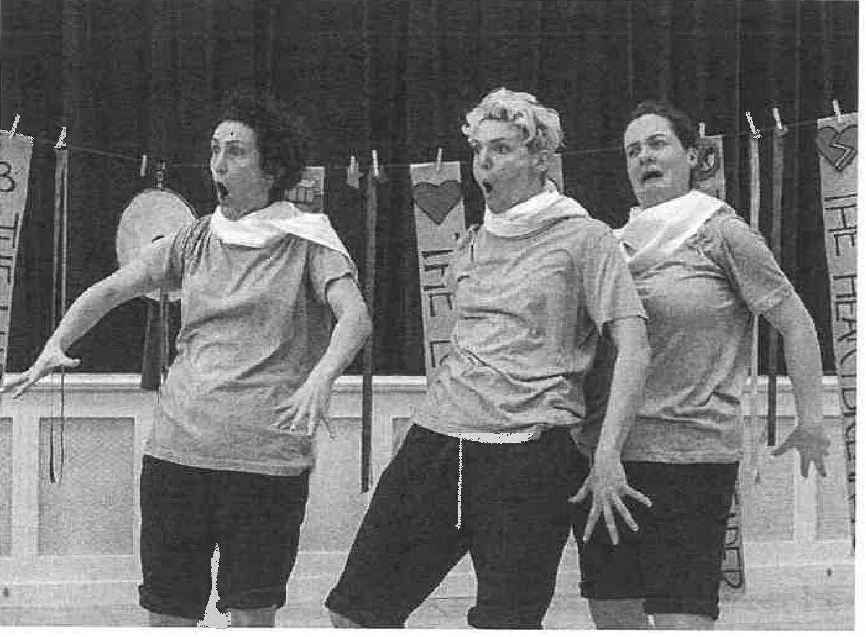
They begin to laugh but are stopped by what they see.

Suitor 2

Suitor 1
(amazed) Oh no, he's doing it. He's stringing the bow in a single, easy movement.

He's picked a single arrow, he's pulling back the string...

They watch the arrow swish by. Choral shock.

Suitor 3 Suitors Suitor 1 Suitors Suitor 1 Suitors Suitor 3
Suitor 2

Suitor 3

Suitor 1 Suitors
From the first to the last, he's not missed one single axe!

No way. That did not just happen.

Gasp!

Gasp!

That's not a beggar, that's...

Odysseus!

The legend has returned, mighty as ever. So dangerous! Odysseus and his son Telem achus.
Wielding sharp-edged swords...

... and armed in resplendent bronze.

{looking at each other, terrified) We're going to get totally slaughtered!

We see the slow-motion destruction of the Suitors as they beg for mercy ['Penelope, save us!', 'I'm too rich to die!', 'I'm still better than you!'). Eventually one of the Suitors morphs into Penelope .

Penelope My heart shook as I realised that this bedraggled stranger was none other than my Odysseus. My eyes flooded with tears, and I flung my arms around my husband's neck and kissed his weather-beaten face. His beautiful face.

We wept and held each other, so tightly that we could never be unpicked. I was finally home.

OMS3

OMS 1 OMS3 OMS2 OMS 1 OMS3 OMS2 ALL OMS2 OMS3

ALL

THE ODYSSEY
Odysseus was finally home, after twenty years. What a journey. One man fights a war for ten years.
One man spends ten years trying to return home. One man. His actions and inactions,
all the words he's spoken, the whispers heard.
The truths and the lies.
All obstacles faced and overcome.
We do, we undo, we redo. Over and over again.
One epic story complete.
(looking out at the audience) [NUMBER] epic stories waiting to be told.
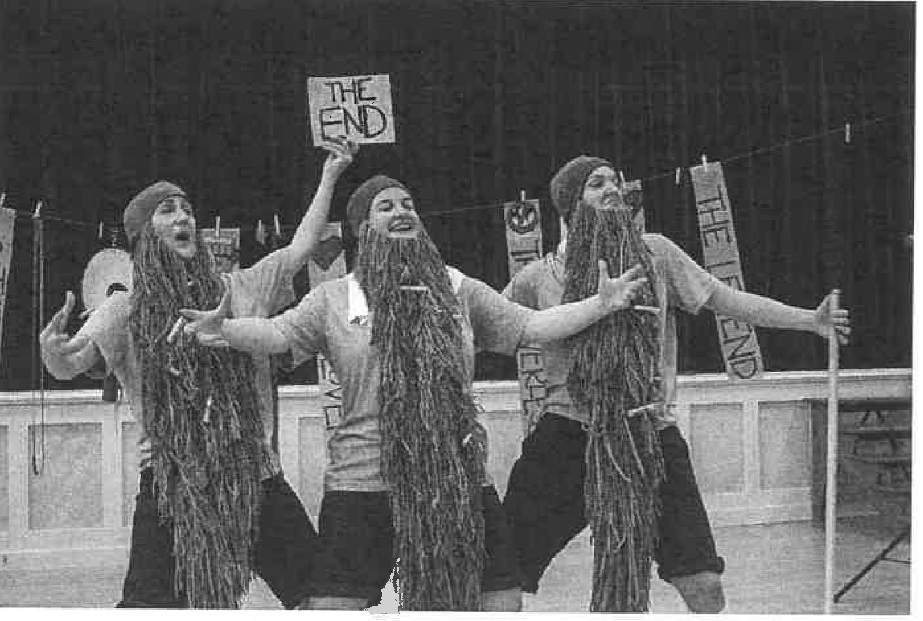
Be legendary.

43

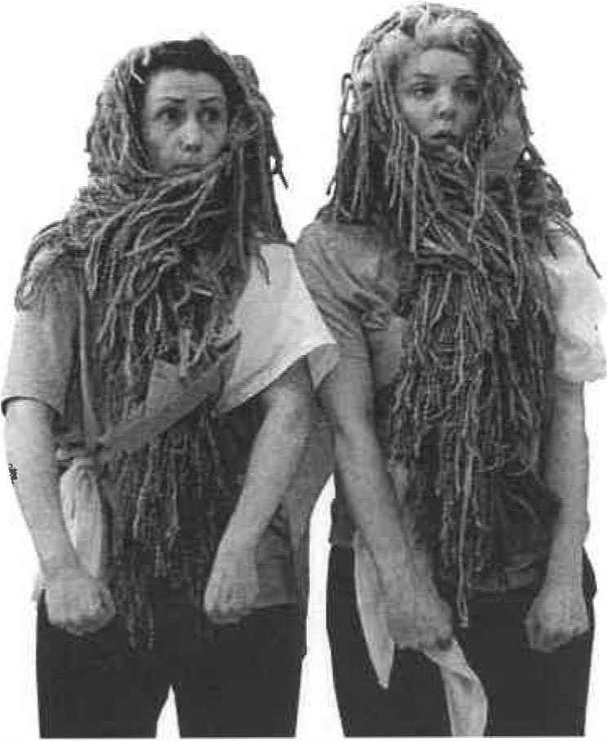
Splendid Productions' The Odyssey
In a brand new creative theatrical adaptation, we retell the story of Odysseus and his famously inconvenient journey home from tl:le Trojan War.

Packing a decade of adventures into a breathless hour, Splendid's heroic cast of three create a mythical world of hungry monsters, powerful sorceresses and frequent shipwrecks as the resourceful Odysseus battles to return to his family.

But, we ask ourelves, is he really a hero, and are his adversaries really villains? And if he's only a legend because his story is told, could it be that we're all legends in the making?

