The Abyssinian Crisis
Where is Abyssinia?  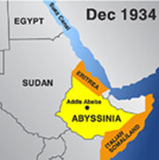 | Why did Mussolini Want Abyssinia?  Why did Mussolini want Abyssinia?
How Did Mussolini Invade Abyssinia?

