Titanic Block Three: Writing Task

You will be creating a piece of writing from the perspective of either a first or third class passenger on board the Titanic.
Your piece of writing will need the following:
- To be written in first person
- Include description of what your area of the ship is like using all five senses
- Have clear emotion, thought and opinion about your part of the ship
- Be at least one and a half pages long
- Show your character’s personality clearly
- Have varied sentences, punctuation and vocabulary
- Include a range of techniques including, but not limited to, SOSMAPS

Planning:
Your first task is to plan your piece of writing. Once you have decided on which type of passenger you are going to write from the perspective of, and you’ve re-read your research on that class, you need to plot what your character is going to go through and what you are going to say.
- Create a table like the one below and note down briefly what you want to write about in the beginning, middle and end of your piece of writing. There is an example written put to help you understand, please do not copy this one.
Beginning | Middle | End
- Description of the ship from outside  - The feeling of walking onto the ship and seeing where I will be staying | - Day to day activities in that class  - Description of living conditions  - Meeting new people and opinions on those | - How I feel a few days into the voyage  - The relationships with those new people  - Description of what I saw of the other class and how I felt about that

- As soon as you have completed a detailed plan of what you will write about you can get stuck in! Please see the sentence starters on the next page to help you if you’re struggling.
- Once you have finished, use the editing and reflecting guide to go back over your work
Sentence Starters:
- I stood, luggage in hand, and looked up at the colossal beast that was the Titanic…
- Feelings of ______ erupted within as I first set eyes on the Titanic…
- ________, I made it along the walkway, the iron railing ______ to touch and a head full of _______...
- The air felt ______ and I could see _____ on the faces of those around me…
- Taking in my surroundings, I …
- The days which followed were so far from what I knew, they were filled with…

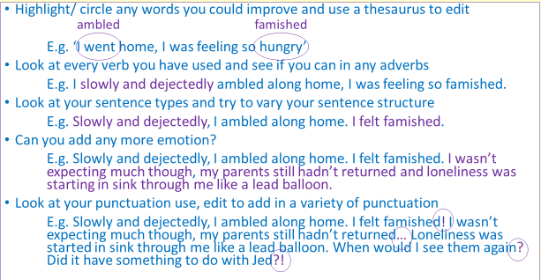
Editing and reflecting:

