Trench Life!

**Building empathy for Tommo, Charlie and WWI soldiers**

1. **Find out what the following WWI terms mean:**

**How to research key terms:**

It’s important you focus on what these terms meant specifically in WWI, so you should include that in the search bar if you’re using a search engine such as google. Try the following:

*In WWI, what did the term _______ mean?*

You could also search for a website which has lots of WWI terminology on to see if you can find multiple answers at once!

1. Pal’s Battalion
2. Trench foot
3. Dug-Out
4. No man’s land
5. Old sweat
6. Field Punishment No. 1
7. Blighty one
8. Over the top
9. Shell shock
10. Bully beef
11. **Now research what life was like in the trenches for WWI soldiers. This will help us understand what Tommo, Charlie and their comrades are going through.**

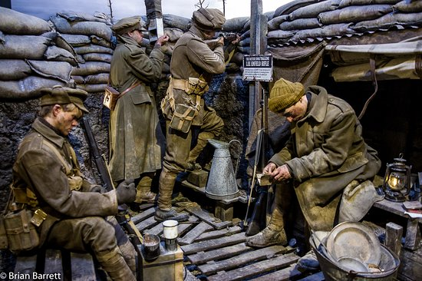

**You could present your findings as a poster or a leaflet, or perhaps you can think of an even more imaginative way?!**

**You may use the structure guide of the back of this sheet to help you to present your research.**

**Jobs and responsibilities:**

**Hygiene and cleanliness:**

**Uniform:**

**Sleeping conditions:**

Life in the

trenches

**Communications:**

**Punishments:**

**Entertainment and relaxing:**