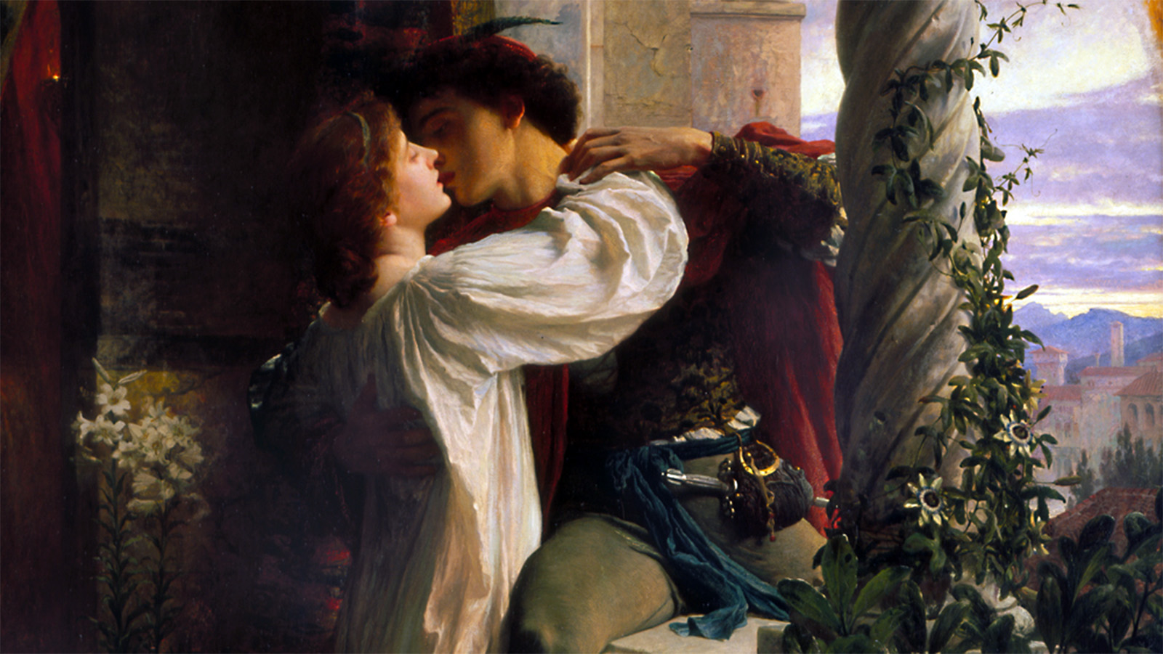
‘These violent delights have violent ends…’
You do not need to complete the whole of this workbook. Find out which scenes you’ll miss and complete those tasks, or complete the tasks linked to the scenes you’ve already done to consolidate your knowledge.
Name: _______________________________

Teacher: _____________________________

The Prologue
Draw or find pictures for each line of the prologue, you can write the prologue out or copy it into a Word doc, then add the images around the side. You then need to memorise the prologue; the images will help you remember each line.

CHORUS:
Two households, both alike in dignity,
In fair Verona, where we lay our scene,
From ancient grudge break to new mutiny,
Where civil blood makes civil hands unclean.
From forth the fatal loins of these two foes
A pair of star-cross'd lovers take their life;
Whose misadventured piteous overthrows
Do with their death bury their parents' strife.
The fearful passage of their death-mark'd love,
And the continuance of their parents' rage,
Which, but their children's end, nought could remove,
Is now the two hours' traffic of our stage;
The which if you with patient ears attend,
What here shall miss, our toil shall strive to mend.

The Theme of Fate

Fate, also known as destiny, is the belief that certain events are beyond the control of an individual and are predetermined by God or other supernatural powers.

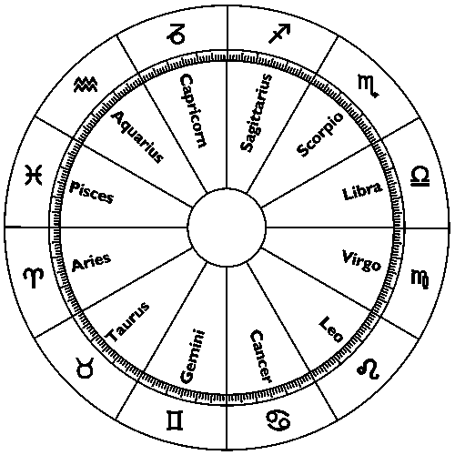

.
Using the box opposite and quotations from the prologue, explain how Shakespeare introduces the theme of fate.
____________________________________________________________________________________________________________________________________________________________________________________________________________________________________________________________________________________________________________________________________________________________________________________________________________________________________________________________________________________________________________________________________________________________________________________________________________________________________________________________________________________________________________________________________________________________________________________________________________________________________________________________________________________________________________________________________________________________________________________________________________________________________________________________________________________________________________________________________________________________________________________________________________________________________________________________________________________________________________________________________________________

.
How does the play conform to the genre of tragedy? Why does Shakespeare reveal key plot points before the play has started?
____________________________________________________________________________________________________________________________________________________________________________________________________________________________________________________________________________________________________________________________________________________________________________________________________________________________________________________________________________________________________________________________________________________________________________________________________________________________________________________________________________________________________________________________________________________________________________________________________________________________________________________________________________________________________________________________________________________________________________________________________________________________________________________________________________________________________________________________________________________________________________________________________________________________________________________________________________________________________________________________________________________

.
Read the prologue and list the five most important things the audience learns about the plot:

The Feud Erupts (Act 1, Scene 1)

GREGORY: I will frown as I pass by, and let them take it as
they list.

SAMPSON: Nay, as they dare. I will bite my thumb at them;
which is a disgrace to them, if they bear it.

Enter ABRAHAM and BALTHASAR

ABRAHAM: Do you bite your thumb at us, sir?

SAMPSON: I do bite my thumb, sir.

ABRAHAM: Do you bite your thumb at us, sir?

SAMPSON: [Aside to GREGORY] Is the law of our side, if I say ‘ay’?

GREGORY: No.

SAMPSON: No, sir, I do not bite my thumb at you, sir, but I
bite my thumb, sir.

GREGORY: Do you quarrel, sir?

ABRAHAM: Quarrel sir! No, sir.

SAMPSON: If you do, sir, I am for you: I serve as good a man as you.

ABRAHAM: No better.

SAMPSON: Well, sir.

GREGORY: Say 'better': here comes one of my master's kinsmen.

SAMPSON: Yes, better, sir.

ABRAHAM: You lie.

SAMPSON: Draw, if you be men. Gregory, remember thy swashing blow.

They fight

The Theme of Honour
Before the brawl begins, how does Shakespeare use language to build tension?
____________________________________________________________________________________________________________________________________________________________________________________________________________________________________________________________________________________________________________________________________________________________________________________________________________________________________________________________________________________________________________________________________________________________________________________________________________________________________________________________________________________________________________________________________________________________________________________________________________________________________________________________________________________________________________________________________________________________________________________________________________________________________________________________________________________________________________________________________________________________________________________________________________________________________________________________________________________________________________________________________________________

.
Physical Sparring: The Duel
- A brawl and a duel are separate: a brawl is a street fight without rules, whereas a duel was a formal fight between men of honour.
- A duel could be non-lethal (fight to first blood) or lethal (a fight to the death).
- There was a strict code of behaviour – a duel was between two men, watched by a crowd.
- Each fighter had a ‘second’ to support them and step in if necessary.
- It was possible to offer an apology before the duel to stop it, but once started, a duel could not be ceased.

.
The Definition of Honour
- Honour is the amount of respect a man holds in society.
- Honour was extremely important to high society and a cornerstone of masculinity.
- Honour was a man’s character – it links to dignity, reputation & glory.
- Honour had to be defended: if a man questioned the honour of another man, violence would ensue through a duel.

.
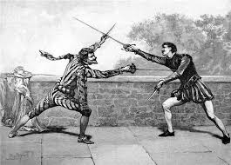
Verbal Sparring: Wit & Wordplay
- As well as physical sparring, men used verbal sparring to outdo each other.
- Men would use wordplay - especially puns, irony and bawdy jokes - to outwit each other.
- Wit was considered the height of intelligence and men would try to use one-liners to amuse those around them – essentially what today is known as ‘banter’.

.

The Prince’s Decree (Act 1, Scene 1)

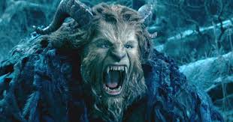
PRINCE ESCALUS:

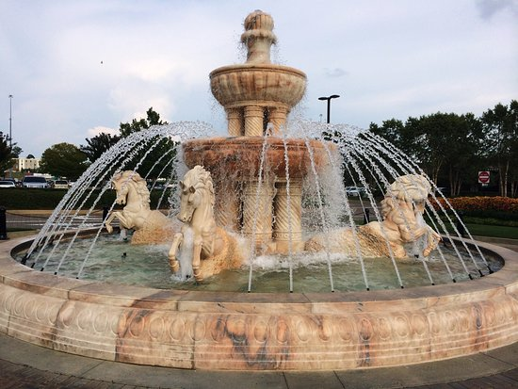
Rebellious subjects, enemies to peace,
Profaners of this neighbour-stained steel,--
Will they not hear? What, ho! you men, you beasts,
That quench the fire of your pernicious rage
With purple fountains issuing from your veins,
On pain of torture, from those bloody hands
Throw your mistemper'd weapons to the ground,
And hear the sentence of your moved prince.
Three civil brawls, bred of an airy word,
By thee, old Capulet, and Montague,
Have thrice disturb'd the quiet of our streets:
If ever you disturb our streets again,
Your lives shall pay the forfeit of the peace.
Once more, on pain of death, all men depart.
Shakespeare has used this metaphor because it compares… with… He has done this to…
Shakespeare has used this metaphor because it compares… with… He has done this to…
- Which image has been repeated from the prologue?
- What has the Prince said the punishment will be if they keep fighting?
- Find a metaphor which suggests what the Prince thinks of the people fighting. How does it suggest this?
- What is the effect of the use of punctuation at the start of his speech?
- What technique is used by the Prince to show his power?
- What does the Prince say is the cause of the fighting?
- Use the above, and the fight during Act 1 Scene 1 to write a newspaper article (see below) about what is happening in Verona

Verona Chronicle
ISSUE 233 THE PEOPLE’S FAVOURITE NEWSPAPER .30L

____________________________________________________________________________________________________________________________________________________________________________________________________________________________________________________________________________________________________________________________________________________________________________________________________________________________________________________________________________________________________________________________________________________________________________________________________________________________________________________________________________________________________________________________________________________________________________________________________________________________________________________________________________________________________________________________________________________________________________________________________________________________________________________________________________________________________________________________________________________________________________________________________________________________________________________________________________________________________________________________________________________

.
____________________________________________________________________________________________________________________________________________________________________________________________________________________________________________________________________________________________________________________________________________________________________________________________________________________________________________________________________________________________________________________________________________________________________________________________________________________________________________________________________________________________________________________________________________________________________________________________________________________________________________________________________________________________________________________________________________________________________________________________________________________________________________________________________________________________________________________________________________________________________________________________________________________________________________________________________________________________________________________________________________________

.
____________________________________________________________________________________________________________________________________________________________________________________________________________________________________________________________________________________________________________________________________________________________________________________________________________________________________________________________________________________________________________________________________________________________________________________________________________________________________________________________________________________________________________________________________________________________________________________________________________________________________________________________________________________________________________________________________________________________________________________________________________________________________________________________________________________________________________________________________________________________________________________________________________________________________________________________________________________________________________________________________________________

.
Romeo’s Introduction (Act 1, Scene 1)

ROMEO: What fray was here?
Yet tell me not, for I have heard it all.
Here's much to do with hate, but more with love.
Why, then, O brawling love! O loving hate!
O anything, of nothing first create!
O heavy lightness! Serious vanity!
Mis-shapen chaos of well-seeming forms!
This love feel I, that feel no love in this.
Dost thou not laugh?

BENVOLIO: No, coz, I rather weep.

ROMEO: Good heart, at what?

BENVOLIO: At thy good heart's oppression.

ROMEO: Why, such is love's transgression.
Griefs of mine own lie heavy in my breast,
Love is a smoke raised with the fume of sighs;
Being purged, a fire sparkling in lovers' eyes;
Being vex'd a sea nourish'd with lovers' tears:
What is it else? A madness most discreet,
A choking gall and a preserving sweet.
Farewell, my coz.

BENVOLIO: Soft! I will go along;
An if you leave me so, you do me wrong.

- What are your first impressions of Romeo based on this extract and why do you think that?

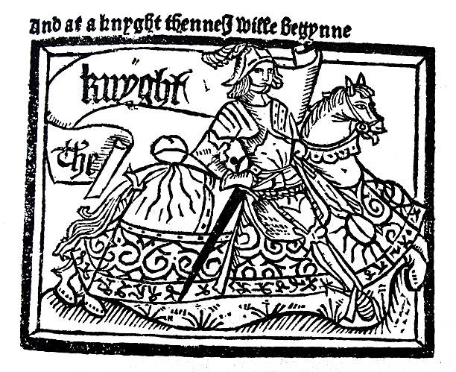
Courtly Love
Defining Courtly Love
- Courtly love spread through Europe in the 12th century.
- It created a language of love that is still associated with romance to this day.
- Falling in love was a formal process with rules.
- As the name suggests, it was linked to the courts of Europe, especially Italy & France.
- A man of a lower class, usually a knight, would see a woman in court and fall in love. He would then try to win her affection.

.
- ‘Romeo’s love for Rosaline is a performance. It is NOT true love.’ To what extent do you agree with this statement? Use evidence in your response.
____________________________________________________________________________________________________________________________________________________________________________________________________________________________________________________________________________________________________________________________________________________________________________________________________________________________________________________________________________________________________________________________________________________________________________________________________________________________________________________________________________________________________________________________________________________________________________________________________________________________________________________________________________________________________________________________________________________________________________________________________________________________________________________________________________________________________________________________________________________________________________________________________________________________________________________________________________________________________________________________________________________

.
Features of Courtly Love
- True love was supposed to happen immediately – at first sight.
- The woman was of a higher social status in comparison to the man.
- He would perform actions of devotion to demonstrate the intensity of his feelings.
- Love was not usually reciprocated by the woman (this was called unrequited love): this led to suffering – love was linked with disease & madness.
- The man’s feelings were supposed to be all-consuming and he would produce works of art about the object of affection – they were usually extremely passionate.
- Typical courtly love writing included: hyperbole, oxymorons and imagery of suffering & worship.

.
Lord Capulet Arranges a Marriage (Act 1, Scene 2)

CAPULET: But Montague is bound as well as I,
In penalty alike; and 'tis not hard, I think,
For men so old as we to keep the peace.

PARIS: Of honourable reckoning are you both;
And pity 'tis you lived at odds so long.
But now, my lord, what say you to my suit?

CAPULET: But saying o'er what I have said before:
My child is yet a stranger in the world;
She hath not seen the change of fourteen years,
Let two more summers wither in their pride,
Ere we may think her ripe to be a bride.
Write a summary of what these four lines mean.
What is your opinion of Juliet’s father based on this and why do you think that?
PARIS: Younger than she are happy mothers made.

CAPULET: And too soon marr'd are those so early made.
The earth hath swallow'd all my hopes but she,
She is the hopeful lady of my earth:
But woo her, gentle Paris, get her heart,
My will to her consent is but a part;
An she agree, within her scope of choice
Lies my consent and fair according voice.
This night I hold an old accustom'd feast,
Whereto I have invited many a guest,
Such as I love; and you, among the store,
One more, most welcome, makes my number more.
At my poor house look to behold this night
Earth-treading stars that make dark heaven light:
Such comfort as do lusty young men feel
When well-apparell'd April on the heel
Of limping winter treads, even such delight
Among fresh female buds shall you this night
Inherit at my house; hear all, all see,
And like her most whose merit most shall be:
Which on more view, of many mine being one
May stand in number, though in reckoning none,
Come, go with me.

Attitudes towards Women
Using the historical context above and the marriage arrangement scene, explain Lord Capulet’s attitude towards his daughter (and women in general).
____________________________________________________________________________________________________________________________________________________________________________________________________________________________________________________________________________________________________________________________________________________________________________________________________________________________________________________________________________________________________________________________________________________________________________________________________________________________________________________________________________________________________________________________________________________________________________________________________________________________________________________________________________________________________________________________________________________________________________________________________________________________________________________________________________________________________________________________________________________________________________________________________________________________________________________________________________________________________________________________________________________

.
- In the Elizabethan era, the idea of marrying for love in high society was fairly new. People usually married for money or social advantage.

- Women could marry very young – legally, from the age of twelve!

- A woman’s place in the world was seen as in the home – only lower class women worked.

- The social order was a patriarchy (male-dominated society). Women were seen as of a lower social status. Women were brought up to obey the men in their lives – first their father, followed by their husband. Women could not own property or vote.

- Married women had children on average every two years. Many women died in childbirth. 50% of children died before the age of five.

Romeo & Mercutio Clash over Love (Act 1, Scene 4)

ROMEO: Give me a torch: I am not for this ambling;
Being but heavy, I will bear the light.

MERCUTIO: Nay, gentle Romeo, we must have you dance.

ROMEO: Not I, believe me: you have dancing shoes
with nimble soles: I have a soul of lead
So stakes me to the ground I cannot move.

MERCUTIO: You are a lover; borrow Cupid's wings,
And soar with them above a common bound.

ROMEO: I am too sore enpierced with his shaft
To soar with his light feathers, and so bound,
I cannot bound a pitch above dull woe:
Under love's heavy burden do I sink.

MERCUTIO: And, to sink in it, should you burden love;
Too great oppression for a tender thing.

ROMEO: Is love a tender thing? it is too rough,
Too rude, too boisterous, and it pricks like thorn.

MERCUTIO: If love be rough with you, be rough with love;
Prick love for pricking, and you beat love down.
ROMEO: And we mean well in going to this mask;
But 'tis no wit to go.

MERCUTIO: Why, may one ask?

ROMEO: I dream'd a dream to-night.

MERCUTIO: And so did I.

ROMEO: Well, what was yours?

MERCUTIO: That dreamers often lie.

Exploring the Love Imagery
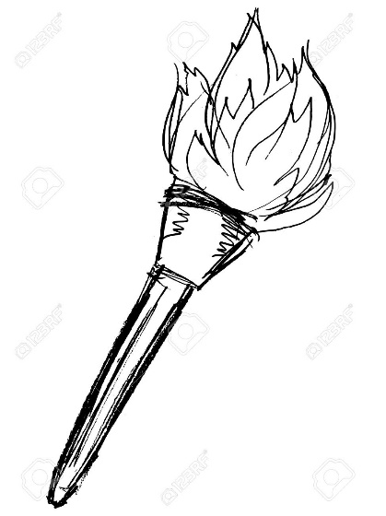
Shakespeare uses imagery throughout the dialogue to allow his characters to discuss the theme of love and bring out different aspects of it in their wordplay. Make notes on each image. Look for different interpretations of each image.
Cupid
____________________________________________________________________________________________________________________________________________________________________________________________________________________________________________________________________________________________________________________________________________________________________________________________________________________________________________________________________________________________________________________________________________________________________________________________________________________________________________________________________________________________________________________________________________________________________________________________________________________________________________________________________________________________________________________________________________________________________________________________________________________________________________________________________________________________________________________________________________________________________________________________________________________________________________________________________________________________________________________________________________________

.
Dancing Shoes
____________________________________________________________________________________________________________________________________________________________________________________________________________________________________________________________________________________________________________________________________________________________________________________________________________________________________________________________________________________________________________________________________________________________________________________________________________________________________________________________________________________________________________________________________________________________________________________________________________________________________________________________________________________________________________________________________________________________________________________________________________________________________________________________________________________________________________________________________________________________________________________________________________________________________________________________________________________________________________________________________________________

.
A Flaming Torch
____________________________________________________________________________________________________________________________________________________________________________________________________________________________________________________________________________________________________________________________________________________________________________________________________________________________________________________________________________________________________________________________________________________________________________________________________________________________________________________________________________________________________________________________________________________________________________________________________________________________________________________________________________________________________________________________________________________________________________________________________________________________________________________________________________________________________________________________________________________________________________________________________________________________________________________________________________________________________________________________________________________

.
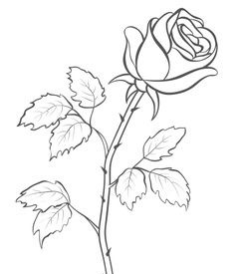
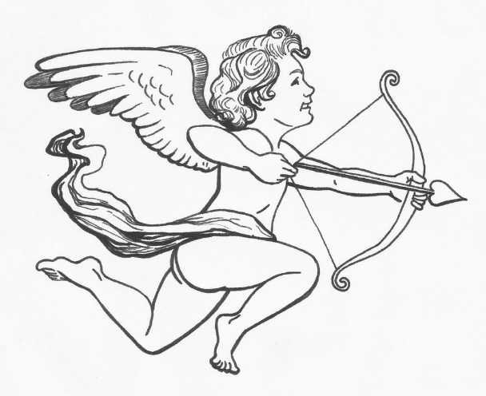
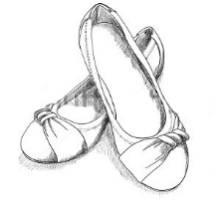
A Thorny Rose
____________________________________________________________________________________________________________________________________________________________________________________________________________________________________________________________________________________________________________________________________________________________________________________________________________________________________________________________________________________________________________________________________________________________________________________________________________________________________________________________________________________________________________________________________________________________________________________________________________________________________________________________________________________________________________________________________________________________________________________________________________________________________________________________________________________________________________________________________________________________________________________________________________________________________________________________________________________________________________________________________________________

.

Lord Capulet Welcomes his Guests (Act 1, Scene 5)

CAPULET:

Welcome, gentlemen! Ladies that have their toes
Unplagued with corns will have a bout with you.
Ah ha, my mistresses! Which of you all
Will now deny to dance? She that makes dainty,
She, I'll swear, hath corns; am I come near ye now?
Welcome, gentlemen! I have seen the day
That I have worn a visor and could tell
A whispering tale in a fair lady's ear,
Such as would please: 'tis gone, 'tis gone, 'tis gone:
You are welcome, gentlemen! Come, musicians, play.
A hall, a hall! Give room! And foot it, girls.

Music plays, and they dance

Create the invitation Capulet would send out. Think about his status, who he would want there and who he wouldn’t.
Capulet Ball Invitation

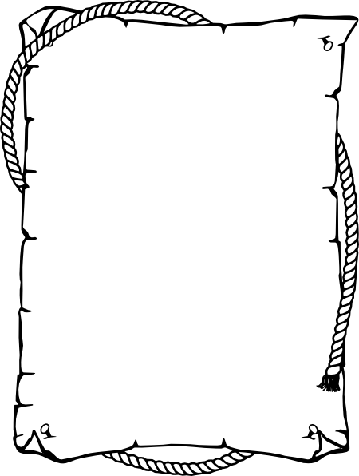
____________________________________________________________________________________________________________________________________________________________________________________________________________________________________________________________________________________________________________________________________________________________________________________________________________________________________________________________________________________________________________________________________________________________________________________________________________________________________________________________________________________________________________________________________________________________________________________________________________________________________________________________________________________________________________________________________________________________________________________________________________________________________________________________________________________________________________________________________________________________________________________________________________________________________________________________________________________________________________________________________________________

.
Tybalt’s Rage (Act 1, Scene 5)

TYBALT: This, by his voice, should be a Montague.
Fetch me my rapier, boy. What dares the slave
Come hither, cover'd with an antic face,
To fleer and scorn at our solemnity?
Now, by the stock and honour of my kin,
To strike him dead, I hold it not a sin.

CAPULET: Why, how now, kinsman! Wherefore storm you so?

TYBALT: Uncle, this is a Montague, our foe,
A villain that is hither come in spite,
To scorn at our solemnity this night.

CAPULET: Young Romeo is it?

TYBALT: 'Tis he, that villain Romeo.

CAPULET: Content thee, gentle coz, let him alone;
I would not for the wealth of all the town
Here in my house do him disparagement:
Therefore be patient, take no note of him:
It is my will, the which if thou respect,
Show a fair presence and put off these frowns,
And ill-beseeming semblance for a feast.

TYBALT: It fits, when such a villain is a guest:
I'll not endure him.

CAPULET: He shall be endured:
What, goodman boy! I say, he shall: go to;
Am I the master here, or you? Go to.
You'll not endure him! God shall mend my soul!
You'll make a mutiny among my guests!
TYBALT: Why, uncle, 'tis a shame.

CAPULET: Go to, go to;
You are a saucy boy: is't so, indeed?
This trick may chance to scathe you, I know what:
You must contrary me! For shame!
I'll make you quiet.

TYBALT: I will withdraw: but this intrusion shall,
Now seeming sweet, convert to bitterest gall.

Exit

Analysing Tybalt & Lord Capulet
What do you notice about the sentence lengths? What does the structure of the dialogue reveal about the characters involved?
____________________________________________________________________________________________________________________________________________________________________________________________________________________________________________________________________________________________________________________________________________________________________________________________________________________________________________________________________________________________________________________________________________________________________________________________________________________________________________________________________________________________________________________________________________________________________________________________________________________________________________________________________________________________________________________________________________________________________________________________________________________________________________________________________________________________________________________________________________________________________________________________________________________________________________________________________________________________________________________________________________________

.
Why might Lord Capulet’s reaction to Romeo’s presence be considered surprising? Why is Lord Capulet so tolerant of him?
____________________________________________________________________________________________________________________________________________________________________________________________________________________________________________________________________________________________________________________________________________________________________________________________________________________________________________________________________________________________________________________________________________________________________________________________________________________________________________________________________________________________________________________________________________________________________________________________________________________________________________________________________________________________________________________________________________________________________________________________________________________________________________________________________________________________________________________________________________________________________________________________________________________________________________________________________________________________________________________________________________________

.
Why does Lord Capulet become so upset with Tybalt? How does he express his wrath?
____________________________________________________________________________________________________________________________________________________________________________________________________________________________________________________________________________________________________________________________________________________________________________________________________________________________________________________________________________________________________________________________________________________________________________________________________________________________________________________________________________________________________________________________________________________________________________________________________________________________________________________________________________________________________________________________________________________________________________________________________________________________________________________________________________________________________________________________________________________________________________________________________________________________________________________________________________________________________________________________________________________

.
Explain, using Tybalt’s opening words, how he immediately expresses his rage & hatred.
____________________________________________________________________________________________________________________________________________________________________________________________________________________________________________________________________________________________________________________________________________________________________________________________________________________________________________________________________________________________________________________________________________________________________________________________________________________________________________________________________________________________________________________________________________________________________________________________________________________________________________________________________________________________________________________________________________________________________________________________________________________________________________________________________________________________________________________________________________________________________________________________________________________________________________________________________________________________________________________________________________________

.

Romeo & Juliet Meet (Act 1, Scene 5)

ROMEO:
[To JULIET] If I profane with my unworthiest hand
This holy shrine, the gentle fine is this:
My lips, two blushing pilgrims, ready stand
To smooth that rough touch with a tender kiss.

JULIET: Good pilgrim, you do wrong your hand too much,
Which mannerly devotion shows in this;
For saints have hands that pilgrims' hands do touch,
And palm to palm is holy palmers' kiss.

ROMEO: Have not saint’s lips, and holy palmers too?

JULIET: Ay, pilgrim, lips that they must use in prayer.

ROMEO: O, then, dear saint, let lips do what hands do;
They pray, grant thou, lest faith turn to despair.

JULIET: Saints do not move, though grant for prayers' sake.

ROMEO: Then move not, while my prayer's effect I take.
Thus from my lips, by yours, my sin is purged.

JULIET: Then have my lips the sin that they have took.

ROMEO: Sin from thy lips? O trespass sweetly urged!
Give me my sin again.

Comparing & Contrasting Romeo’s Love for Rosaline & Juliet
Using quotations, compare and contrast Romeo’s feelings for his two loves.
____________________________________________________________________________________________________________________________________________________________________________________________________________________________________________________________________________________________________________________________________________________________________________________________________________________________________________________________________________________________________________________________________________________________________________________________________________________________________________________________________________________________________________________________________________________________________________________________________________________________________________________________________________________________________________________________________________________________________________________________________________________________________________________________________________________________________________________________________________________________________________________________________________________________________________________________________________________________________________________________________________________

.
Look at Act 1, Scene 5 and list how Romeo expresses his feelings for Juliet:

Look back at Act 1, Scene 1 and list how Romeo expresses his feelings for Rosaline:

Romeo & Juliet Woo on the Balcony (Act 2, Scene 2)

ROMEO: Lady, by yonder blessed moon I swear
That tips with silver all these fruit-tree tops--

JULIET: O, swear not by the moon, the inconstant moon,
That monthly changes in her circled orb,
Lest that thy love prove likewise variable.

ROMEO: What shall I swear by?

JULIET: Do not swear at all;
Or, if thou wilt, swear by thy gracious self,
Which is the god of my idolatry,
And I'll believe thee.

ROMEO: If my heart's dear love--

JULIET: Well, do not swear: although I joy in thee,
I have no joy of this contract to-night:
It is too rash, too unadvised, too sudden;
Too like the lightning. Sweet, good night!
This bud of love, by summer's ripening breath,
May prove a beauteous flower when next we meet.
Good night, good night!

ROMEO: O, wilt thou leave me so unsatisfied?

JULIET: What satisfaction canst thou have to-night?

ROMEO: The exchange of thy love's faithful vow for mine.

The Theme of Love
The Greeks claimed there were six different types of love:
Name | Meaning | Link to the play
Storge | Love for your family.
Philia | Love your friends.
Ludus | Playful, fun, exciting love.
Philautia | Self-love; being kind to yourself.
Pragma | Love that endures.
Eros | Sexual love.

Think about how the main characters have different attitudes when it comes to love. Everyone expresses a different type of love that has a different set of values. Make notes on which types of love are expressed by the following characters, giving examples from the play:
Romeo | Juliet
Mercutio | Lord Capulet

Romeo Convinces Friar Laurence of his Feelings (Act 2, Scene 3)

FRIAR LAURENCE: God pardon sin! Was thou with Rosaline?

ROMEO: With Rosaline, my ghostly father? No;
I have forgot that name, and that name's woe.

FRIAR LAURENCE: That's my good son: but where hast thou been, then?

ROMEO: I'll tell thee, ere thou ask it me again.
I have been feasting with mine enemy,
Where on a sudden one hath wounded me,
That's by me wounded: both our remedies
Within thy help and holy physic lies:
I bear no hatred, blessed man, for, lo,
My intercession likewise steads my foe.

FRIAR LAURENCE: Be plain, good son, and homely in thy drift;
Riddling confession finds but riddling shrift.

ROMEO: Then plainly know my heart's dear love is set
On the fair daughter of rich Capulet:
As mine on hers, so hers is set on mine;
And all combined, save what thou must combine
By holy marriage: when and where and how
We met, we woo'd and made exchange of vow,
I'll tell thee as we pass; but this I pray,
That thou consent to marry us to-day.

FRIAR LAURENCE: Holy Saint Francis, what a change is here!
Is Rosaline, whom thou didst love so dear,
So soon forsaken? Young men's love then lies
Not truly in their hearts, but in their eyes.

Friar Laurence’s Marriage Advice (Act 2, Scene 6)

FRIAR LAURENCE:

These violent delights have violent ends
And in their triumph die, like fire and powder,
Which as they kiss consume: the sweetest honey
Is loathsome in his own deliciousness
And in the taste confounds the appetite:
Therefore love moderately; long love doth so;
Too swift arrives as tardy as too slow.

The Role of Friar Laurence
Annotate the image of Friar Laurence with aspects of his character. Think about his thoughts & feelings, role in the play, position in society and his language.

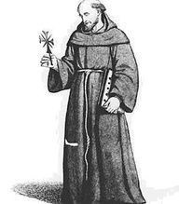

Tybalt takes his Revenge (Act 3, Scene 1)

BENVOLIO: By my head, here come the Capulets.

MERCUTIO: By my heel, I care not.

Enter TYBALT and others

TYBALT: Follow me close, for I will speak to them.
Gentlemen, good den: a word with one of you.

MERCUTIO: And but one word with one of us? Couple it with
something: make it a word and a blow.

TYBALT: You shall find me apt enough to that, sir; an you
will give me occasion.

MERCUTIO: Could you not take some occasion without giving?

TYBALT: Mercutio, thou consort'st with Romeo--

MERCUTIO: Consort! What, dost thou make us minstrels? And
thou make minstrels of us, look to hear nothing but
discords: here's my fiddlestick; here's that shall
make you dance.

BENVOLIO: We talk here in the public haunt of men:
Either withdraw unto some private place,
And reason coldly of your grievances,
Or else depart; here all eyes gaze on us.

MERCUTIO: Men's eyes were made to look, and let them gaze;
I will not budge for no man's pleasure, I.

Enter ROMEO

TYBALT: Well, peace be with you, sir: here comes my man.

MERCUTIO: But I'll be hanged, sir, if he wear your livery:
Marry, go before to field, he'll be your follower;
Your worship in that sense may call him 'man.'

TYBALT: Romeo, the hate I bear thee can afford
No better term than this -- thou art a villain!

ROMEO: Tybalt, the reason that I have to love thee
Doth much excuse the appertaining rage
To such a greeting: villain am I none;
Therefore farewell; I see thou know'st me not.

TYBALT: Boy, this shall not excuse the injuries
That thou hast done me; therefore turn and draw.

Analysing Mercutio
Quotation | Explanation
His name: ‘Mercutio’
“Romeo, Madman! Passion! Lover!”
“If love be rough with you, be rough with love; Prick love for pricking and you beat love down.”
"O calm, dishonourable, vile submission."
“Look for me tomorrow and you shall find me a grave man.”
“A plague on both your houses.”

Comparing the Brawl Scenes
Zeffirelli’s Romeo & Juliet (1960s) | Luhrmann’s Romeo & Juliet (1990s)
Use YouTube to find Mercutio’s death scene in both these versions. Make notes on how they have been presented, e.g. how violent, music, scenery, characters actions etc…

Lord Capulet’s Rage (Act 3, Scene 5)

LADY CAPULET: Here comes your father; tell him so yourself,
And see how he will take it at your hands.

Enter CAPULET and Nurse

CAPULET: What, still in tears?
Evermore showering? How now, wife!
Have you deliver'd to her our decree?

LADY CAPULET: Ay, sir; but she will none, she gives you thanks.
I would the fool were married to her grave!

CAPULET: Soft! Take me with you, take me with you, wife.
How! Will she none? Doth she not give us thanks?
Is she not proud? Doth she not count her blest,
Unworthy as she is, that we have wrought
So worthy a gentleman to be her bridegroom?

JULIET: Not proud, you have; but thankful, that you have:
Proud can I never be of what I hate.

CAPULET: How now, how now, chop-logic! What is this?
Thank me no thankings, nor, proud me no prouds,
But fettle your fine joints 'gainst Thursday next,
To go with Paris to Saint Peter's Church,
Or I will drag thee on a hurdle thither.
Out, you green-sickness carrion!

LADY CAPULET: Fie, fie! What, are you mad?

JULIET: Good father, I beseech you on my knees,
Hear me with patience but to speak a word.

CAPULET: Hang thee, young baggage! Disobedient wretch!
I tell thee what: get thee to church o' Thursday,
Or never after look me in the face:
Speak not, reply not, do not answer me;
My fingers itch. Wife, we scarce thought us blest
That God had lent us but this only child;
But now I see this one is one too much,
And that we have a curse in having her:
Out on her, hilding!

LADY CAPULET: You are too hot.

CAPULET: Look to't, think on't, I do not use to jest.
Thursday is near; lay hand on heart, advise:
An you be mine, I'll give you to my friend;
And you be not, hang, beg, starve, die in
the streets, for, by my soul, I'll ne'er acknowledge thee:
Trust to't, bethink you; I'll not be forsworn.

Lord Capulet’s Diary
Write a diary entry for Lord Capulet covering the events of the day. Express this thoughts and feelings through your tone and language choice. Be sure to show his attitudes towards women. Consider his point of view.
____________________________________________________________________________________________________________________________________________________________________________________________________________________________________________________________________________________________________________________________________________________________________________________________________________________________________________________________________________________________________________________________________________________________________________________________________________________________________________________________________________________________________________________________________________________________________________________________________________________________________________________________________________________________________________________________________________________________________________________________________________________________________________________________________________________________________________________________________________________________________________________________________________________________________________________________________________________________________________________________________________________

.
Romeo Says Farewell to Juliet (Act 5, Scene 3)

ROMEO:

A lantern, slaughter'd youth,
For here lies Juliet, and her beauty makes
This vault a feasting presence full of light.
Death, lie thou there, by a dead man interr'd.

Laying PARIS in the tomb

O my love! My wife!
Death, that hath suck'd the honey of thy breath,
Hath had no power yet upon thy beauty:
Thou art not conquer'd; beauty's ensign yet
Is crimson in thy lips and in thy cheeks,
And death's pale flag is not advanced there.
Why art thou yet so fair? Shall I believe
That unsubstantial death is amorous,
And that the lean abhorred monster keeps
Thee here in dark to be his paramour?
For fear of that, I still will stay with thee;
And never from this palace of dim night
Depart again: here, here will I remain
With worms that are thy chamber-maids; O, here
Will I set up my everlasting rest,
And shake the yoke of inauspicious stars
From this world-wearied flesh. Here's to my love!

Drinks

O true apothecary!
Thy drugs are quick. Thus with a kiss I die.

Dies

Tracking the Relationship of Romeo & Juliet
Using the clock, chronologically track the development of Romeo & Juliet throughout the play. Include key quotations from across the play.

The Feud Ends (Act 5, Scene 3)

PRINCE ESCALUS: Where be these enemies? Capulet! Montague!
See, what a scourge is laid upon your hate,
That heaven finds means to kill your joys with love.
And I for winking at your discords too
Have lost a brace of kinsmen: all are punish'd.

CAPULET: O brother Montague, give me thy hand:
This is my daughter's jointure, for no more
Can I demand.

MONTAGUE: But I can give thee more:
For I will raise her statue in pure gold;
That while Verona by that name is known,
There shall no figure at such rate be set
As that of true and faithful Juliet.

CAPULET: As rich shall Romeo's by his lady's lie;
Poor sacrifices of our enmity!

PRINCE ESCALUS: A glooming peace this morning with it brings;
The sun, for sorrow, will not show his head:
Go hence, to have more talk of these sad things;
Some shall be pardon'd, and some punished:
For never was a story of more woe
Than this of Juliet and her Romeo.

Exeunt

Diamond Ranking
Rank the following characters in order in which you blame them for the deaths of Romeo & Juliet. Explain you reasons in the space below:
Romeo; Juliet; Prince Escalus; the Nurse; Tybalt;
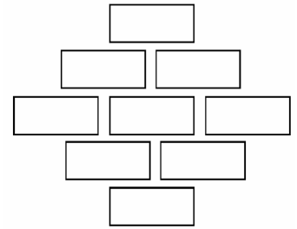
Friar Laurence; Lord Montague; Lord Capulet; Mercutio
____________________________________________________________________________________________________________________________________________________________________________________________________________________________________________________________________________________________________________________________________________________________________________________________________________________________________________________________________________________________________________________________________________________________________________________________________________________________________________________________________________________________________________________________________________________________________________________________________________________________________________________________________________________________________________________________________________________________________________________________________________________________________________________________________________________________________________________________________________________________________________________________________________________________________________________________________________________________________________________________________________________

.

