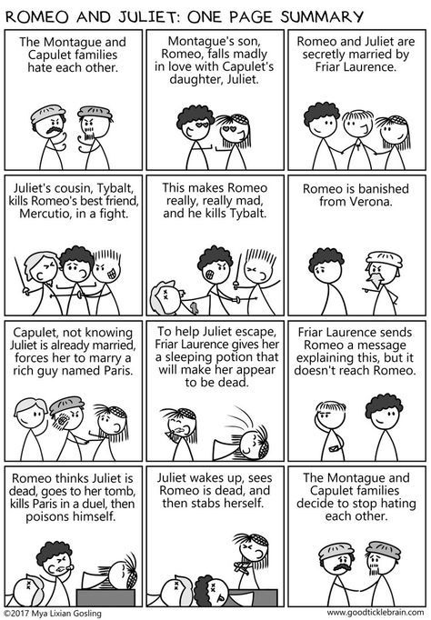
KS4 Romeo and Juliet Home Learning
If you are going to be off for a long period of time, please work through the Accompanying Workbook.
Generic Tasks:
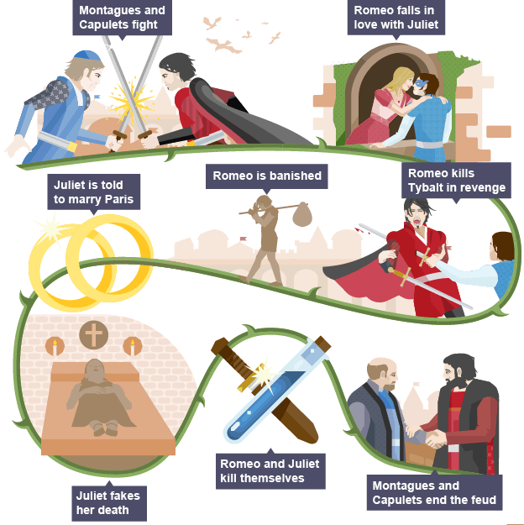
- Create a detailed plot flow chart or story board for the story of Romeo and Juliet (use the internet to help you make sure it’s correct). This will be useful for revision.
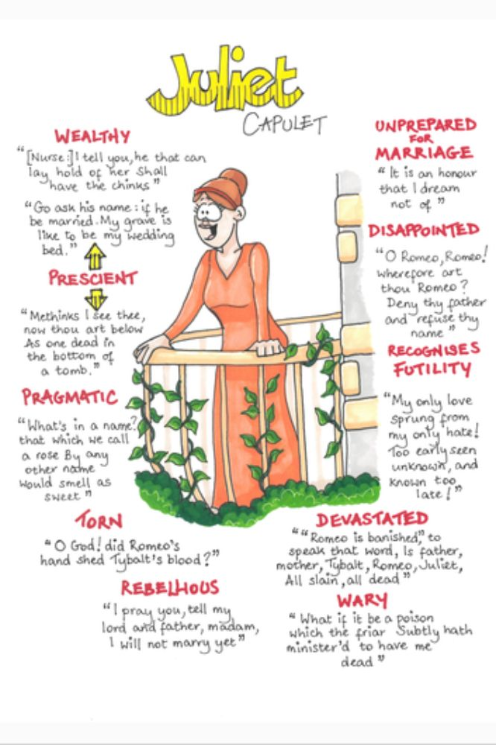
- Create character profiles for each of the main characters. This should include: how they treat others, how they are treated, what happens to them, key quotes, how they impact the plot.

Specific Tasks:
- Draw or find pictures for each line of the prologue, you can write the prologue out or copy it into a Word doc, then add the images around the side. You then need to memorise the prologue; the images will help you remember each line.
- You will need to find out which acts/ scenes you are missing. Then use the Spark Notes website to read the scene and the translation to help you understand it. This website, and lots of others, will have a summary of the scene, you should read these and then write your own summary in your words.
- Make a list of the main characters in this scene. For each one go through their lines and, using the translation on Spark Notes if you need to, try to pick out key words or phrases which they have said which can tell us about how they are feeling. E.g. Tybalt calls Romeo a ‘villain’ – Villain = criminal, an insult on Romeo’s honour, shows how angry he is, shows he is trying to provoke a fight.
- Then answer the following question about at least one of those using a PEA structure:

How has the character of __________ been presented in this scene?

