Power and Conflict Shadow Curriculum

You will need to find out which poems you are missing. Then complete the following tasks:

- Create a fact file on the poet
- Create a research poster or leaflet with context of the poem (if you can) e.g. WWI, Kamikaze pilots etc.
- Make notes using GCSE Pod, BBC Bitesize and Mr Bruff on Youtube
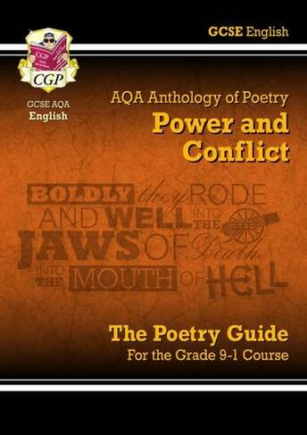
- If you have a copy of the AQA Power and Conflict Revision Guide you can make annotations on your copy of the poem using that

