Lesson 2

Date: ..…………………
LO: To understand how we can create tension in Drama.

TASK 1:
Reflect on the questions. Type/write a response underneath each question:
- How do you feel in this room right at this moment?

- What is it that is creating that feeling?

Load up the sound effects on the links below:
Grandfather clock - https://www.youtube.com/watch?v=N9hIpjiGDq4
Footsteps - https://www.youtube.com/watch?v=spDzJCAL5lk
Owl Hooting - https://www.youtube.com/watch?v=FA0vtdQBsqA
Scary Laughter - https://www.youtube.com/watch?v=f3BPx2lt6E0
Play them all at the same time if you can. Close your eyes and listen to the sound effects…

- How do you feel this room whilst listening to the sound effects?

- What might ‘atmosphere’ mean?

- What might the atmosphere in be this room?

6.) How might music help to create a particular atmosphere?

TASK 2:
Listen to the music by following this link:
https://www.youtube.com/watch?v=A9QTSyLwd4w
Reflect on one of the challenges from the table and make note as you listen in the space below:

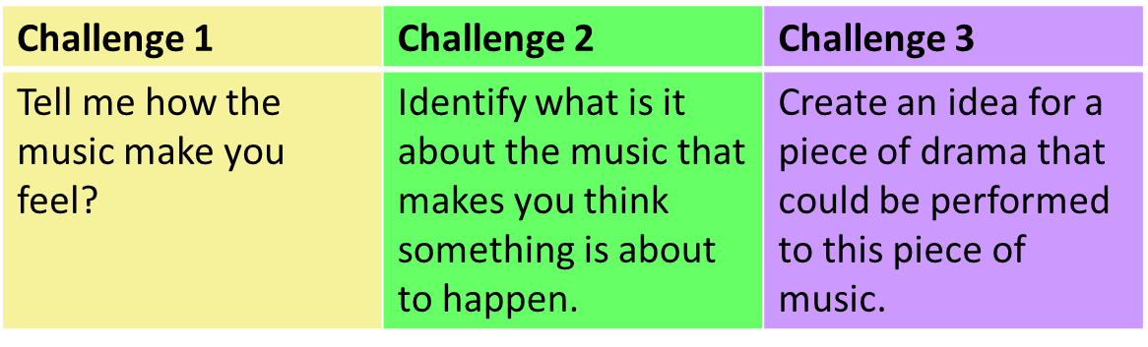
TASK 3:
Listen to my ghost story by following this link: https://www.loom.com/share/468288d17348489aa9f3cf3953856e4d

Challenge 1 | Challenge 2 | Challenge 3
Describe what makes the story scary. Is it scary? | Identify how I use a range of vocal skills; volume, pace, dramatic pause, pitch. | Can you think of any way I could have created more tension when I was telling my story?
Write notes here: | Write notes here: | Write notes here:

TASK 4:
Write your very own ghost story! Complete this on the space provided below and onto the next page. Can you complete all 3 challenges?

Challenge 1 | Challenge 2 | Challenge 3
Tell a ghost story. Make sure you story has a be- ginning, middle and end! | Develop your story using the senses. What can you see, smell, touch, taste or feel? | Create tension using onomatopoeia and… ellipsis…

Need some help getting started? Use one of sentence starters below:
• Our story begins when…
• It was a cold, dark night…
• You want me to tell you about the worst night of my life? ….
Begin writing your story here. Continue onto the next page…

TASK 5: SELF EVALUATION
Reflect on your written work by filling in the box below. Please write or type in purple.
WHAT WENT WELL…
My work was good because…
EVEN BETTER IF…
To improve my work I could…

