BTEC Assignment Brief
Qualification | Pearson BTEC Level 1/Level 2 Tech Award in Art and Design Practice
Unit or Component number and title | Component 1: Generating Ideas in Art and Design  Component 2: Develop Practical Skills in Art and Design
Learning Aims | Component 1: Generating Ideas in Art and Design  A Investigate art and design practice  B Generate and communicate art and design ideas  Component 2: Develop Practical Skills in Art and Design  A Develop Practical Skills in Art and Design  B Record and Communicate Skills Development
Assignment title | Design Styles
Assessor | A Jelf
IV | C Simkiss
Hand out date | Thursday 2nd September 2021
Hand in deadline | Component 1 – Friday 4th February 2022  Component 2 – Friday 15th July 2022
Vocational Scenario or Context | 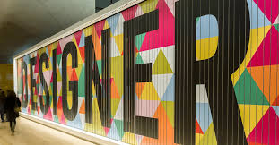  You have been approached by the Design Museum in London. The design museum is showcasing the creativity and innovation of artists and designers using the theme Design from the last 150 Years.  Researching artists and designers that have worked with similar themes can inspire your ideas. Researching art and design outcomes that inspire you, can be adapted to the theme. Look at how artists and designers work within the design movements below:  - Arts and Crafts  - Art Nouveau  - Art Deco  - Memphis  - Pop Art  - De Stijl  - Shaker  - High Tech  - Organics / Biomorphic  - Streamline Moderne  - Abstract Modernism
Task 1 –  Comp 1: Learning Aim A | Product designers do research before deciding on what to make. With a rough idea of the type of the household items you are interested in, you should put together a series of research boards covering:  - Mindmap of the target audience you intend to aim for, such as their age, tastes, habits and lifestyle. Include colours, textures, shapes and materials they might like, collecting samples if possible. Make notes of information or use images to record your findings.  - Inspiration board: shapes, patterns, textures, motifs, colours of design styles from the last 150 years and everything that inspires you for this project. Use images, notes, collected objects, samples etc. You should make notes about how the materials and techniques that inspire you.  - Artists and designers products board: products others have created and what you think is interesting about them. Think about the materials, techniques and processes that have been used across different types of product and compare them where possible. Determine the formal elements, design principles, construction, properties of materials and techniques used. Consider which is most suitable for your own ideas or what you might like to use and why?  - Personal responses: you can use quick 2D and 3D processes to try similar ideas to the products you have seen, using different materials and techniques. This will give you an idea of how and why products are designed in different ways. You should show how you have responded to the artists and designers you have looked at.  You must:  - research the work of artists and designers in chosen design movements  - research the characteristics of different design movements that inspire you  - explore a range of materials, techniques and processes to create practical work in the style of your researched design movement.  - conduct primary and secondary research into the theme of ‘Design Styles’.
Checklist of evidence required | Evidence:  You will need to provide the following evidence for assessment in your sketchbook:  - examples of art and design work by a broad range of artists, designers and design movements related to the theme and who inspire you  - art and design work in the style of artists and designers you have researched  - primary research such as drawing from observation and photographs related to the theme  - secondary research from books, journals and the internet related to the theme
Criteria covered by this task:
Component 1 Learning Aim A | To achieve the criteria you must show that you are able to:
A.2D1 | Effective exploration of art and design informed by research of art and design practice.
A.2M1 | Competent exploration of art and design informed by research of art and design practice.
A.2P1 | Generally adequate exploration of art and design informed by research of art and design practice.
A.1M2 | Basic exploration of art and design practice.
A.1P2 | Limited exploration of art and design practice.
A.1M1 | Demonstration of basic practical research skills.
A.1P1 | Demonstration of limited practical research skills.
Task 2 Comp 1: Learning Aim B | 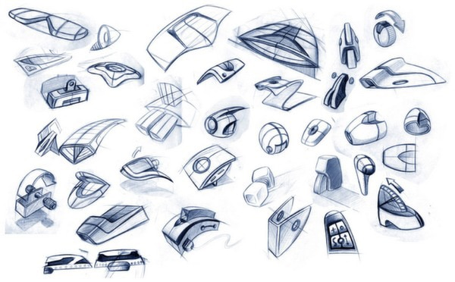  Based on your research into the theme and relevant artists and designers, you must develop a broad range of art and design ideas for a household item. This may include one or more of the following products.  Three Dimensional sculpture (objet d’art, award/trophy, paperweight) Container  Clock  Mirror  Light  Small item of furniture (coffee table, side table, chair, shoe storage unit)  The Design Museum would like to see development models of your designs. The outcomes can be prototypes and you can use any materials that you are able to manipulate. Your final prototype does not have to be functional, but should communicate the overall look form and function.
Checklist of evidence required | You will need to document your ideas development in sketchbooks and design sheets. You must include:  - how you developed your ideas in the form of notes, mindmaps and moodboards.  - visual presentations of your ideas using techniques such as drawing, photography, CAD.  - evidence of how you have selected and refined your final idea through further sketches and studies.
Criteria covered by this task:
Component 1 Learning Aim B | To achieve the criteria you must show that you are able to:
B.2D2 | Confident ideas generation techniques and ability to visually communicate ideas informed by investigation.
B.2M2 | Competent ideas generation techniques and ability to visually communicate ideas informed by investigation.
B.2P2 | Generally adequate ideas generation techniques and ability to visually communicate ideas informed by investigation.
B.1M4 | Show basic ability to visually communicate ideas.
B.1P4 | Show limited ability to visually communicate ideas.
B.1M3 | Apply basic ideas generation techniques.
B.1P3 | Apply limited ideas generation techniques.
Task 3 Comp 2: Learning Aim A | 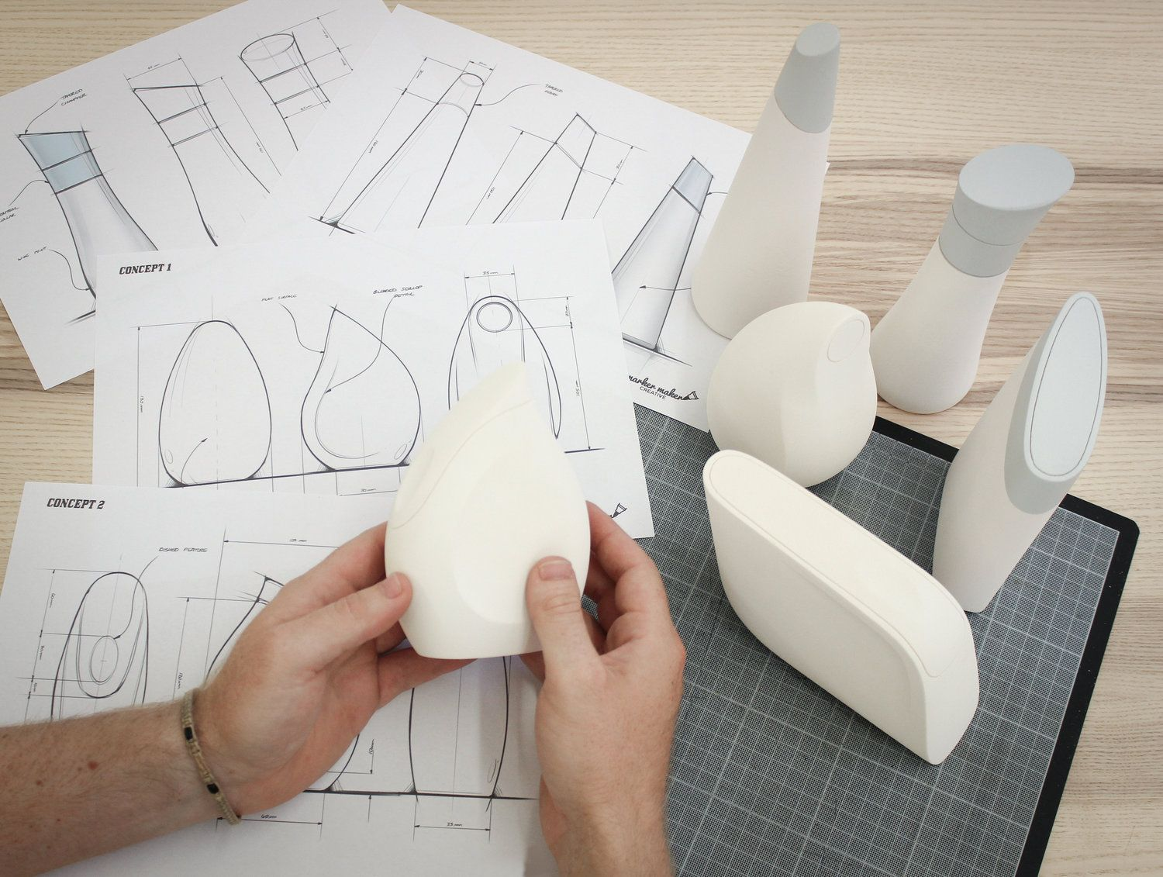  The Design Museum would like to see a complete a prototype of your final art and design outcome.  You are to experiment with a wide range of equipment and techniques to demonstrate a broad range of specialist skills.  Below are a list of specialist skills to demonstrate in your design experimentation and prototyping:  - Computer Aided Design – 2D Design  - Computer Aided Manufacture – laser cutting  - Strip heater  - Vacuum former  - Styrofoam modelling  - Card modelling  - Plaster of Paris / Concrete casting  - Concrete casting – pattern, texture and surface finish experimentation  - Wood lamination
Checklist of evidence required | Evidence:  - draft sketches  - original photography or illustration. This should include:  - experiments with different materials  - experiments with different manufacturing techniques  - sample mock ups  - refined design prototypes  - Final design solution  - Design sheets which effectively communicate your experiment and design development and prototyping work  - well-presented images of work in progress
Criteria covered by this task:
Component 2 Learning Aim A | To achieve the criteria you must show that you are able to:
A.2D1 | Effective application of specialist skills with reasoned review and consistent improvement.
A.2M1 | Competent application of specialist skills with clear review and improvement.
A.2P2 | Generally adequate review and improvement of skills.
A.2P1 | Generally adequate application of specialist skills.
A.1M2 | Basic review and improvement of skills.
A.1M1 | Basic application of specialist skills.
A.1P2 | Limited review and improvement of skills
A.1P1 | Tentative application of specialist skills.
Task 4 Comp 2: Learning Aim B | The Design Museum would like you to present your process and outcome in a professional way. You should look at how other product designers have presented their work to help you inform your own presentation. Your presentation should include:  - records of development and skills used in a logical order  - good quality images, diagrams, sketches and supporting information to help people understand the design  - visuals of the outcome from different angles and key details  - titles and supporting information such as material swatches and colour palette.
Component 2 Learning Aim B | To achieve the criteria you must show that you are able to:
B.2D2 | Effective presentation and communication of skills.
B.2M2 | Competent presentation and communication of skills
B.2P3 | Generally adequate presentation and communication of skills
B.1M3 | Basic description and recording of skills.
B.1P3 | Limited identification and recording of skills.
Sources of information to support you with this Assignment | - Arts and Crafts  https://www.vam.ac.uk/articles/arts-and-crafts-an-introduction  - Art Nouveau  https://www.vam.ac.uk/collections/art-nouveau  - Art Deco  https://www.vam.ac.uk/collections/art-deco  - Memphis  https://designmuseum.org/memphis  - Pop Art  http://www.tate.org.uk/art/art-terms/p/pop-art  - De Stijl  http://www.tate.org.uk/art/art-terms/d/de-stijl  - Shaker  https://www.metmuseum.org/toah/hd/shak/hd_shak.htm  - High Tech  https://www.architecture.com/knowledge-and-resources/knowledge-landing-page/high-tech  - Organics / Biomorphic  http://www.museiitaliani.org/organic-design/  - Streamlining  - https://study.com/academy/lesson/streamline-moderne-houses-furniture-architecture.html

