Lesson 1: Why do we study RESPECT?

In this lesson we are going to:

* Evaluate the purpose of RESPECT as a course.

**Task 1. Rules and Expectations**

|  |  |
| --- | --- |
| 1 |  |
| 2 |  |
| 3 |  |
| 4 |  |
| 5 |  |
| 6 |  |
| 7 |  |
| 8 |  |
| 9 |  |
| 10 |  |

**“Knowledge that flavors the claim”**

K. Hammond

**Task 2. Create a Spider Diagram linking up how RESPECT supports GCSE choices**

**Task 3: Write down three reasons why studying RESPECT can help you be successful.**



**Lesson 2: Identity!**

In this lesson we are going to:

* Evaluate what is more important personal identity or group identity?

|  |  |
| --- | --- |
| Things in common | Individual things |
|  |  |

|  |
| --- |
| Does religion identify who you are? |
|  |

**Lesson 3: What is Britishness?**

In this lesson we are going to: Evaluate what is “Britishness”?

*Brit·ish·ness*

*[ˈbrɪtɪʃnəs]*

*NOUN*

1. *the quality of being British or of having characteristics regarded as typically British:*

**Task 1. What does this flag represent? Label and explain the different parts of the flag**

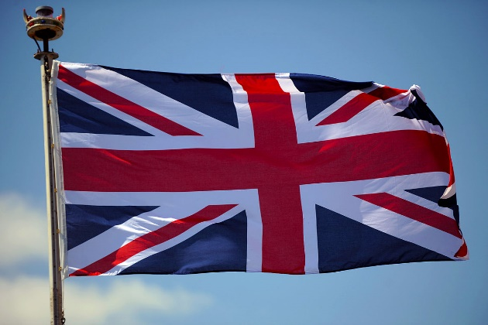

**Task 2: Create a list what it actually means to be British?**

*For example – loves tea, was born in England, Wales, Scotland, Northern Ireland*

**Task 3: Answer in full sentences your book;**

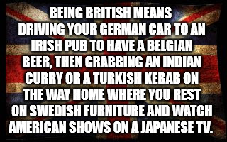

1. **Is it true, do we all do those things?**

**________________________________________________________________________________________________________________________________________________________________________________________________________________________________________________________________________________________________________________________________________________________________________**

1. **What do you think other countries think about the British? Give an example.**

**________________________________________________________________________________________________________________________________________________________________________________________________________________________________________________________________________________________________________________________________________________________________________**

1. **What do you think it means to be British?**

**________________________________________________________________________________________________________________________________________________________________________________________________________________________________________________________________________________________________________________________________________________________________________**

**Task 4: Explain what the Four Key British Values mean**

|  |  |
| --- | --- |
| Personal Freedom | Tolerance And Respect For Diversity |
|  |  |
| Equality Of Opportunity | Representative Democracy And The Rule Of Law |
|  |  |

**Lesson 4: How British are you?**

In this lesson we are going to: Analyse what makes someone British?

* Challenge 1: One minute to list as many ways you can judge Britishness!
* Challenge 2: Three Minutes Can you write down all the words of the National Anthem.

**________________________________________________________________________________________________________________________________________________________________________________________________________________________________________________________________________________________________________________________________________________________________________________________________________________________________________________________________________________________________________________________________________________________________________________________________________________________________________________________________________________________________________________________________________________**

**________________________________________________________________________________________________________________________________________________________________________________________________________________________________________________________________________________________________________________________________________________________________________**

Challenge 3: Take the British Citizenship test, How British are you?

* Q1: Who served as prime minister during WWII?
* Q2: How many houses make up the U.K. Parliament?
* Q3: In the English county of Wiltshire, there is a prehistoric monument. What’s this iconic landmark called?
* Q4: What is the official flower of England?
* Q5: What flower do people wear on Remembrance Day?
* Q6 : What is the name of the official flag of the United Kingdom?
* Q7: In what year did British women win the right to vote at the same age as men?
* Q8: How often are UK general elections held?
* Q9: What’s the official home of the prime minister?
* Q10: 10 Downing Street in London, England, is the headquarters of the Government of the United Kingdom.

**Task 1: Watch the clips, complete the table.**

|  |  |
| --- | --- |
| Country | What they think of British People |
|  |  |
|  |  |
|  |  |
|  |  |

**Lesson 5: What do we celebrate as British?**

**In this lesson we are going to:**

* Understand who Edward Colston is.
* Assess the reasons why his statue was famously thrown in the river.
* Evaluate whether if the removal of the statue was against British values.

Wrong and illegal to pull it down

1. Write down your own personal opinion on the opinion line given to you, be prepared to share with the rest of the class.
2. Add the viewpoints of British politicians on this matter.
3. **Challenge**: Add your personal viewpoint to their opinions, do you agree or not and why?

**Opinion Line on the pulling down of Edward Colston’s Statue**

**Lesson 5: What do we celebrate as British?**

**In this lesson we are going to:**

* **Assess how should Bristol remember Bristol's slaving past?**

**Task 1 Read:**

Excerpt from Bristol and Transataltic Slavery Orangins, Impact and Legacy 2021

The Black Lives Matter protests that spread across the world following the murder of George Floyd in May 2020 forced people to think hard about racism. The debates following the toppoling of Colston’s statue in Bristol demonstrated the connectio between modern racism and historical injustices of slavery.

**Did race prejudice cause slavery? Or was it the other way around?**

*The Historian Peter Fryer asked these questions to introduce a long running historical debate. For the Trinidadian Historian Eric Williams, the desire to make money lead Europeans to adopt slavery. Racism, in his view was a way of justifying the brutal treatment of inslaved people. Other historians have challenged Willaims by pointing to racist ideas that existed before transalatic slavery began.*

**Today**

*Racism still scars our city, as it does people and places across the world. Cities like Bristol have not yet fully acknowledged the extent to which their economic and physical development rested on the racist ideas at the heart of the slave trade. Yet as the Black Lives Matter demonstrations of 2020 made clear, ordinary men and women will continue to protest against and resist racism and injustice.*

**What is race?**

*In the 19th century, people began to understand race in ascientific way.Even today we might think of terms like ‘Black’ and ‘white’ as scientific realities. Yet genetic science provides no evidence to support these catagories. All humans share 99.9% of their DNA, regardless of skin colour national origin. Most of the 0.1 differences exist within groups like ‘Black’ and ‘white’ not between them. Race is not made by our genes but by our history.*

**How should we remember Bristol’s slaving past?**

*The process of memorialisation, the way we remember the past, can be complicated. Societies use public spaces to memorialise people and events in history that are important to them, but there is rarely a full agreement on who or what is appropriate and peoples feelings about this change over time. The past does not change, but what and who we choose to memorialise from it does. Bristol like other cities, has struggled to agree about how we should remember its involvement in transatlantic slavery.*

Commemorating Colston

*When we discuss remembering transatlantic slavery in Bristol, it is important to remember that memorials to some of the people involved already exist.*

*Colston’s statue was erected in 1895, more than170 years after he died.*

*In the early 19th Century, Colston was not particularly well-known or popular in Bristol. However, there was at least four societies dedicated to doing charitable works in his memory. They began to raise funds for a Colston Statue by asking for public donations. They admired Colston because he was a successful businessman who had spent a lot of money improving the city. They believed that how he spent the money was more important than how he made it. (See 19th Century view below). They did not consider that by commemorating Colston they might also be condoning his slave trading past.*

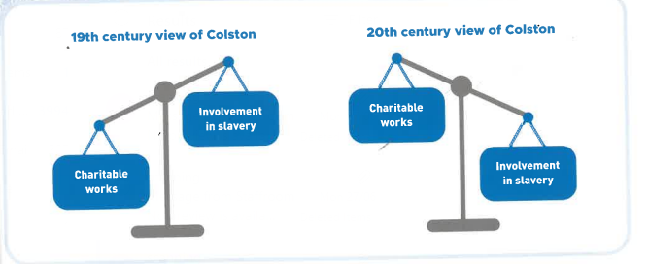

**Task 2: Proposal of how Bristol’s slaving past should be remember.**

**You need a poster explaining your ideas**

**Lesson 7: What is the most important British Value?**

**In this lesson we are going to:**

* **Debate which of the four British Values are most important.**

**.** Use the information and ideas to argue that your British value is the most fundamental

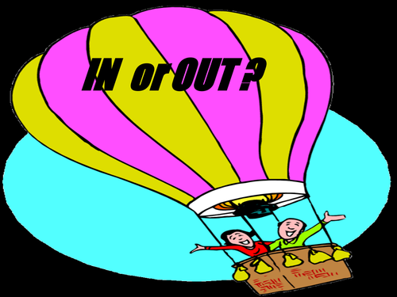

Personal Freedom Debate Ideas

**Philosopher: John Stuart Mill Principle of Harm –**

For Mill – and the many politicians, philosophers and legal theorists who have agreed with him – social disapproval or dislike (“mere offence”) for a person’s actions isn’t enough to justify intervention by government unless they actually harm or pose a significant threat to someone.

For example – Consenting adults should be able to whatever they like,

The phrase “Your freedom to swing your fist ends where my nose begins” captures the general sentiment of the principle, which is why it’s usually linked to the idea of “negative rights”. These are demands someone not do something to you.

For example - we have a negative right to not be assaulted.

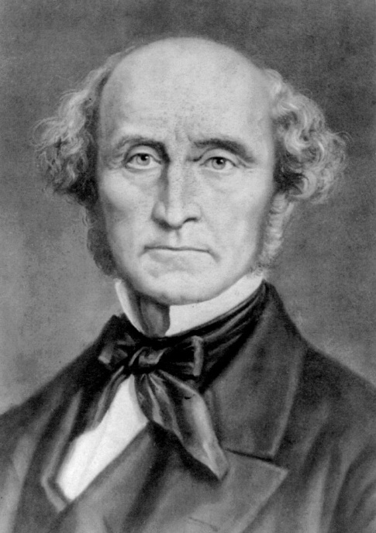

Current Political Controversies to Consider

1. Compulsory vaccinations for Covid
2. LGBTQ+ Equal Rights
3. Reclaim the night (legislation to ensure women safety at night, including a male curfew.)
4. Access to safe and legal abortions
5. 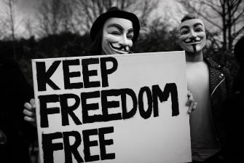Smoke tobacco

Tolerence and Respect for Diversity Debate Ideas

**Philosopher: Michal Foucault–**

Foucault rejects the standard picture according to which power is always about the strong oppressing the weak, the rich oppressing the poor, the monarchy oppressing its subjects. Instead he suggests that in the modern world, power is spread throughout society. You and I are just as much conduits of power as a CEO or a member of congress: we internalize the norms of our society, and we end up policing ourselves and other people, whether we realize it or not. We all act as unwitting enforcers of the power structure.

So it’s no longer a simple “us versus them” story. And one consequence is that we can start thinking of injustice as something *systemic* or *structural*: injustice is not just a set of acts that bad people do, but a system that even otherwise *good* people can end up perpetuating, often in spite of themselves.

Current Political Controversies to Consider

1. Black Lives Matter Movement
2. How we commemorate history
3. Compulsory preference of pronouns being used on badges and emails
4. Inclusion of Creationist ideas of evolution in the science curriculum

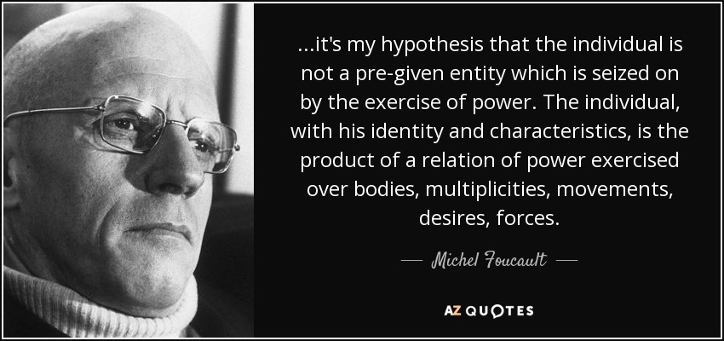

Acceptable and right to pull it down

Equality and Opportunity Debate Ideas

**Philosopher: John Rawls**

John Rawls asks us to complete a thought experiment.

If before you were born you knew how unjust the world is. For example: If you knew that one billion of the earths eight billion people live in slums.  Approximately [842 million](https://www.mercycorps.org/articles/quick-facts-what-you-need-know-about-global-hunger) people suffer from hunger worldwide. That’s almost 12 percent of the world’s population. That 71 countries it is illegal to be Gay. That 1% of the world is a refugee. That if you are a women you were going to be 23% less worth off than if you are a man.

If you knew that you had equal chance growing up in any current world circumstance, would you gamble coming to earth as it is? Or would you make the world a little fairer with less privileged people but a lot less vulnerable people?

If you would make the world less risky before you would gamble on coming to Earth, we morally should be making the world fairer.

Current Political Controversies to Consider

1. Gender pay gap in the UK is still 7%
2. There is a 13% attainment gap between ‘white’ and BAME students
3. Cycle of Poverty - poor families become trapped in poverty for generations. Because they have limited or no access to critical resources, such as education and financial services, subsequent generations are also impoverished
4. 65% of all judges in the UK, went to a private school.



Representative Democracy and the Rule of Law – Debate ideas

**Philosopher: Aristotle**

The Rule of Law is a principle that all people and organizations within a country, state, or community are held accountable to the same set of laws. The Rule of Law has its origins in ancient Greece and, more specifically, in the philosophy of Aristotle. In his work titled Politics, Aristotle raised the question of whether it is better to be ruled by the best leader or the best laws. In exploring this question he found advantages and disadvantages to both governing methods. His conclusion, however, suggested that laws were appropriate for most societies since they were carefully thought out and could be applied to most situations. Therefore, people should be ruled by the best laws.

Current Political Controversies to Consider

1. 60% of the UK population would vote to bring back the death penalty
2. Referendum for Scottish independence
3. Just 7% of**British** people are**privately educated,** compared to two-fifths (29%) of MPS.
4. Party Gate, parties in 10 downing street during lock down
5. Only 34% of MPs are women
6. 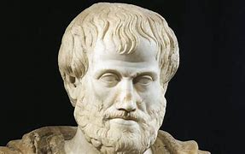Brexit