NAME
TUTOR GROUP
LESSON DAY AND TIME
TEACHER

Beliefs
CHRISTIANITY
CHRISTIAN BELIEFS
LEARNING TARGETS
1 | I will know the official definition of God.
2 | I will know what “immanent” and “transcendent” mean.
3 | I will understand the concept of the Trinity.”
4 | I will know the Biblical Creation stories.
1 | I will know what “The Problem Of Evil And Suffering” is.
2 | I will know the story of The Fall.
3 | I will understand some different theodicies.
4 | I will understand the role that Jesus plays.

At the start of the topic, draw a line on the confidenceometer to show how confident you are about the subject matter. At the end of the topic draw another line to show how confident you are after the lessons on the topic. Don’t forget to label your lines “1” and “2”.
VERY CONFIDENT
NO CONFIDENCE

Notes, ideas, scribbles, thoughts and doodles

Teacher dialogue page

challenge
The motion is…
“This house believes that bad things happen for a reason.”
INSTRUCTIONS
You will work in teams of four. Your team will either be proposition (for the statement) or opposition (against the statement). Each member of your team will stand up and speak for five minutes. You should prepare your speeches together so that you are not repeating or contradicting each other.
Each three minute speech is split as follows:-
- Minute one = protected (no interruptions).
- Minutes two - four = Points Of Information (interruptions from the team playing against you) are allowed, but you don’t have to accept them.
- Minute five = protected.
You will be playing against another team of four people who will hold the opposite view to you. Speeches run in the following order:-
PROPOSITION |  |  | OPPOSITION
P1 | first | second | O1
P2 | third | fourth | O2
P3 | fifth | sixth | O3
P4 | seventh | last | O4

As you listen to the speeches of the team against you, you must also give them a score out of ten. At the end of the debate each member’s scores should be added up.

MY TEAM
Speaker One________________________________________________
Speaker Two________________________________________________
Speaker Three_______________________________________________
Speaker Four_______________________________________________

We are……………. .PROPOSITION/OPPOSITION
(Delete as appropriate)

SCORE SHEET (FOR THE TEAM AGAINST US)
Speaker (name). | Evidence And Technical Terms  /5 | Debating Skills  /5 | Total  /10

MY SCORE (OUT OF 40):___________

DEBATE SCORING
USE OF EVIDENCE/TECHNICAL TERMS | SCORE
One mark for each technical term or word used, up to a maximum of five marks. No marks for repetition of the same word or term. | 0 - 5

What To Look For | At this level the student… | SCORE
Nothing relevant/nothing said. | - Shows no knowledge or understanding of the issue.  - Has misunderstood the concept or has not prepared. | 0
A basic point made on the subject or a statement of opinion without any real explanation. | - Shows a little, but not much understanding of the issue.  - Has some awareness of what the statement means  - Can see that people can have an opinion about it. | 1
A fully explained argument or opinion BACKED UP with reasoning and some explanation  OR…  More than one basic, outlined argument or statements of different opinions without any real explanation. | Can either:  - demonstrate knowledge and understanding of one key aspect of the debate  or  - show an awareness that there are a number of different points of view/ideas. | 2
Fully explained argument(s) or opinion(s) BACKED UP with reasoning and some explanation, together with an attempt to ARGUE AGAINST opposite views. | - Shows understanding of the issue  - Shows understanding that there are two sides to the argument  - is able to make some attempt to argue against the opposite view | 3
A number of different views/arguments are addressed. All points made are well argued and successful. The speech is persuasive. | - Knows the arguments for and against and can explain/criticize them.  - Can confidently explore and support or attack a number of the arguments for and against the statement. | 4
A number of different views/arguments are addressed. All points made are well argued and successful. The speech is persuasive AND REFERENCES ARE MADE TO CURRENT AFFAIRS/REAL LIFE ISSUES. | - Knows the arguments for and against and can explain/criticize them.  - Can confidently explore and support or attack a number of the arguments for and against the statement.  - Understands the relevance of the issues to the real world. | 5

Debate Speech

WHAT IS GOOD AND WHAT IS EVIL?
Alongside each of the images write down whether you think it is good or evil. Then explain why it is good or evil. Are there any images which could be both good AND evil?
 | GOOD OR EVIL? | REASONS
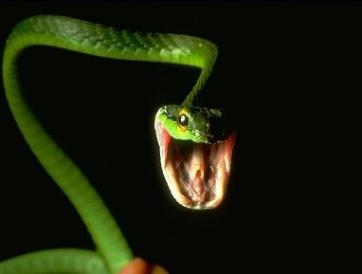
1. Snakes
2. Hurricanes
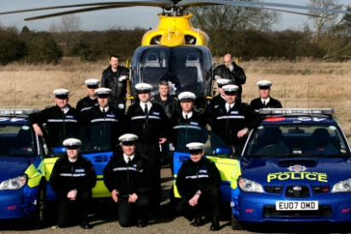
3. The Police
4. Charity
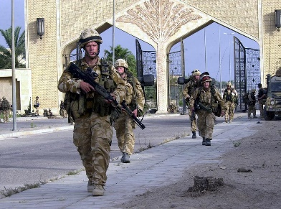
5. War

COULD ANY BE BOTH GOOD AND EVIL? GIVE REASONS BELOW.

THE PROBLEM OF EVIL AND SUFFERING

Unjumble the following statements.
1) supposed be God to is good completely.
2) that All God created is therefore also be to supposed completely good.
3) where So does come from evil?
4) Also, God if is all-knowing, all-powerful all-loving and…
5) surely …then wouldn’t He bad happen things let.
6) answer The only can be there that is no God.

MORAL EVIL AND NATURAL EVIL
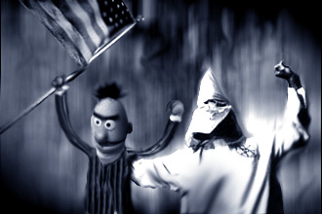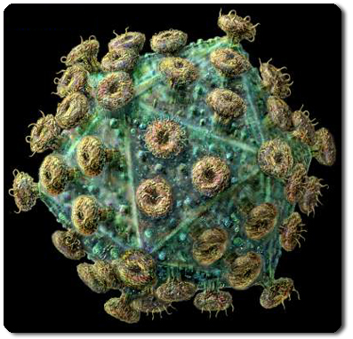
?
List as many examples as you can of each type of evil in the table below.
MORAL EVIL | NATURAL EVIL
Murder, racism, | Tsunamis, disease,

Evil exists
The Inconsistent Triad

God is omnipotent
God is omnibenevolent

CHALLENGE ONE – THE VAGUELY IMPOSSIBLE INFORMATION GRID

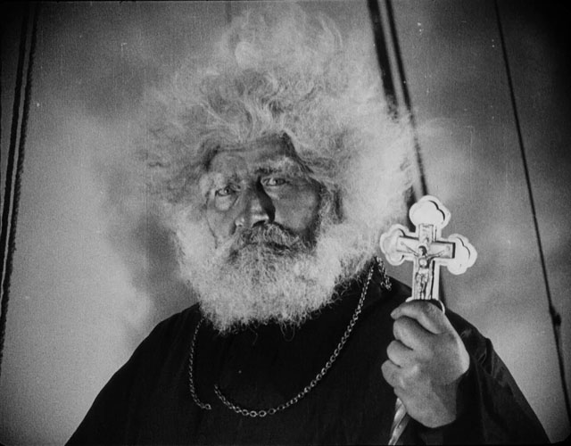
I guess this means I have to stop believing in God now….

No, wait! Christians have come up with answers…there are reasons why God can still exist alongside evil and suffering.
THE DEVIL
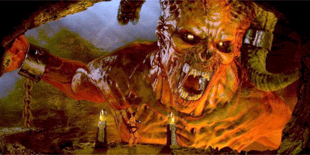
Some Christians believe that there is evil in the world because of the Devil, who is sometimes called Satan. They believe that he is the enemy of God and he rules over hell and tries to make people do bad things. Different Christians have various different ways of thinking of the devil. Read the descriptions below and draw a devil to match each one.
DEVIL ONE
Red in colour.
Horns.
Forked tail.
Legs like a goat.
(The devil is often depicted this way in paintings and in folklore).
DEVIL TWO
A snake.
(Some Christians believe this was the disguise that the devil used when he tempted evil in the Garden of Eden).

DEVIL THREE
A human.
(Some Christians believe that the devil is the evil living within all humans. This is also the way they think he appeared to Jesus when he was tempting him in the wilderness).
DEVIL FOUR
Nothing.
(Some Christians think the devil doesn’t really exist at all).

What are your views on the devil?

THE ORIGINAL SIN/STORY OF THE FALL
Some Christians believe that evil exists because of the Fall of Adam and Eve.

Evil entered the world when Adam and Eve disobeyed God. This does not answer all the questions though. Identify the problems that this leaves Christians with by ticking the correct ones in the table below. Ignore the ones that you think should not be there.
POSSIBLE PROBLEMS | TICK?
Why did God not make Adam and Eve so perfect that they would always choose the right thing to do?
If everything God made in the Garden was good, where did the evil snake come from?
Who ate all the pies?

How come God couldn’t predict what was going to happen?

Which came first, the chicken or the egg?

What was the point of having a “Tree Of Knowledge” in the Garden of Eden in the first place?
This accounts for moral evil, but how would it account for natural evil?

LIFE IS A TEST

Rewrite the following paragraph, filling in the missing words. Use the words from the box below to help you, but watch out for words that don’t belong.
Some Christians say that evil and ___________ are in the world as a kind of test. Humans were not created fully ____________ and need to ___________ and become more __________. For this reason ___________ has created a world that includes suffering and ___________ to help people to develop and strengthen as they ___________ to overcome their hardships. Suffering teaches important _________. We could never be __________ if there was nothing to be afraid of. It can also be seen as a test of ________ in god. If people still have faith in god no matter what ___________ things happen in the world, then they are worthy of god’s love and a place in ___________ after they die.

WORDS TO HELP:

heaven faith suffering mature brave bad

ferrets struggle lemonade learn developed god

evil lessons

WRITE OUT THE COMPLETED PARAGRAPH HERE:

FREE WILL
Some Christians say that there is evil in the word because God gave us free will. It means we are able to make our own choices about how we act or behave. Without this ability we would just be like robots doing exactly what god wants. God would not want us to be robots though, because robots cannot love god properly. They would be programmed to love him, which isn’t the same thing. They would not be choosing to love him.
For love to mean something, people have to choose to do it. But the down side of free will is that it means can choose to do bad things as well.

Theodicy Corner

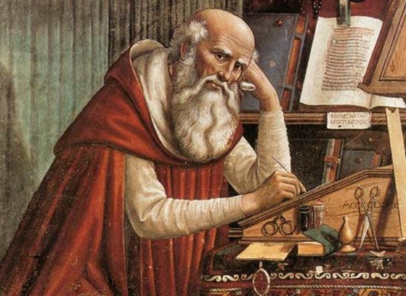
St Augustine
Perfect creation.
Evil.
Absence of goodness.
Free Will.
Bad choice.

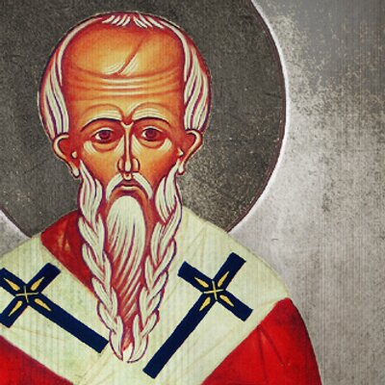
Evil is allowed to exist.
Created good and bad.
Choose.
Learn.
Free will.
Soul making.

St Ireneus

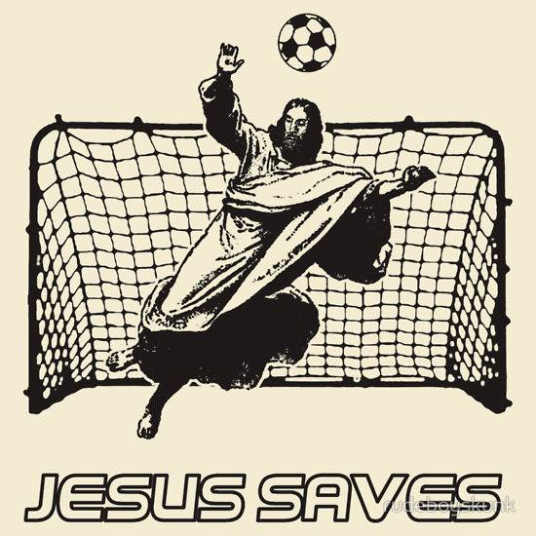
CHALLENGE – JESUS QUIZ
(STICK COMPLETED QUIZ SHEET HERE)

SCORE |  | RE-TEST SCORE
The Jesus Timeline
1 |  | 2
3 |  | 4
5 |  | 6
7 |  | 8
9 |  | 10
11 |  | 12
13 |  | 14

Healings
Miracles
Parables

Who Was Jesus?

Jesus 1 | Jesus 2 | Jesus 3

The Beatitudes

Other key jesus teachings

Spot The Crucifix
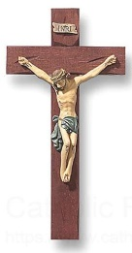

The Last Week Of Jesus’ Life

Picture | Text
- Apocalypse

- Resurrection

- Heaven

- Hell

- Purgatory

