NAME:
FORM:

This module looks at what different people believe about god and about how they go about worshipping god.
You will look at only one religion in this module, and that will be Christianity.

SOME IMPORTANT WORDS
WORD | MEANING | WORD | MEANING | WORD | MEANING
Atheist | Somebody who believes there is no god | Omnipotent | All-powerful (there is nothing god cannot do) | Numinous | An experience that is believed to be through direct contact with god – visions, etc.
Agnostic | Somebody who has not yet decided whether they believe in god or not | Omniscient | All-knowing (god knows absolutely everything there is to know) | Conversion | When a person’s life is changed by becoming devoted to god
Theist | Somebody who believes in god | Communion | The Christian act of worship remembering Jesus’ sacrifice. Also known as mass or the eucharist. | Miracle | An event that is believed to have a supernatural cause (god)
Monotheist | Somebody who believes there is only one god | Prostrate | Bowing down on the floor, as low as you can go! | Awe | Feelings of something which is much greater than you
Polytheist | Somebody who believes there are many gods | Denomination | A particular branch of the Christian church. Eg C of E, Baptist, Roman Catholic. | Pulpit | The special stand in a church where the vicar or priest preaches his/her sermon.
Altar | The table that represents the table at the last supper. It is the focal point of the church. | Mystical | An experience of something supernatural or religious | Sermon | The main preaching part of the church sermon – like a little speech from the vicar.

WHY DO PEOPLE BELIEVE IN A GOD?

There are loads of different reasons why people believe in a god. This module looks at some of the more popular reasons. They are listed below. Your job is to rank the reasons in order (put “1st” by the one you think is best, “2nd” by the next best and so on). Then, for each one, write a couple of reasons why you think it deserved this score.

REASON FOR BELIEVING | RANK | YOUR REASONS
RELIGIOUS UPBRINGING
Somebody might believe in god because they have been brought up in a religious family. This might involve saying prayers at meal times and bed times. They might have been Christened in church as a baby, and then Confirmed later on. They might have been taken to church regularly as a child, attended Sunday School and been a part of other church organisations like youth clubs, choir, Boys Brigade. They might have been sent to a Church School (Primary and Secondary). All this might make them convinced that there is a god.
THE PRESENCE OF RELIGION IN THE WORLD
Somebody might see all the good things that come out of religion in the world. This might include a sense of community among religious people, the large amount of charity work that Christians do (Christian Aid etc), the work in the community that Christians do (helping the elderly, feeding the homeless etc). They might have been influenced by famous religious people who have done great things (Martin Luther King). All these good things might convince somebody that there must be a god.
THE SEARCH FOR MEANING
Somebody might come to the conclusion that god must exist because of the great mysteries of life. They might think about the unanswerable questions such as how the universe came to be created and what is the meaning of life. Through their search for meaning and answers in life they might decide that the only real answer is that there must be a god.
RELIGIOUS EXPERIENCE
Somebody might come to believe in god because they feel that they have experienced god. It might be that they think they have witnessed a miracle, or that god has spoken to them in their dreams. They might have experienced a vision from god. Or they might have seen some beautiful aspect of the world and responded with feelings of awe. This might cause them to believe that god is the creator of the world.

To sum up…
People may believe in god because…
They have been brought up as members of a church community. | They see that there is religion in the world and that many good things come out of it.
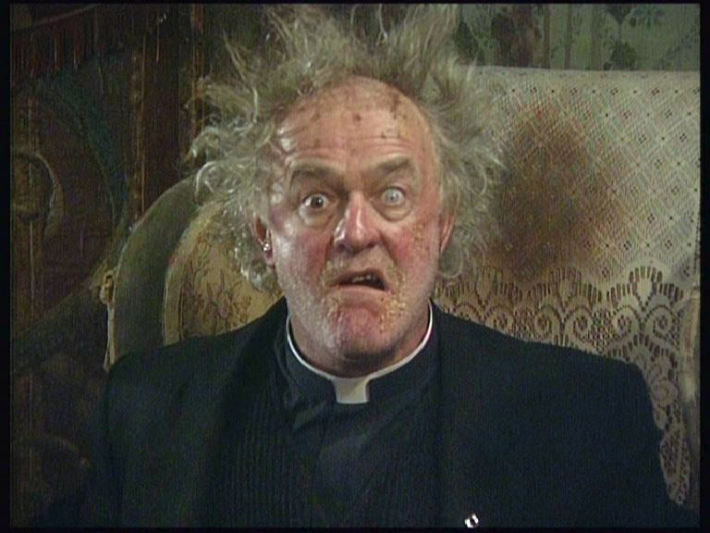 | 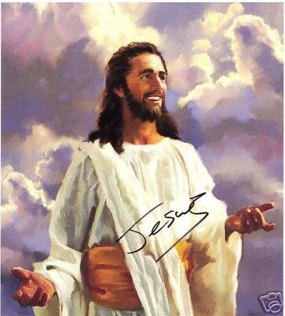Signed picture of Jesus on ebay – money to charity!
They think god is the only answer to life’s mysteries. | They are struck by the beauty of things in the world and believe only god could have created such beauty
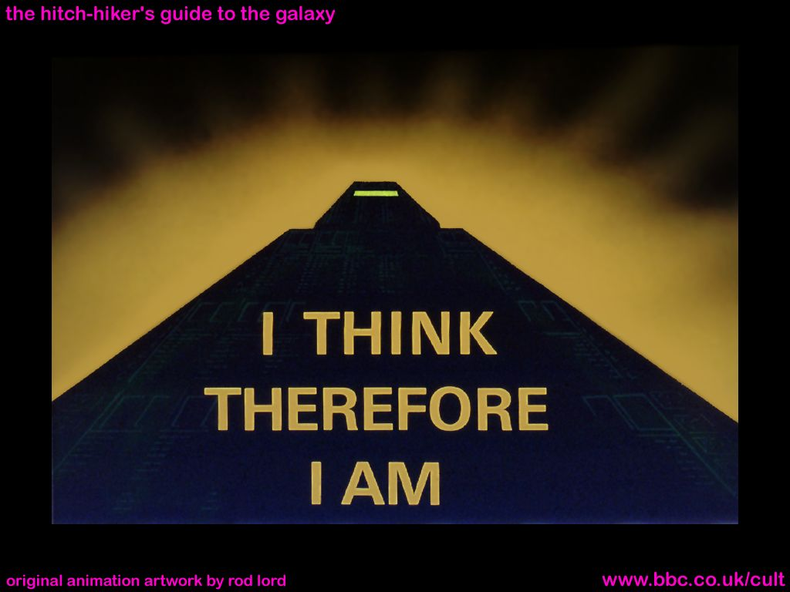 | 

CHRISTIAN WORSHIP

The Features Of A Christian Church. (Write in the names).
THE FEATURE | IT LOOKS LIKE… | ITS PURPOSE
 | A big table in the front of the church.  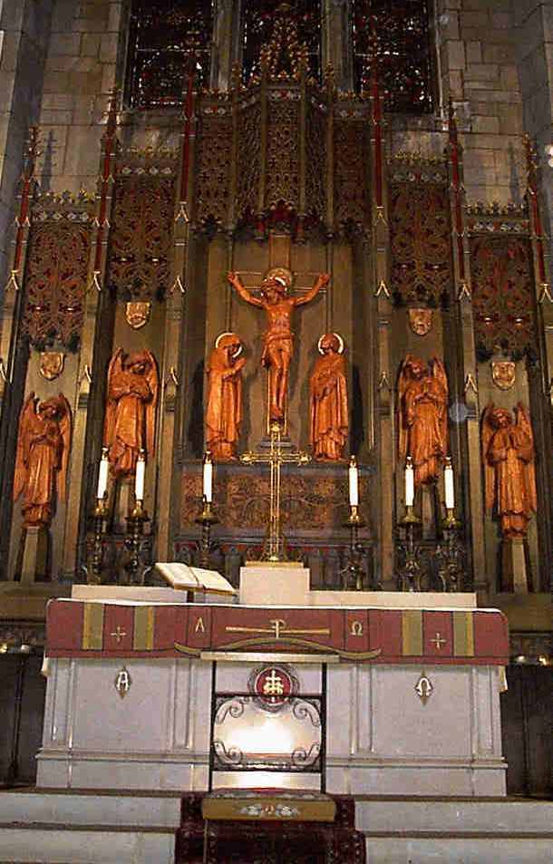 | To remind the worshippers of the last supper, where Jesus ate with his friends shortly before his sacrifice. This is where they come to get their bread and wine.
 | It is the symbol of Christianity  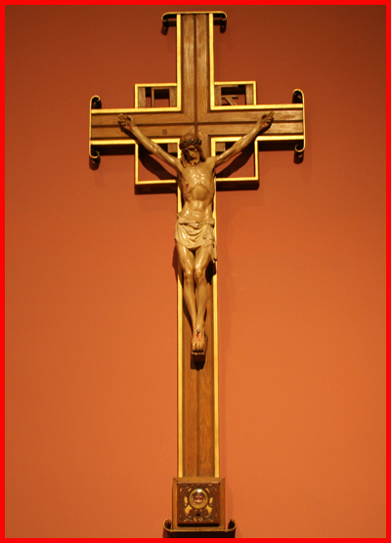 | To focus the minds of the worshippers on Jesus’ death and the way he beat death to come back three days later.
 | A book stand, often made in the shape of an eagle.  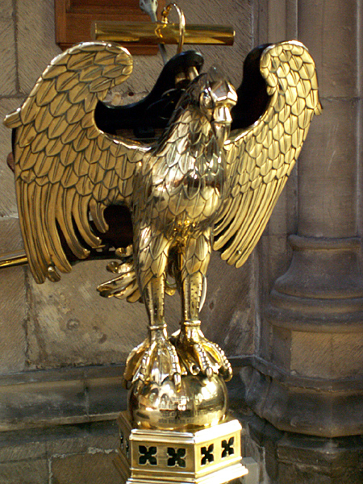 | A focal point for readings from the bible. The eagle represents St John, taking the words of the bible around the globe.
 | A raised platform.  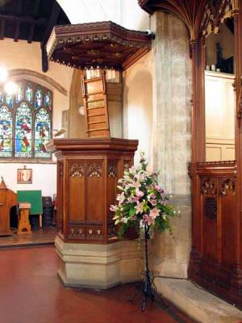 | It is where the priest/vicar stands to give the sermon which is the main teaching of the service.
 | A big bowl of water.  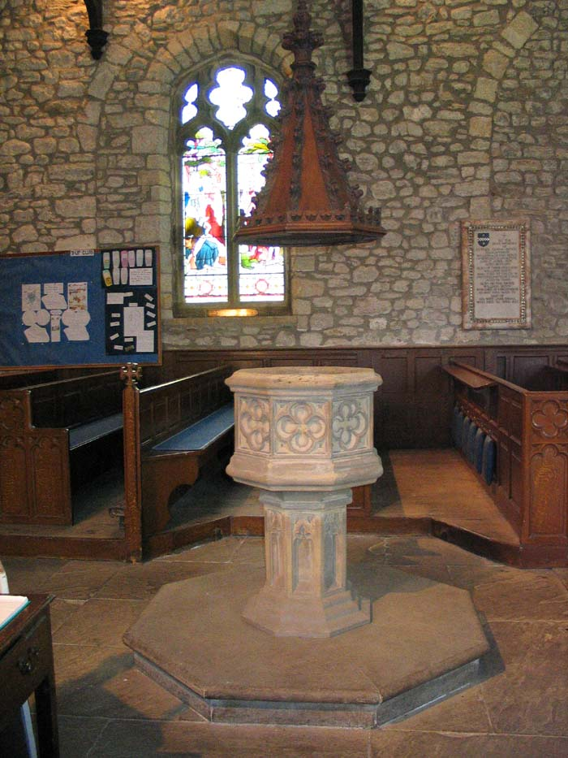 | This is where babies are baptised to welcome them into the church community. It is often near the door as a general welcoming sign.
 | Pretty.  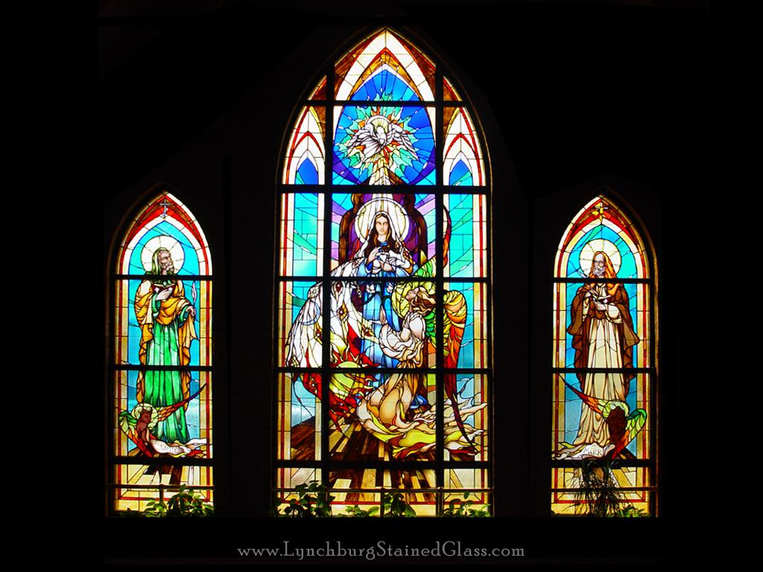 | They are coloured windows that show pictures from the lives of Jesus and the Saints. They inspire worshippers.
 | Long wooden benches or seats  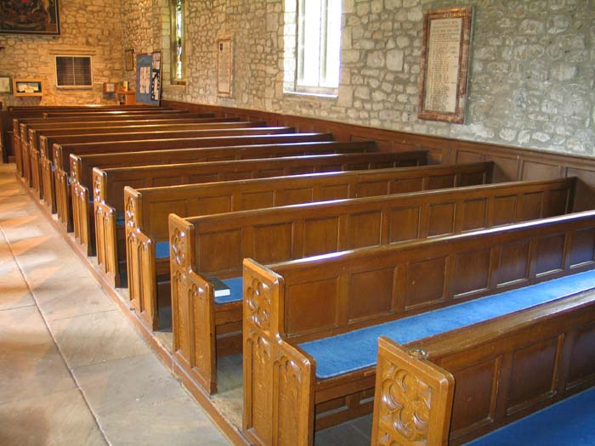 | This is where the worshippers (known as the congregation) sit. Often they are provided with kneelers – cushions to kneel on during prayers.
 | A bell, sometimes hidden in a tower.  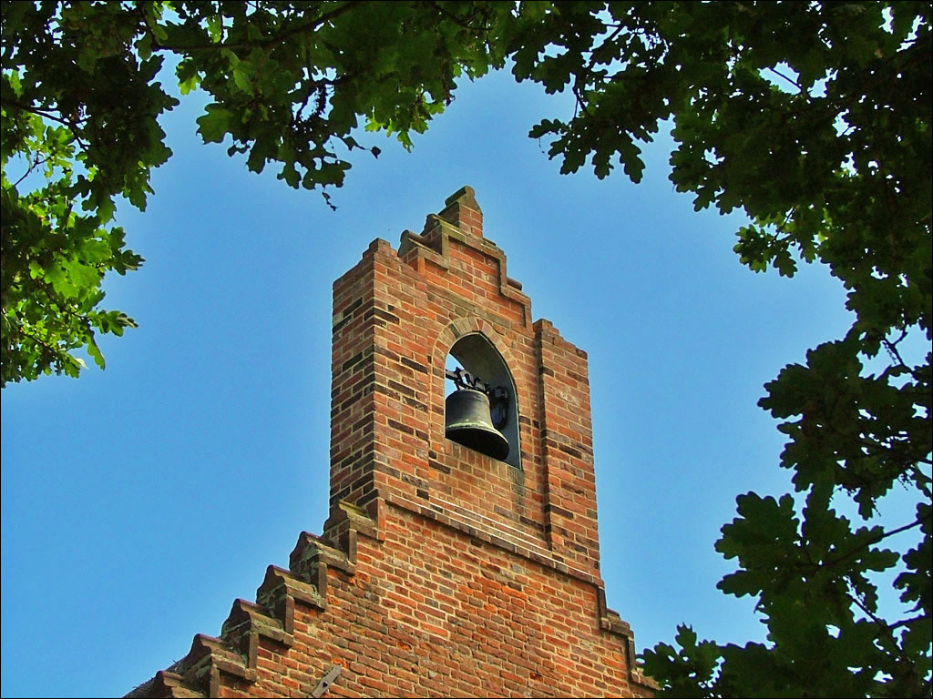 | This calls the worshippers to the church when it is time for a service. It is also used during the service itself.
The names of the features are…
Church Bell The Font The Altar The Cross The Lectern Stained Glass Windows The Pulpit The Pews

WORSHIP IN THE CHURCH.
Copy out the text below and fill in the blanks.

Christians usually go to _________ to worship. The main holy day is _________. Sunday remembers the day of rest after God had created the world. Christians believe that ________ rose from the dead on Sunday. The ___________ service (also called the Eucharist or the Lord’s Supper or _______) is an important part of worship. It remembers the Last Supper when Jesus broke bread and gave wine to his ___________. These represented his __________ and his __________.
The service usually starts with a ________. The vicar comes in during this hymn. There follows some prayers, readings and more hymns. There is often one reading from the Old Testament and one from the New ____________. This is followed by a ___________ - a sort of speech from the vicar that is linked to the readings. Everyone will have the opportunity to come up to the ______ and share in the bread and wine.

Some words to help:

altar Testament sermon hymn body disciples blood Sunday

church cardigan Jesus mass communion

PRAYER

Unjumble!

Prayer way is a speaking of God to.
Taught Jesus his disciples to special say a prayer.
Called it is Lord’s The Prayer.
Christians use prayers set and might also they personal their say own prayers.

WHY DO CHRISTIANS PRAY?

The following are the reason why Christians pray. They are in no particular order, but you must rank them in order of importance and explain why you put them in this particular order. But beware! Two of them are impostors and do note belong in the list. Remove them and throw them away forever, never to return.

TO THANK GOD FOR THINGS | 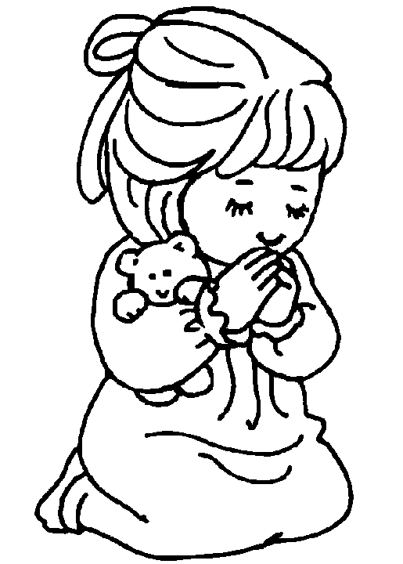
TO SAY SORRY FOR SINS.

TO PASS THE TIME WHEN THEY ARE BORED.

BECAUSE PRAYING TOGETHER GIVES THEM A SENSE OF COMMUNITY

TO FEEL CLOSER TO GOD, AND TO BUILD THEIR RELATIONSHIP WITH GOD.

BECAUSE PRAYING MAKES YOU SOUND INTELLIGENT.
TO PRAISE GOD.

Now complete the following table, ranking the reasons in the order of importance and explaining your choices.

1.

2.

3.

4.

5.

MATCH UP THE LINES FROM THE “LORD’S PRAYER” TO THEIR CORRECT MEANINGS.
PRAYER LINE |  | MEANING
1 | Our Father, who art in heaven, hallowed by thy name. |  | Christians understand that they can only have their faith tested so much – and they ask God to protect them from more than they can bear.
2 | Thy Kingdom come, thy will be done on earth as it is in heaven. | 1 | Praises God and gives thanks (“hallowed” means holy)
3 | Give us this day our daily bread, |  | Requests the forgiveness of sins (trespasses), agreeing that a Christian should be prepared to forgive others.
4 | And forgive us our trespasses, as we forgive those who trespass against us, |  | Ends with praise and thanks, and an acknowledgement that God’s power is everlasting.
5 | And lead us not into temptation, but deliver us from evil. |  | Asks for God’s will to be done in the world.
6 | For thine is the kingdom, the power and the glory forever and ever, Amen. |  | Asks for help, or for God to provide in particular circumstances/

Some Different Christian Denominations.

They are like crisps (“Crispians”) because they are all basically the same thing, its just that they have different flavours and do things slightly differently.


GREEK ORTHODOX
RUSSIAN ORTHODOX
ROMAN CATHOLIC
PROTESTANT CHURCHES
- Church of England (Anglican)
- Baptist
- Methodist
ROMAN CATHOLIC
- Quaker
Papal
Choice

PRIVATE WORSHIP

TRUE OR FALSE?
 | TRUE | FALSE
Many Christians set aside a special time of the day for private worship.
During this time they dress up as farmyard animals and make silly noises.
They usually like this time to be a quiet, contemplative time.
So they turn up the volume on all household appliances to warn people to keep quiet.
They might read a passage from the Bible, and they might use a prayer book too which explains what the passages from the Bible mean.
They also take a Jumbo Colouring Book with them.
They will pray silently, about anything happening in their lives or the lives of people they know.
They use a megaphone to make sure that God hears them.

Christians often feel that private worship gives them chance to build their personal relationship with God.
MUSIC AND ART IN CHRISTIAN WORSHIP
Some churches use a lot of art. The most common form is stained-glass windows, to tell stories from the Bible (when they were first made lots of people couldn’t read). You might also find paintings in churches, statues, carvings etc.
But some Christians (such as Orthodox and Roman Catholic denominations) feel that this might encourage people to worship the statues and not God. This is called idolatry.
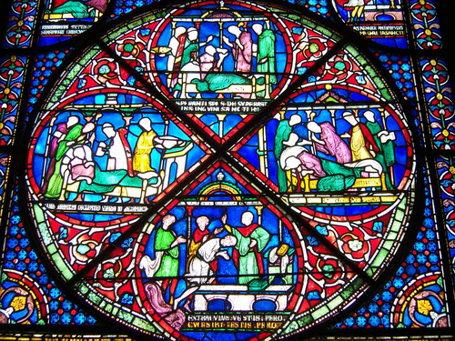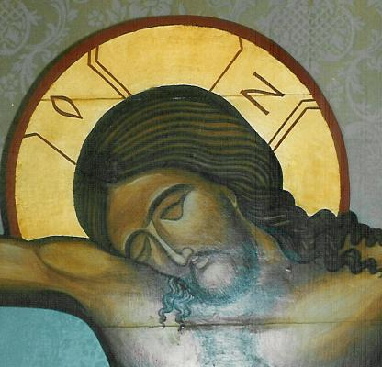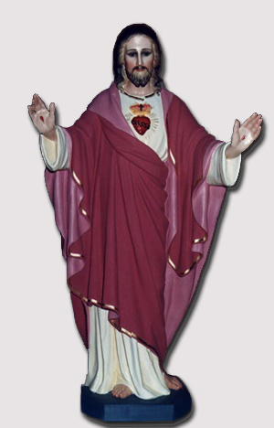

Music is also used in church services.
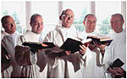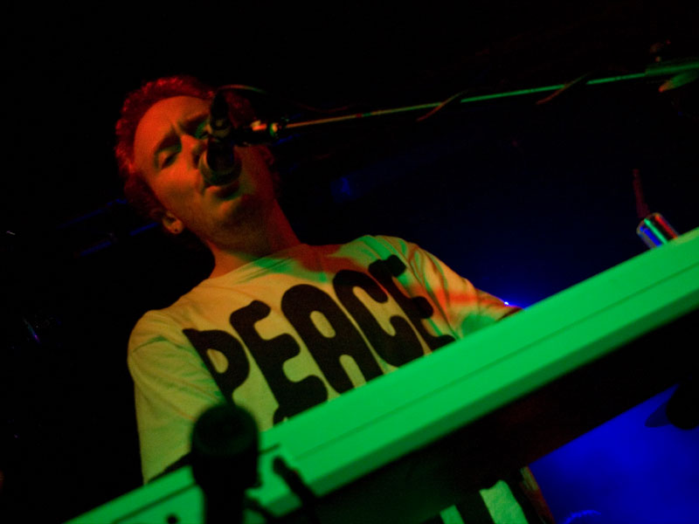
CHRISTIAN RELIGIOUS SYMBOLS WORDSEARCH

I | P | C | H | I | - | R | H | O | I
O | C | F | Y | O | A | H | P | L | A
W | S | T | S | F | S | X | L | O | G
C | T | R | H | E | N | E | V | W | E
O | R | I | E | U | L | N | E | A | M
S | E | N | P | A | S | E | G | T | O
S | O | I | H | D | O | V | E | E | W
O | M | T | E | N | H | T | A | R | S
R | E | Y | R | P | N | E | G | R | I
C | H | K | D | O | U | R | I | A | L

- _ _ _ - _ _ _ : a symbol made from two Greek letters, showing the first and last
two letters of the word “Christ”.
- _ _ _ _ _: the wooden frame that Jesus was killed on.
- _ _ _ _ _ _ _ _: Jesus is seen as this – looking after his sheep.
- _ _ _ _: a bird that symbolises peace, love and hope.
- _ _ _ _ _: the first letter of the Greek alphabet, used together with…
- _ _ _ _ _ : the last letter of the Greek alphabet, to show that God is the
beginning and the end of all things.
7) _ _ _ _ _ _ _: A coded message used by early Christians during times of
persecution. The word means “fish” in Greek, but each letter
stands for the initial letter of “Jesus Christ, Song Of God,
Saviour.”
8) _ _ _ _ _: a substance used to symbolise the cleansing of sins.
9) _ _ _ _ _ _ _ : God is three things at once – Father, Son and Holy Spirit.

