NAME:
FORM:

This module looks at some of the possible points of conflict between religion and science. In particular it looks at two different views of the creation of the world and the role of humans. It also looks at our responsibilities to the environment.

SOME IMPORTANT WORDS
WORD | MEANING | WORD | MEANING | WORD | MEANING
Atheist | Somebody who believes there is no god | Omnipotent | All-powerful (there is nothing god cannot do) | Numinous | An experience that is believed to be through direct contact with god – visions, etc.
Agnostic | Somebody who has not yet decided whether they believe in god or not | Omniscient | All-knowing (god knows absolutely everything there is to know) | Omnipotent | All-powerful (there is nothing that god cannot do).
Theist | Somebody who believes in god | Omni-benevolent | All-loving | Miracle | An impossible event that is caused by the power of god.
Monotheist | Somebody who believes there is only one god | Transcendent | God exists outside the created world | Evolution | The process by which a species changes and develops over successive generations.
Polytheist | Somebody who believes there are many gods | Immanent | God is ever-present everywhere in the universe | Natural Selection | Where only the strongest/best equipped members of a species survive and produce offspring.
Big Bang | The scientific theory of the creation of the universe. | Creationist | Somebody who believes that the world was created by god in seven days (as in the bible). | Stewardship | The belief that humans have a duty to look after the planet and everything on it.

THE BIBLICAL STORY OF CREATION
The different days of the seven day creation story have been jumbled up. Write in the correct day number for each one.
DAY | GOD CREATED… | FURTHER POINTS
 | The sky. | It was good.
 | Nothing. He had a rest on this day. | This is why Jews and Christians believe it is important to have a Sabbath day – a day of rest.
 | Birds and fish. | They were good.
 | Light and dark. | It was good.
 | Animals and finally people. | Humans were created last of all to show how special they were. They were created in god’s image (which is also pretty special) and given mastery over all the animals, plants and fish.
 | Sun, moon and stars. | They were good.
 | Earth, oceans and plants. | They were good.
TRUE OR FALSE
People used to believe… | TRUE | FALSE
That the earth was the centre of the universe.
That the sky was solid.
That the earth was flat.
That the sun, moon and stars were only there to light up the earth.
That the earth was just there for humans to live on.
That humans were the most important thing in the universe and everything else was put there just for our benefit.
FILL IN THE BLANKS
In the bible, according to the book of __________, it says that the universe was made by __________ and that God made it all out of _____________. There are two stories in Genesis. They both show that __________ went according to God’s _________ and that God was completely in _____________.

Words to help out (but watch out – one of them is an imposter).

nothing control God plan trumpet Genesis creation

RE-WRITE THE COMPLETE PARAGRAPH HERE:

HUMANS

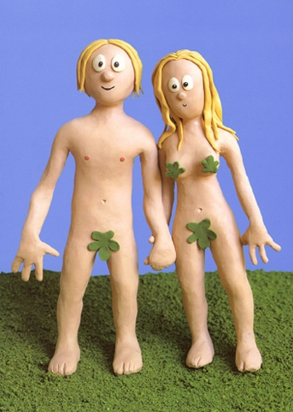
made God men women and as a creation special In bible the.
them gave He place pride of.
made were They God image of in the.
were They given of live to in The Of Eden Garden.
perfect was Everything!

SO WHAT WENT WRONG?

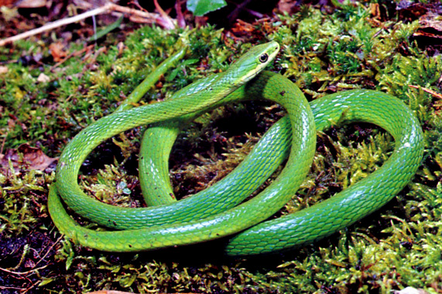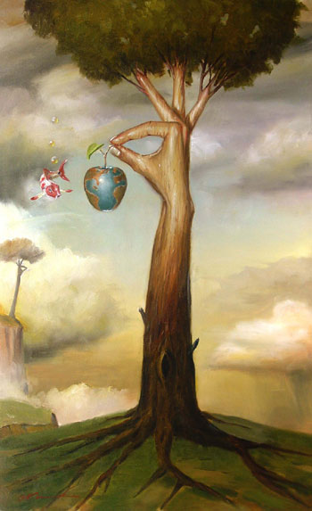

According to the bible, God’s perfect and good created world was tainted with evil and suffering when a serpent tempted Eve to eat the fruit from the Tree Of Knowledge in the Garden Of Eden. This explain why the world we now know is not as perfect and good as God says it is during the story of the creation.

SCIENTIFIC THEORIES ABOUT THE ORIGINS OF THE WORLD.

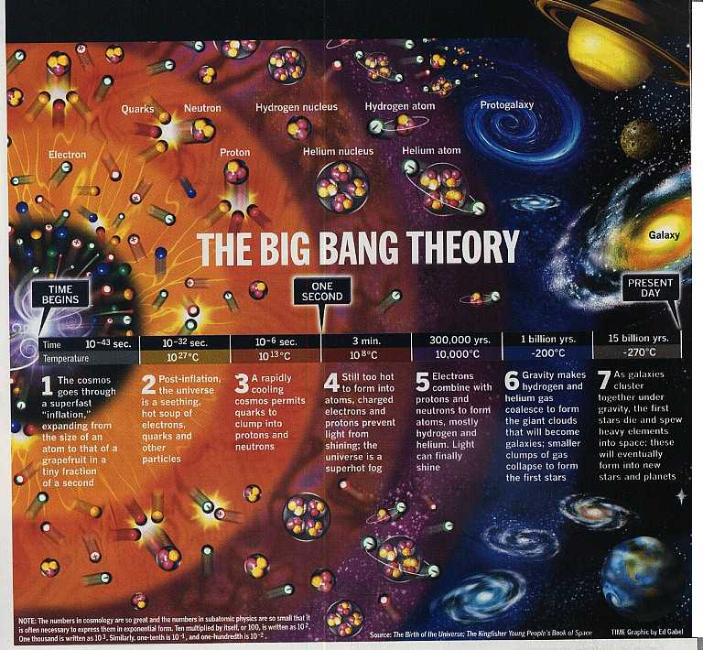

Most scientists now agree that the universe as we know it was formed during an event known as “The Big Bang.” There is evidence to support this theory – scientists are still able to identify background radiation left over from the Big Bang.

THE BIG BANG (A SIMPLE VERSION)
Draw your own pictures into the third column to illustrate the Big Bang.
1 | Over 18 billion years ago, the universe is tiny – everything in it is compressed into the size of an atom.
2 | Suddenly, for some unknown reason, this atom-sized universe expands like a balloon at an extremely fast rate. In a fraction of a second it becomes the size of a grapefruit.
3 | Within the expanding universe is a seething mad-hot soup of crazy particles and electrons and quarks and stuff.
4 | It starts to cool down and all particles begin to clump together and hold on to each other (they might be scared because it is still too hot to allow light to shine through).
5 | It gets even cooler. Atoms form and light begins to shine through the soup. Gravity makes gases and stuff stick together to form whole galaxies and stars etc.
6 | Billions of years later planets like ours begin to form. The universe is still expanding now. Many scientists believe that one day the process will reverse and the universe will contract again – The Big Crunch.

SCIENTIFIC THEORIES ABOUT THE ORIGINS OF HUMANITY

FILL IN THE BLANKS!
The theory of _____________ is widely accepted by scientists as how ___________ came into existence. It was made famous in the nineteenth ___________ by the work of Charles ___________. He said that all life evolves by ___________ ____________. For example, on an island where the main food supply is hard ____________, only the finches with the best nut-cracking ________ survive to breed more ________-beaked __________. The animals or plants that are best ___________ to their ____________ survive. Those that are not ________ out.
According to this theory, human, ____________ and plant life had __________ itself! However, Darwin never attempted to explain where the original ___________ blocks of life on __________ came from, just how they adapted and changed once they were here.
Words to help (but watch out for the one that shouldn’t be there!):

designed evolution humanity century beaks building

animal Earth Darwin natural selection strong suited

pies nuts finches environment die

RE-WRITE THE COMPLETED PARAGRAPH HERE:

WHAT REALLY UPSETS CREATIONISTS ABOUT THE BIG BANG AND EVOLUTION?

Write down the order you think these following statements should come in, with 1 being the most offensive to Christian Creationists (those who believe the biblical story of creation is right), 2 being slightly less offensive, 3 being even slightlier less offensive…etc. Then, in your own words, explain why you have put them in this order.
STATEMENT | RANK  (IN ORDER OF OFFENSIVENESS TO CHRISTIAN CREATIONISTS) | YOUR REASON FOR RANKING.
The Big Bang is full of chaos and nothing is in control. Everything is random.
It took such a long period of time – hundreds of millions of years.

The universe is uncaring and full of things that can destroy us. There are no rights and wrongs.

Human beings are just another form of animal.

Humans have evolved and developed into our current form so that we are best suited to our environment. We look like this because of the world in which we live.

CAN YOU BE A CHRISTIAN AND A SCIENTIST AT THE SAME TIME?

Yes!
Many Christians accept the scientific versions of creation and evolution. Many scientists are Christians. It would be wrong to think that no Christians accept Big Bang theory as most of them probably do. Those who don’t are called Creationists.

- Many Christians see the Genesis creation story as myth. They do not look for scientific truth in the bible. They see it as a kind of poem or hymn to be used in worship. It tells them something about God, not about how the universe was created.
- Many Christians accept that when the bible was written, people did not have the scientific knowledge we have now, so it was never going to be an accurate explanation of how the world was made.
- Many Christians believe God is “Transcendent” – he exists outside the universe. He was the one who started the Big Bang, and he designed the universe to develop without his input. Humans might have evolved, but that was part of the process that God “programmed” into the universe.

STEWARDSHIP
UNJUMBLE!
Christians that believe people put are on Earth act to as Stewards.
because is This they believe God that them gave responsibility to care take of all the animals and plants.
Christianity teaches also greedy should people not be that.
Which Teaching? (Tick the correct box).
 | DON’T BE GREEDY! | EVERYTHING BELONGS TO GOD. | HUMANS HAVE EXTRA RESPONSIBILITY.
“Then God said ‘Let us make man in our image, according to our likeness and let him have dominion over the birds of the air, the cattle, the wild animals…’”
“The earth is the Lord’s and all that is in it. The world, and those who live in it.”
“He said to his disciples, ‘Therefore I tell you, do not worry about your life, what you will eat, or about your body, what you will wear. For life is more than food and the body more than clothing.’”
EXAMINATION QUESTIONS AND ANSWERS

HOW COULD YOU IMPROVE THE ANSWERS?

(d) Describe Christian teachings about people and their responsibility for the planet. [6]

(d) Christians believe that the created world is God’s creation. They also believe that when god created the world he had a plan and everything that was created was part of this plan. This can be seen in the structured and controlled way in which God creates everything in the Genesis creation story. Humans were God’s final and most important creation and, like everything else, humans have their part to play in God’s plan. God makes this very clear. He says “let us make humankind in our image, according to our likeness; and let them have dominion over the fish of the sea, and the over the cattle, and over all the wild animals of the earth, and every other creeping thing that creeps upon the earth.” This means humans are the next thing to God and so are in charge of everything on earth. This is a great responsibility. But humans also have to remember that the world still belongs to god. “The earth is the Lord’s, and all that is in it” (Psalm 24). So Christians would say that there job is to be stewards – to look after the world and its species for God – and they are able to do this because god made them in his own image and gave them power over the other species.

(d) Explain why some Christians might believe that humans are the most important part
of creation. [6]

(d) Many Christian would say that humans are the most important part of creation simply because they are the most advanced beings on the planet and are at the top of the food chain. They would probably think that this has happened because God made them in his own image so they are better than the other species. In the bible god also gives humans the job of naming the different species – this suggests to Christians that they have a sort of mastery and control over the other animals, making humans more important. If humans are made in god’s image then that would surely automatically make them more god-like and therefore more important than anything else on earth. Also, Christians believe that humans have souls. Most Christians believe that this is what really sets them apart from other animals and plants etc. Animals will not be granted another life in heaven if they do not have souls, and so their lives are not sacred and not covered by the “sanctity of life” teachings.
However, it is worth remembering that not all Christians have the same beliefs. Many Christians would argue that “stewardship” is a duty that humans have to do but this does not really mean that humans are any better than any other animal. And scientists are discovering more and more that eco-systems are all connected. If the bees all die out then humans could die out too because of this. This suggests to some Christians that all creatures on the earth are of equal value.
(e) ‘It is the responsibility of every Christian to care for the planet.’
Do you agree? Give reasons to support your answer and show that you have
thought about different points of view. [12]

(e) I agree that all Christians have a responsibility to care for the planet. They should believe this too because it says so quite clearly in Genesis. They would say that the planet is god’s and he wants it back one day in good condition. I think that this extends beyond Christians too though. It doesn’t matter whether you are religious or not, all humans have a duty to look after the environment and should do so out of a wish to help future generations if nothing else. Global warming and climate change is already a reality. If our children are to have good lives in the future then we should all act – recycling, reducing waste, re-using, walking or cycling rather than driving etc. These are things everyone should be doing.
Some Christians might disagree though. They would say that god put them in charge so they can do what they want. And that god said “Go forth and multiply” which means we must continue to have children despite the effect of the growing population on the planet. It just goes to show that you can take religious teachings either way if you want to. Personally I believe that we have to do what we can to help ourselves – “god helps those who help themselves” – and the way to do this is to prevent any more climate change. It is the responsible thing to do and if there is a god then it is what he would want us to do.

PART “e” QUOTATIONS: HOW WOULD YOU RESPOND?

REMEMBER: Simply “I think… X thinks…Y thinks…” answers are not good enough. Your answers must contain reasons and arguments.
Don’t forget to mention the religion and throw in technical terms etc.

- ‘It is the responsibility of every Christian to care for the planet.
- ‘Humans were created for a reason.’
- ‘Human beings are not capable of caring for the environment.’
- ‘Science is right so religion is wrong.’

