THE BIRTH OF JESUS

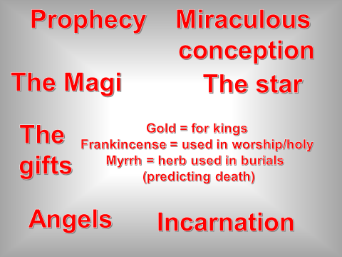

TRADITION | C OF E | R.C. | ORTHADOX | OTHER | NON-RELIGIOUS
MIDNIGHT MASS
CAROLS
FASTING
LIGHTING CANDLES
LIGHTING PALM LEAVES
SHARING GIFTS
THE YULE LOG
CELEBRATING CHRISTMAS ON 25TH DECEMBER
CELEBRATING CHRISTMAS ON 7TH JANUARY
MINCE PIES
CHRISTMAS TREES
WASSAILING

CHRISTIANITY CHRISTMAS CARD

AN IDIOT’S GUIDE TO LENT

HOLY WEEK

PALM SUNDAY | MAUNDY THURSDAY | GOOD FRIDAY | HOLY SATURDAY AND EASTER SUNDAY

CHRISTIANITY AND LOVE/MARRIAGE

UNSCRAMBLE THE FOLLOWING PARAGRAPHS:

To you are married Churches sex teach should only happen with All Christian the person you.

Have married get to not do Christians. Christians believe that God decide what people them to want do their life with.

Marriage All Christians that believe life for be should, some but divorce allow do Churches.

THE PURPOSE OF MARRIAGE
The following are the acknowledged purposes of marriage in the Christian religion.
They are in no particular order, but you must rank them in order of importance and explain why you put them in this particular order. But beware! Two of them are impostors and do note belong in the list. Remove them and throw them away forever, never to return.
HAVE CHILDREN

SHARE LOVE AND COMPANIONSHIP
KEEP GERBILS

ENJOY SEX IN GOD’S WAY

FORM A CHRISTIAN FAMILY

TEND TO THE SEVEN PRECEPTS OF MAHOGANY
SHOW THEIR LOVE FOR EACH OTHER AND GAIN GOD’S HELP IN THEIR MARRIAGE

Now complete the following table, ranking the reasons in the order of importance and explaining your choices.

1.

2.

3.

4.

5.

THE MAIN FEATURES OF A CHRISTIAN WEDDING SERVICE
True or false?
The main features of a Christian wedding service are…
 | TRUE | FALSE
Talk and Bible readings explaining the purpose of Christian marriage

Nudity.

Bride and groom exchanging vows that they will stay together for life and not have sex with anyone else.
The priest dancing on the altar.

Rings exchanged to show that marriage is like a ring, with no end.

Prayers asking for God’s help with the marriage.

WHAT ELSE HAPPENS?
What is the point of a Christian Funeral Service?
It reminds __________ of the hope of an _____________ with God. It thanks God for the dead person’s _________ on __________. It is an acknowledgement that the person is no longer part of this __________ but is ___________ in _________ care.
They can draw _____________ from other ____________.
They may feel ____________ as the dead person’s life is ____________.
It is an opportunity to express their _____________ in public.
It marks the beginning of a new life without the person who has died.

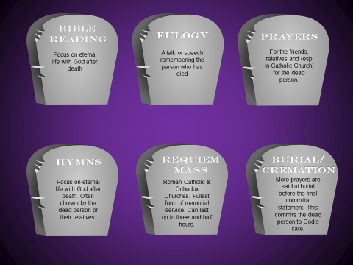

CHRISTIANITY AND THE FAMILY
In a ____________ family, parents should provide their children with ________, clothes etc. Parents should give __________ to their children and to each other. Parents should teach their children about ___________ and how to have a Christian life. Parents should set their children a good ________ of the Christian life. Parents should encourage their children to go to _________ or Sunday __________ and be ___________. Young children should ________ and respect their parents. Children should look after their parents if they can no longer look after themselves.

Some words to help:
Christian Christianity confirmed love school food example hedgehog
Church obey

Christians believe that family life is important because
- it was created by god to keep society together
- it is the only way god wants children to be brought up
- it is the place where children learn about Christianity.

EXPLAIN THE DIFFERENT WAYS CHURCHES HELP FAMILY LIFE
Baptism

Sunday Schools/Confirmation Classes
Family Services

Youth Clubs

Priests acting as counsellors

The running of Church Schools

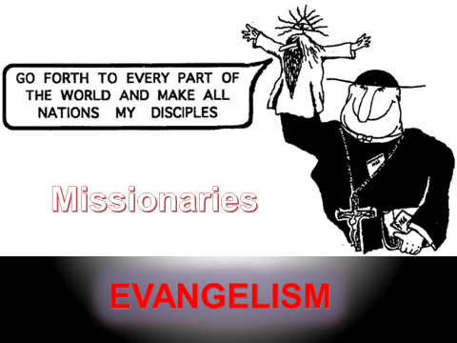
THE GREAT COMMISSION

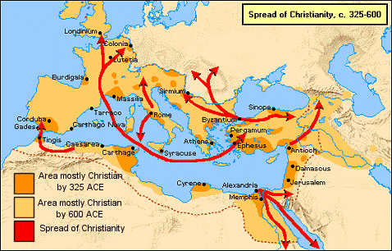

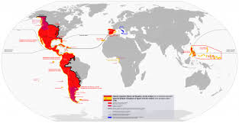

What do these maps show?

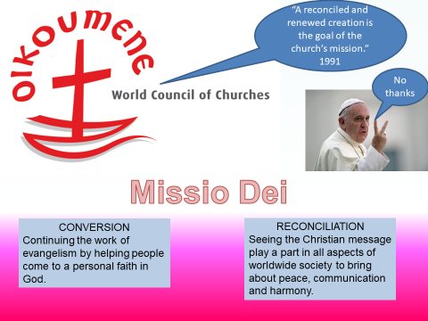
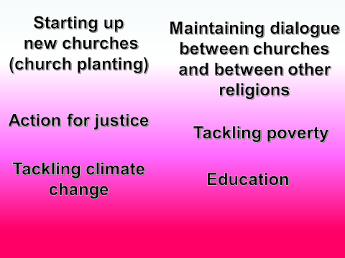
WHAT IS THE CHURCH’S MISSION?

 | Who? | Mission
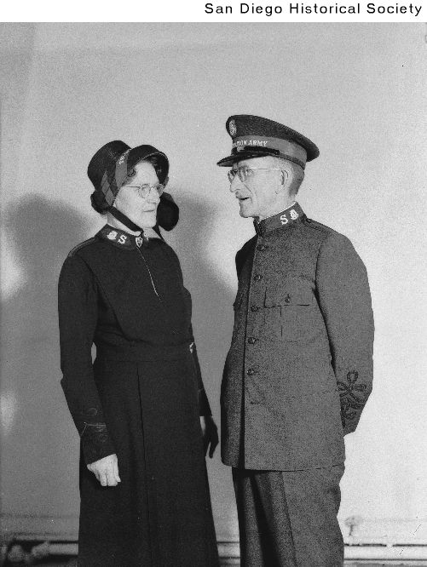
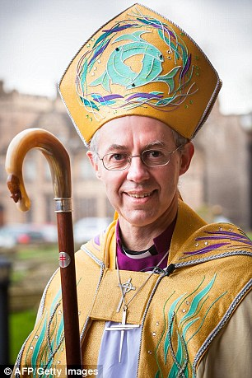

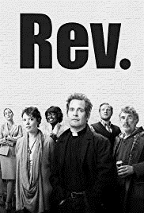

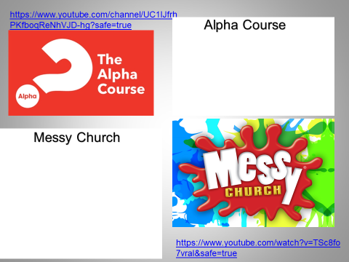
“That would be an ecumenical matter.”

Corrymeela
Iona
Taize

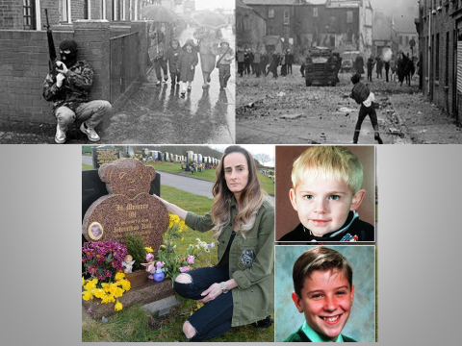

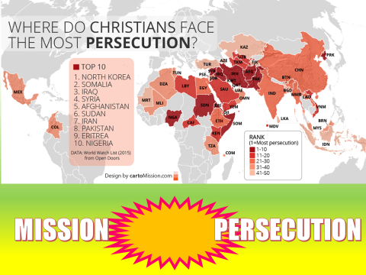

Does Christian “mission” make Christianity more of a target for persecution?

WHO? | WHAT?
OPEN DOORS
THE BARNABAS FUND
CAFOD
CHRISTIAN AID
TEARFUND
OPERATION CHRISTMAS CHILD

