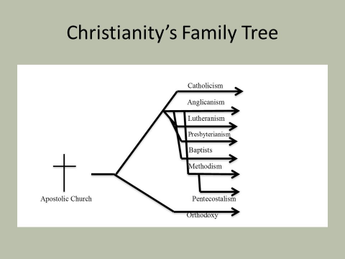
What Is Worship All About?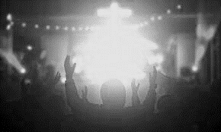

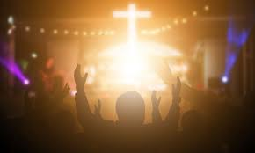

In ______________ there are different ways of worshipping ________. Worship is an area where there is great _____________,
even within individual _____________ groups or _____________.
The most obvious form of worship for Christians in _____________ is ___________ worship as a group in a _____________ dedicated for that ______________.
Each type of ______________ helps Christians in a different way. They may feel a benefit to worshipping in __________ groups sometimes and other times feel that worshipping ___________ allows them to __________ much better.

COMMUNAL WORSHIP

LITURGICAL WORSHIP

COLOUR |  | USE
 |  | Used for special celebrations, like Easter and Christmas.
 |  | (The colour of blood) used on days when Christians remember the suffering and death (the Passion) of Jesus.
 |  | Used during Ordinary Time. Represents hope.
 |  | Used in Advent to help remind Christians that it is a time of preparation for the coming of Christ. Also used during Lent.

Eucharist

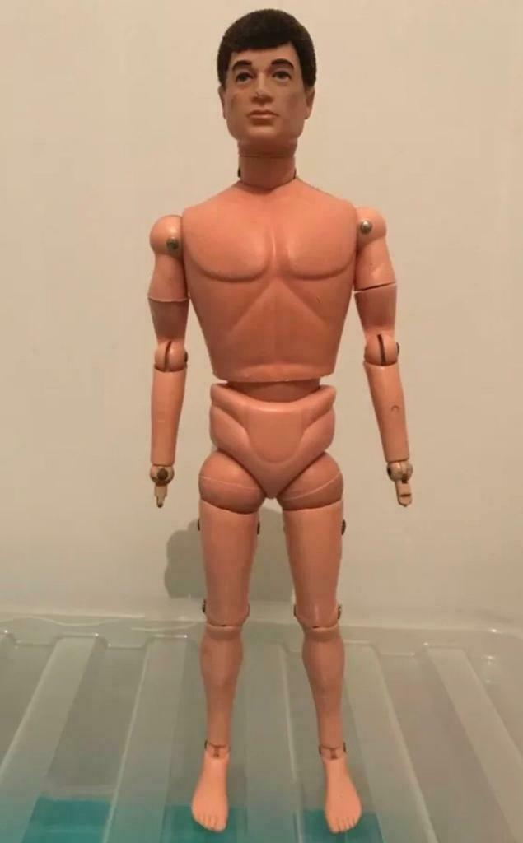 | 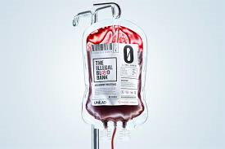

The Service Of The Word
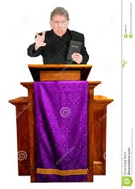

WHAT WOULD YOU EXPECT TO FIND INSIDE A CHURCH?
The Features Of A Christian Church. (Write in the names).
THE FEATURE | IT LOOKS LIKE… | ITS PURPOSE
 | A big table in the front of the church.  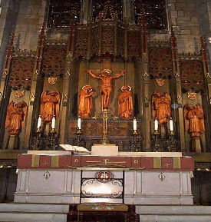 | To remind the worshippers of the last supper, where Jesus ate with his friends shortly before his sacrifice. This is where they come to get their bread and wine.
 | It is the symbol of Christianity  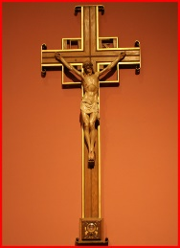 | To focus the minds of the worshippers on Jesus’ death and the way he beat death to come back three days later.
 | A book stand, often made in the shape of an eagle.  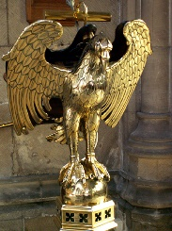 | A focal point for readings from the bible. The eagle represents St John, taking the words of the bible around the globe.
 | A raised platform.  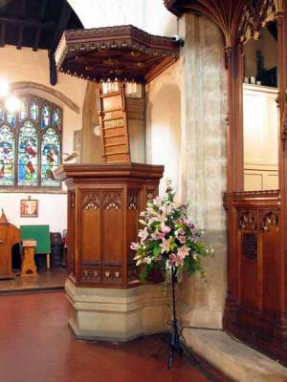 | It is where the priest/vicar stands to give the sermon which is the main teaching of the service.
 | A big bowl of water.  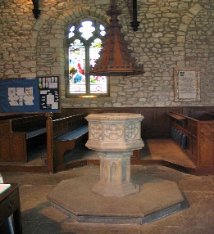 | This is where babies are baptised to welcome them into the church community. It is often near the door as a general welcoming sign.
 | Pretty.  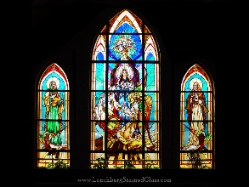 | They are coloured windows that show pictures from the lives of Jesus and the Saints. They inspire worshippers.
 | Long wooden benches or seats  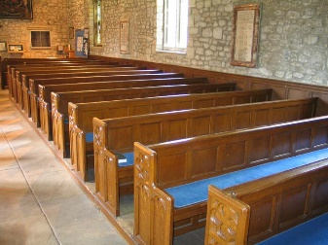 | This is where the worshippers (known as the congregation) sit. Often they are provided with kneelers – cushions to kneel on during prayers.
 | A bell, sometimes hidden in a tower.  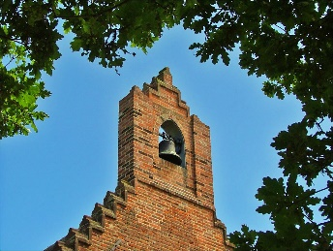 | This calls the worshippers to the church when it is time for a service. It is also used during the service itself.
The names of the features are…
Church Bell The Font The Altar The Cross The Lectern Stained Glass Windows The Pulpit The Pews
WORSHIP IN THE CHURCH.
Copy out the text below and fill in the blanks.

Christians usually go to _________ to worship. The main holy day is _________. Sunday remembers the day of rest after God had created the world. Christians believe that ________ rose from the dead on Sunday. The ___________ service (also called the Eucharist or the Lord’s Supper or _______) is an important part of worship. It remembers the Last Supper when Jesus broke bread and gave wine to his ___________. These represented his __________ and his __________.
The service usually starts with a ________. The vicar comes in during this hymn. There follows some prayers, readings and more hymns. There is often one reading from the Old Testament and one from the New ____________. This is followed by a ___________ - a sort of speech from the vicar that is linked to the readings. Everyone will have the opportunity to come up to the ______ and share in the bread and wine.

Some words to help:

altar Testament sermon hymn body disciples blood Sunday

church cardigan Jesus mass communion

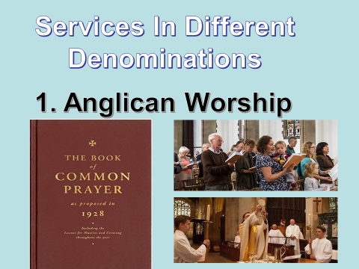
Part Of The Service | What happens
The Gathering
The Liturgy Of The Word.
The Liturgy Of The Sacrament.
Sending Out Of God’s People.

2 | Roman Catholic
3 | Quaker
4 | Greek Orthodox
5 | Methodist

NON -LITURGICAL WORSHIP

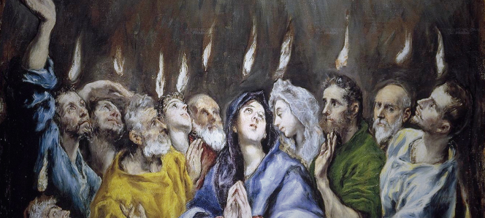
Pentecost

Why Do Some Christians Like To Worship Individually?

THE SACRAMENTS

ROMAN CATHOLIC CHURCH – 7 SACRAMENTS
1 | MISTPAB
2 | ARCHIE STU
3 | FANTOM IRONIC
4 | CITROEN NICOLAI
5 | ARA GRIME
6 | DROOLER SHY
7 | CHOKING INFESTATION

Which sacraments do the Protestant Churches have?

Baptism

Water?
INFANT BAPTISM | BELIEVER’S BAPTISM
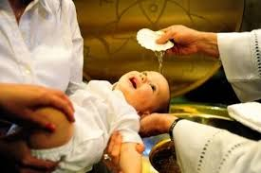 | 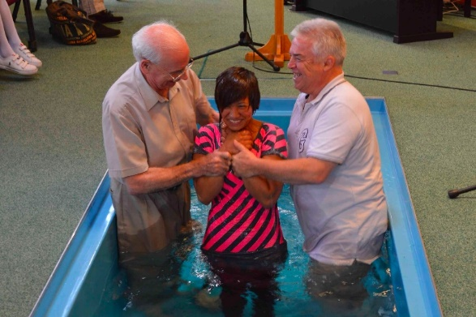

Baptism _______ the way for a person to become a full ________ of the Christian __________. In most ___________ a person needs to be baptised before they can share in the __________ or communion.
For most Christians baptism is _______ of removal of sin and a real __________ by washing away of sin. In the __________ Catholic Church baptism is believed to wash away _______ Sin and is seen as necessary for __________.

-----------------------------------------------------------------------------------------------------------------------------------------------------
Prayer

TO THANK GOD FOR THINGS | 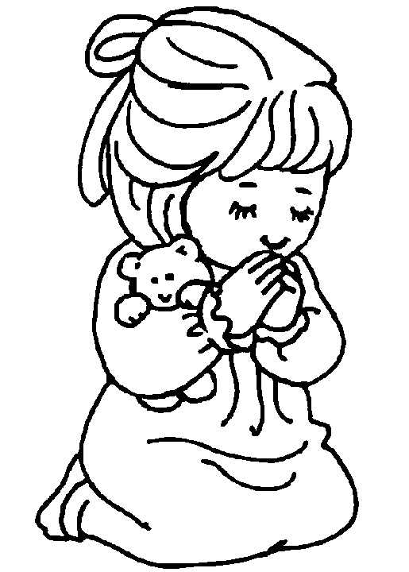
TO SAY SORRY FOR SINS.

TO PASS THE TIME WHEN THEY ARE BORED.

BECAUSE PRAYING TOGETHER GIVES THEM A SENSE OF COMMUNITY

TO FEEL CLOSER TO GOD, AND TO BUILD THEIR RELATIONSHIP WITH GOD.

BECAUSE PRAYING MAKES YOU SOUND INTELLIGENT.
TO PRAISE GOD.

Now complete the following table, ranking the reasons in the order of importance and explaining your choices.

1.

2.

3.

4.

5.

Prayer way is a speaking of God to.
Taught Jesus his disciples to special say a prayer.
Called it is Lord’s The Prayer.
Christians use prayers set and might also they personal their say own prayers.

MATCH UP THE LINES FROM THE “LORD’S PRAYER” TO THEIR CORRECT MEANINGS.
PRAYER LINE |  | MEANING
1 | Our Father, who art in heaven, hallowed by thy name. |  | Christians understand that they can only have their faith tested so much – and they ask God to protect them from more than they can bear.
2 | Thy Kingdom come, thy will be done on earth as it is in heaven. | 1 | Praises God and gives thanks (“hallowed” means holy)
3 | Give us this day our daily bread, |  | Requests the forgiveness of sins (trespasses), agreeing that a Christian should be prepared to forgive others.
4 | And forgive us our trespasses, as we forgive those who trespass against us, |  | Ends with praise and thanks, and an acknowledgement that God’s power is everlasting.
5 | And lead us not into temptation, but deliver us from evil. |  | Asks for God’s will to be done in the world.
6 | For thine is the kingdom, the power and the glory forever and ever, Amen. |  | Asks for help, or for God to provide in particular circumstances/

PRIVATE WORSHIP

TRUE OR FALSE?
 | TRUE | FALSE
Many Christians set aside a special time of the day for private worship.
During this time they dress up as farmyard animals and make silly noises.
They usually like this time to be a quiet, contemplative time.
So they turn up the volume on all household appliances to warn people to keep quiet.
They might read a passage from the Bible, and they might use a prayer book too which explains what the passages from the Bible mean.
They also take a Jumbo Colouring Book with them.
They will pray silently, about anything happening in their lives or the lives of people they know.
They use a megaphone to make sure that God hears them.

Christians often feel that private worship gives them chance to build their personal relationship with God.

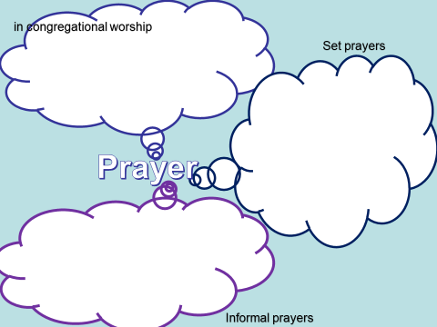

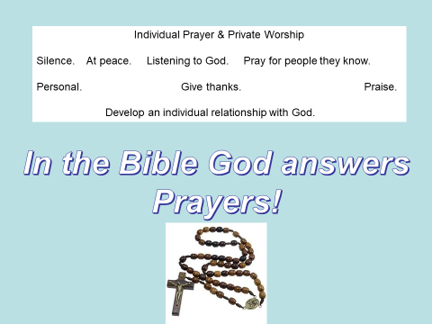

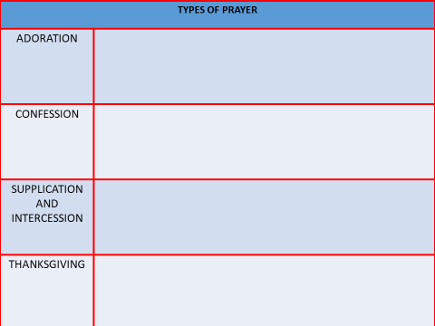
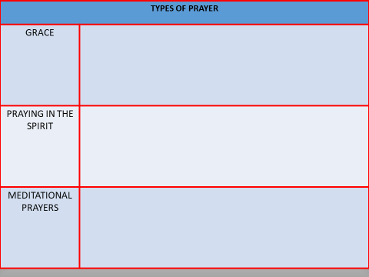

MUSIC AND ART IN CHRISTIAN WORSHIP
Some churches use a lot of art. The most common form is stained-glass windows, to tell stories from the Bible (when they were first made lots of people couldn’t read). You might also find paintings in churches, statues, carvings etc.
But some Christians (such as Orthodox and Roman Catholic denominations) feel that this might encourage people to worship the statues and not God. This is called idolatry.
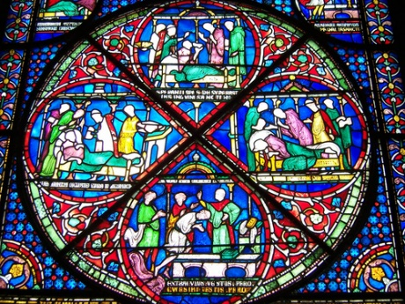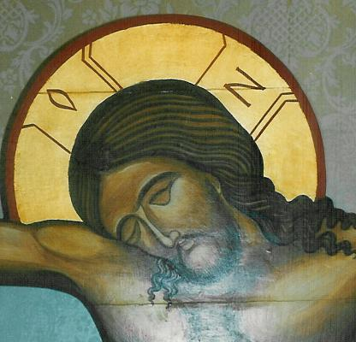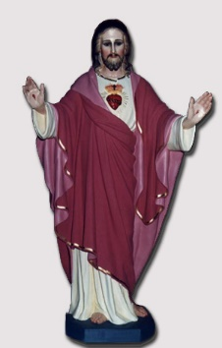

Music is also used in church services.
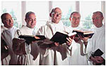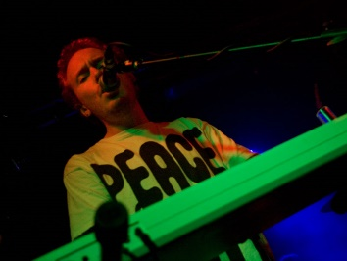

CHRISTIAN RELIGIOUS SYMBOLS WORDSEARCH
- _ _ _ - _ _ _ : a symbol made from two Greek letters, showing the first and last
two letters of the word “Christ”.
- _ _ _ _ _: the wooden frame that Jesus was killed on.
- _ _ _ _ _ _ _ _: Jesus is seen as this – looking after his sheep.
- _ _ _ _: a bird that symbolises peace, love and hope.
- _ _ _ _ _: the first letter of the Greek alphabet, used together with…
- _ _ _ _ _ : the last letter of the Greek alphabet, to show that God is the
beginning and the end of all things.
7) _ _ _ _ _ _ _: A coded message used by early Christians during times of
persecution. The word means “fish” in Greek, but each letter
stands for the initial letter of “Jesus Christ, Song Of God,
Saviour.”
8) _ _ _ _ _: a substance used to symbolise the cleansing of sins.
9) _ _ _ _ _ _ _ : God is three things at once – Father, Son and Holy Spirit.

I | P | C | H | I | - | R | H | O | I
O | C | F | Y | O | A | H | P | L | A
W | S | T | S | F | S | X | L | O | G
C | T | R | H | E | N | E | V | W | E
O | R | I | E | U | L | N | E | A | M
S | E | N | P | A | S | E | G | T | O
S | O | I | H | D | O | V | E | E | W
O | M | T | E | N | H | T | A | R | S
R | E | Y | R | P | N | E | G | R | I
C | H | K | D | O | U | R | I | A | L

PILGRIMAGE

