|  |
| --- |
| COMMON IDEAS AND THEMES |

**The Official Definition Of God**

|  |  |  |  |
| --- | --- | --- | --- |
| God is… |  | …which means |  |
| God is… |  | …which means |  |
| God is… |  | …which means |  |
| God is… |  | …which means |  |
| God is… |  | …which means |  |

|  |
| --- |
| What are your thoughts/ideas/views on this definition? |
|  |

CHRISTIAN VIEWS OF

GOD

|  |  |
| --- | --- |
| king-hearts1 | father-and-son-beach |
|  |  |
| superman-overlooking-metropolis | ghost4 |
|  |  |

Christianity is known as a _______________ religion because it teaches that there is only _______________ God. They believe God is _______________ and exists outside _____________. The word for this is ______________. Time is part of the ____________ that God ______________. He is in control of both ____________ and ____________. God is able to see the ____________, the ______________ and the _____________. Existing outside space and time means he is ______________ and above all created things.

|  |
| --- |
|  |
|  |
|  |
|  |
|  |
|  |
|  |
|  |
|  |
|  |
|  |
|  |
|  |
|  |
|  |

KEY WORDS QUIZ

|  |  |
| --- | --- |
|  |  |
|  |  |
|  |  |
|  |  |
|  |  |
|  |  |
|  |  |
|  |  |
|  |  |
|  |  |
|  |  |
|  |  |

Christianity also teaches that God is _______________, meaning He is ____________ with the __________ and human____________. By acting in this way God shows His ______________ (love and ___________ towards __________) and His ______________. In the Bible, God is often shown to have relationships with ____________ through __________, ___________ and the presence of the ____________ ____________. So Christianity understands Him to be a ______________ God.

|  |
| --- |
|  |
|  |
|  |
|  |
|  |
|  |
|  |
|  |
|  |
|  |
|  |
|  |
|  |
|  |
|  |



**How is God like a cup of tea?**

Word Up!

### **The Word Became Flesh**

**1**In the beginning was the Word, and the Word was with God, and the Word was God. **2**He was with God in the beginning. **3**Through him all things were made; without him nothing was made that has been made. **4**In him was life, and that life was the light of all mankind. **5**The light shines in the darkness, and the darkness has not overcomeit.

**14**The Word became flesh and made his dwelling among us. We have seen his glory, the glory of the one and only Son, who came from the Father, full of grace and truth.

|  |  |
| --- | --- |
| **GOOD THINGS THAT HAPPENED TO ME OVER THE WEEK** | **BAD THINGS THAT HAPPENED TO ME OVER THE WEEK** |
|  |  |



**R**

|  |  |
| --- | --- |
| **E** |  |
|  |  |
|  |  |
|  |  |

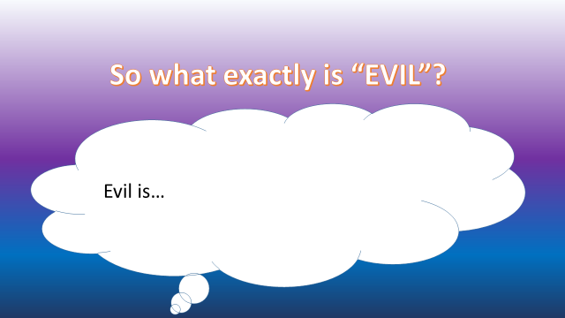

|  |
| --- |
| What are your thoughts on this definition? |
|  |
|  |
|  |
|  |
|  |
|  |
|  |
|  |
|  |
|  |
|  |
|  |
|  |
|  |
|  |

|  |  |
| --- | --- |
| Augustinian Theodicy  Strengths | Irenaean Theodicy  Strengths |
|  |  |
| Augustinian Theodicy  Weaknesses | Irenaean Theodicy  Weaknesses |
|  |  |

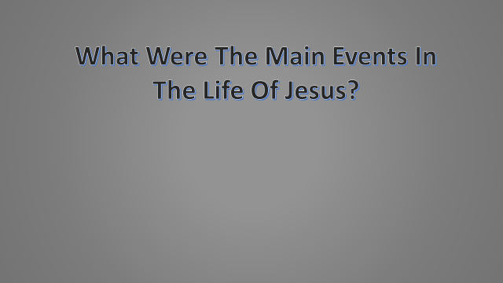

**2**

**1**

|  |  |
| --- | --- |
|  |  |
|  |  |
|  |  |
|  |  |
|  |  |
|  |  |
|  |  |
|  |  |
|  |  |
|  |  |
|  |  |
|  |  |

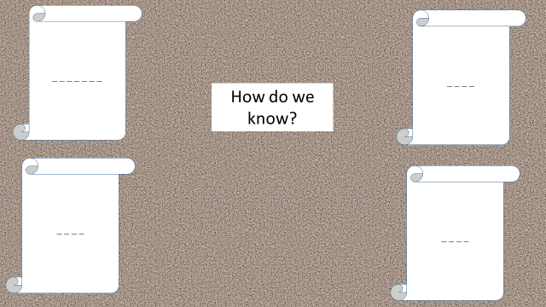

THE FOUR GOSPELS

|  |
| --- |
| RESEARCH – FIND OUT ABOUT THE GOSPELS |
|  |
|  |
|  |
|  |
|  |
|  |
|  |
|  |
|  |
|  |
|  |
|  |
|  |
|  |
|  |
|  |
|  |

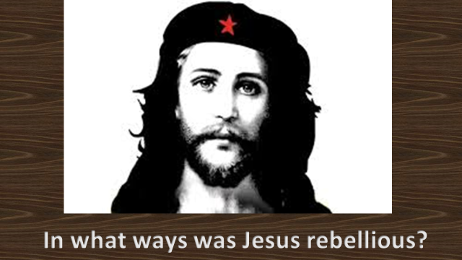

**The Sermon On The Mount**

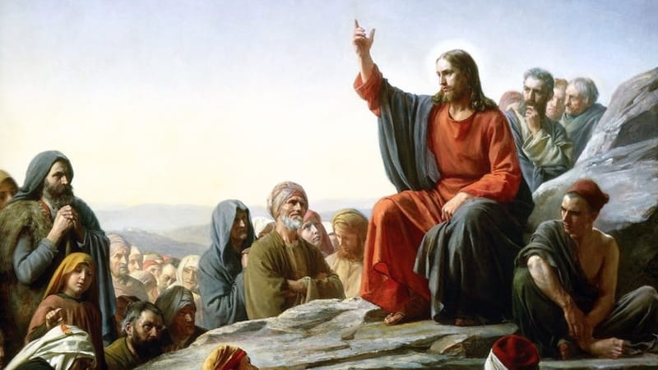

1. THE BEATITUDES
2. JESUS AND THE LAW
3. TRUE DISCIPLESHIP
4. TRUE RIGHTEOUSNESS
5. THE NARROW GATEWAY
6. BUILDING ON SOLID FOUNDATIONS

**How Beatitudiful Are You?**

|  |  |  |
| --- | --- | --- |
| QUESTION | ANSWERS | SCORE |
|  |  |  |
|  |  |
|  |  |
| QUESTION | ANSWERS | SCORE |
|  |  |  |
|  |  |
|  |  |
| QUESTION | ANSWERS | SCORE |
|  |  |  |
|  |  |
|  |  |
| QUESTION | ANSWERS | SCORE |
|  |  |  |
|  |  |
|  |  |

|  |  |  |
| --- | --- | --- |
| QUESTION | ANSWERS | SCORE |
|  |  |  |
|  |  |
|  |  |
| QUESTION | ANSWERS | SCORE |
|  |  |  |
|  |  |
|  |  |
| QUESTION | ANSWERS | SCORE |
|  |  |  |
|  |  |
|  |  |
| QUESTION | ANSWERS | SCORE |
|  |  |  |
|  |  |
|  |  |

|  |  |
| --- | --- |
| What your scores tell you | |
|  |  |
|  |  |
|  |  |



**Ten Commandments**

|  |  |  |  |  |
| --- | --- | --- | --- | --- |
|  |  |  |  |  |
|  |  |  |  |  |

CORRECTIONS

|  |  |
| --- | --- |
| 1 |  |
| 2 |  |
| 3 |  |
| 4 |  |
| 5 |  |
| 6 |  |
| 7 |  |
| 8 |  |
| 9 |  |
| 19 |  |

JESUS’ CORRECTIONS…

|  |
| --- |
|  |

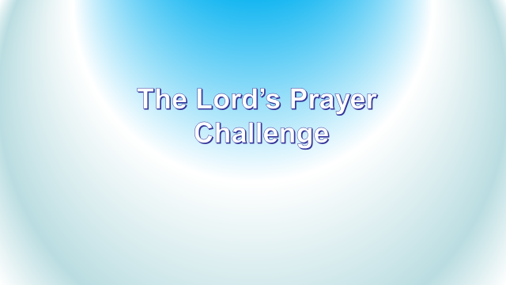

|  |  |
| --- | --- |
| THE LORD’S PRAYER | WHAT DOES IT MEAN? |
|  |  |

**True Righteousness**

|  |  |  |
| --- | --- | --- |
|  | Your attempt | Actual Meaning |
| 1 |  |  |
| 2 |  |  |
| 3 |  |  |
| 4 |  |  |

THE NARROW GATEWAY



|  |
| --- |
| What does this teaching tell us? |
|  |

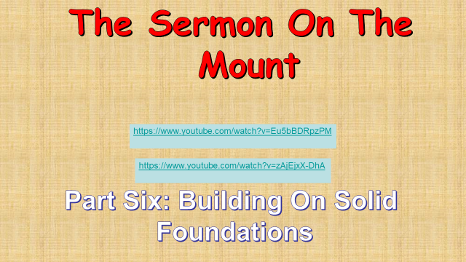

|  |  |
| --- | --- |
| The Wise Man’s Approach To Building | The Foolish Man’s Approach To Building |
|  |  |

|  |
| --- |
|  |



**The Sixty Second**

**Challenge.**

**The Passion**

|  |
| --- |
|  |
|  |
|  |
|  |
|  |
|  |
|  |
|  |
|  |
|  |
|  |
|  |
|  |
|  |
|  |
|  |
|  |
|  |
|  |

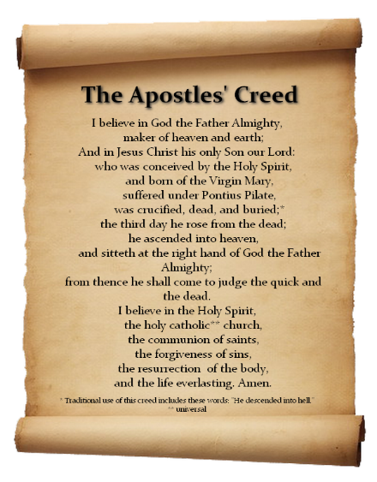

Christians believe that because Adam and ______ sinned in The _______, the human ___________ with God had been broken. Something had to be done to ____________ the relationship.

Humans have to be saved from their __________. The Christian message is that this saving process, or ___________ was done by ______ Himself. He did it by becoming _____________ as Jesus (the ______________) and died as a _____________ in the place of humans. This is known as the _____________ (something that makes amends or pays for having done something _________).

CONCEPTS:

* Salvation
* Atonement
* Repentance
* Forgiveness
* Sin
* Grace
* Redemption

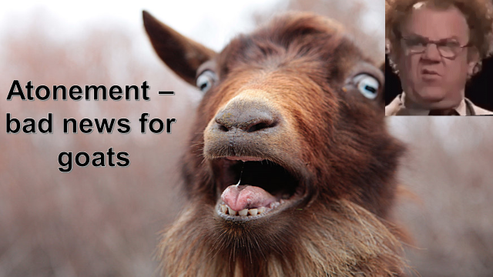

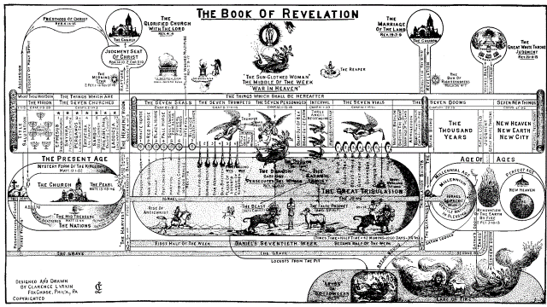

THE APOCALYPSO