The Reoccupation of the Rhineland
Where Is The Rhineland?  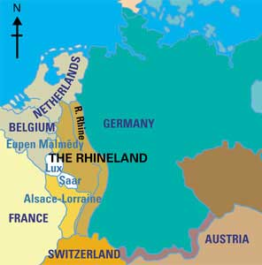  Why Did Hitler Want It? | Describe How The Nazis Took The Rhineland:
Why Didn’t Britain React?  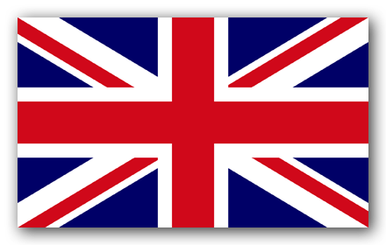 | Could Hitler Have Been Stopped?
 | Why The Reoccupation Of The Rhineland Was A Step To WWII
Why Didn’t France React?
Why Didn’t The League of Nations React?

