Test on Part 3 (The Origins and Outbreak of the Second World War)
You need to answer all four questions from this section, using the sources specifically for answering Q1 and Q2.

Source A – A British cartoon by David Low from 1936. The first three steps have the words ‘Rearmament’ ‘Rhineland Fortification’ (Remilitarisation) and ‘Danzig’ written on them. The top step says ‘Boss of the Universe’.
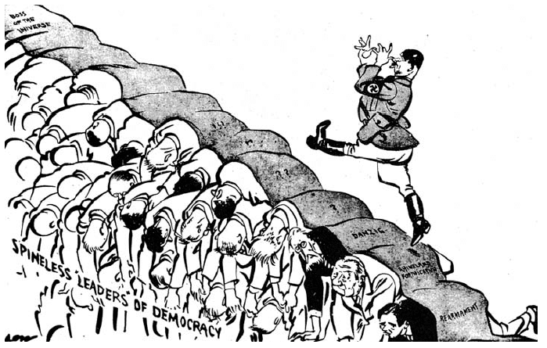

Source B – A British cartoon published in September 1939 commenting on the Nazi-Soviet Pact. The standing figures represent Hitler and Stalin. The figure on the ground represents Poland.
Source C – Winston Churchill speaking in the House of Commons in October 1938 after the Munich Conference. Churchill was a leading British politician.
Appeasement has been totally defeated. The Munich agreement has abandoned Czechoslovakia. This is a disaster for Great Britain and France. There can never be friendship between British democracy and an aggressive, pitiless and murderous Nazi government. The danger still exists and now we will pay the price for pursing good intensions, avoiding a fight and neglecting our air defences.

Answer questions 01, 02, 03 and 04.

- Study Source A.
Source A is critical of the Munich Agreement. How do you know?
Explain your answer by using Source A and your contextual knowledge.
[4 marks]

- Study Sources B and C.
How useful are Sources B and C to a historian studying the causes of the Second World War?
Explain your answer using Sources B and C and your contextual knowledge.
[12 marks]

- Write an account of how the remilitarisation of the Rhineland increased international tension.
[8 marks]

- The policy of appeasement was the main cause of the Second World War.

How far do you agree with this statement? Explain your answer.
[16 marks]
[SPaG: 4 marks]

