Test on Part 2 (The League Of Nations And International Peace)
You need to answer all four questions from this section, using the sources specifically for answering Q1 and Q2.
Source D – A cartoon created by David Low, published in the Evening Standard on 24th November 1932, called ‘Trial by Geneva’. The judges represent the League of Nations and lawyers are frantically reading the Lytton Report. Japan is not intimidated and is pulling faces.

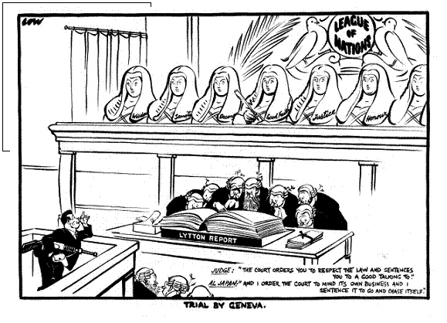

Source E – Unemployed Germans queuing to find work outside an employment office in Hanover in 1930. The writing on the warehouse wall translates as ‘Vote Hitler’.

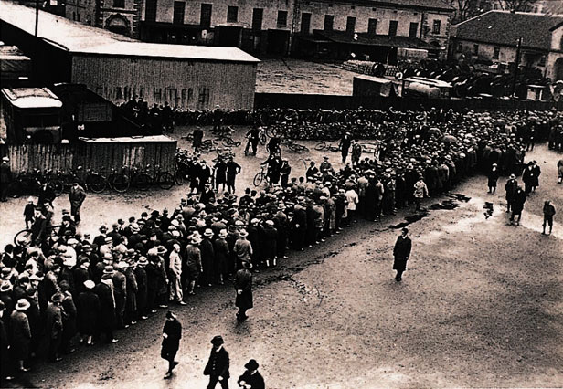

Source F – Adapted from an entry in a 1934 essay competition, by a German railway worker:
Thousands of factories closed their doors. Hunger was the daily companion of the German working man. Many an honest working man had to resort to theft to obtain food. All fellow citizens yearned for better times. As for me, like many another, I had lost all I possessed, so, early in 1930, I joined the Nazi Party.

Answer questions 01, 02, 03 and 04.

- Study Source D.
Source D opposes the League of Nations. How do you know?
Explain your answer by using Source D and your contextual knowledge.
[4 marks]

- Study Sources E and F.
How useful are Sources E and F to a historian studying the impact of the Depression on Germany?
Explain your answer using Sources E and F and your contextual knowledge.
[12 marks]

- Write an account of how Mussolini’s invasion of Abyssinia led to Italy leaving the League of Nations.
[8 marks]

- Structural weaknesses in the League of Nations when it was first set up were the main reasons it was doomed to fail.

How far do you agree with this statement? Explain your answer.
[16 marks]
[SPaG: 4 marks]

